**DATABASE MANAGEMENT SYSTEM (01CT0407)**

**Department of Information Communication and Technology**

**4rd Semester**

**Lab Manual (Dec-Apr 23-24)**

# Index

|  |  |
| --- | --- |
| **Lab** | **Programs** |
| 1 | Introduction to RDBMS and APEX Login |
| 2 | DDL Commands and Table Creation |
| 3 | DML Commands and Queries |
| 4 | DML Commands and Related Queries |
| 5 | Constraint-Based DML Commands |
| 6 | Functions and Queries |
| 7 | Implement operator, null and special operator-based queries |
| 8 | Implement Constraint-based and Group by related queries |
| 9 | Range Function and Operator based Queries |
| 10 | Join based Queries having Functions |
| 11 | Understand and implement Conditions and looping in PL/SQL |
| 12 | Implement a PL/SQL Block |
| 13 | Implement a Procedure and Function for given Statement |
| 14 | Understand and Implement Triggers |

**Practical 1**

## Aim: Introduction to RDBMS and APEX Login.

**APEX login:**

Step 1:https://apex.oracle.com/pls/apex/ Step 2: Click on Request a workspace.

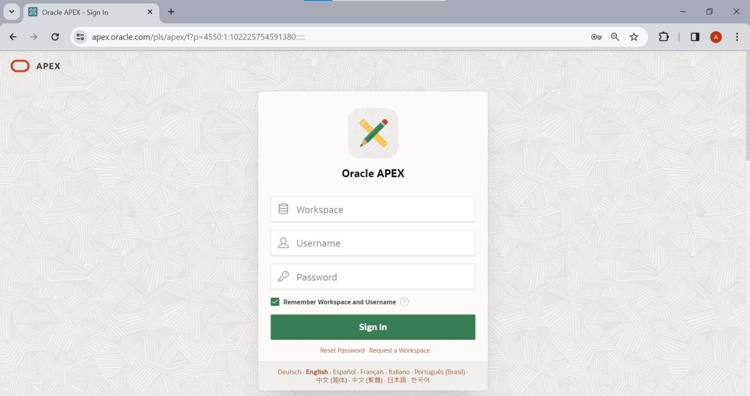

Step 3:Fill all the required details carefully like: First Name: Your name(ex. Harikesh) Last Name: Your last name (ex. Chauhan)

Email: Use your institute email address only. Workspace:name_surname And click on next.

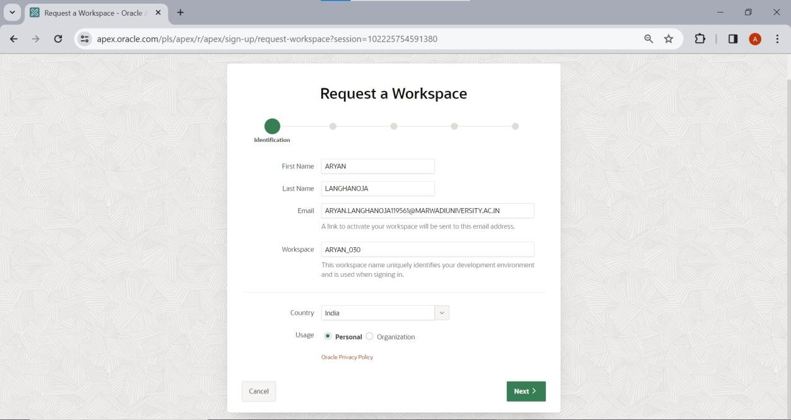

Step 4: Fill survey detail same as below and click on next.

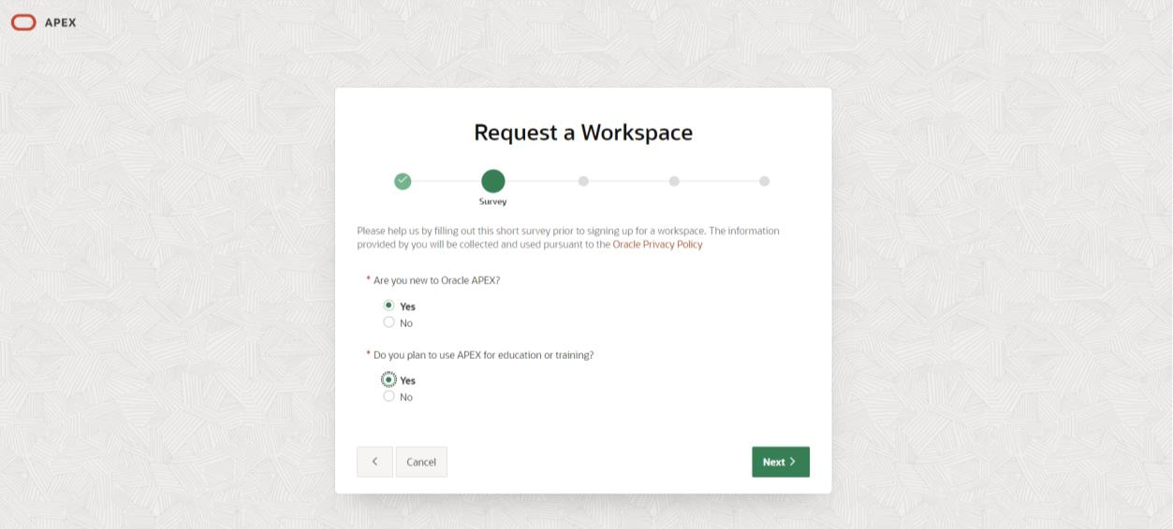

Step 5: Write appropriate text in textarea and Click on next,

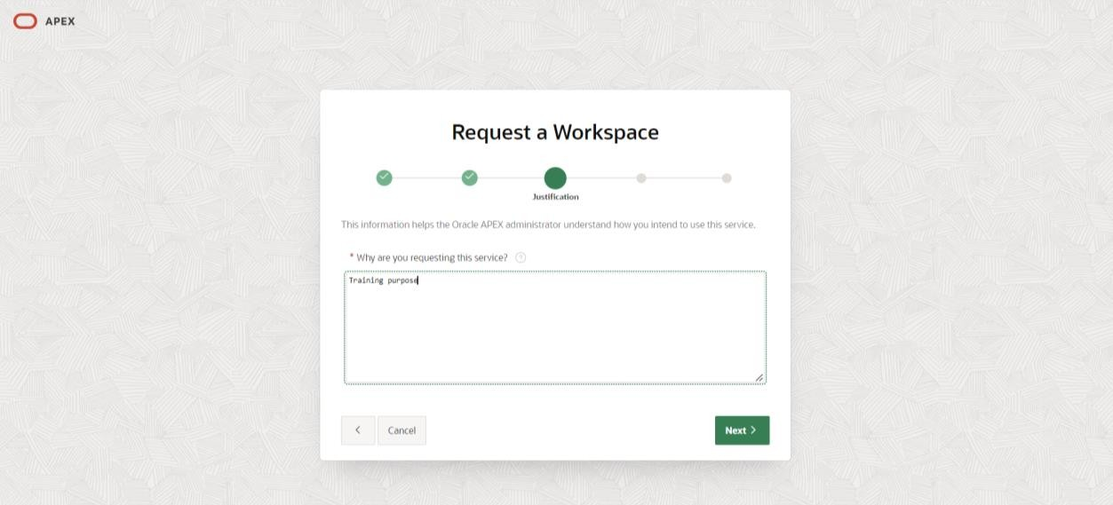

Step 6:Click on check box to agree terms and conditions and Click on next.

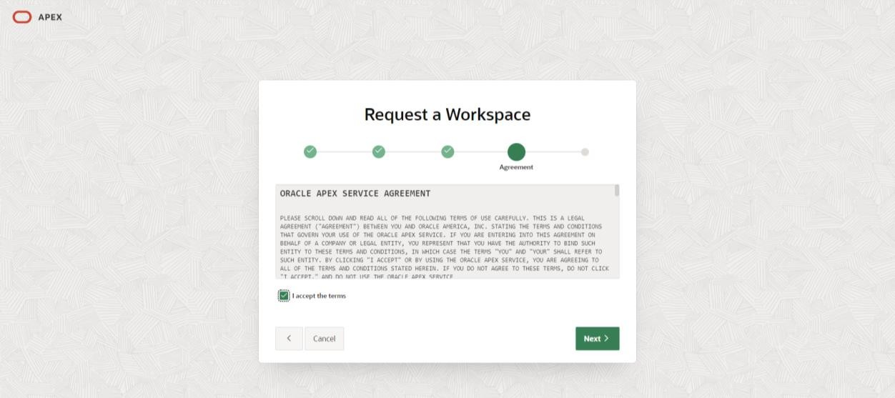

Step 7:Click on submit request button and Click on next

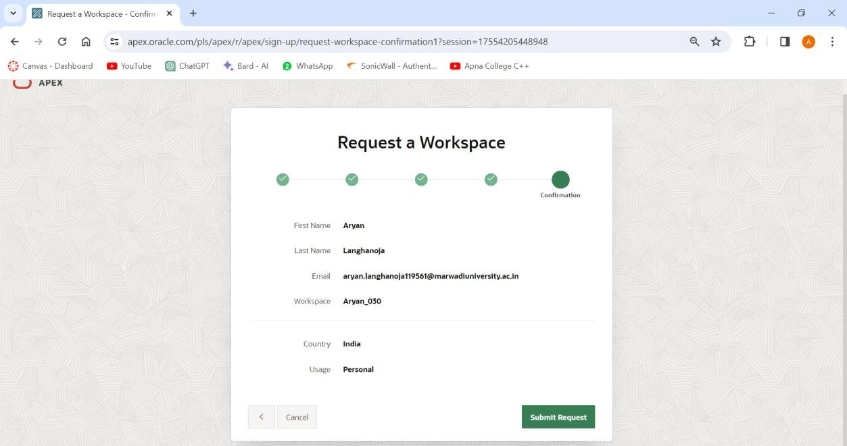

Step 8: After that you will receive an email on your institute email id.

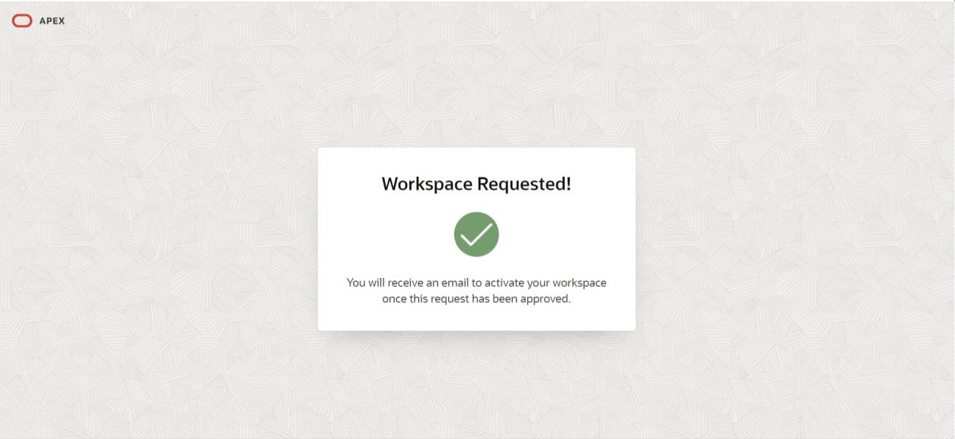

Step 9: Click on create workspace.

Step 10: Click on Continue to sign in screen.

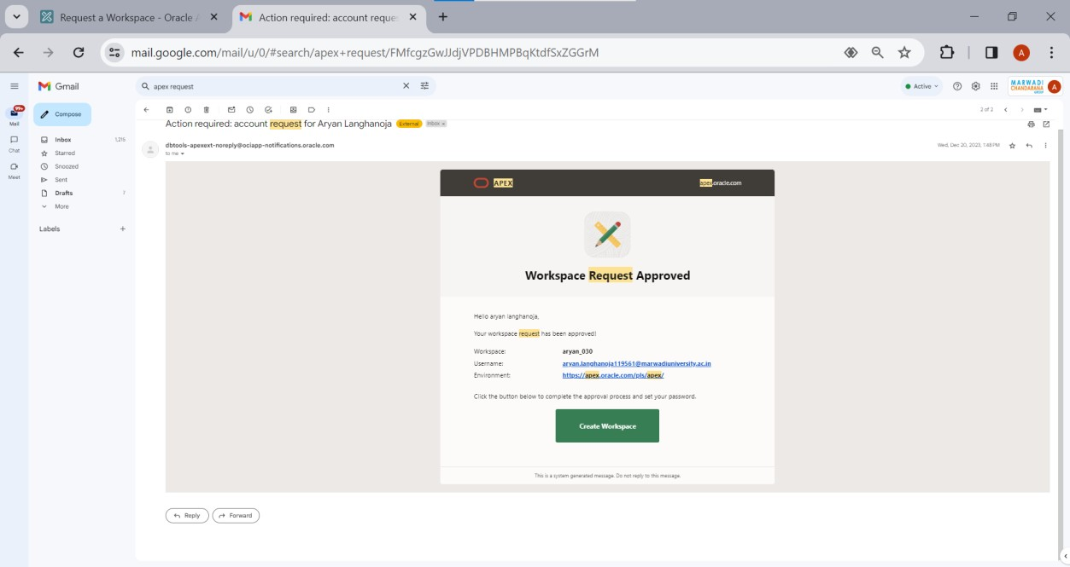

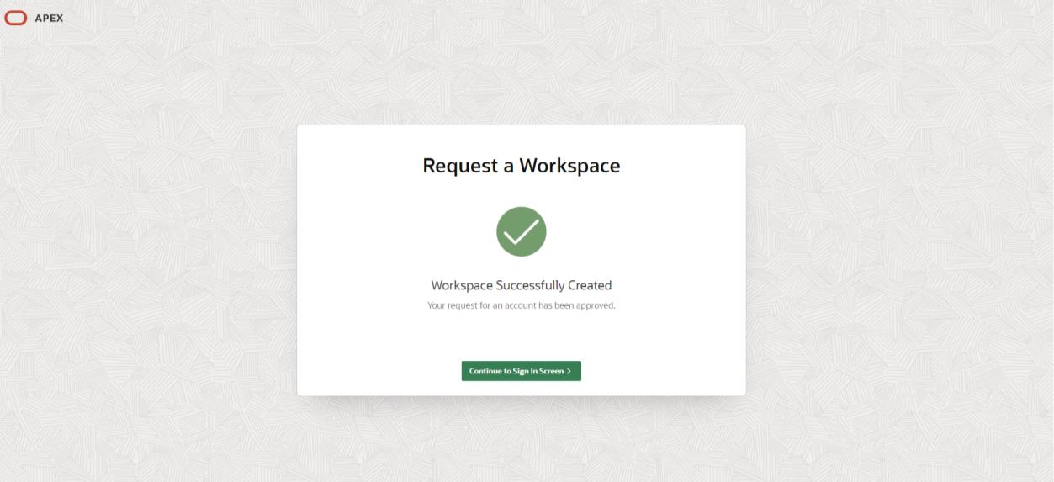

Step 11: Set your new password and confirm password and click on change password.

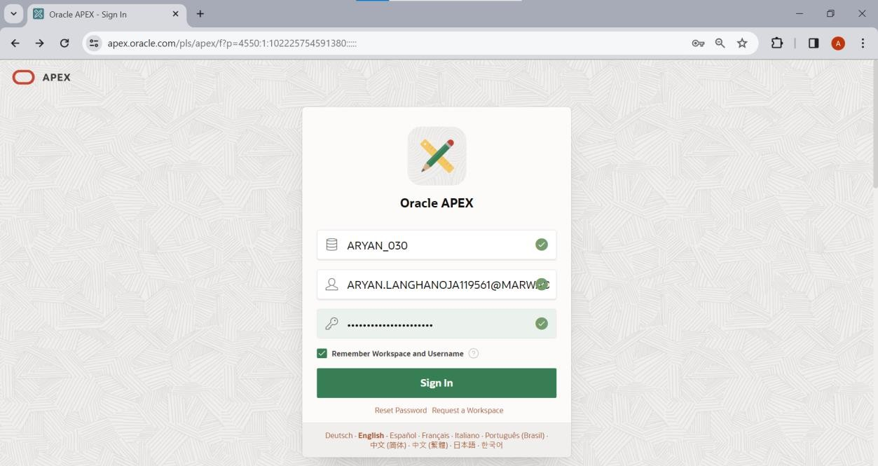

Step 12: Click on SQL workshop.

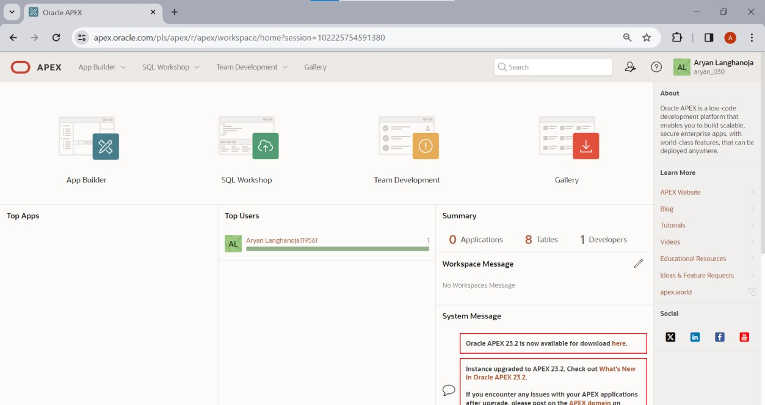

Step 13: Click on SQL Commands.

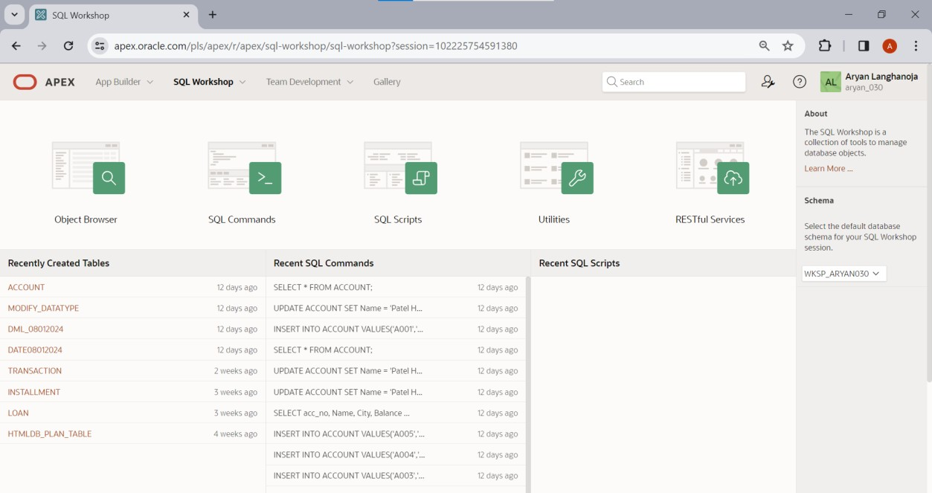

Step 14: Now you can perform your queries.

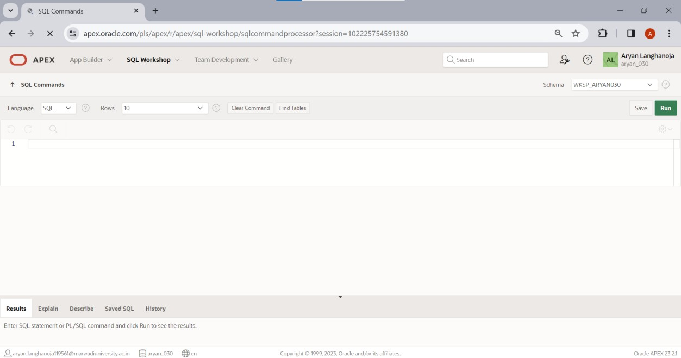

# Practical 2

## Aim: DDL Commands and Table Creation.

### Create a table ACCOUNT

|  |  |  |
| --- | --- | --- |
| **Column name** | **Data Type** | **Size** |
| acc_no | varchar2 | 5 |
| Name | varchar2 | 30 |
| City | varchar2 | 20 |
| Balance | Number | 10,2 |
| loan_taken | varchar2 | 5 |

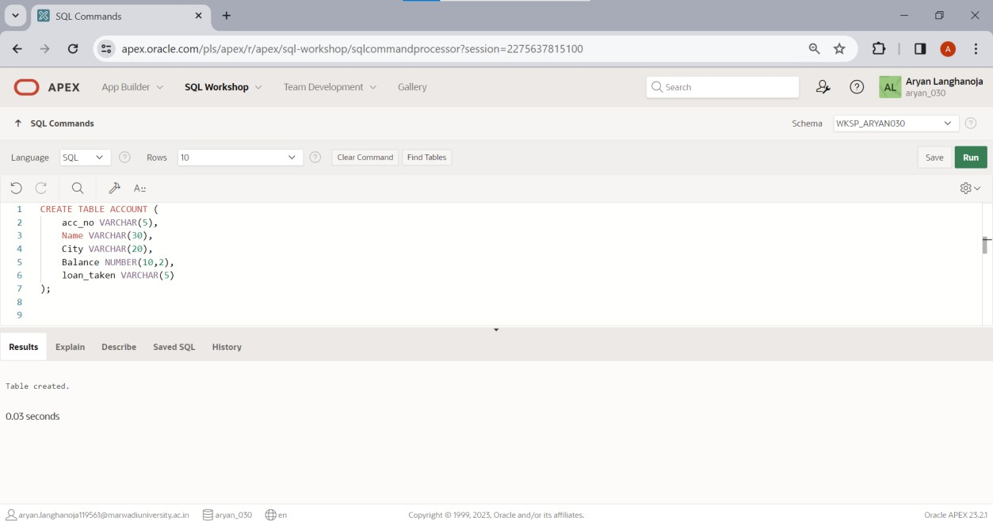

**Insert the following records.**

|  |  |  |  |  |
| --- | --- | --- | --- | --- |
| **acc_no** | **Name** | **City** | **Balance** | **loan_taken** |
| A001 | Patel Jigar | Mehsana | 50000 | YES |
| A002 | Patel Ramesh | Mehsana | 50000 | YES |
| A003 | Dave Hardik | Ahmedabad | 75000 | NO |
| A004 | Soni Hetal | Ahmedabad | 100000 | NO |
| A005 | Sony Atul | Vadodara | 100000 | YES |

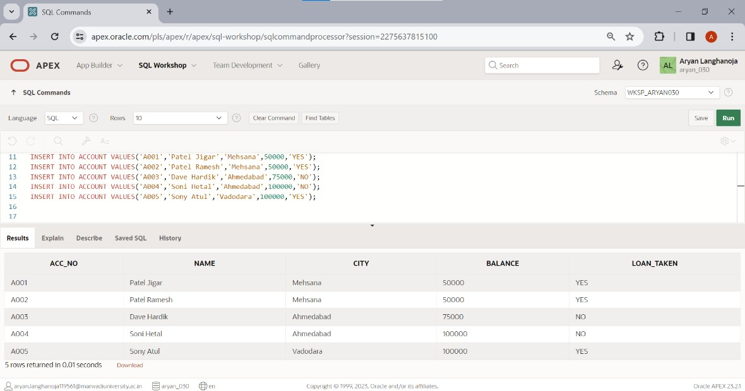

### Create a Table LOAN

|  |  |  |
| --- | --- | --- |
| **Column Name** | **Data Type** | **Size** |
| loan_no | varchar2 | 5 |
| acc_no | varchar2 | 5 |
| loan_amt | number | 10,2 |
| interest_rate | number | 5,2 |
| loan_date | date |  |
| remaining_loa n | number | 10,2 |

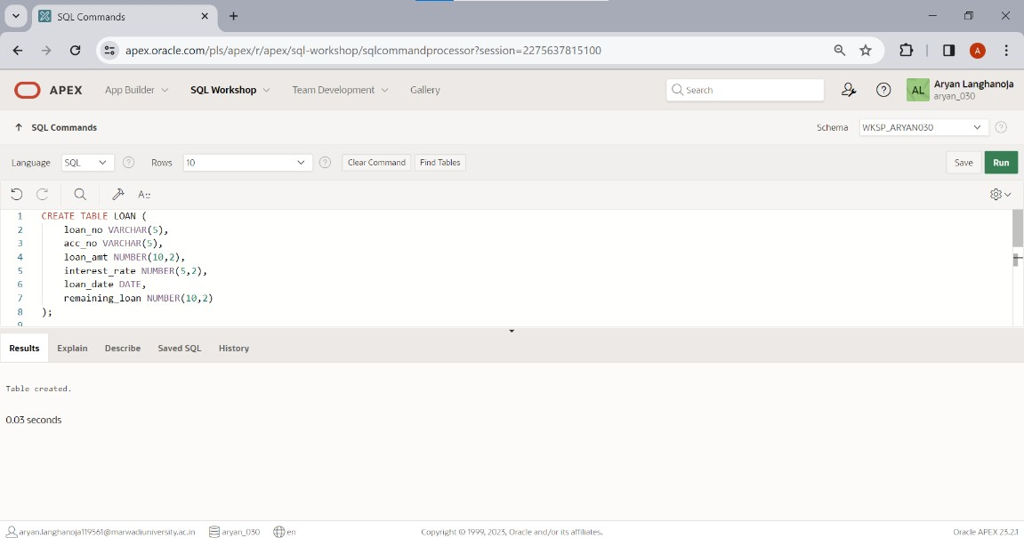

**Insert the following Records.**

|  |  |  |  |  |  |
| --- | --- | --- | --- | --- | --- |
| **Loan_n o** | **Acc_n o** | **Loan_a mt** | **Interest_rat e** | **Loan_date** | **Remaining_loan** |
| L001 | A001 | 100000 | 7 | 1-jan-04 | 75000 |
| L002 | A002 | 300000 | 9 | 18-may-04 | 150000 |
| L003 | A005 | 500000 | 11 | 15-june-04 | 300000 |

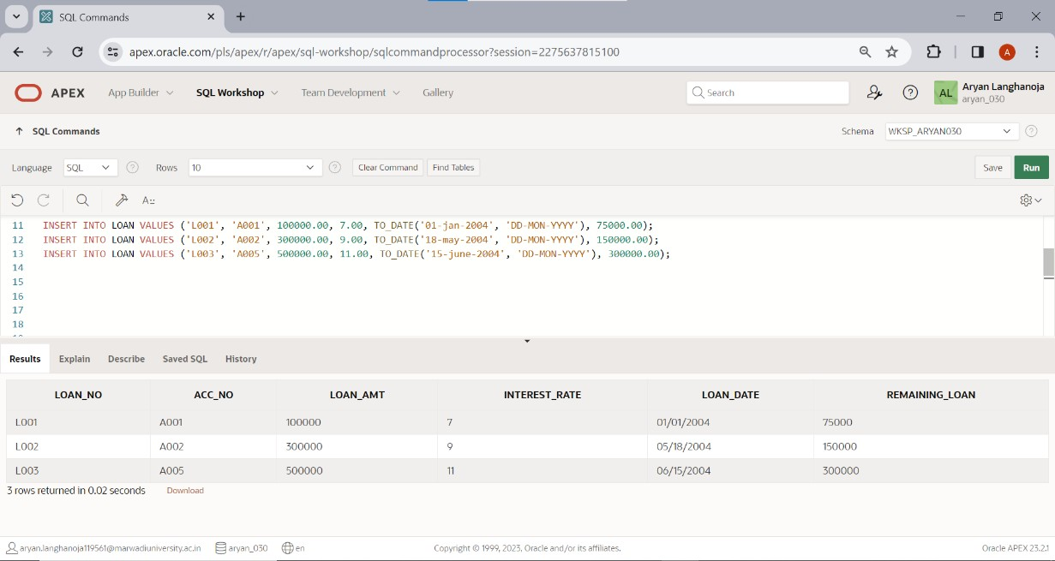

### Create a table INSTALLMENT

|  |  |  |
| --- | --- | --- |
| **Column Name** | **Data Type** | **Size** |
| loan_no | varchar2 | 5 |
| inst_no | varchar2 | 5 |
| inst_Date | Date |  |
| Amount | Number | 10,2 |

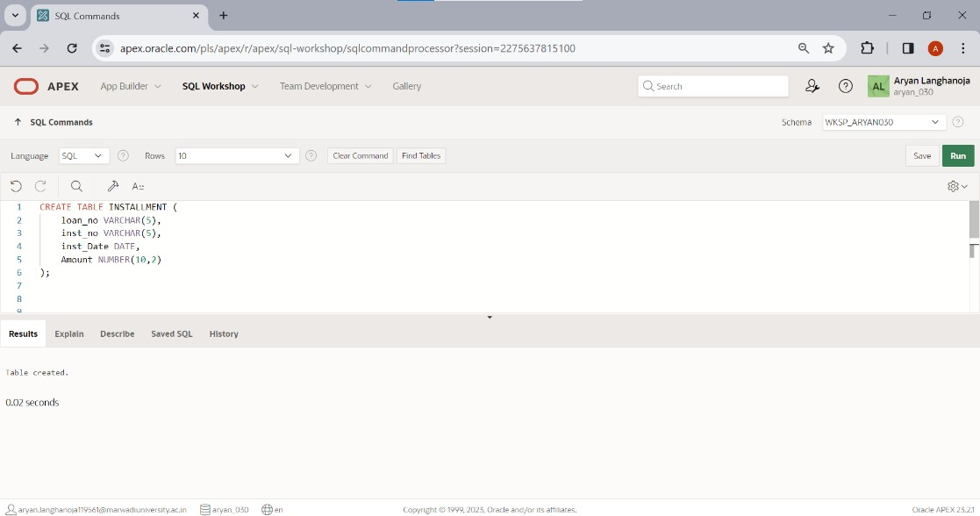

**Insert following Records**

|  |  |  |  |
| --- | --- | --- | --- |
| **Loan_ no** | **Inst_ no** | **Date** | **Amou nt** |
| L001 | I001 | 2-Feb-04 | 15000 |
| L002 | I002 | 18-June- 04 | 20000 |
| L003 | I003 | 15-July- 04 | 20000 |

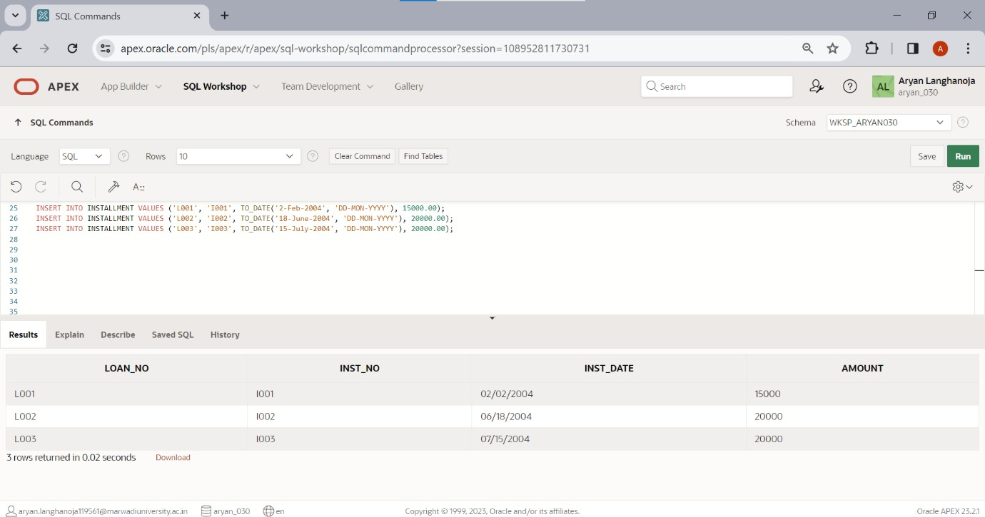

### Create a Table TRANSACTION

|  |  |  |
| --- | --- | --- |
| **Column Name** | **Data Type** | **Si ze** |
| acc_no | Varchar2 | 5 |
| tr_Date | Date |  |
| Amt | Number | 10  ,2 |
| type_of_tr | Char | 1 |
| mode_of_pay | Varchar2 | 10 |

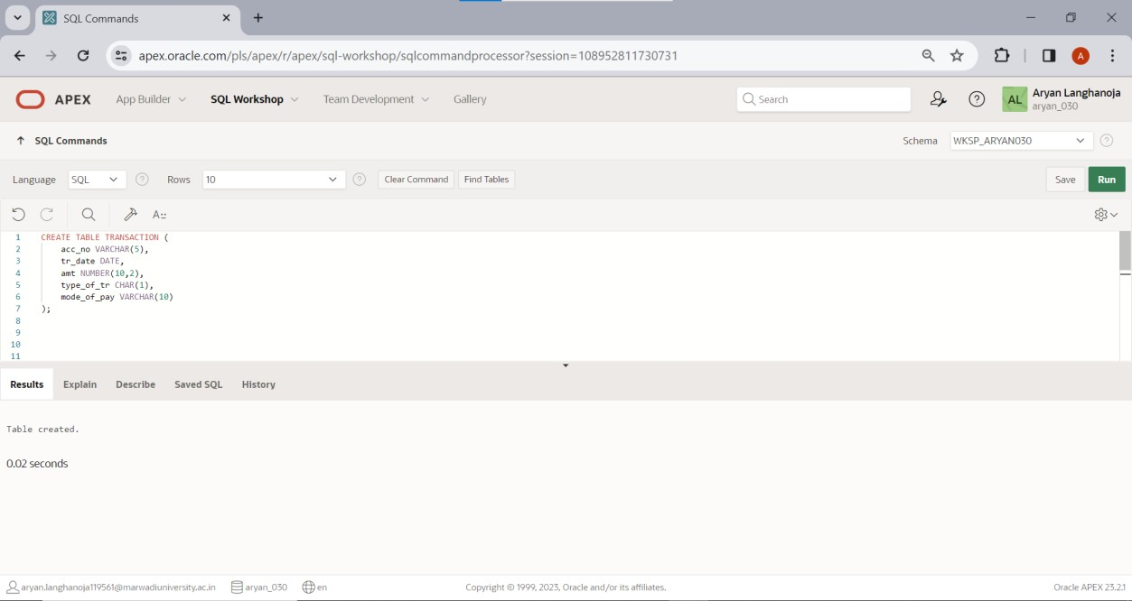

**Insert a Following Records**

|  |  |  |  |  |
| --- | --- | --- | --- | --- |
| **Acc_no** | **Date** | **Amt** | **Type_of_tr** | **Mode_of_pay** |
| A001 | 3-may-04 | 10000 | D | Cash |
| A002 | 5-july-04 | 5000 | W | Cheque |
| A003 | 12-Aug-04 | 25000 | D | Cheque |
| A004 | 15-may-04 | 30000 | D | Cheque |
| A005 | 22-oct-04 | 15000 | W | Cash |

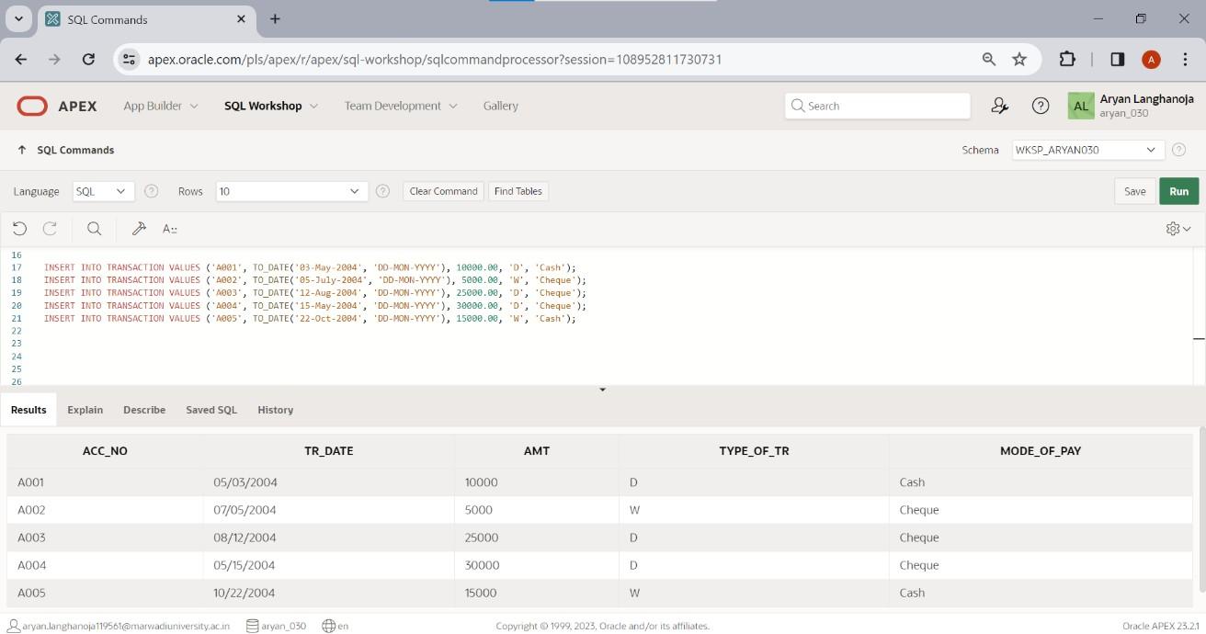

### Table-Account

**List of queries**

1. Display all rows and all columns of table Transaction.

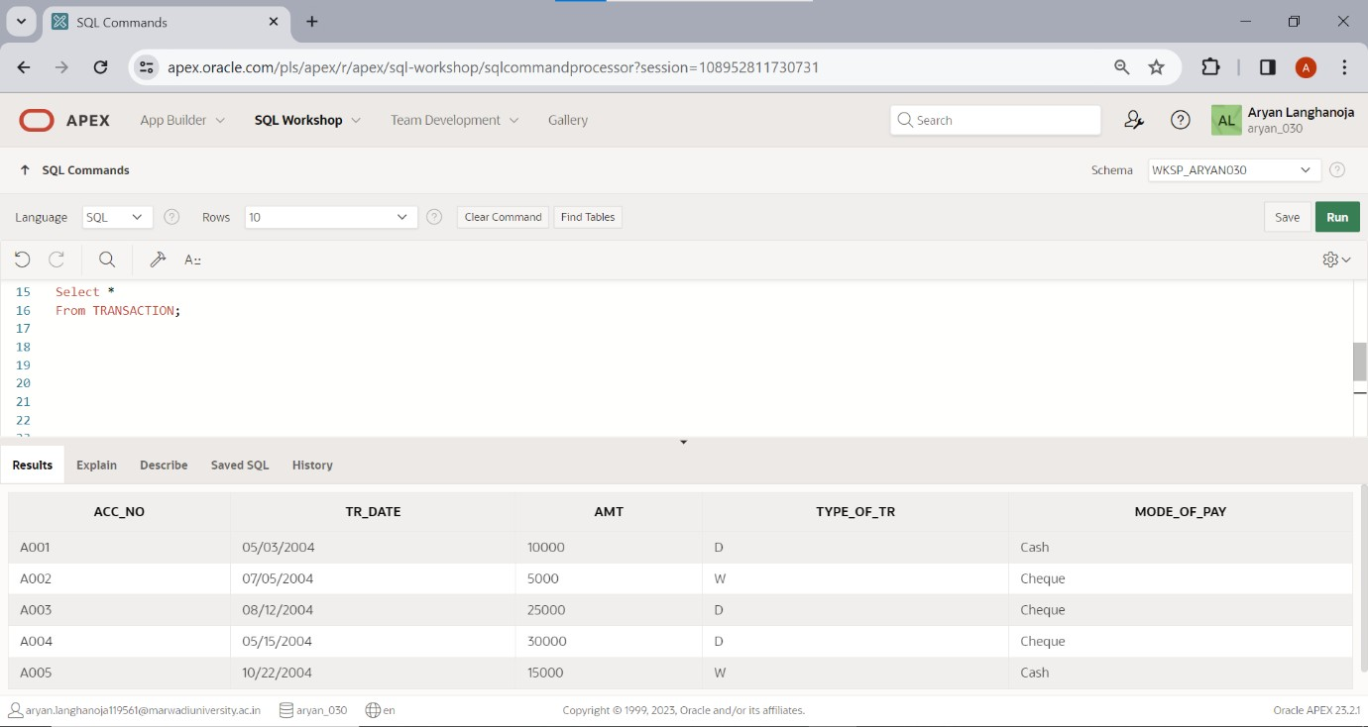

1. Display all rows and selected columns of table Installment.

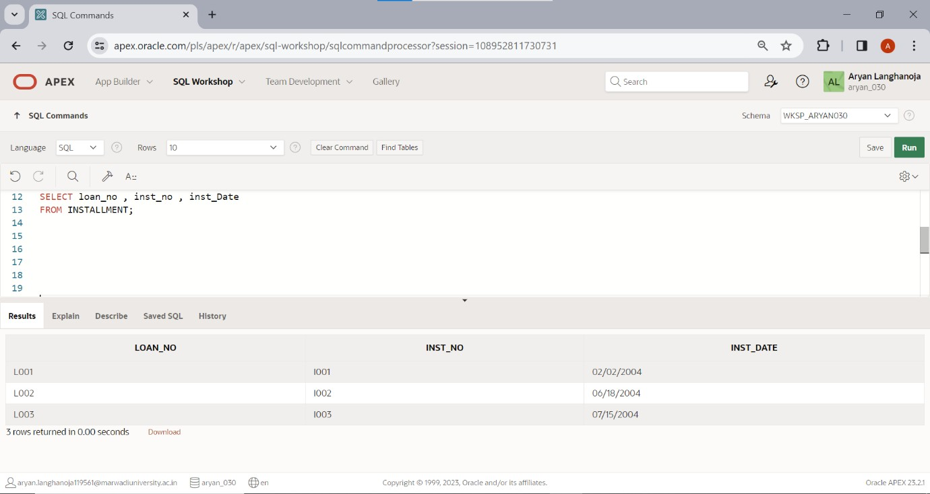

1. 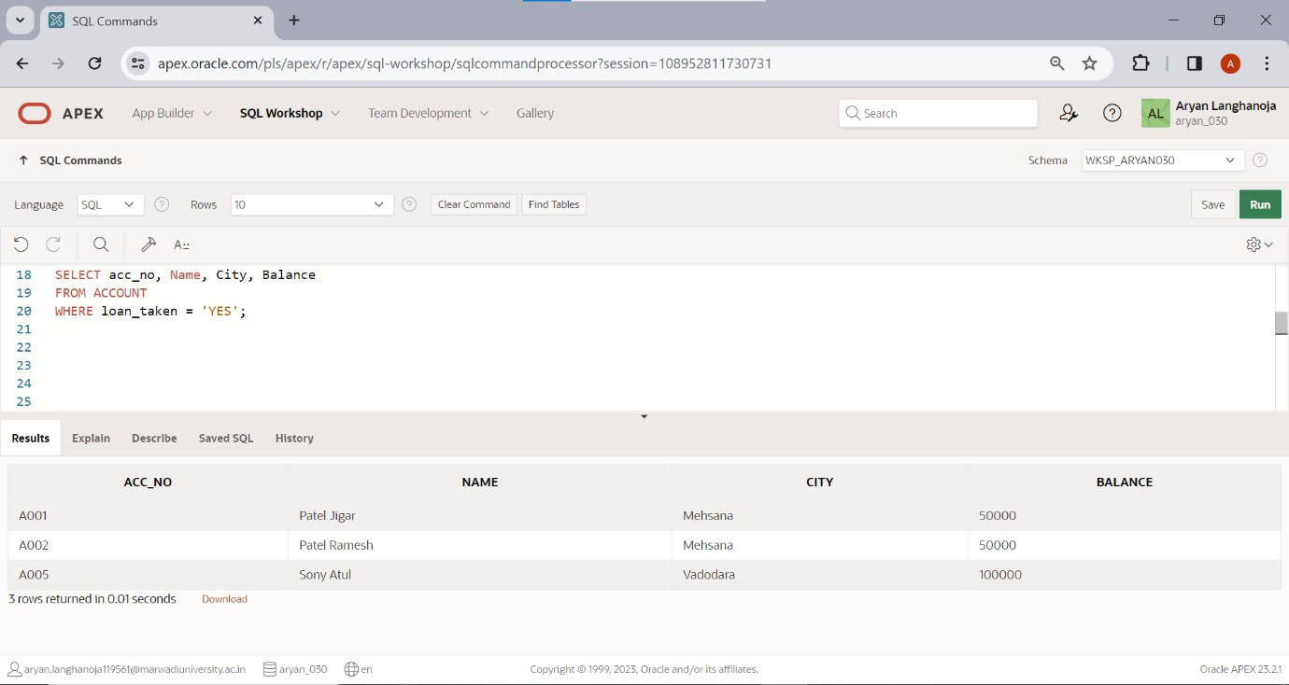Display selected rows and selected columns of table Account.
2. Display selected rows and all columns of table loan.

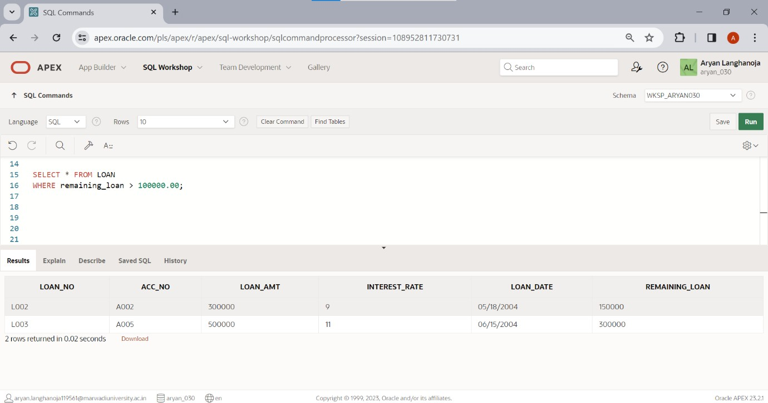

1. Show the structure of the table loan, account and transaction. desc loan;

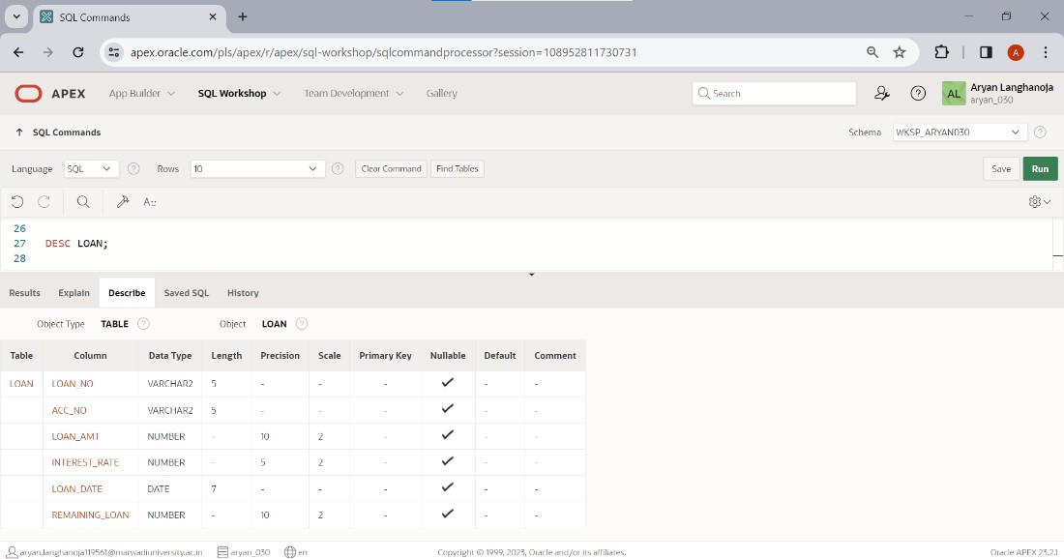

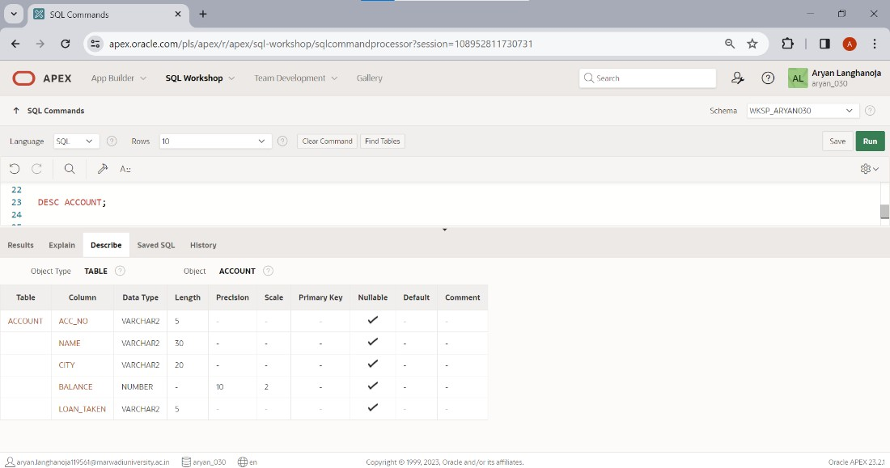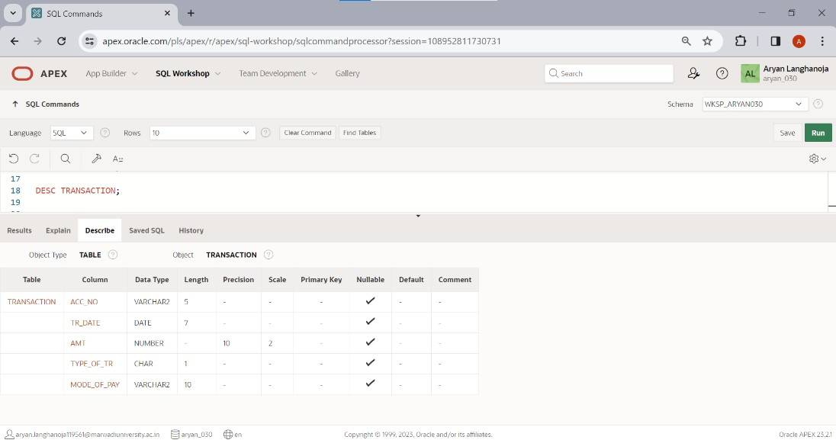

# Practical 3

## Aim: DML Commands and Queries

Table: **ACCOUNT**.

Insert the following records if you have not inserted in PRACTICAL - 1

|  |  |  |  |  |
| --- | --- | --- | --- | --- |
| **Acc_ no** | **Name** | **City** | **Balanc e** | **Loan_take n** |
| A001 | Patel Jigar | Mehsana | 50000 | YES |
| A002 | Patel  Ramesh | Mehsana | 50000 | Yes |
| A003 | Dave  Hardik | Ahmedaba  d | 75000 | NO |
| A004 | Soni Hetal | Ahmedaba d | 10000  0 | NO |
| A005 | Soni Atul | Vadodara | 10000  0 | YES |

1. Change the name ‘patel jigar’ to ‘patel hiren’.

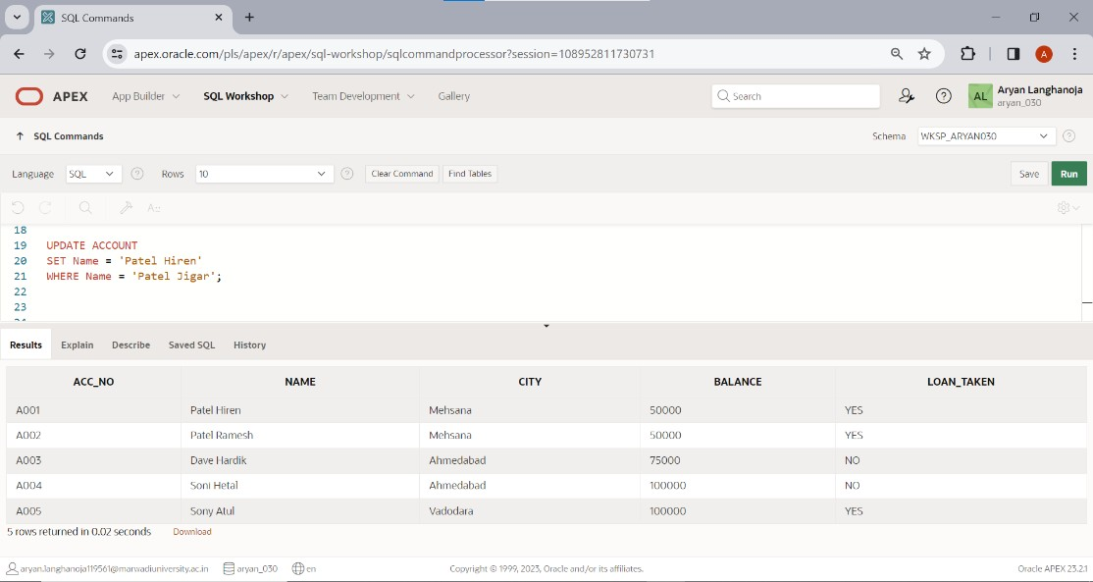

1. Change the name and city where account number is A005. (new name = ‘kothari nehal’ and new city = ‘patan’).

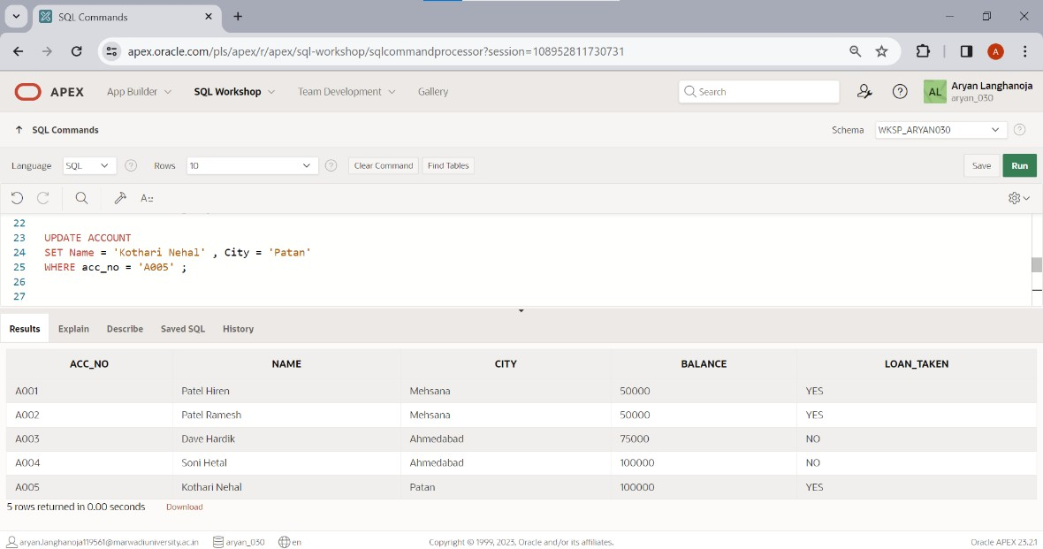

1. 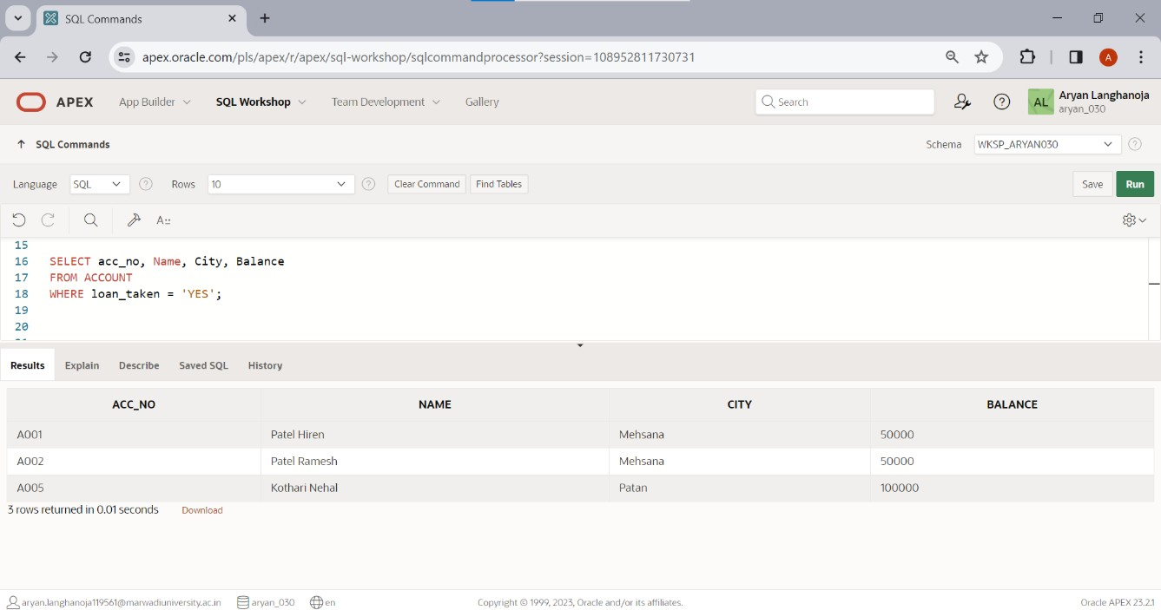Display only those records where loan taken status is ‘YES’.
2. 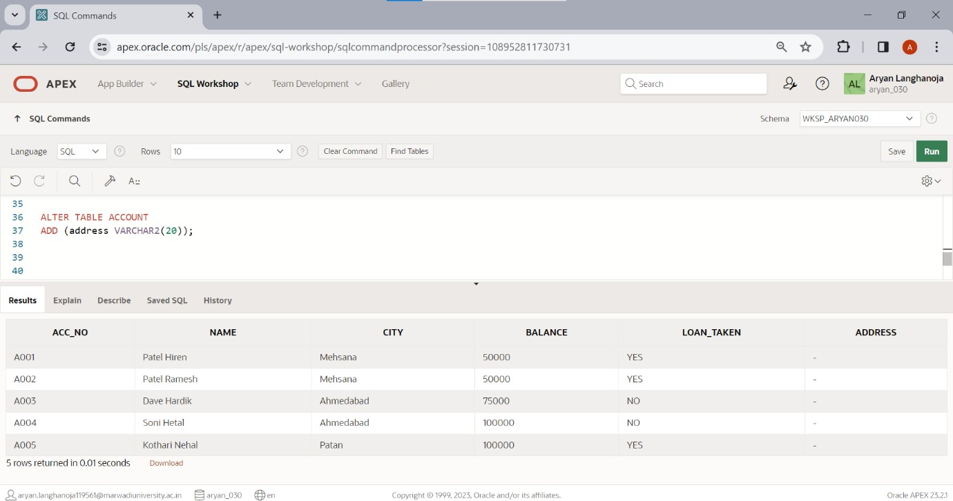Add the new column (address varchar2 (20)) into table ACCOUNT.
3. Create another table ACCOUNT_TEMP (acc_no, name, balance) from table ACCOUNT.

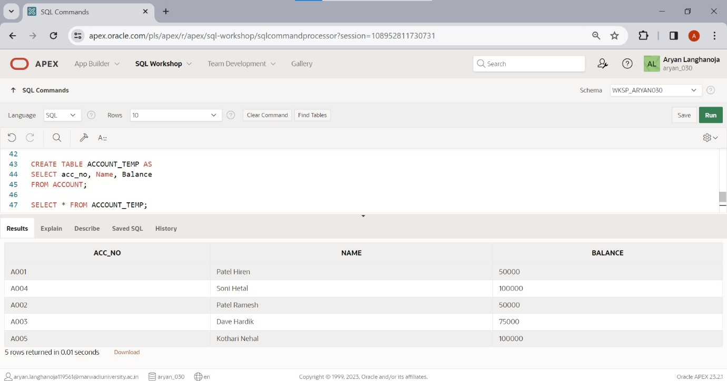

1. Rename the table ACCOUNT to ACCOUNT_MASTER.

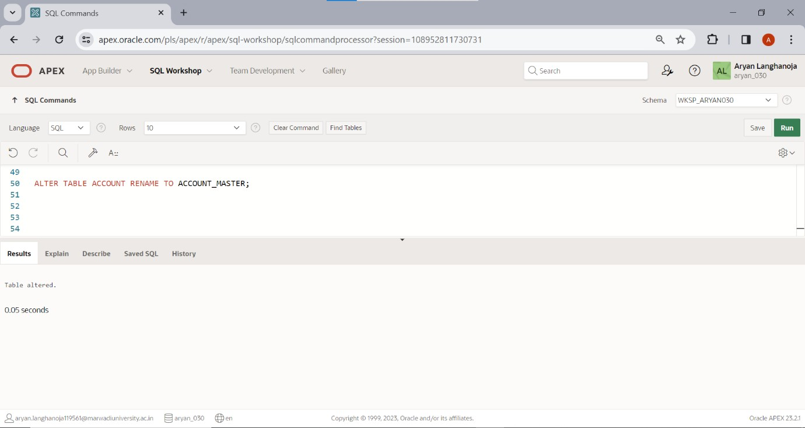

1. Update the column balance for all the account holders. (Multiply the balance by 2 for each account holders)

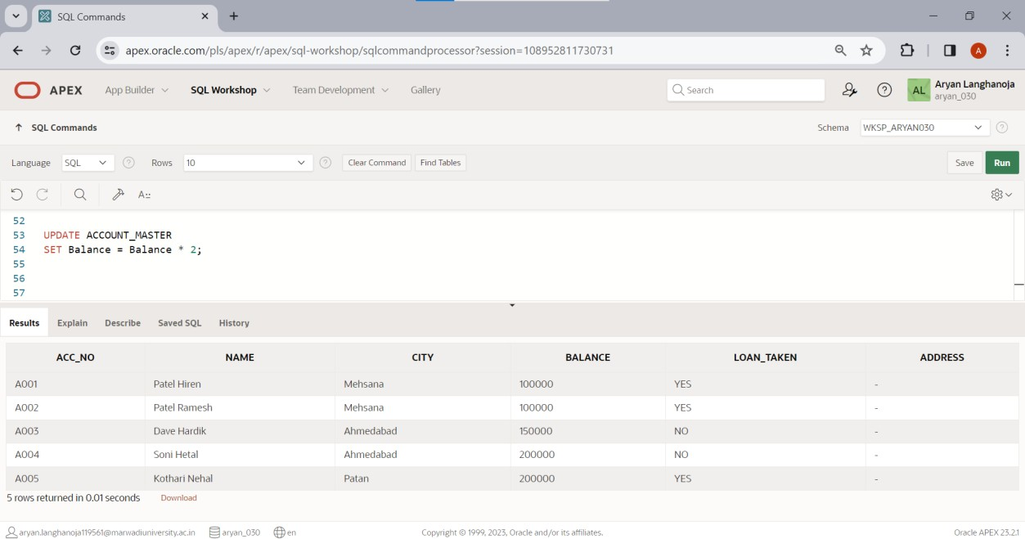

1. Describe the structure of table ACCOUNT.

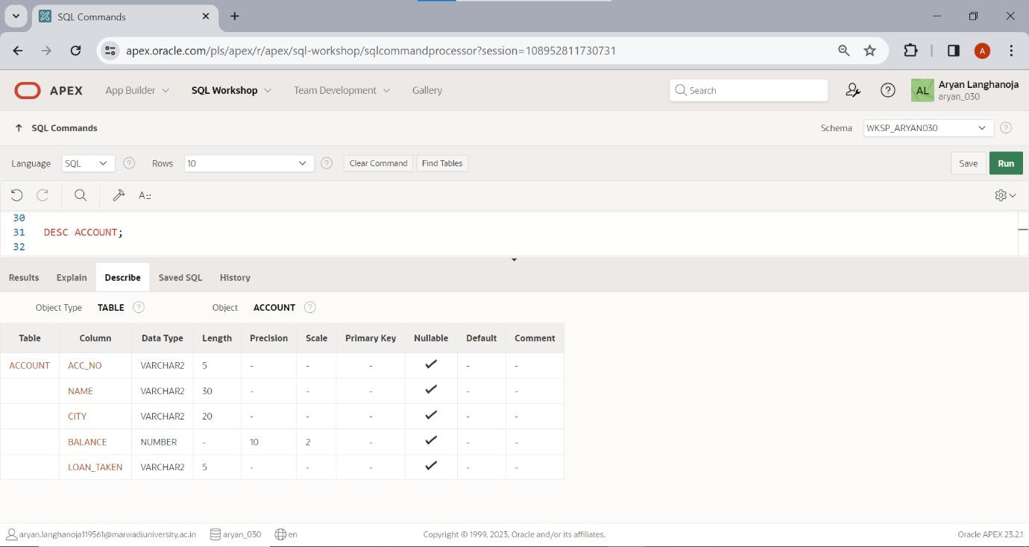

1. Delete the records whose account no is A004.

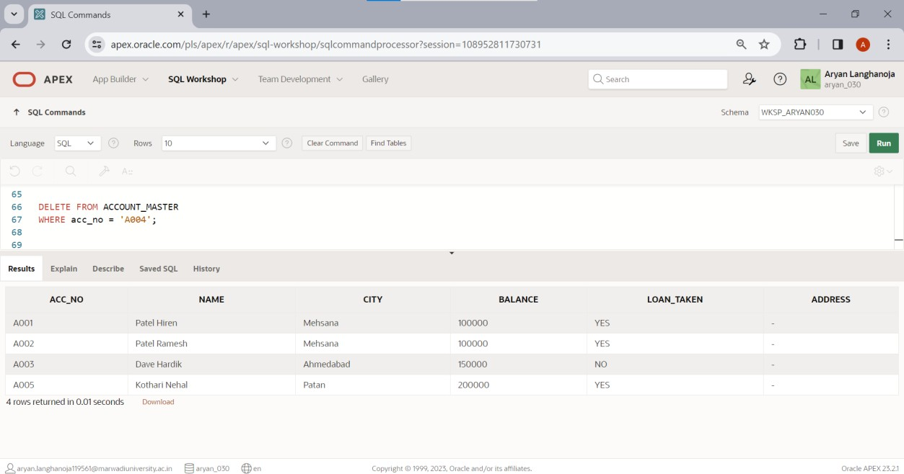

Table: **LOAN**.

Insert the following Records if you have not inserted in PRACTICAL-1

|  |  |  |  |  |  |
| --- | --- | --- | --- | --- | --- |
| **Loan_n o** | **Acc_ no** | **Loan_am t** | **Interest_ra te** | **Loan_date** | **Remaining_loa n** |
| L001 | A001 | 100000 | 7 | 1-jan-04 | 75000 |
| L002 | A002 | 300000 | 9 | 18-may-04 | 150000 |
| L003 | A005 | 500000 | 11 | 15-june-04 | 300000 |

* 1. For each loan holders Add 100000 Rs. Amount into the column loan_amt.

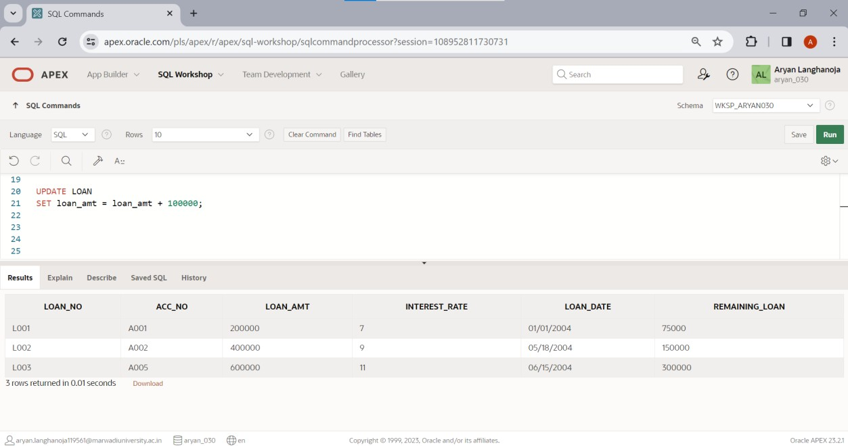

* 1. for each loan holders Increase the interest rate 2%.

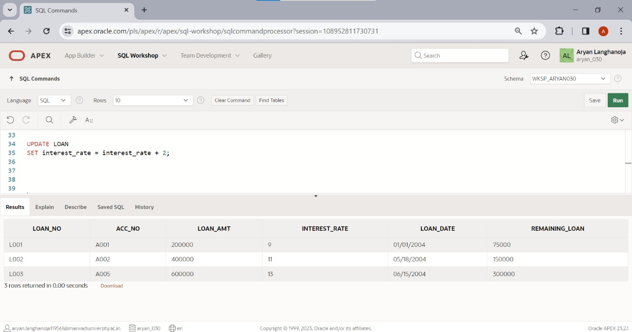

* 1. Create another table LOAN_TEMP (loan_no, Acc_no, loan_amt, loan_date) from The table LOAN.

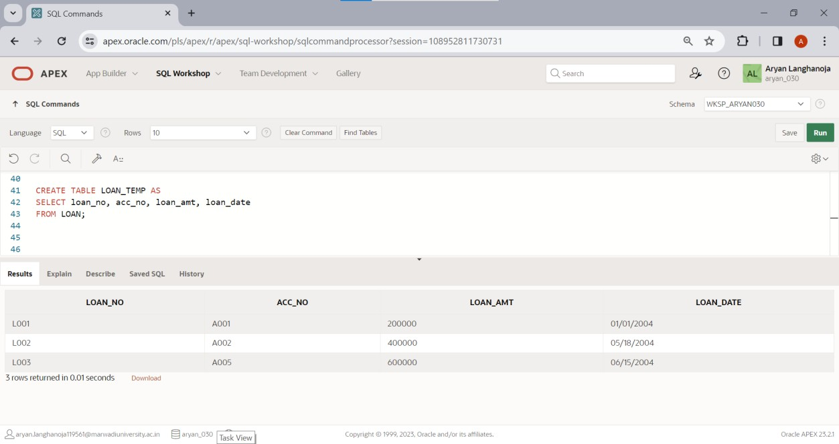

* 1. 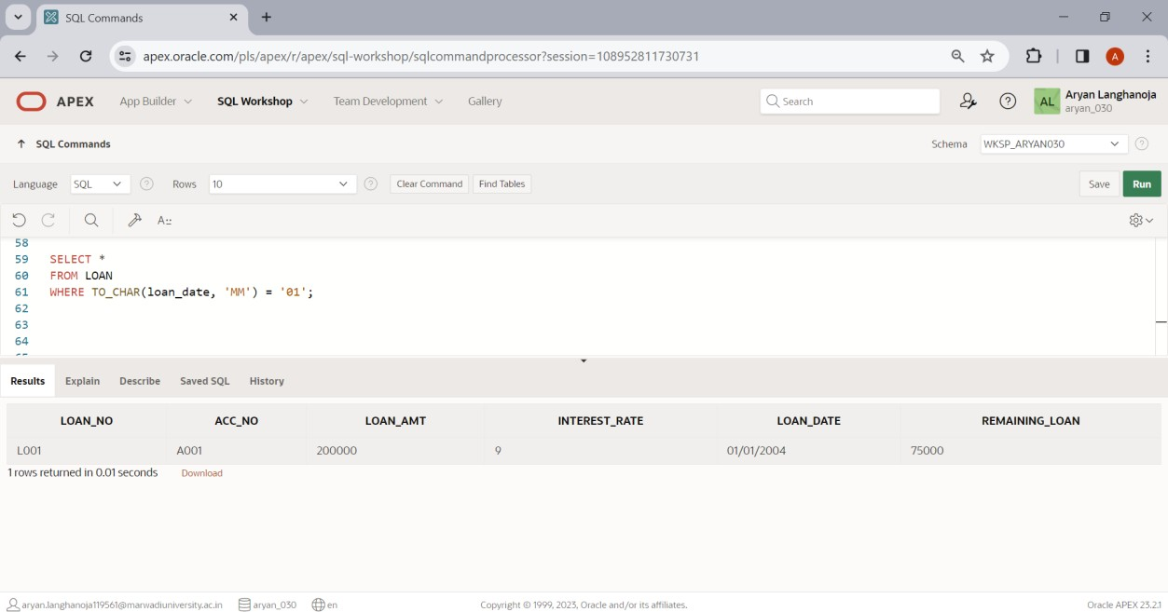Display only those records where loan holder taken a loan in month of January.
  2. 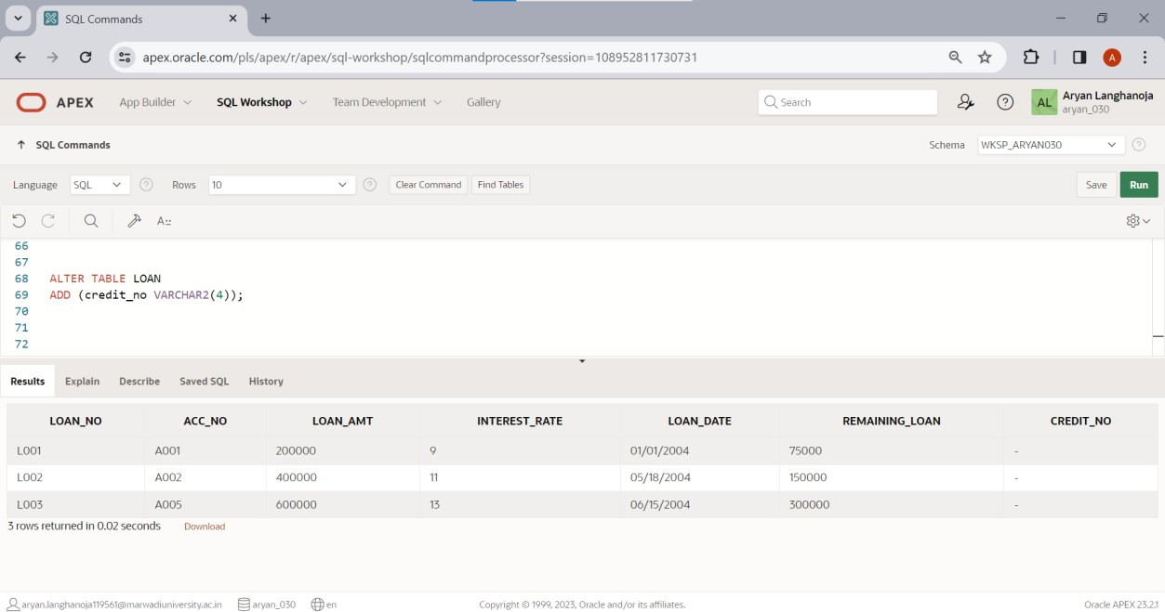Modify the structure of table LOAN by adding one column credit_no varchar2 (4).
  3. Display the Loan amount*2 of table LOAN.

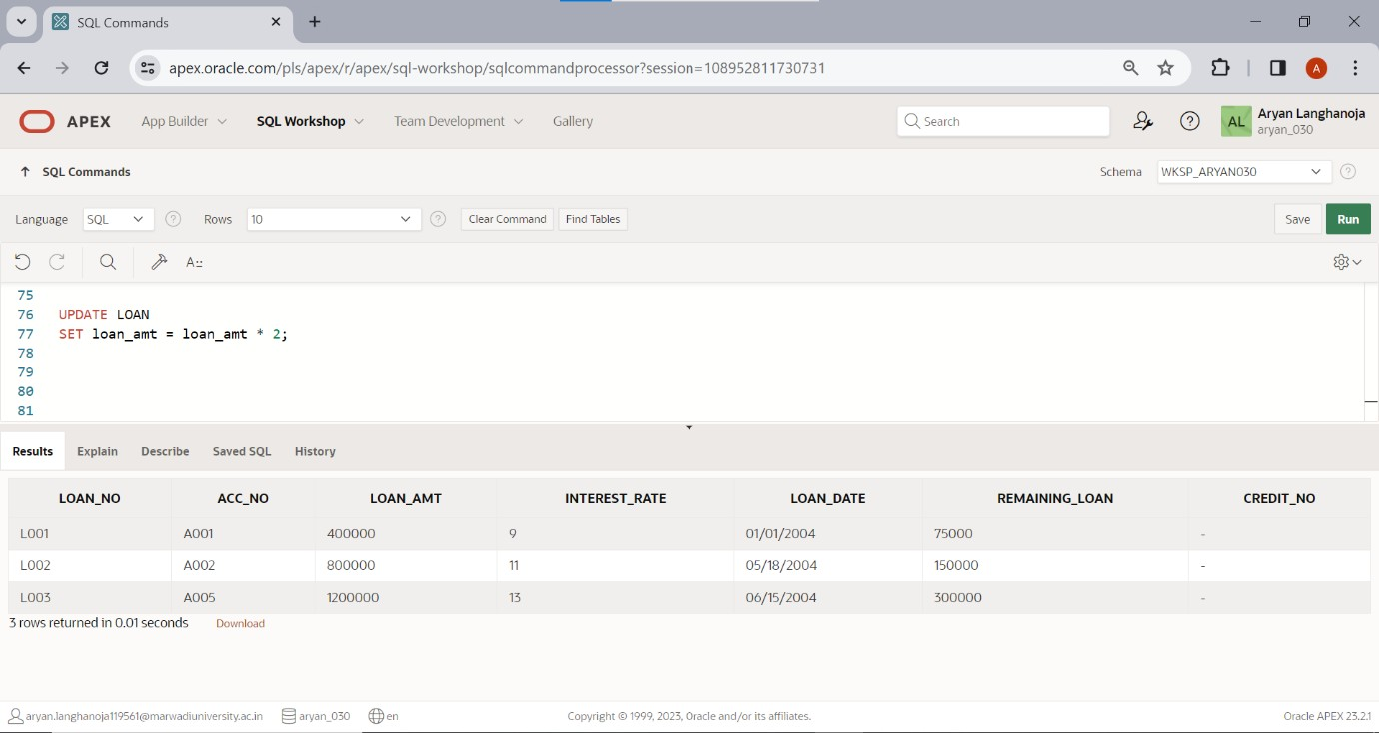

* 1. Display the records of table LOAN by date wise in ascending order.

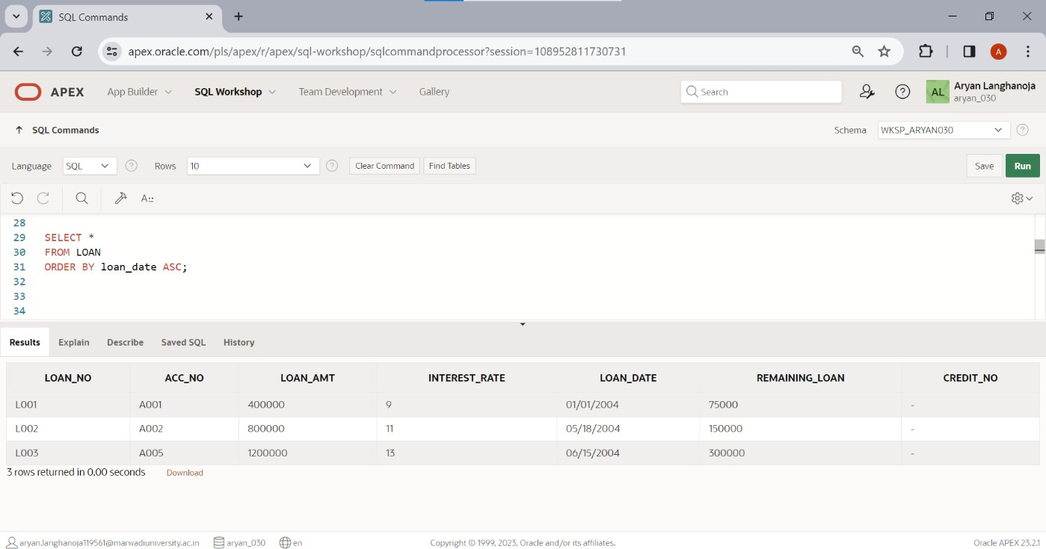

* 1. Display the records of table LOAN by account number wise in descending Order.

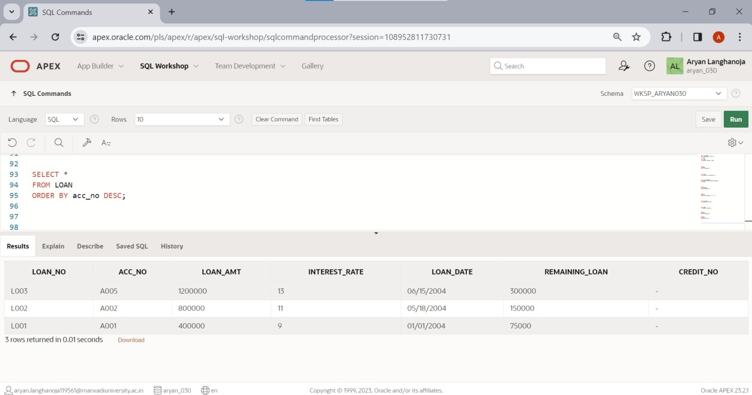

# Practical 4

## Aim: DML Commands and Related Queries

Table: **INSTALLMENT**.

* + 1. Insert following Records if you have not inserted in PRACTICAL-1.

|  |  |  |  |
| --- | --- | --- | --- |
| **Loan_ no** | **Inst_n o** | **Inst_Dat e** | **Amou nt** |
| L001 | I001 | 2-Feb-04 | 15000 |
| L002 | I002 | 18-June- 04 | 20000 |
| L003 | I003 | 15-July- 04 | 20000 |

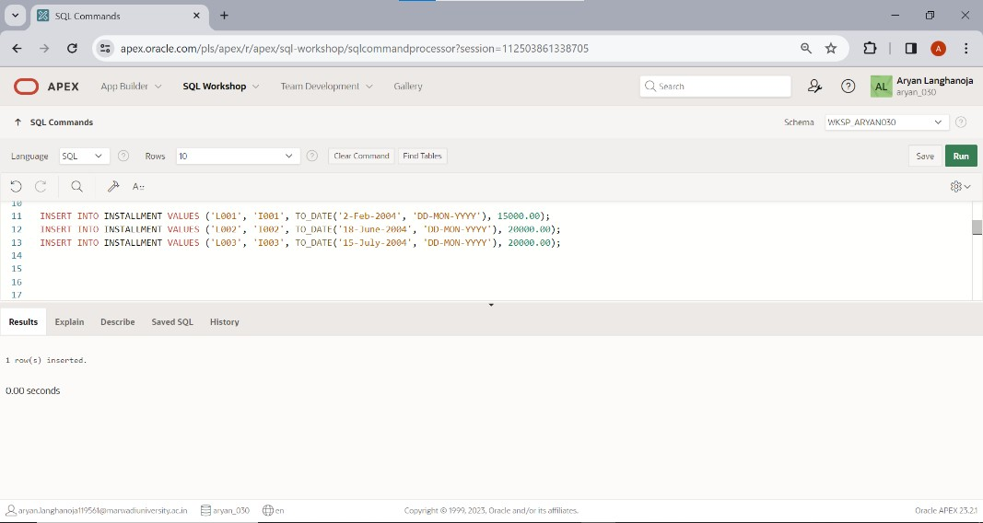

* + 1. Change the Inst_Date ‘2-Feb-04’ to ’3-Mar-04’.

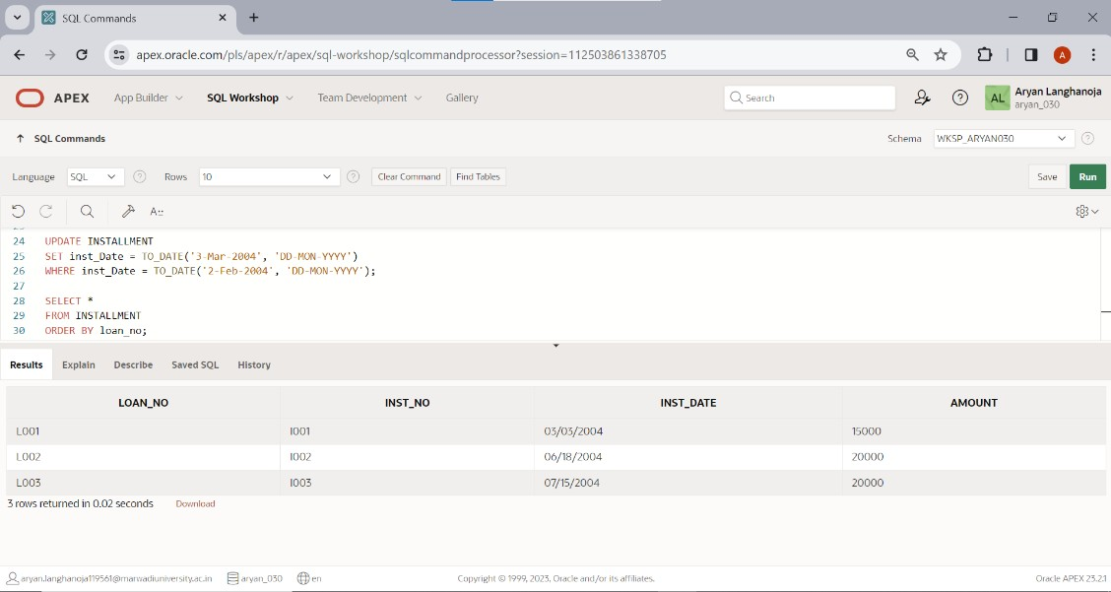

* + 1. 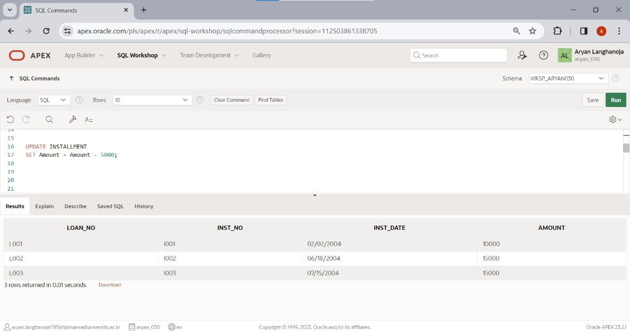Reduce 5000 amount from all Installment holders.
    2. Add the amount 5000 where loan no is ‘L003’ and ‘L002’.

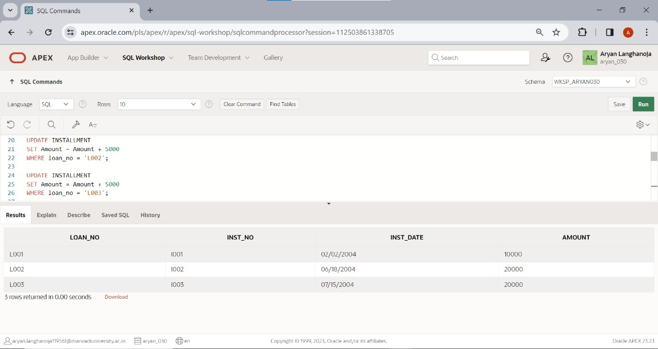

* + 1. Change the column size of 5 to 7 where column name is Loan_no.

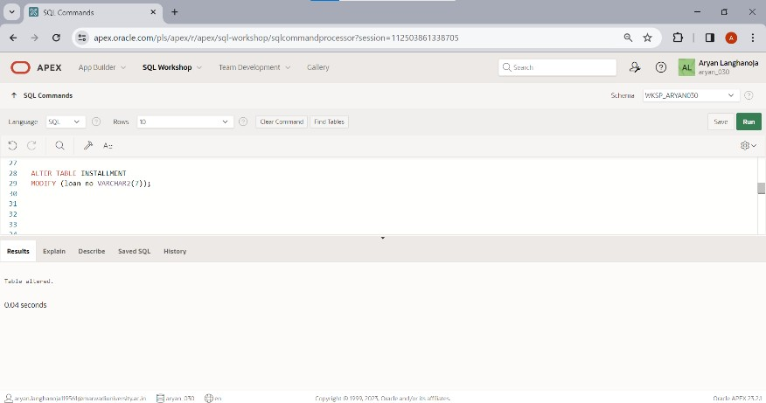

* + 1. 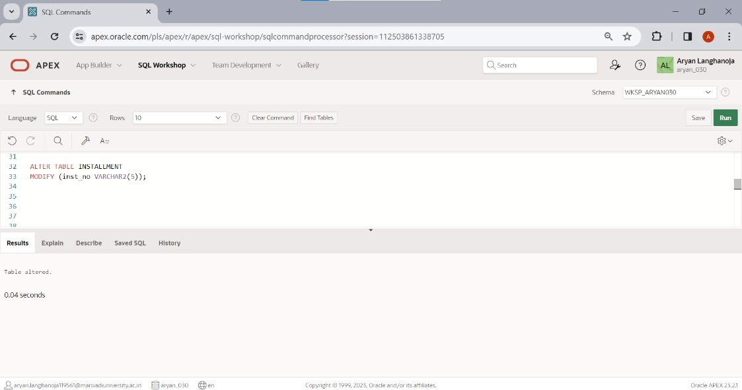Decrease the column size 5 to 4 where column name Inst_no.
    2. Show the structure of the Table.

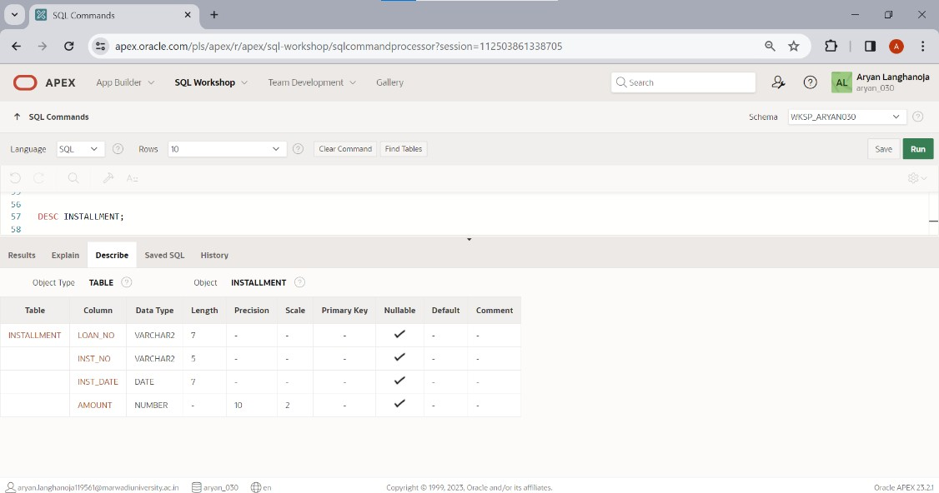

* + 1. Change the amount 15000 to 5000 where loan number is L001

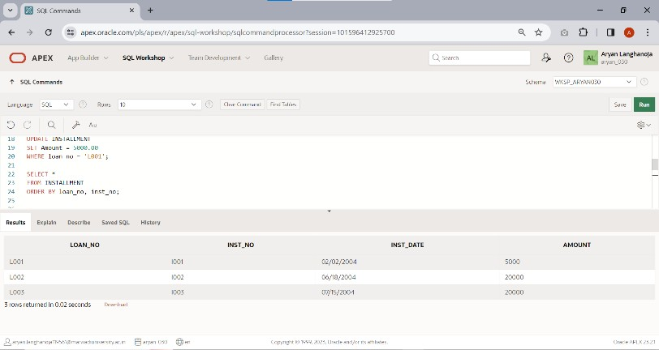

* + 1. 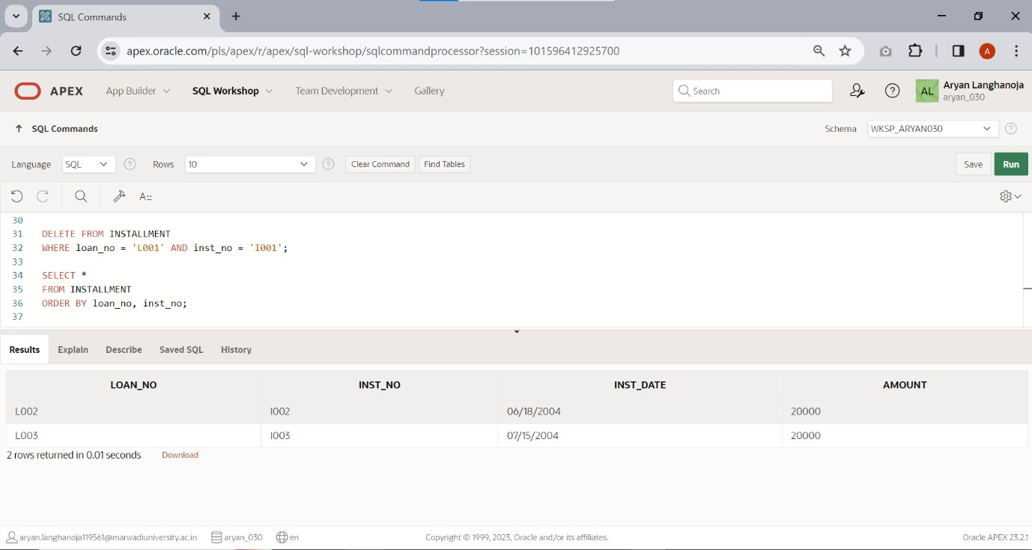Perform delete operation. (Delete only particular one record)
    2. Only create a structure of table installment1 from table installment.

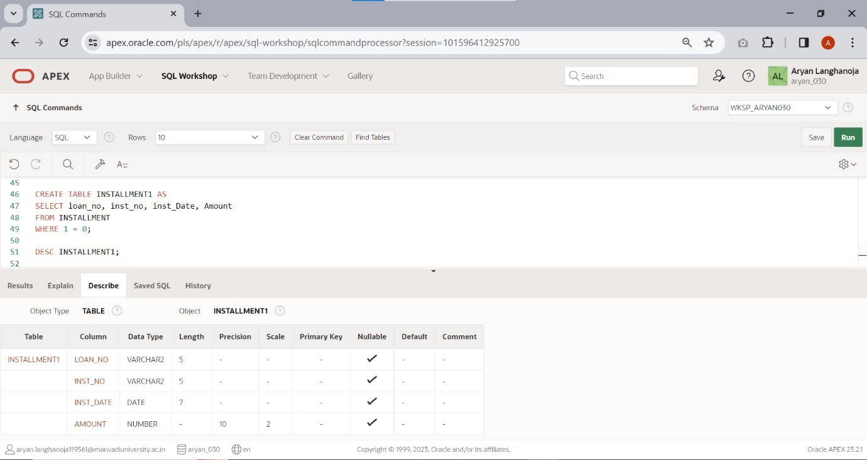

Table: **TRANSACTION**.

1. Insert a Following Records if you have not inserted in PRACTICAL-1.

|  |  |  |  |  |
| --- | --- | --- | --- | --- |
| **Acc_no** | **Trans_Da**  **te** | **Amt** | **Type_of_tr** | **Mode_of_p**  **ay** |
| A001 | 3-may-04 | 10000 | D | Cash |
| A002 | 5-july-04 | 5000 | W | Check |
| A003 | 12-Aug-04 | 25000 | D | Check |
| A004 | 15-may-04 | 30000 | D | Check |
| A005 | 22-oct-04 | 15000 | W | Cash |

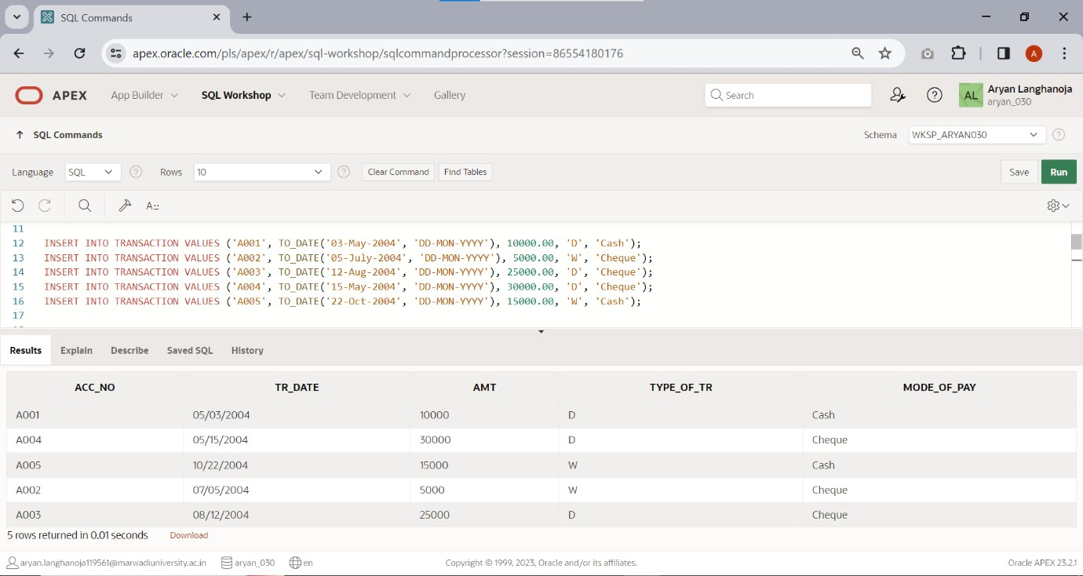

1. 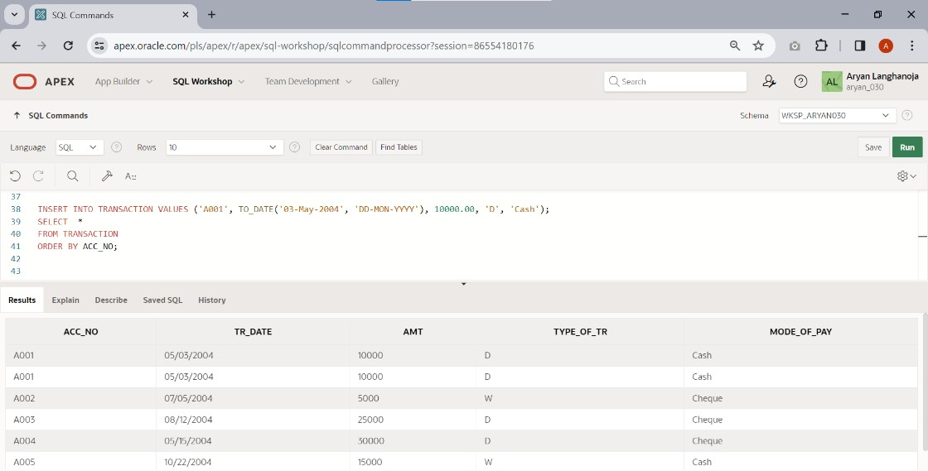Insert any duplicate value and display all the records without any duplicate rows.
2. 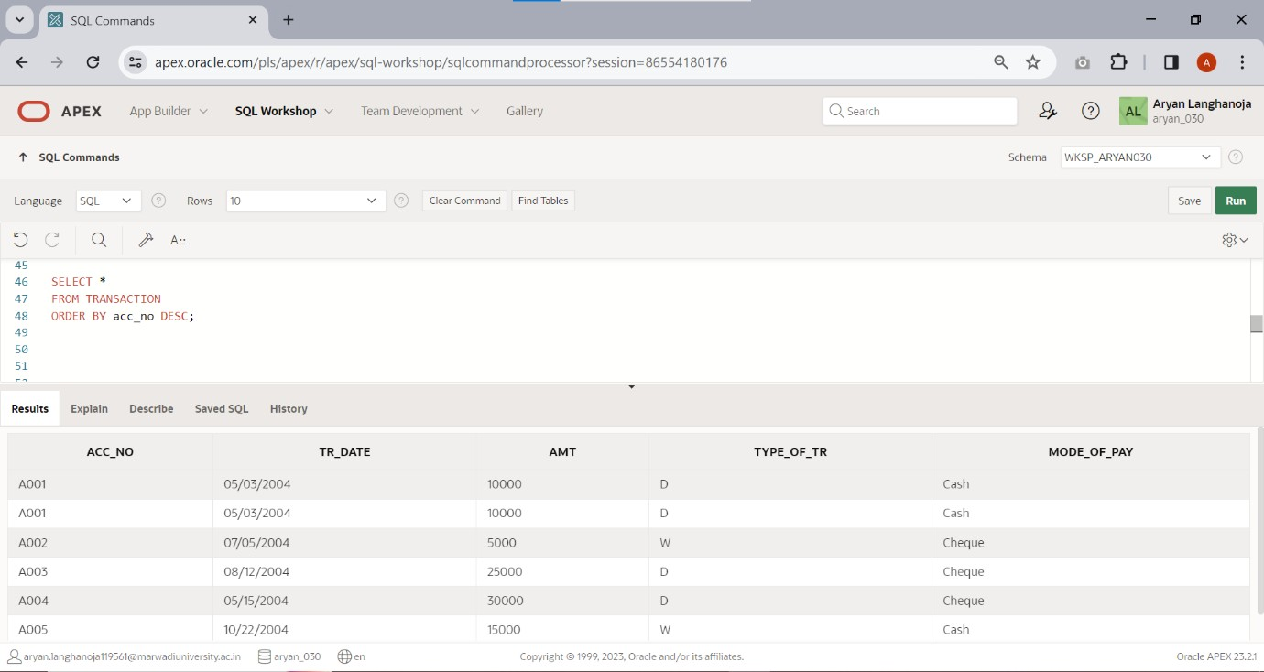Select all the records in descending order(account number wise).
3. Display amt, date, and type of transaction by date wise.

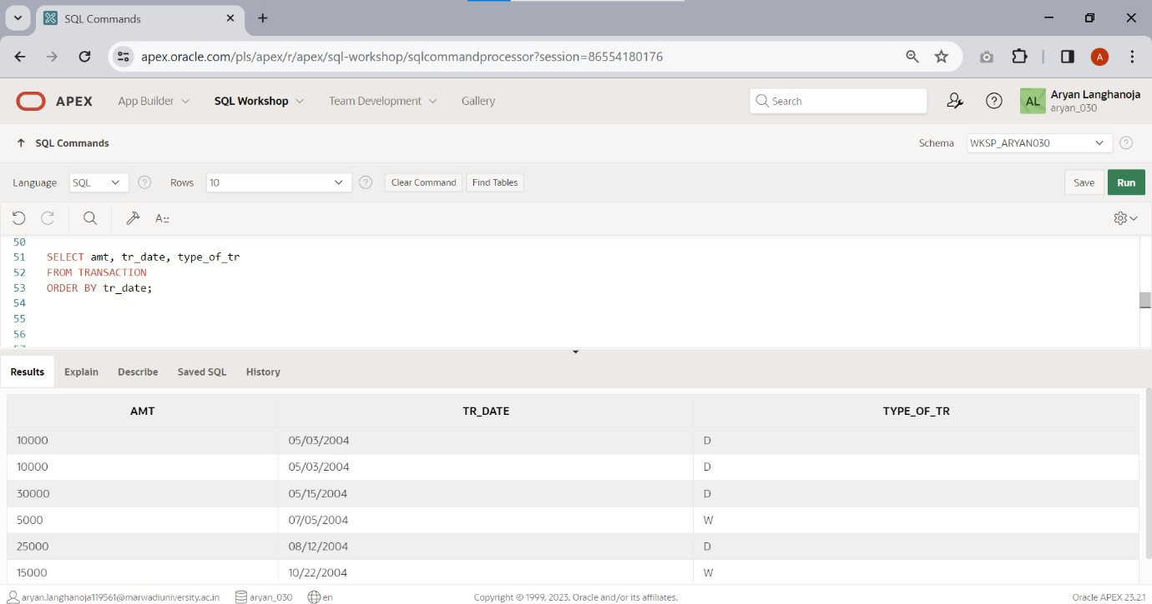

1. 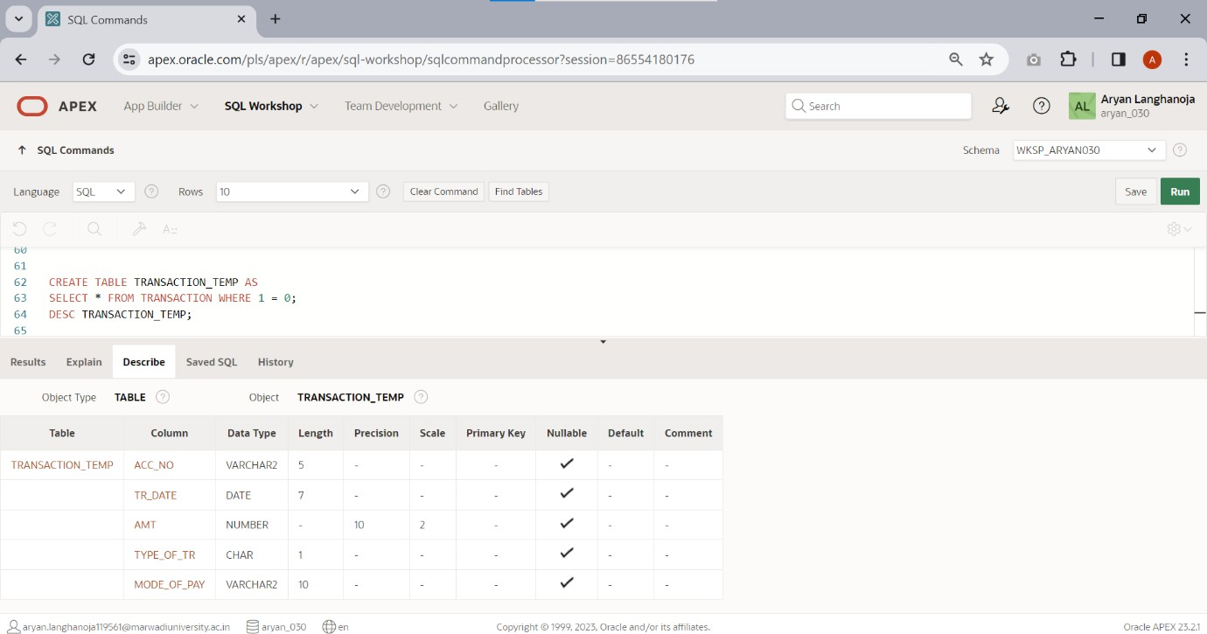Create another table TRANSACTION_TEMP from this table.
2. Create a another table TRANS_TEMP by change the column name acc_no to account_no.

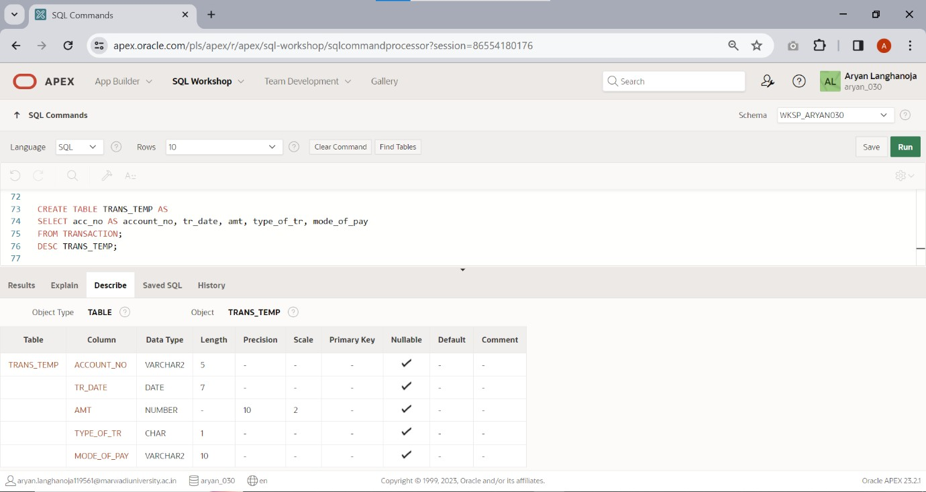

1. 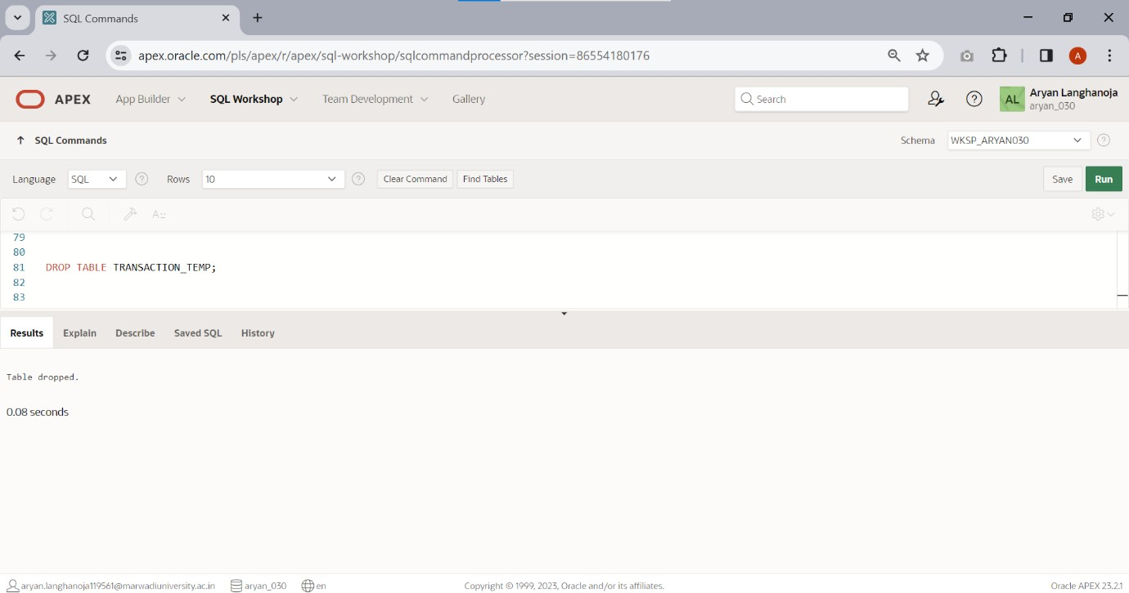Delete a table TRANSACTION_TEMP.
2. Rename the table TRANSACTION to TRANS.

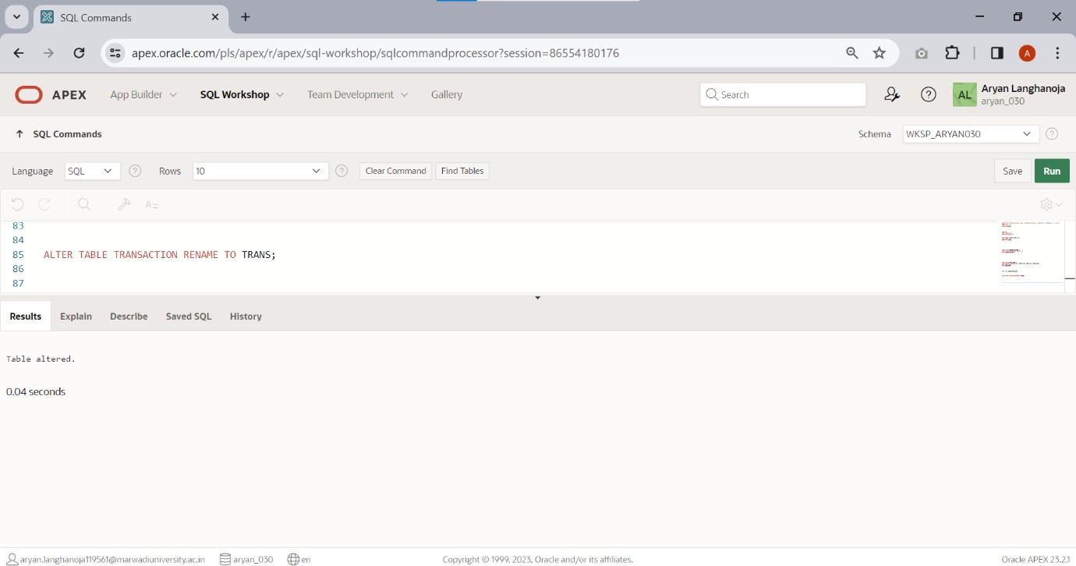

1. 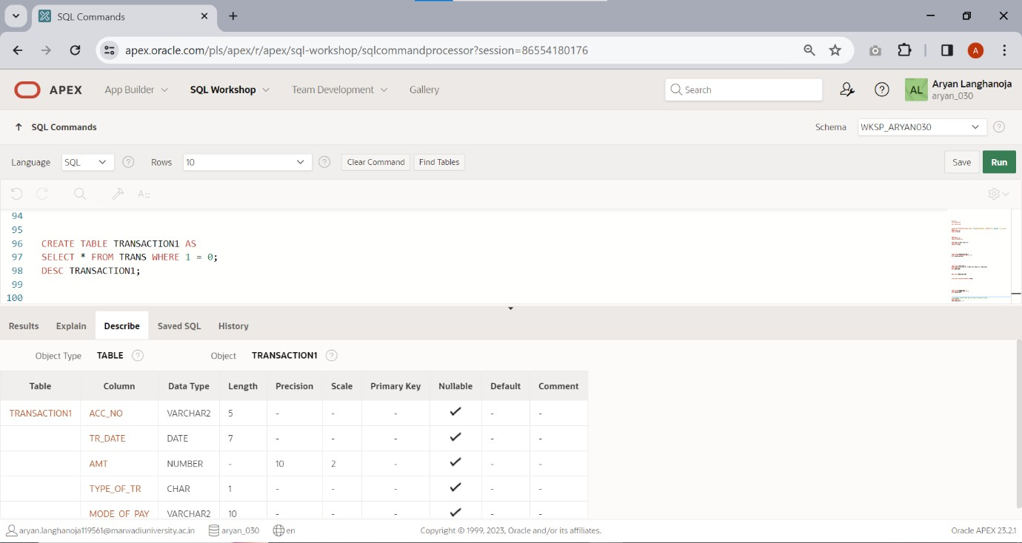Only create a structure of table transaction1 from table transaction.
2. Display account number where type of transaction is ‘D’.

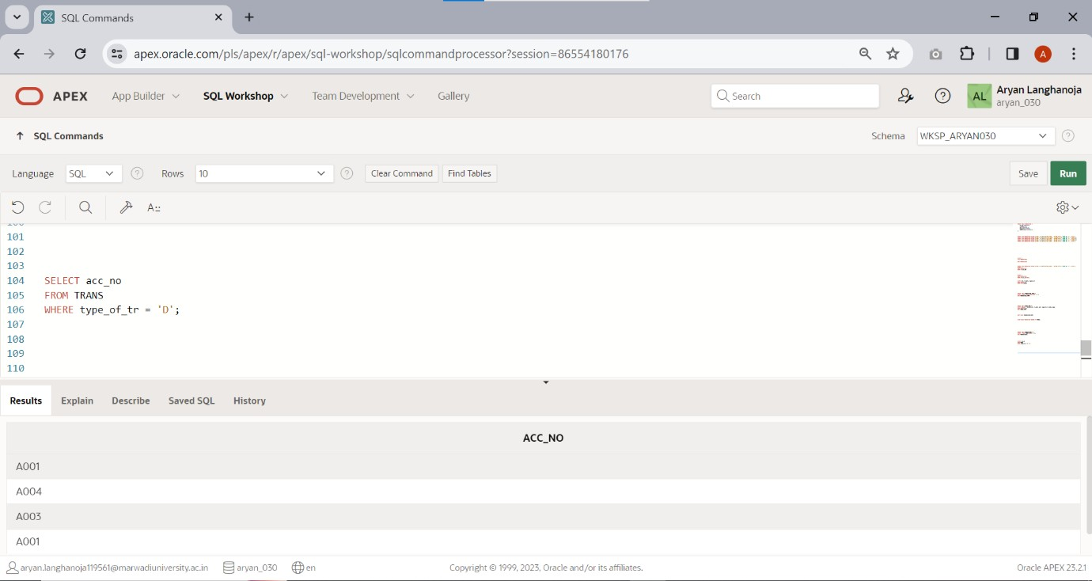

# Practical 5

## Aim: Constraint Based DML Commands

### Note: Bold and Underline column name indicates a primary key

Create a table **ACCOUNT**.

|  |  |  |  |
| --- | --- | --- | --- |
| **Column name** | **Data Type** | **Si ze** | **Attribute s** |
| **Acc_no** | Varchar2 | 5 | Primary key/first letter must start with ‘A’ |
| Name | Varchar2 | 30 | NOT NULL |
| City | Varchar2 | 20 | NOT NULL |
| Balance | Number | 10  ,2 | Balance  >=500 |
| Loan_taken | Varchar2 | 3 | Values(‘NO’,’YES’) |

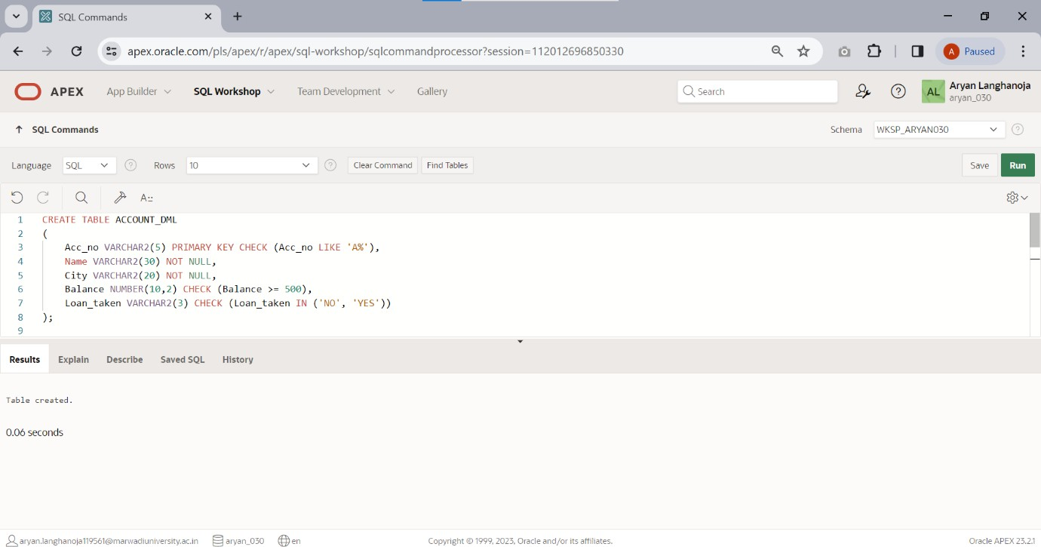

1. Insert the records using Practical list 1.

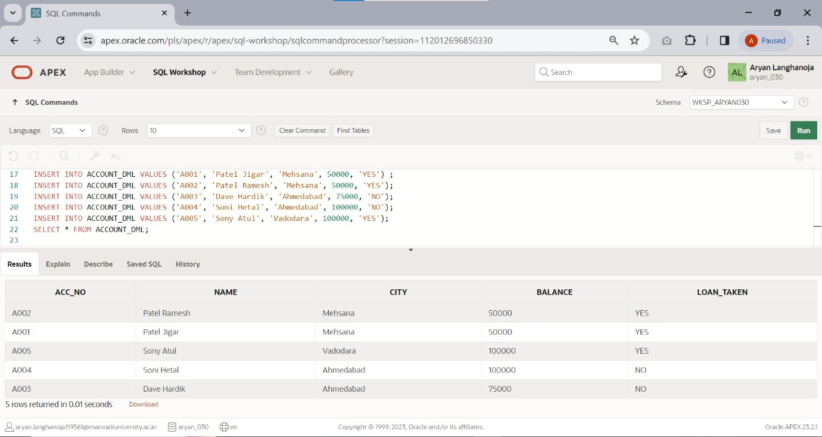

Create a Table **LOAN**.

|  |  |  |  |
| --- | --- | --- | --- |
| **Column Name** | **Data**  **Type** | **Si ze** | **Attribute s** |
| **Loan_no** | Varchar  2 | 5 | Primary Key / first letter must start with ‘L’ |
| Acc_no | Varchar 2 | 5 | Foreign key References Acc_no of account  table |
| Loan_amt | Numbe r | 1  0,  2 | NOT NULL |
| Interest_rate | Numbe r | 5,  2 | NOT NULL |
| Loan_date | Date |  |  |
| Remaining_loa n | Numbe r | 1  0,  2 | Remaining loan<loan amount |

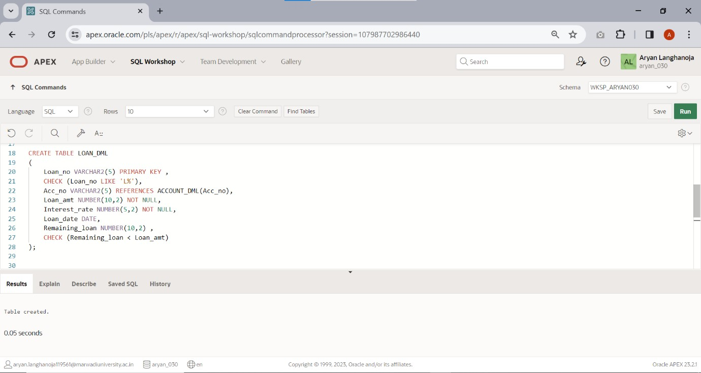

1. Insert the records using practical list-1.

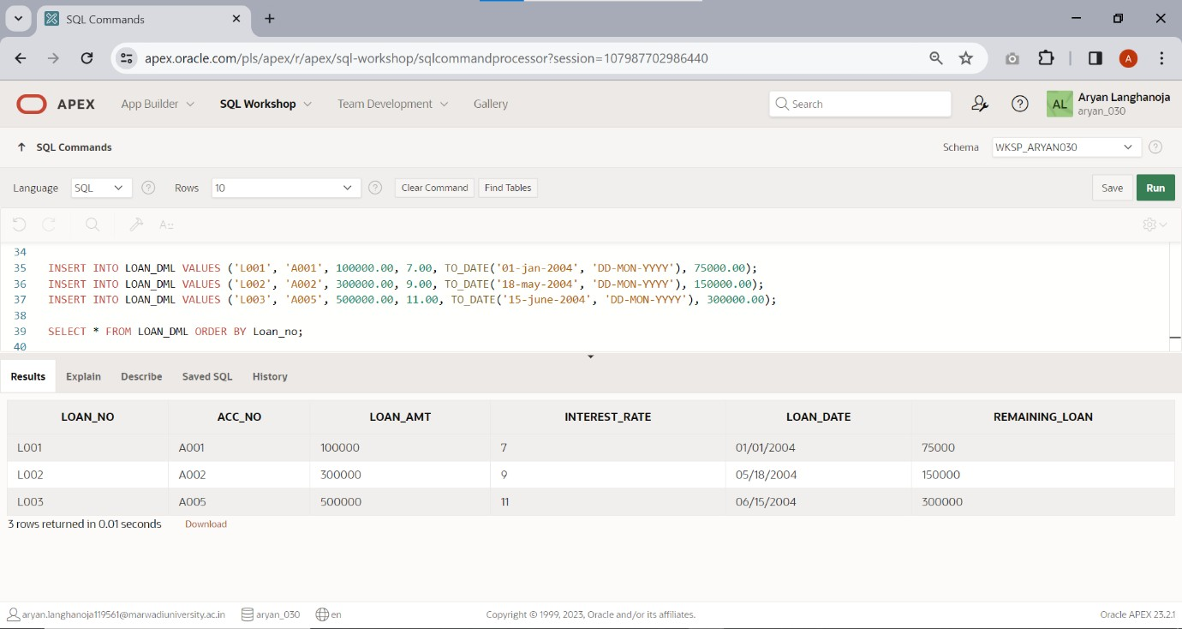

Create a table **INSTALLMENT**.

|  |  |  |  |
| --- | --- | --- | --- |
| **Column**  **Name** | **Data**  **Type** | **Si**  **ze** | **Attributes** |
| **Loan_no** | Varchar2 | 5 | Foreign key References Loan_no of Loan  table |
| Inst_no | Varchar2 | 5 | first letter must start with ‘I’ |
| IDate | Date |  | NOT NULL |
| Amount | Number | 10  ,2 | NOT NULL |

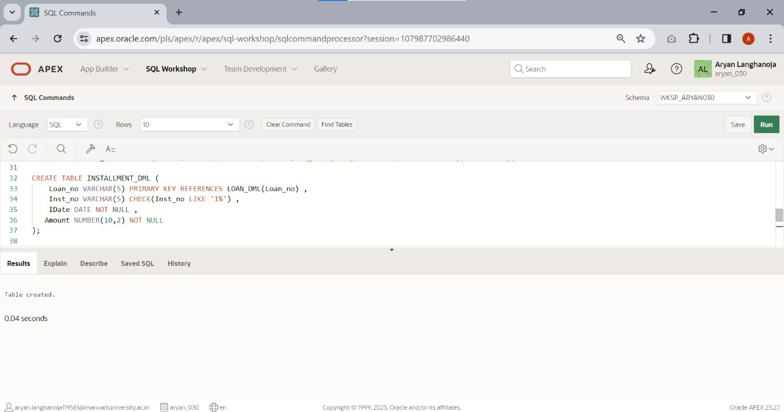

1. Insert the records using Practical list-1

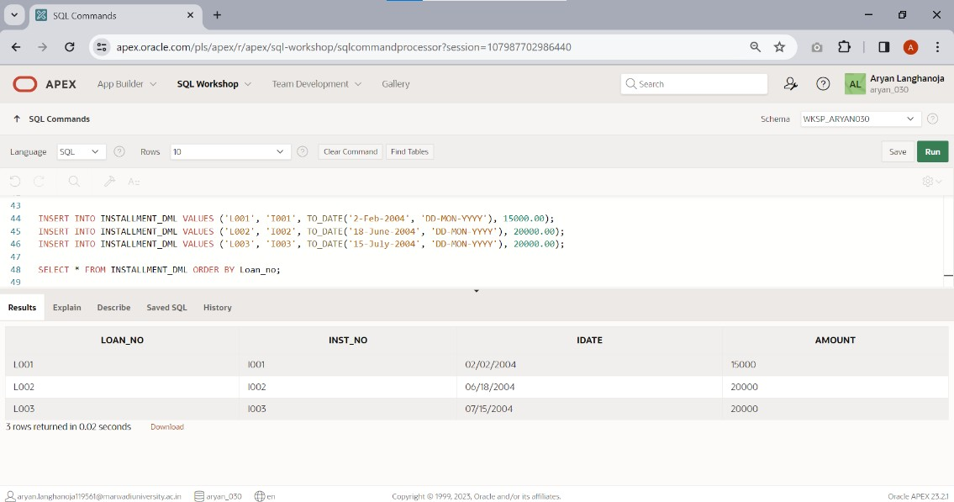

Create a Table **X** .

|  |  |  |  |
| --- | --- | --- | --- |
| **Column**  **Name** | **Data**  **Type** | **Si**  **ze** | **Attributes** |
| **Acc_no** | Varchar2 | 5 | Foreign key References Acc_no of account  table |
| Trans_Dat  e | Date |  | NOT NULL |
| Amt | Number | 10,2 | NOT NULL |
| Type_of_t  r | Char | 1 | Values in  (‘D’,’W’) |
| Mode_of_ pay | Varchar2 | 10 | Values in (‘cash’,’check’  ) |

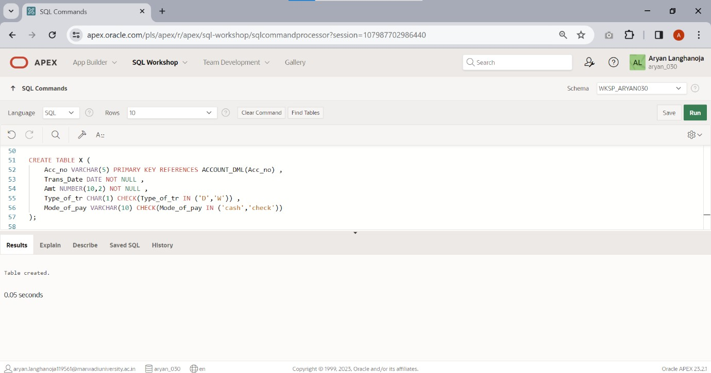

* 1. Insert the records using Practical list-1.

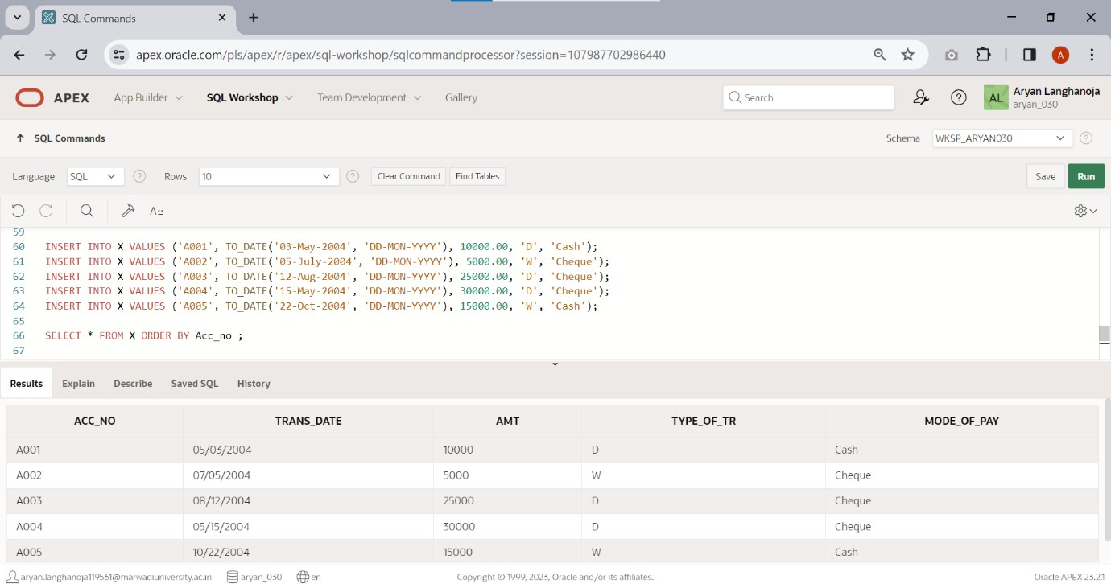

# Practical 6

## Aim: Functions and Queries

### Using Operator: NOT,BETWEEN,NOT BETWEEN,IN,NOT IN

1. 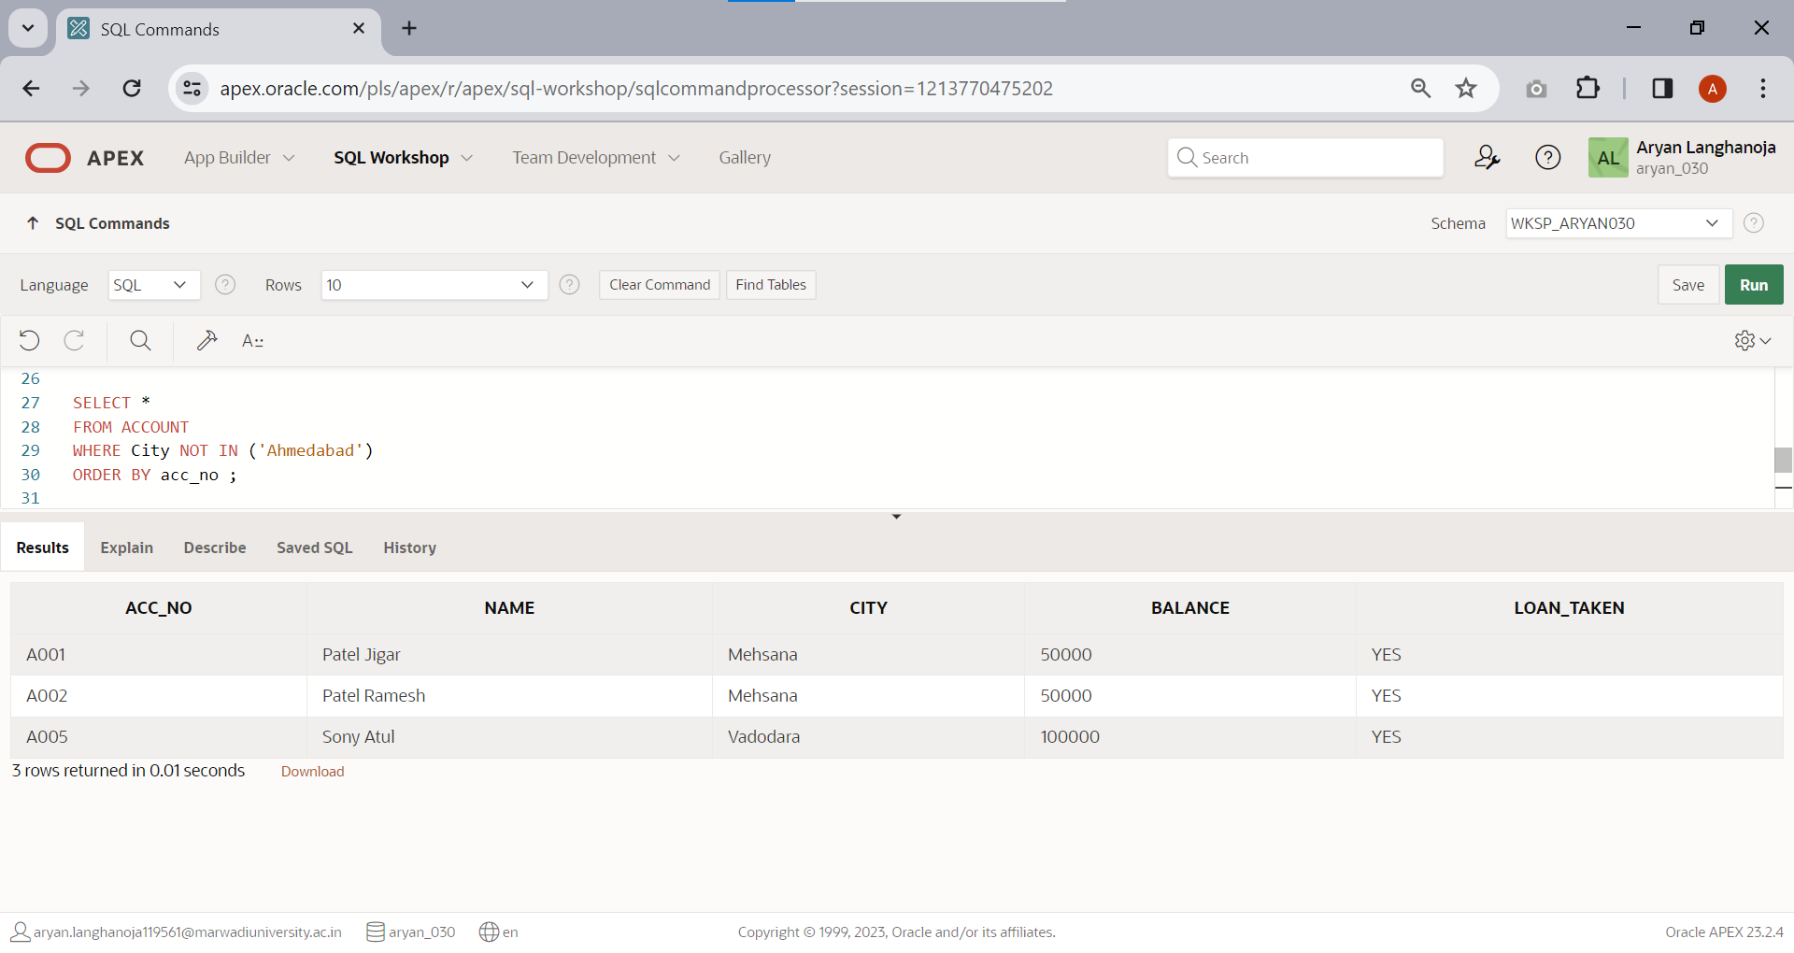Retrieve specified information for the account holder who are not in ‘Ahmedabad’.
2. 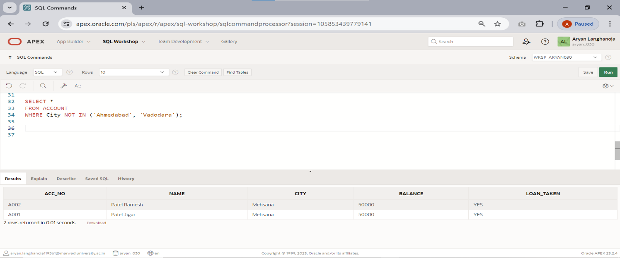Retrieve specified information for the account holder who are not in ‘Ahmedabad’ or ‘Vadodara’.
3. 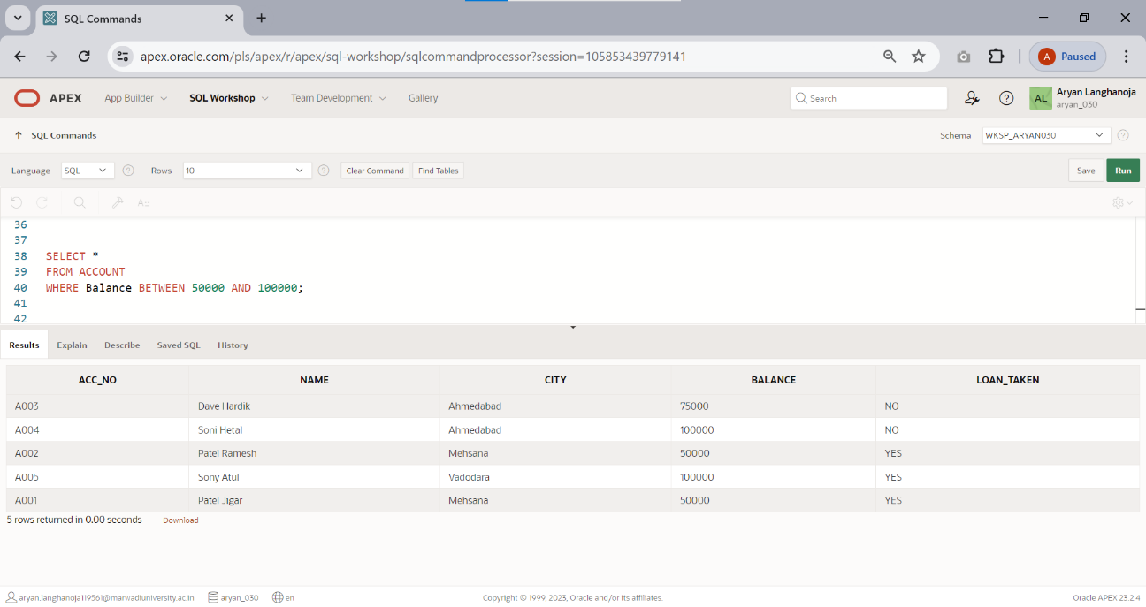Retrieve those records of Account holder whose balance between is 50000 and 100000.
4. 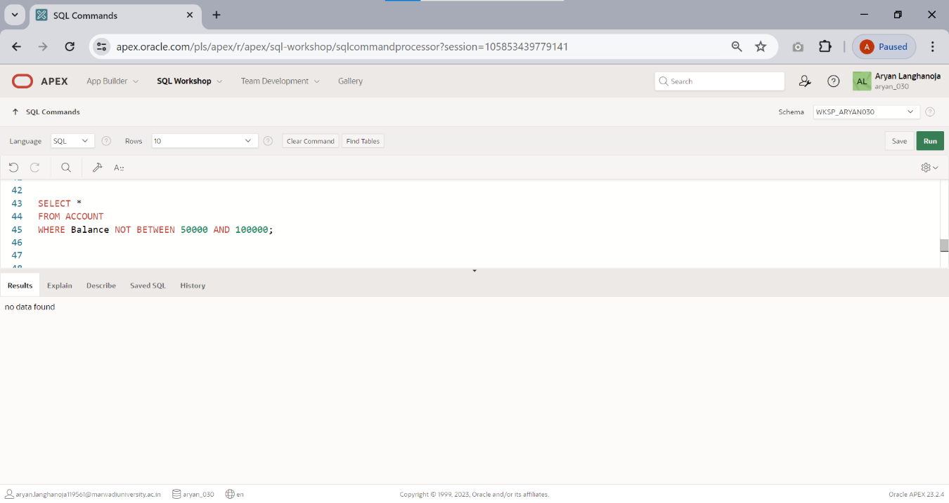Retrieve those records of Account holder whose balance not between is 50000 and 100000.
5. 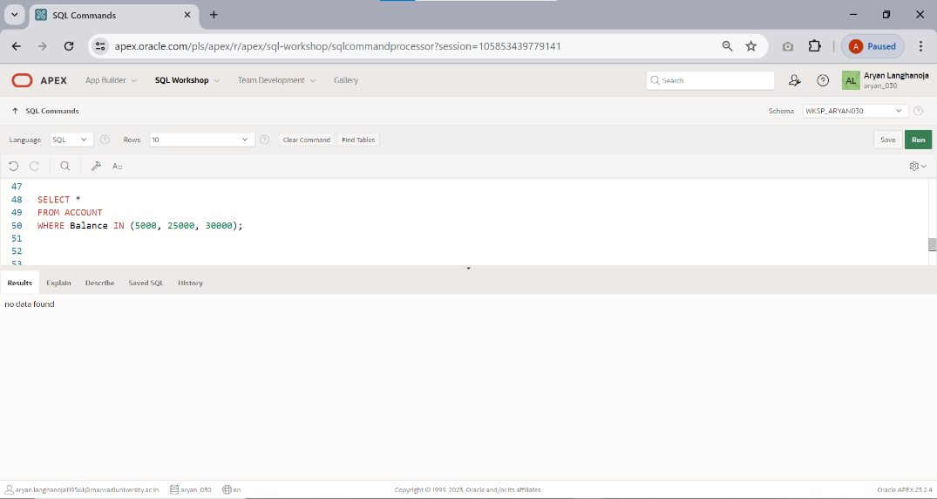Display only those records whose amount is 5000, 25000, 30000.
6. 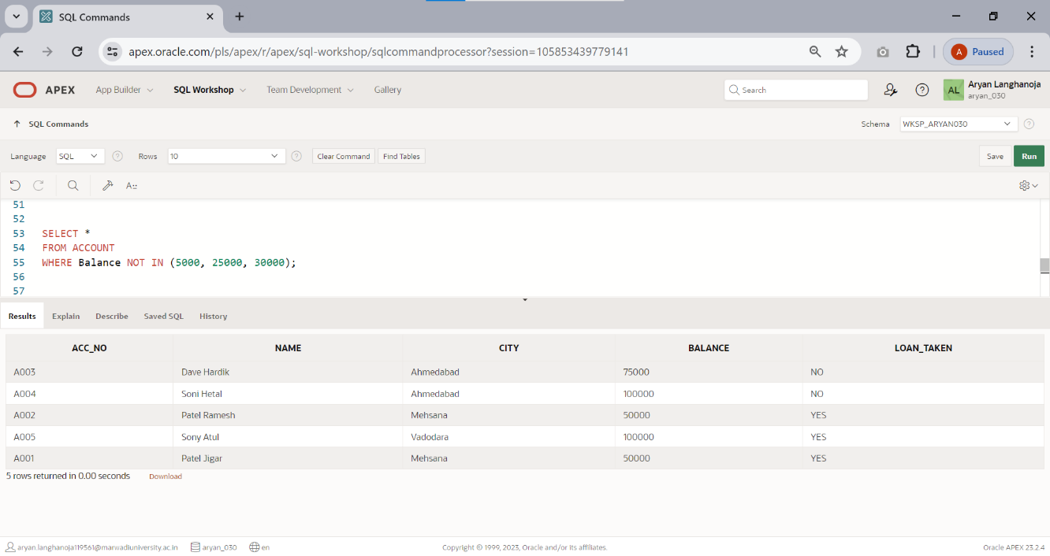Display only those records whose amount not in 5000, 25000, 30000.
7. Display System date.

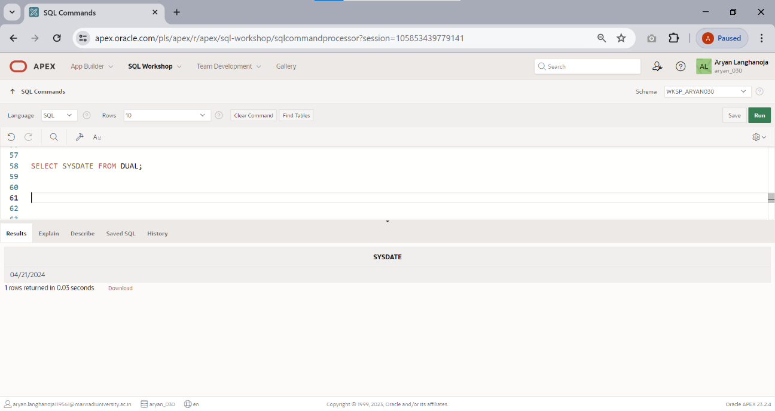

1. 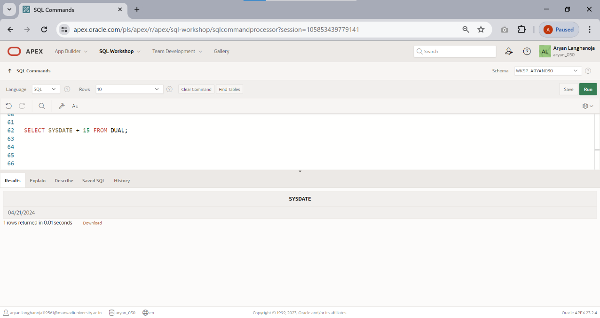Find the date,15 days after today’s date.
2. Perform following operation using DUAL table. 5*5,34+34,1000/300,length of ‘uvpce’,display only month of systemdate

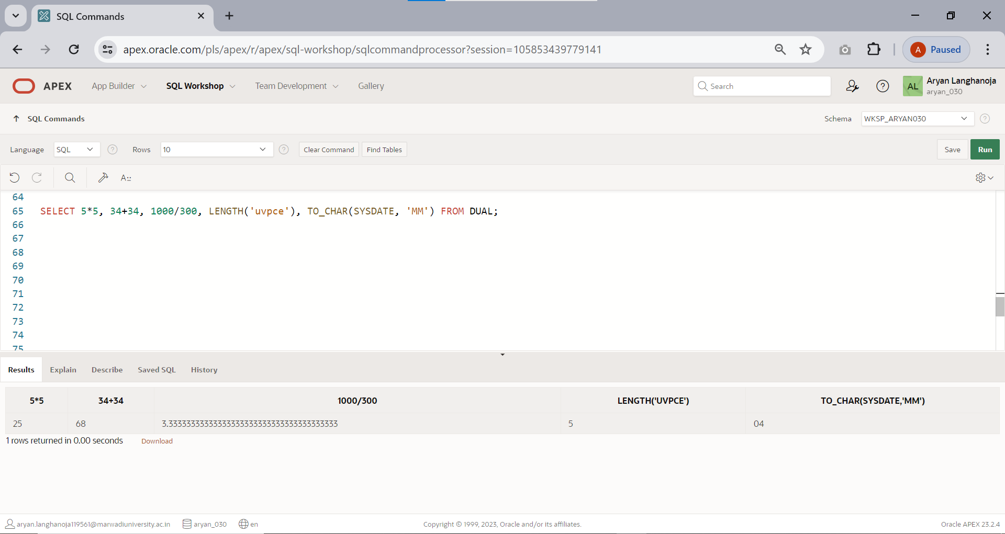

1. Find the date, 20 days before today’s date.

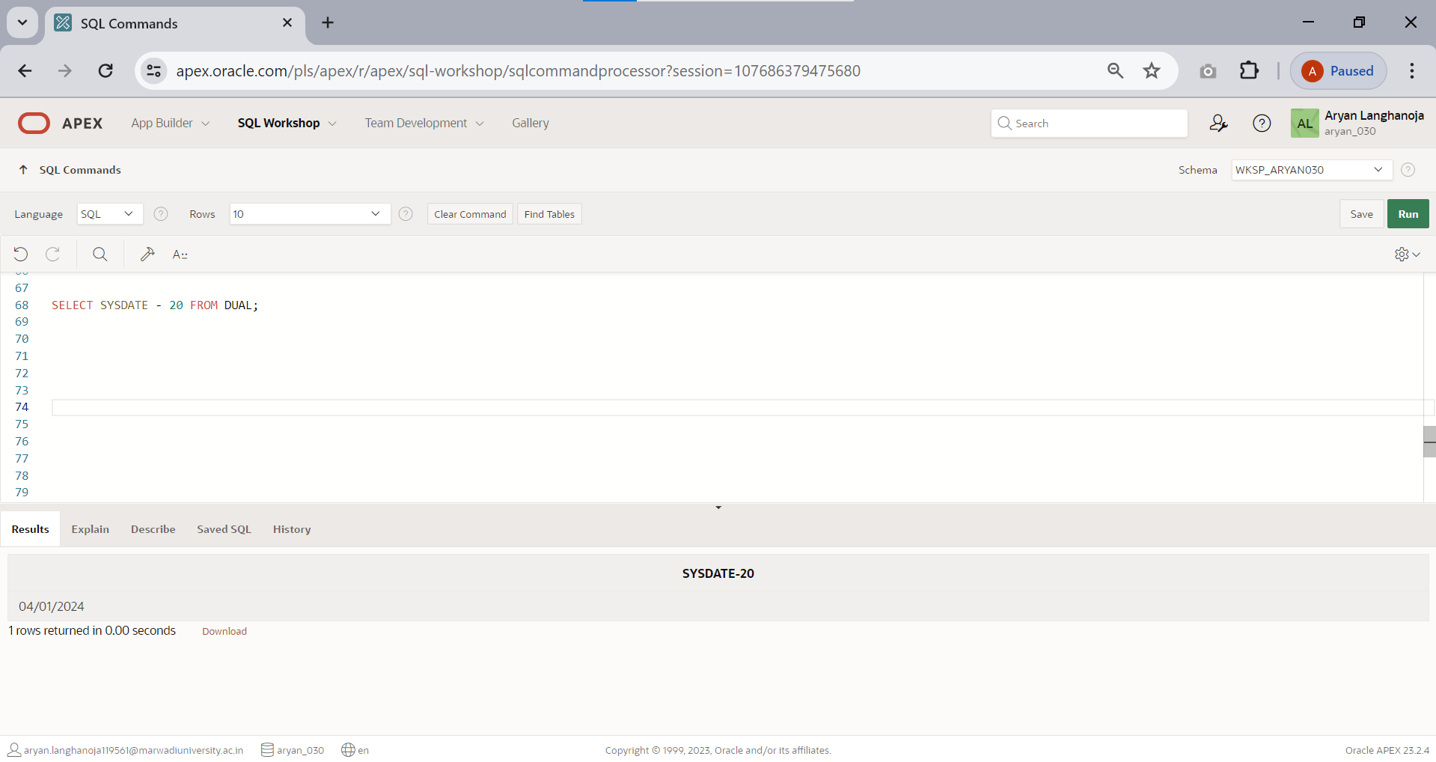

## Function Based Queries.

1. 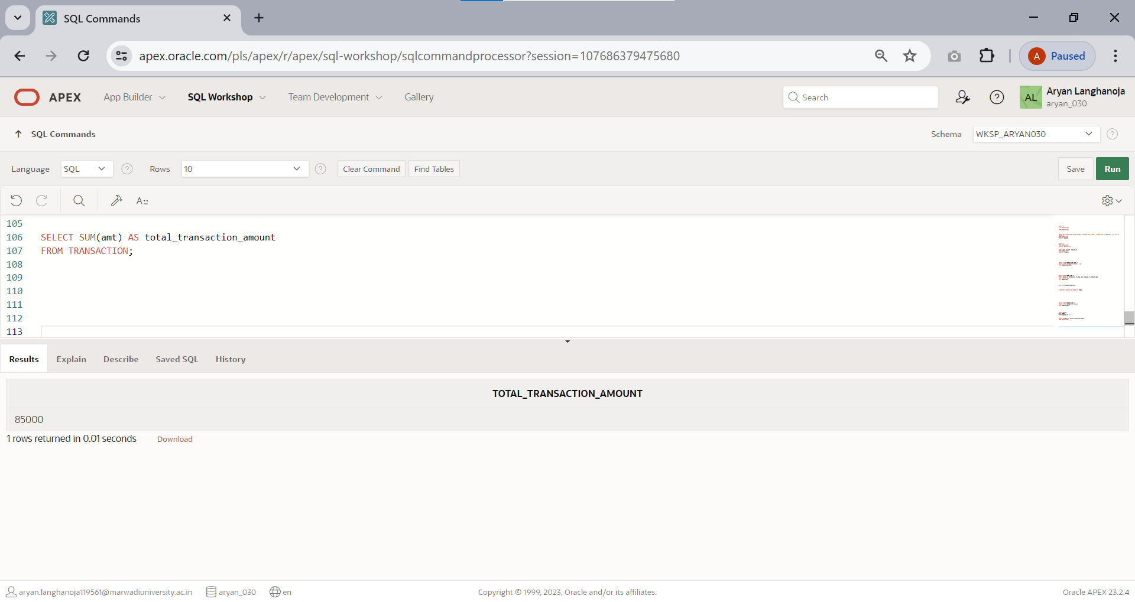Find the total transaction amount of account holder from transaction table.
2. Find minimum amount of transaction.

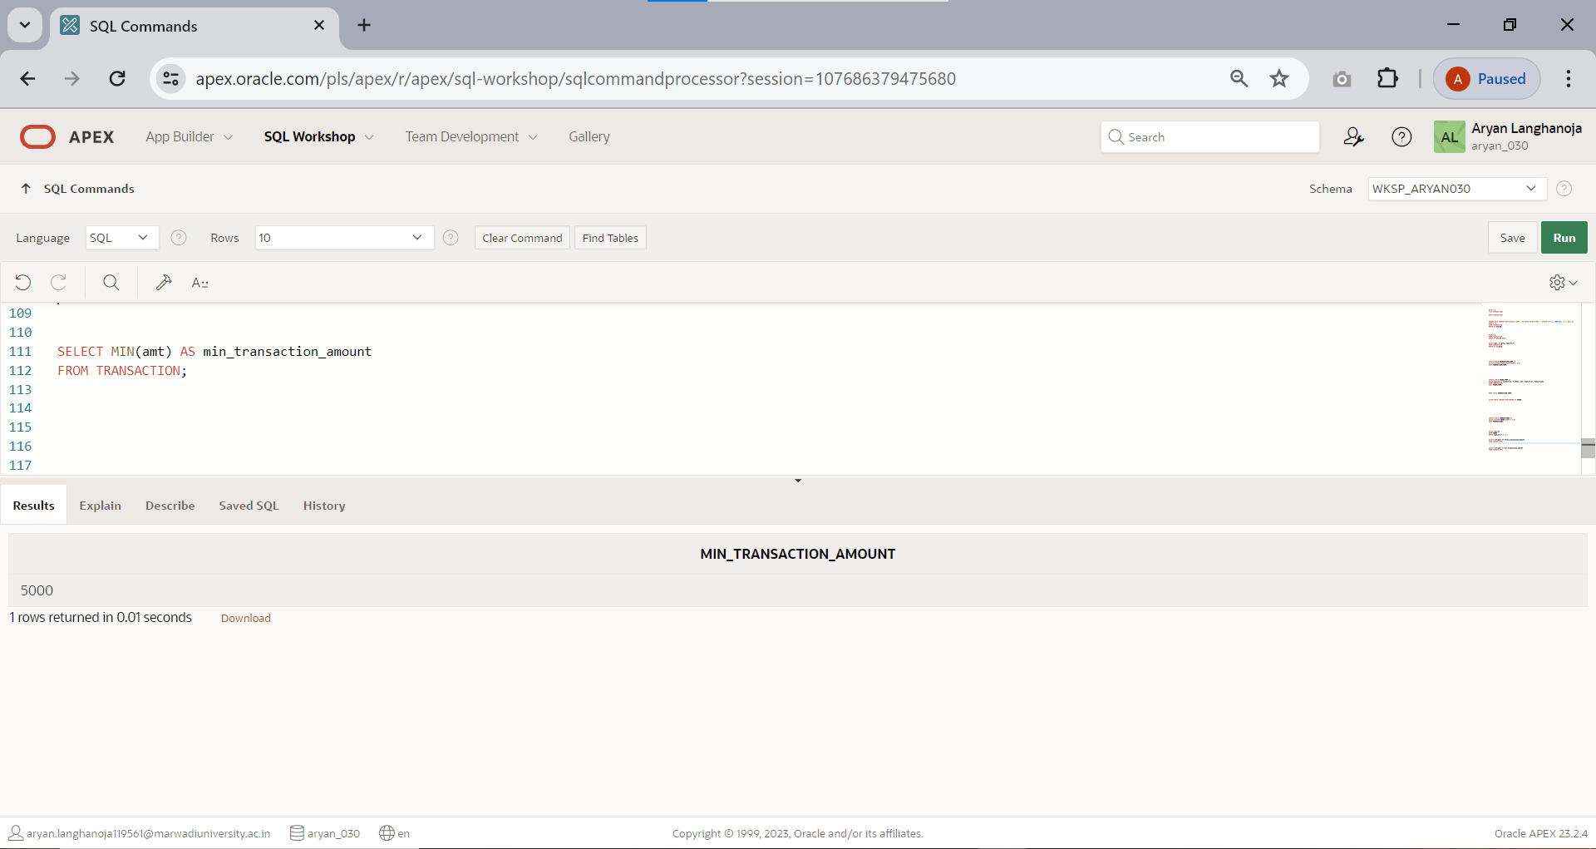

1. 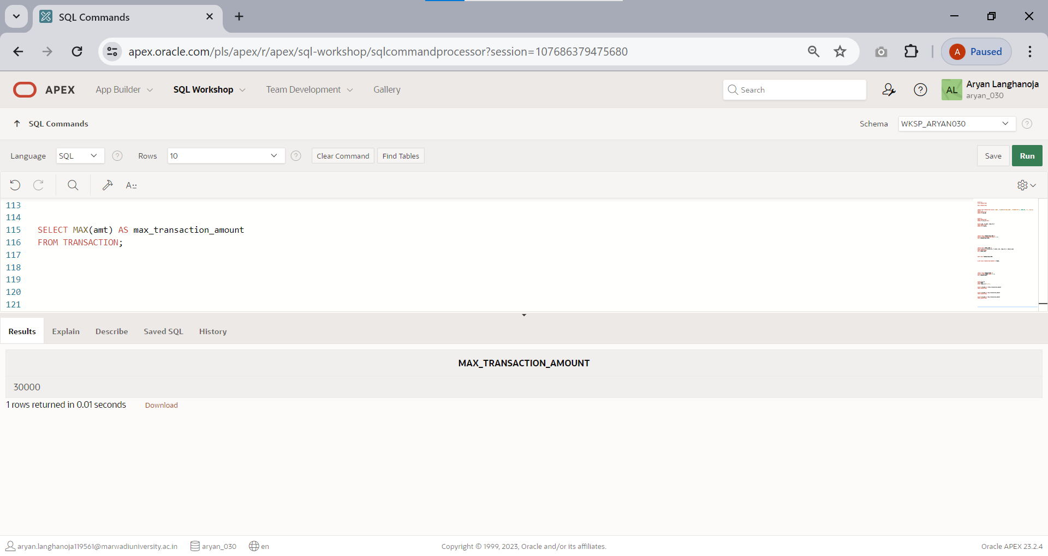Find maximum amount of transaction.
2. Count the total account holders.

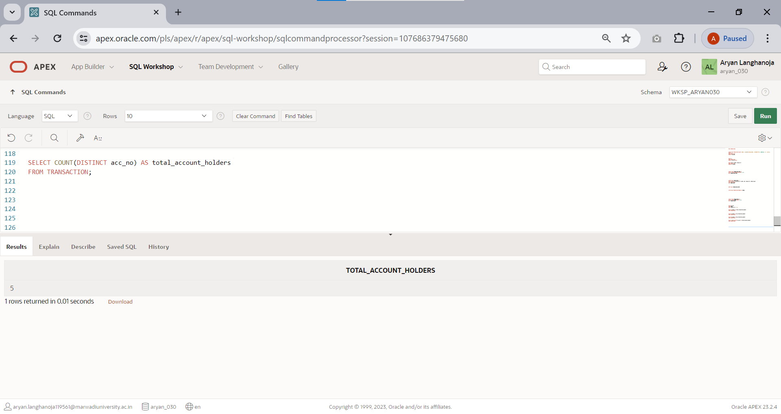

1. 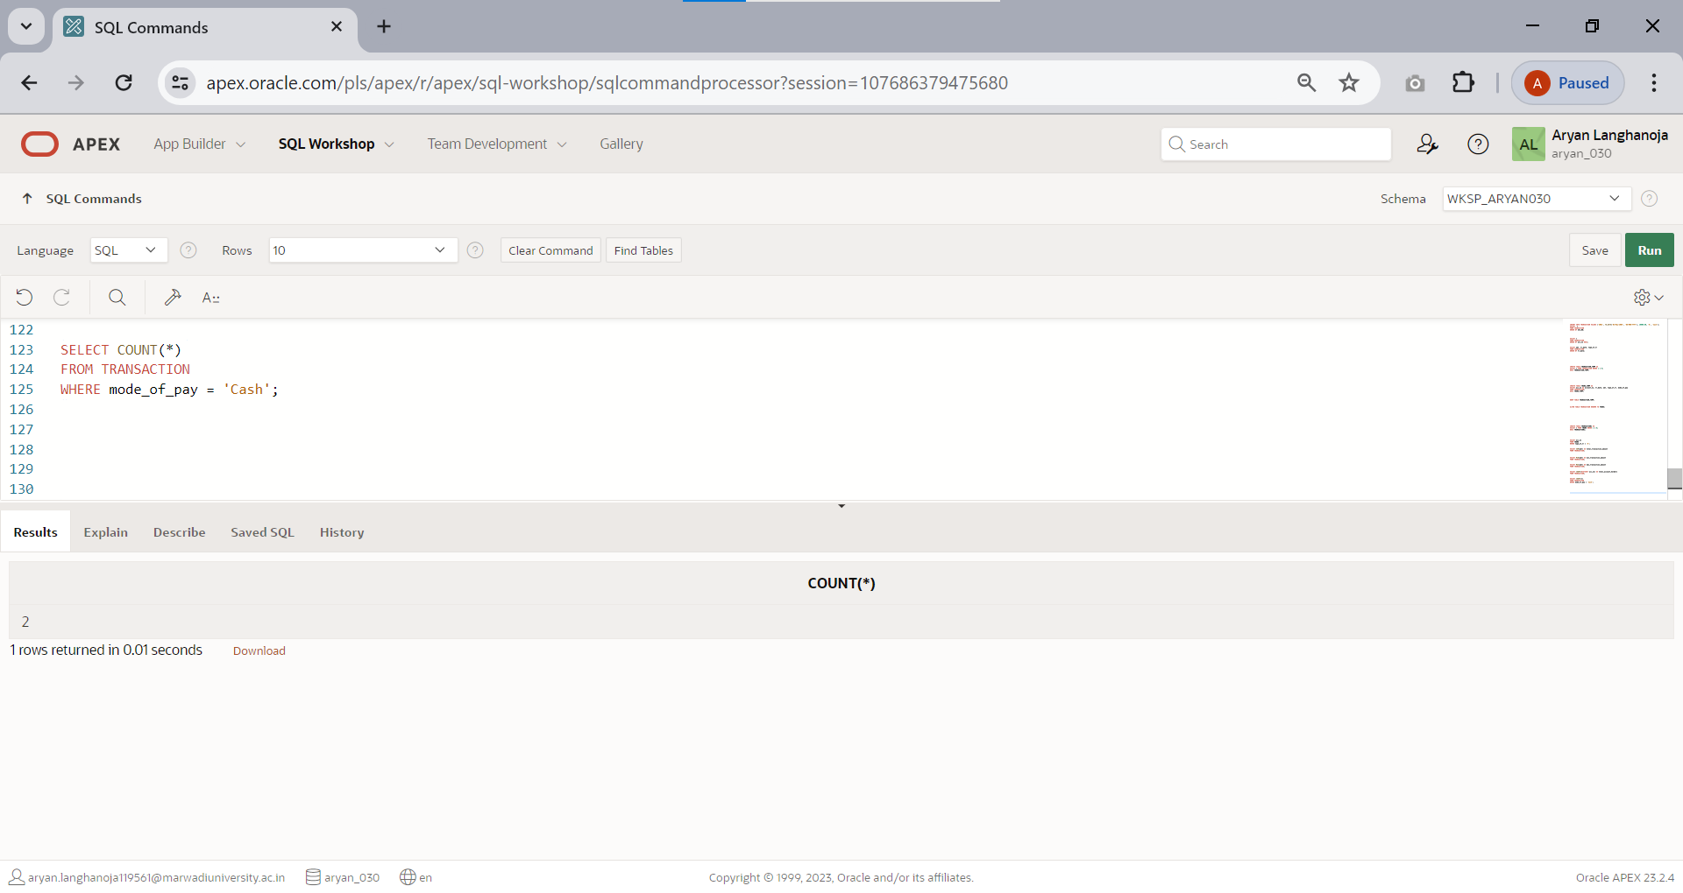Count only those records whose made of payment is ‘cash’.
2. Count only those records whose transaction made in the month of ‘MAY’.

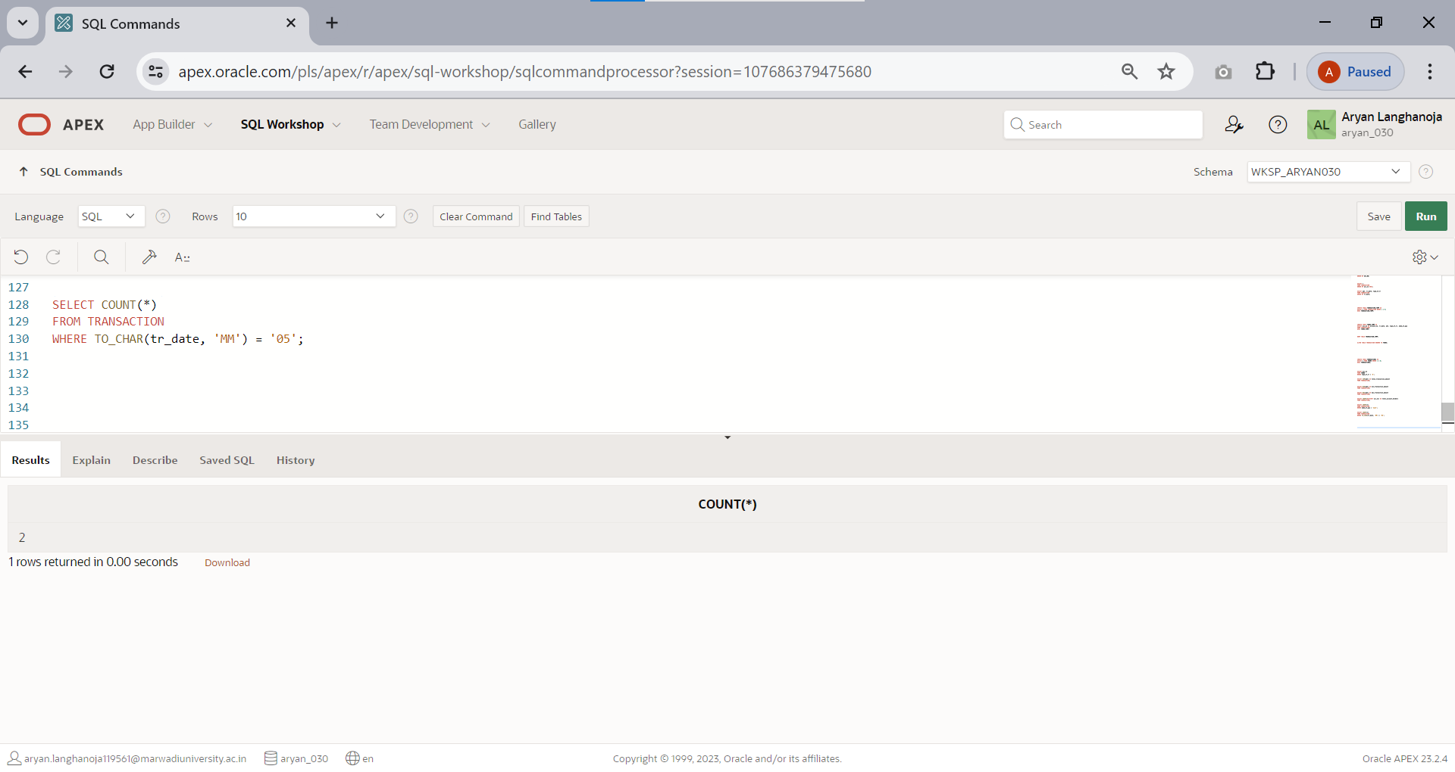

1. 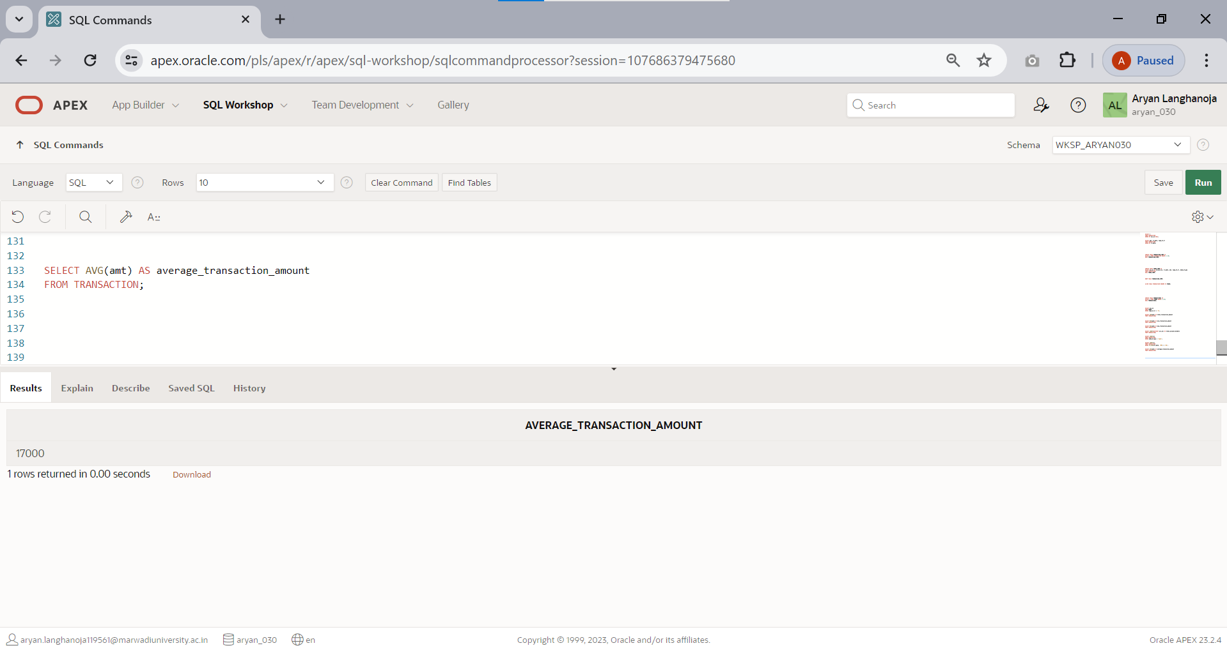Find the average value of transaction.
2. Display the result of 4 rest to 4.

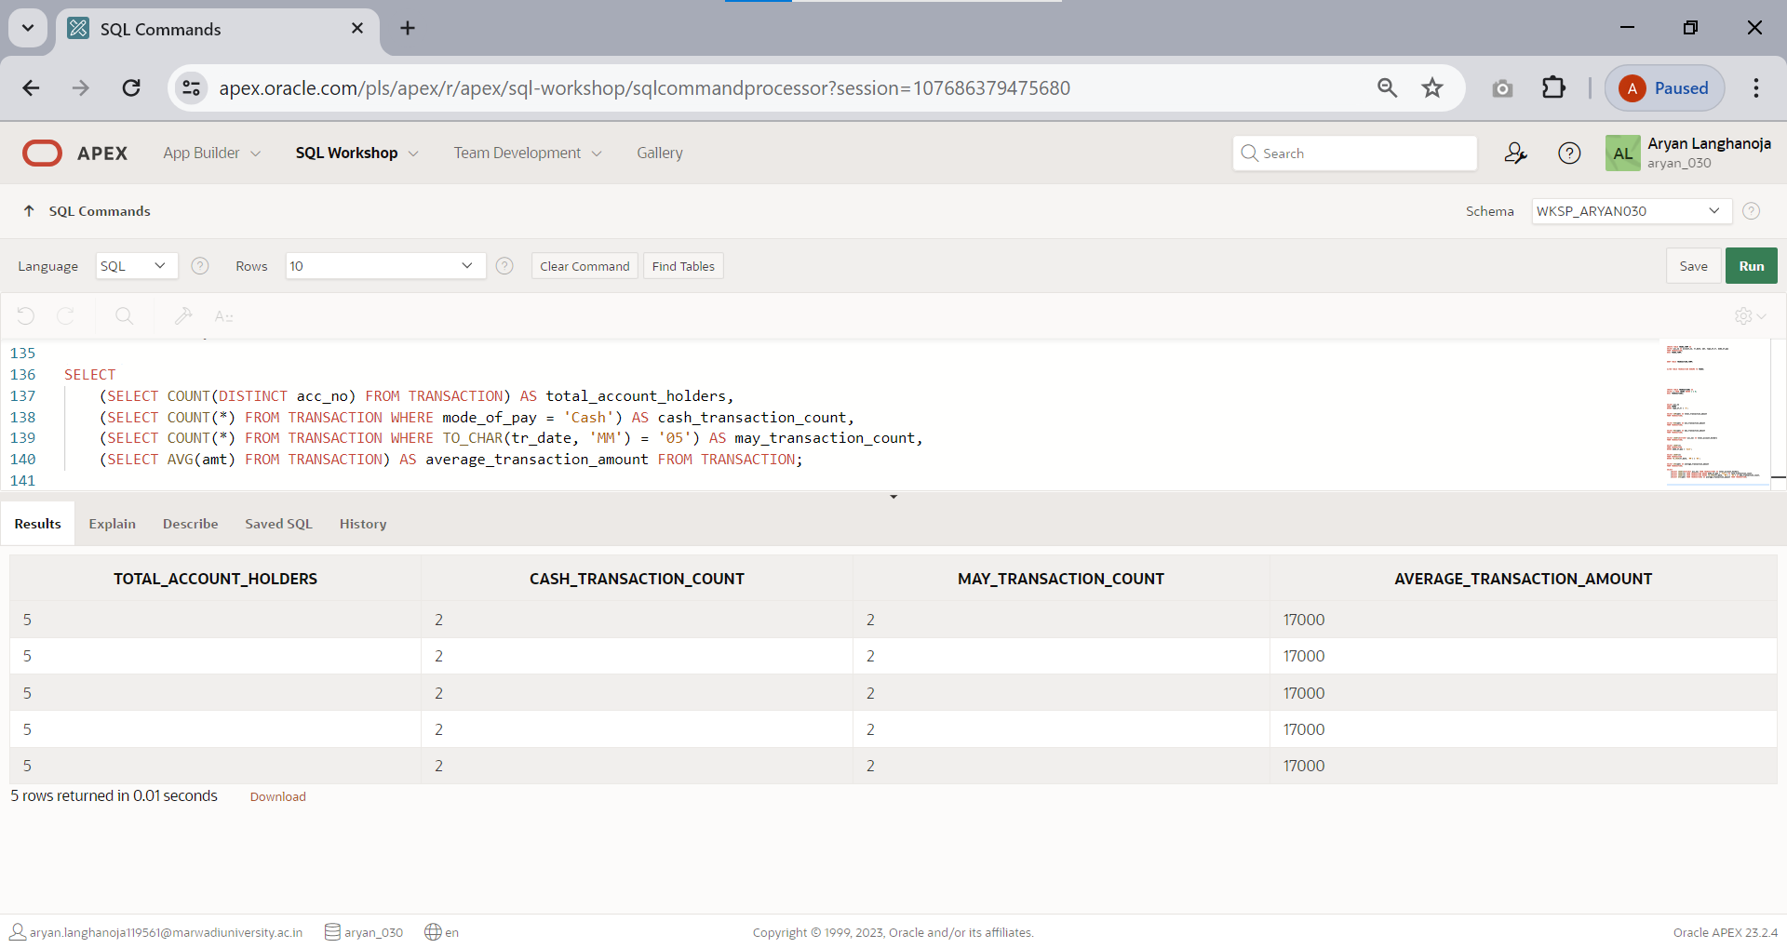

1. 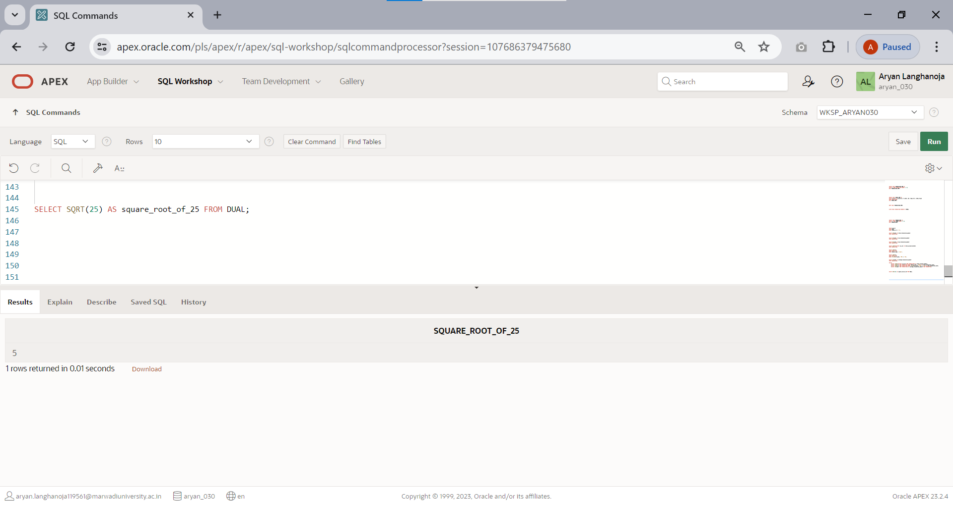Find the square root of 25.
2. Write the query for the following Function. LOWER,INITCAP,UPPER,SUBSTR,LENGTH,LTRIM,RTRIM,LPAD,RPAD

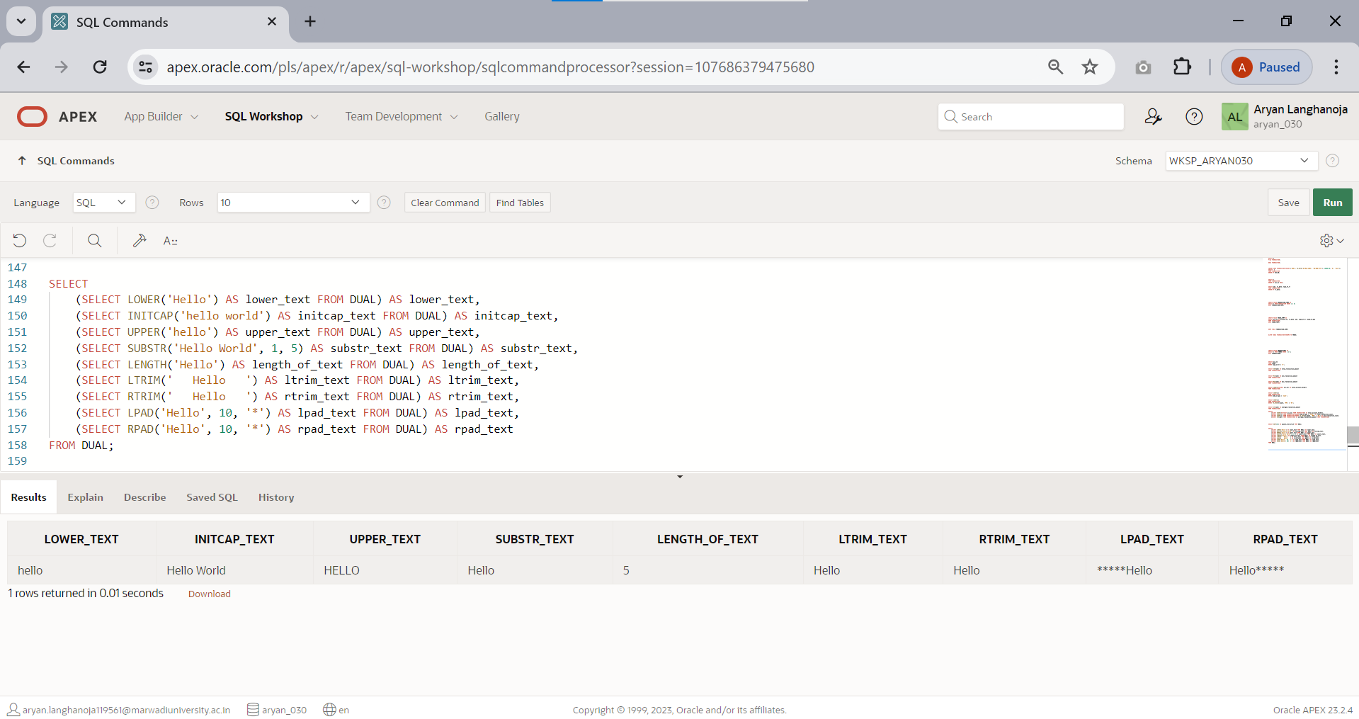

### CONSTRAINTS Based queries.

Create a table: **STUDENT**

|  |  |
| --- | --- |
| **Name of column** | **Type and Size** |
| Rollno | Varchar2(6) |
| Name | Varchar2(20) |
| Branch | Varchar2(6) |
| Address | Varchar2(20) |

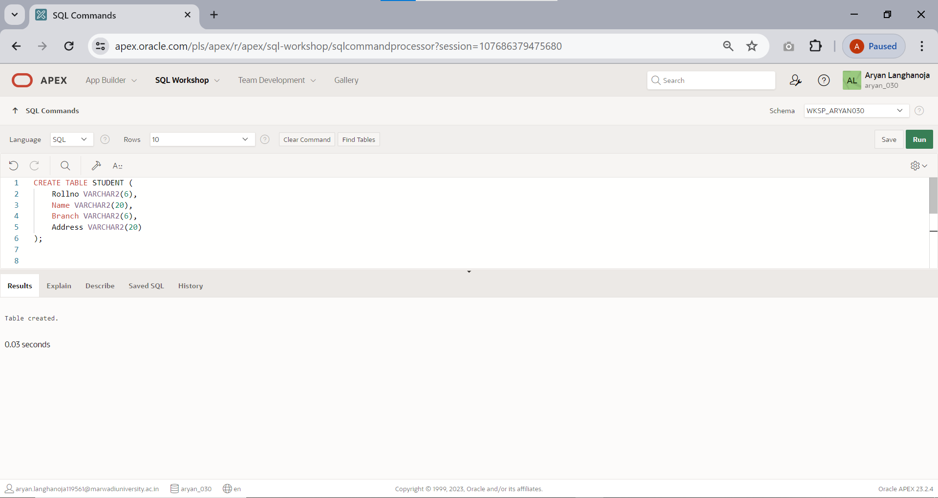

1. 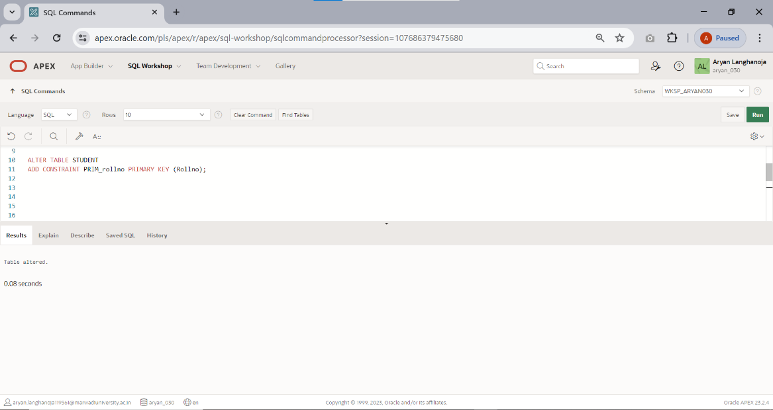Add PRIMARY KEY (roll no) and provide constraint name PRIM_rollno.
2. 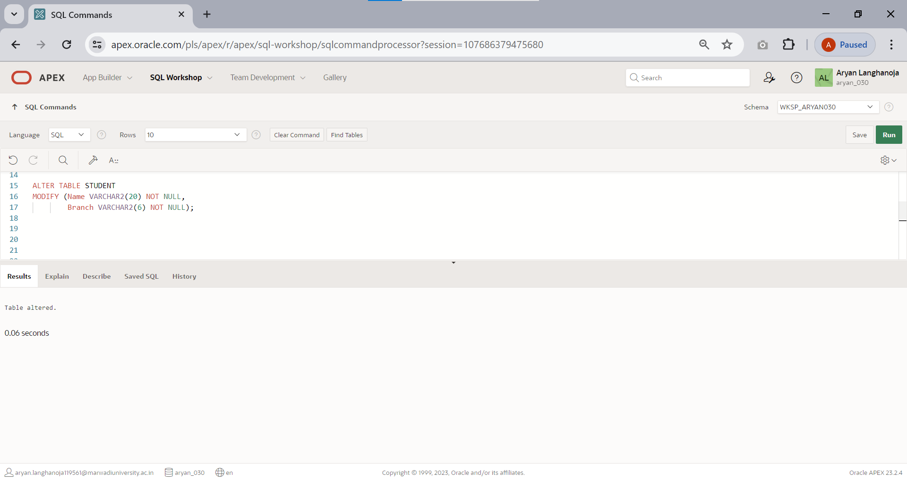Add NOT NULL constraint to name,branch for student table.
3. Add check constraint and check name is in capital letter.

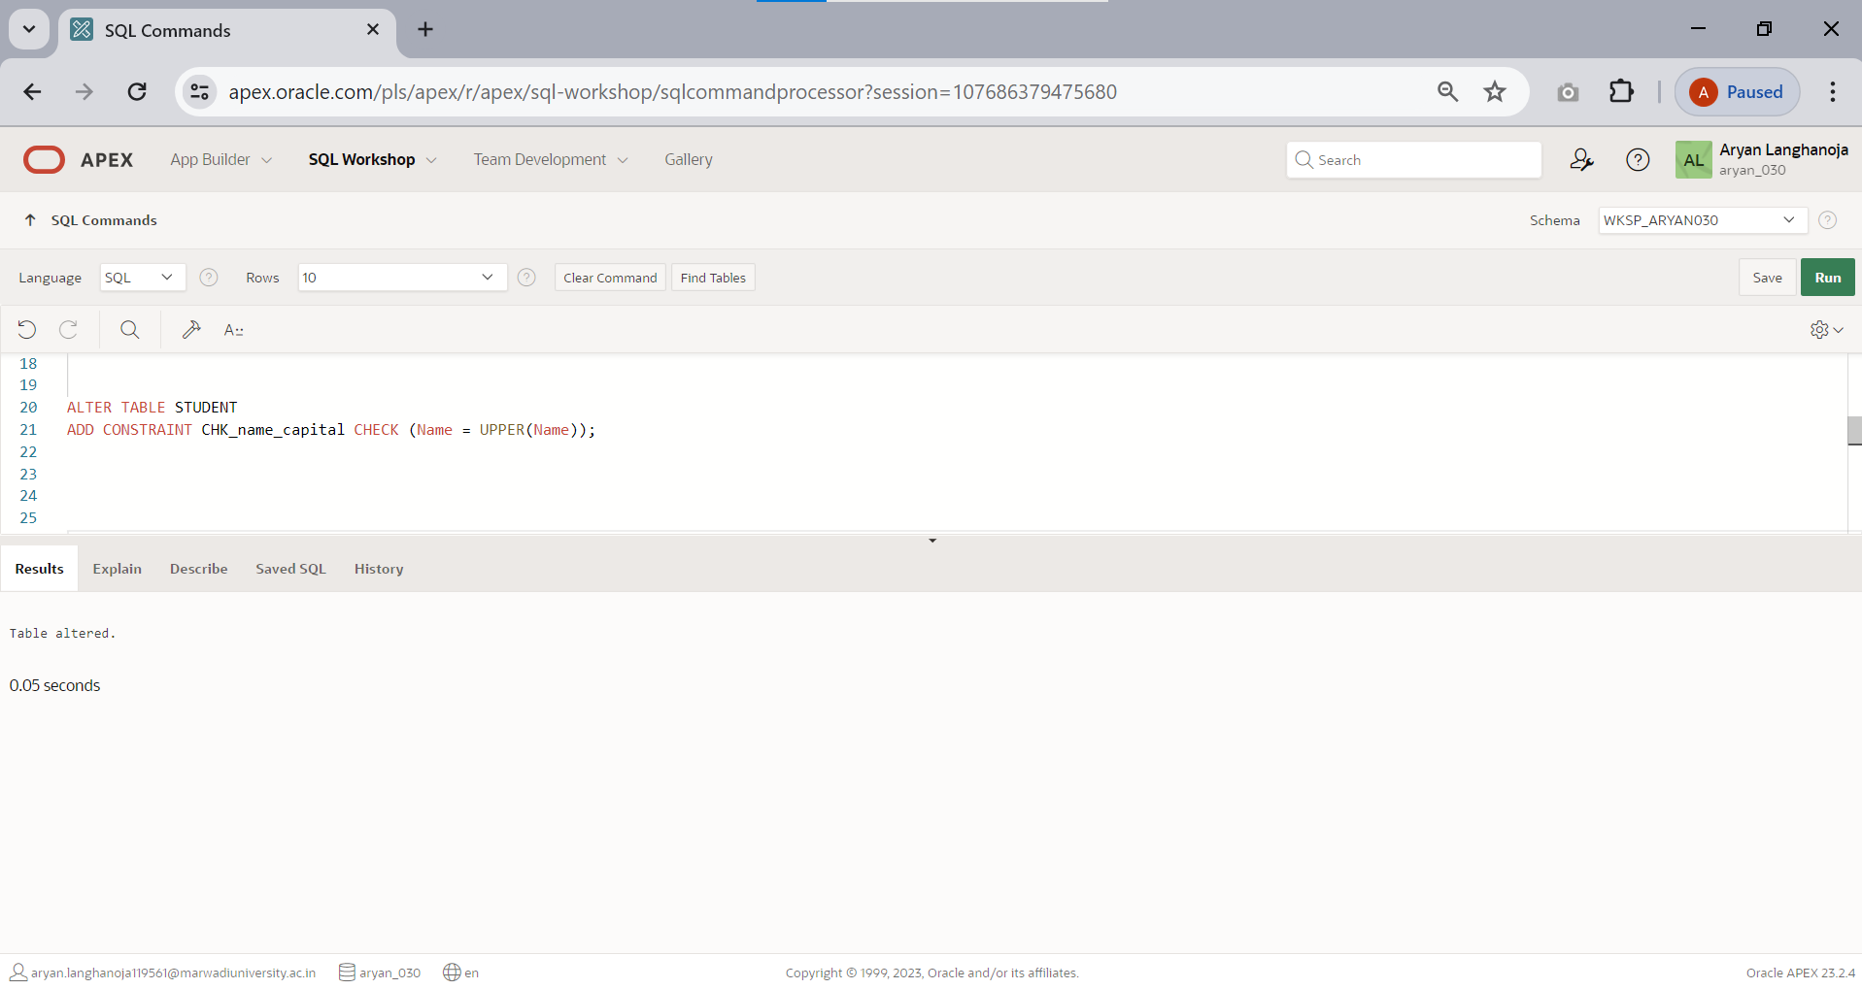

1. 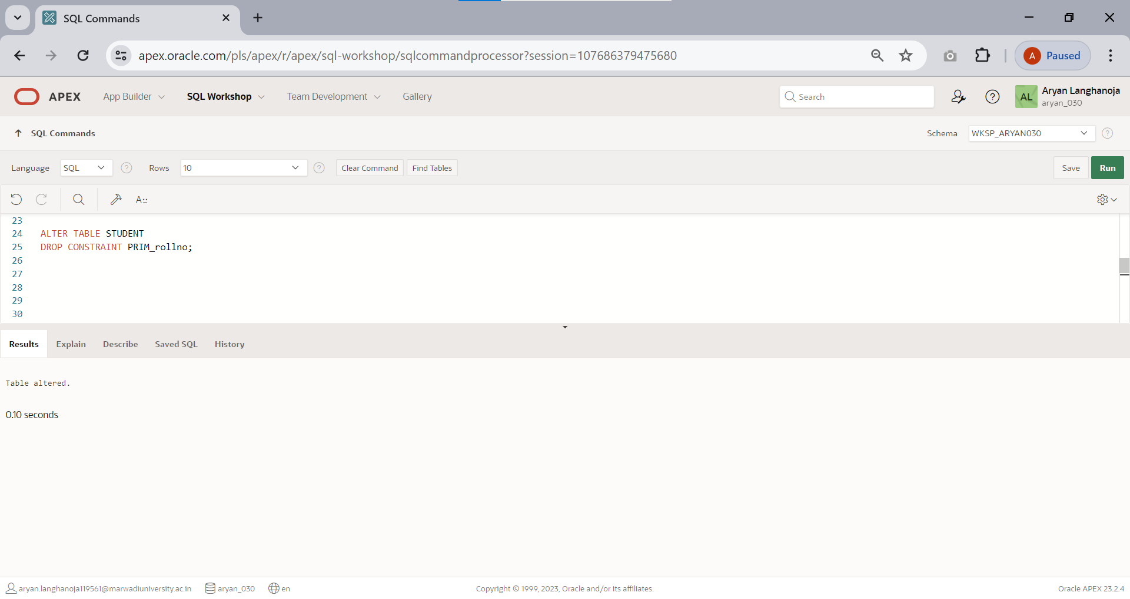Drop the primary key.
2. Drop the constraint.

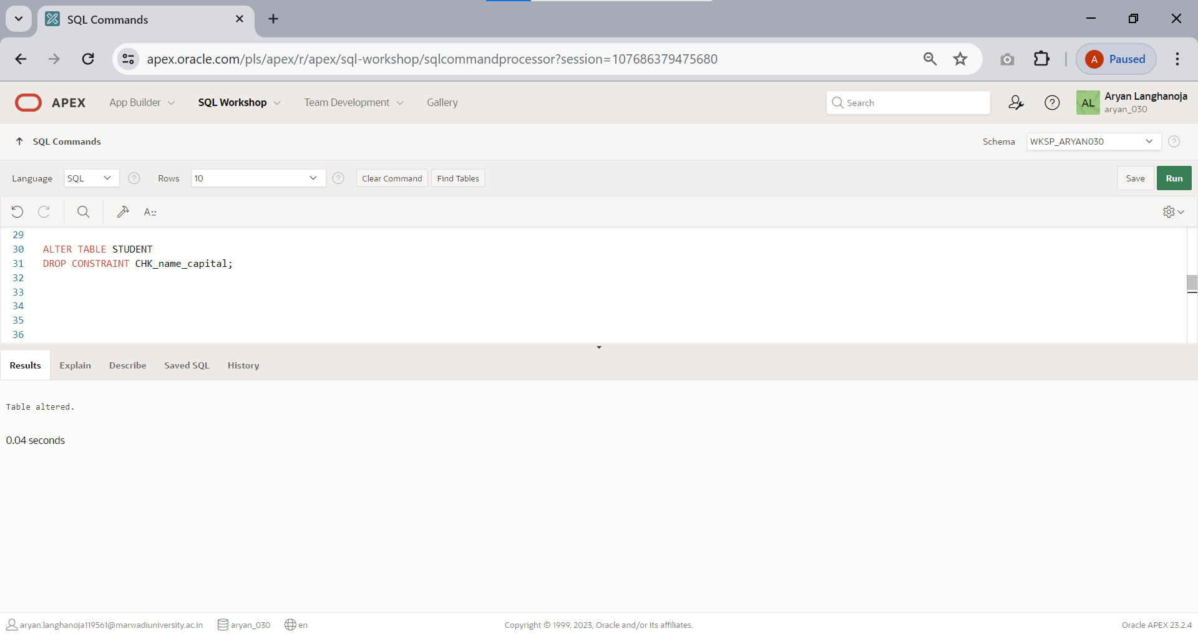

Create a Table **REGISTER.**

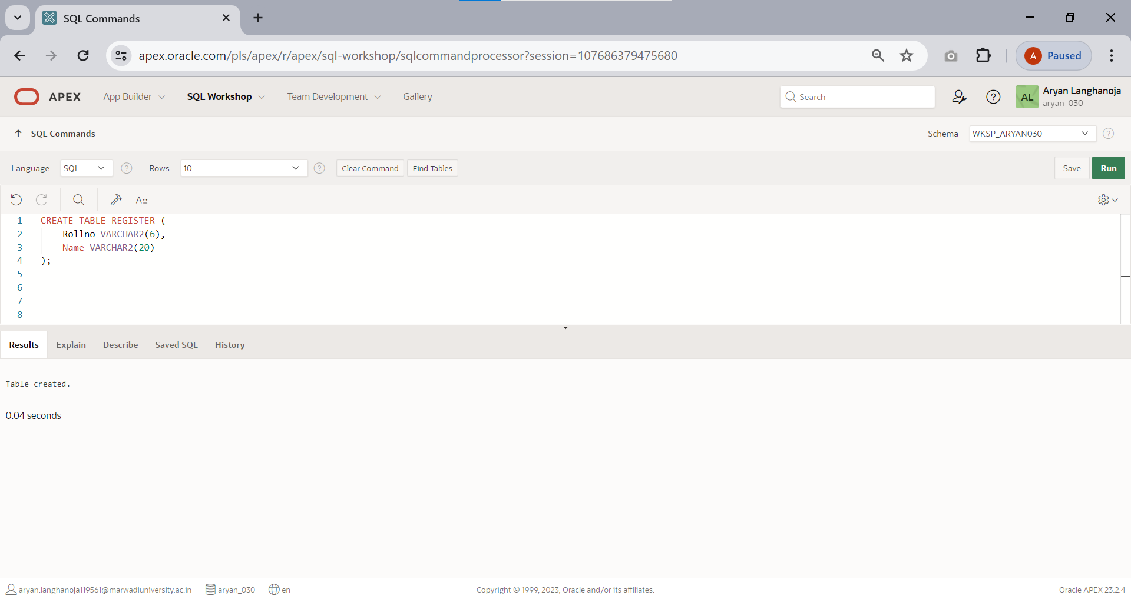

|  |  |
| --- | --- |
| **Name of column** | **Type and Size** |
| Rollno | Varchar2(6) |
| Name | Varchar2(20) |

1. 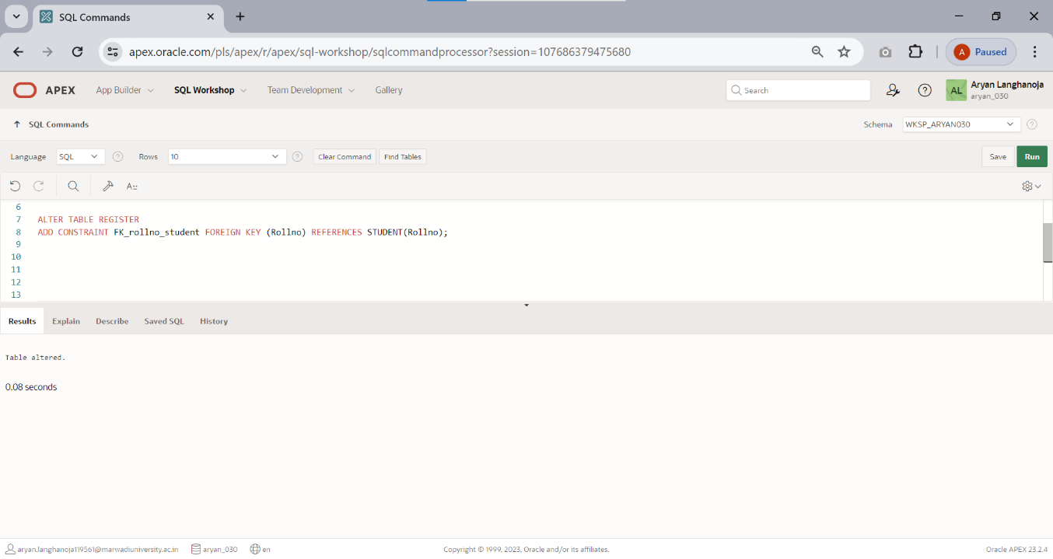Provide foreign key references rollno of student table.
2. 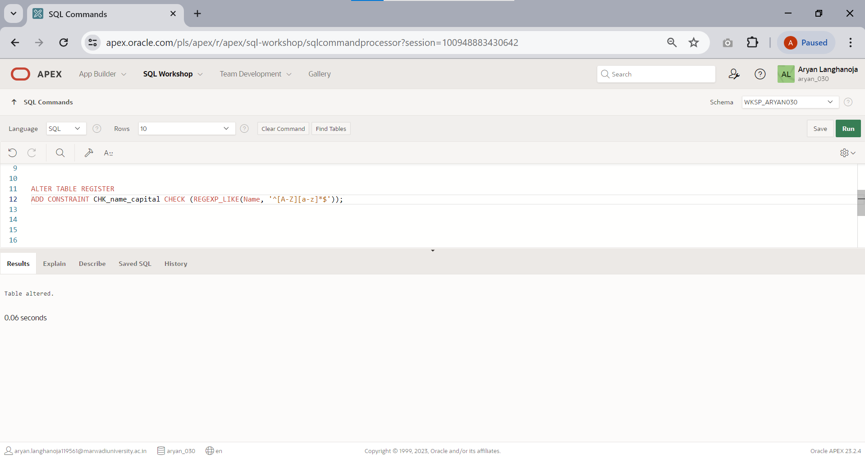Add check constraint to check name’s first letter is always capital.
3. Add NOT NULL constraint to name of register table.

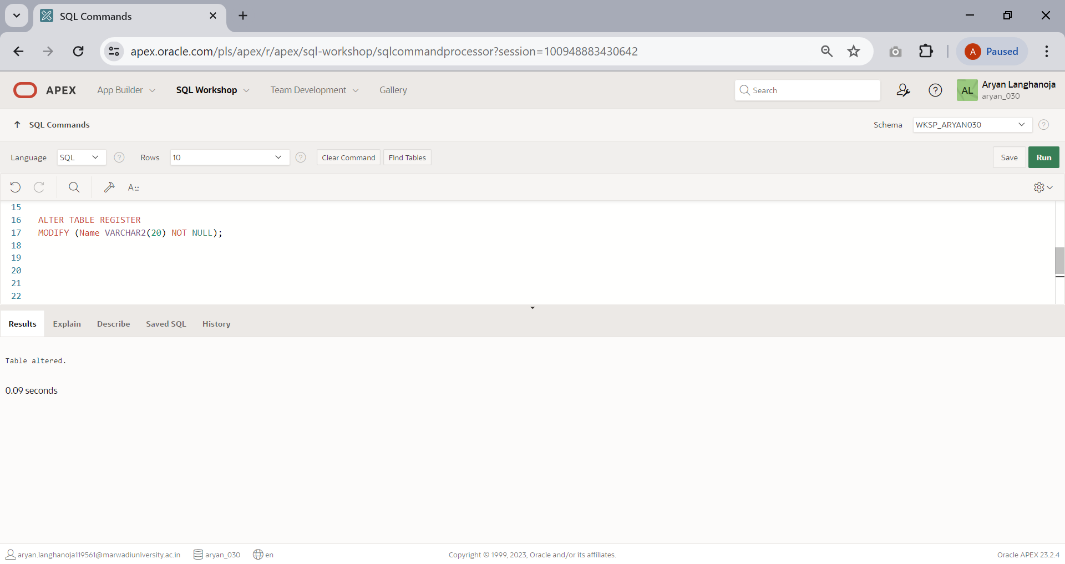

1. 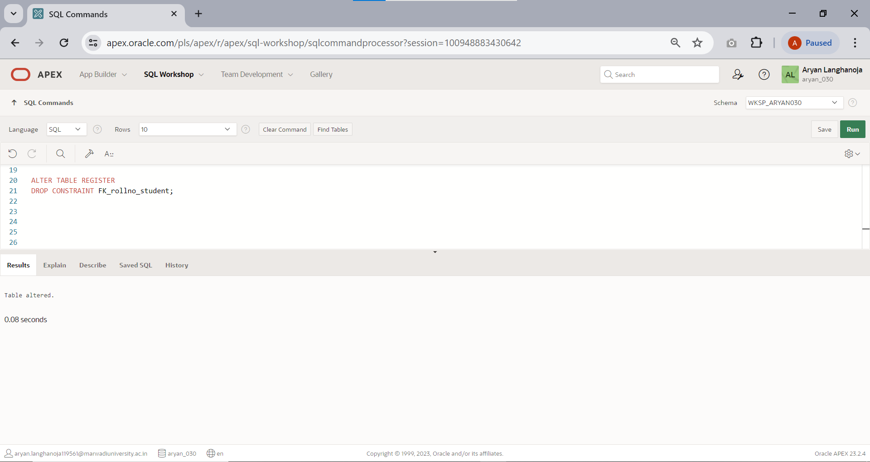Drop foreign key of REGISTER table.
2. Drop NOT NULL constraint.

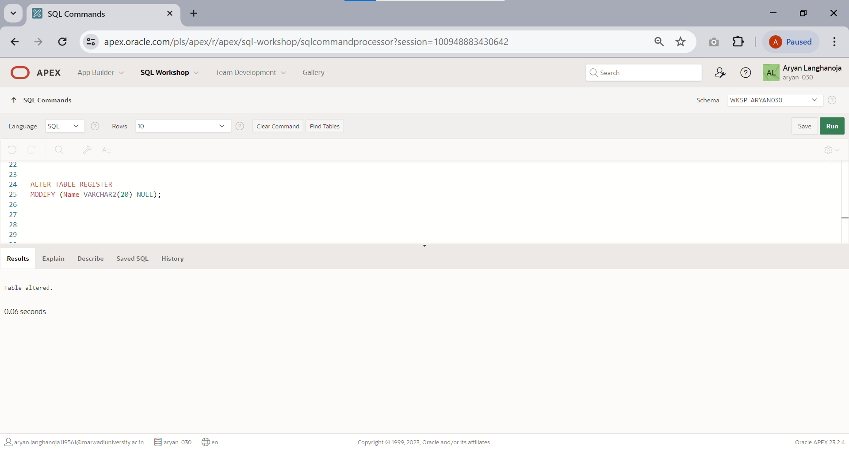

# Practical 7

## Aim: Implement operator, null and special operator-based queries

### NOTE: for following queries use TABLES of PRACTICAL-1

* 1. 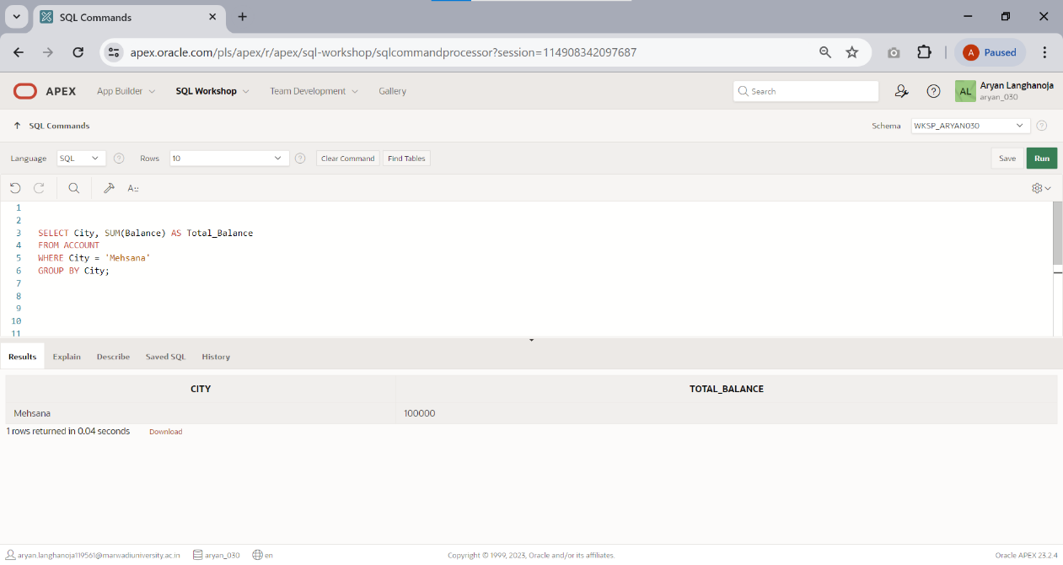Display the sum of balance of account holders who’s live in same city ‘Mehsana’ using group by clause.
  2. 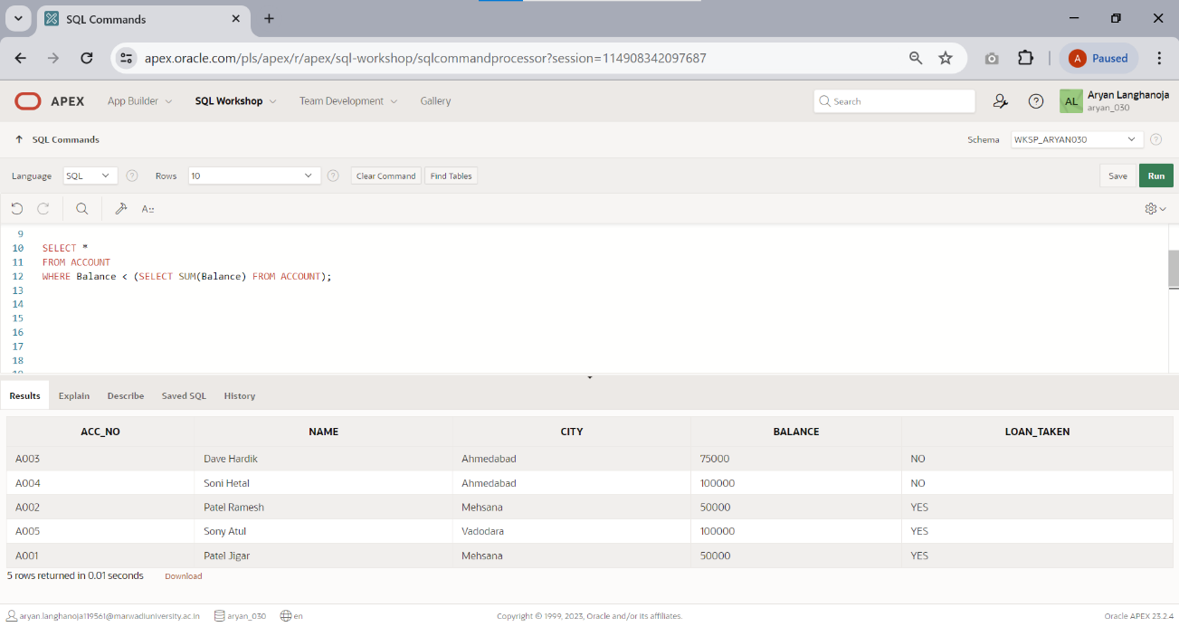Display the information about account where balance is less than total balance of all account holders.
  3. 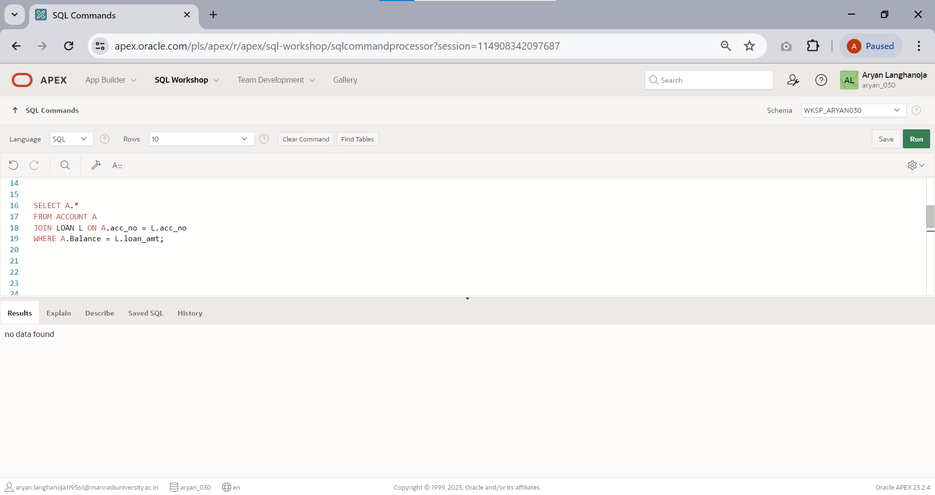Displays the information of account holders whose loan amount and balance both are same.
  4. Display the name of city, remaining loan amount, account, date of loan and loan number of account holders.

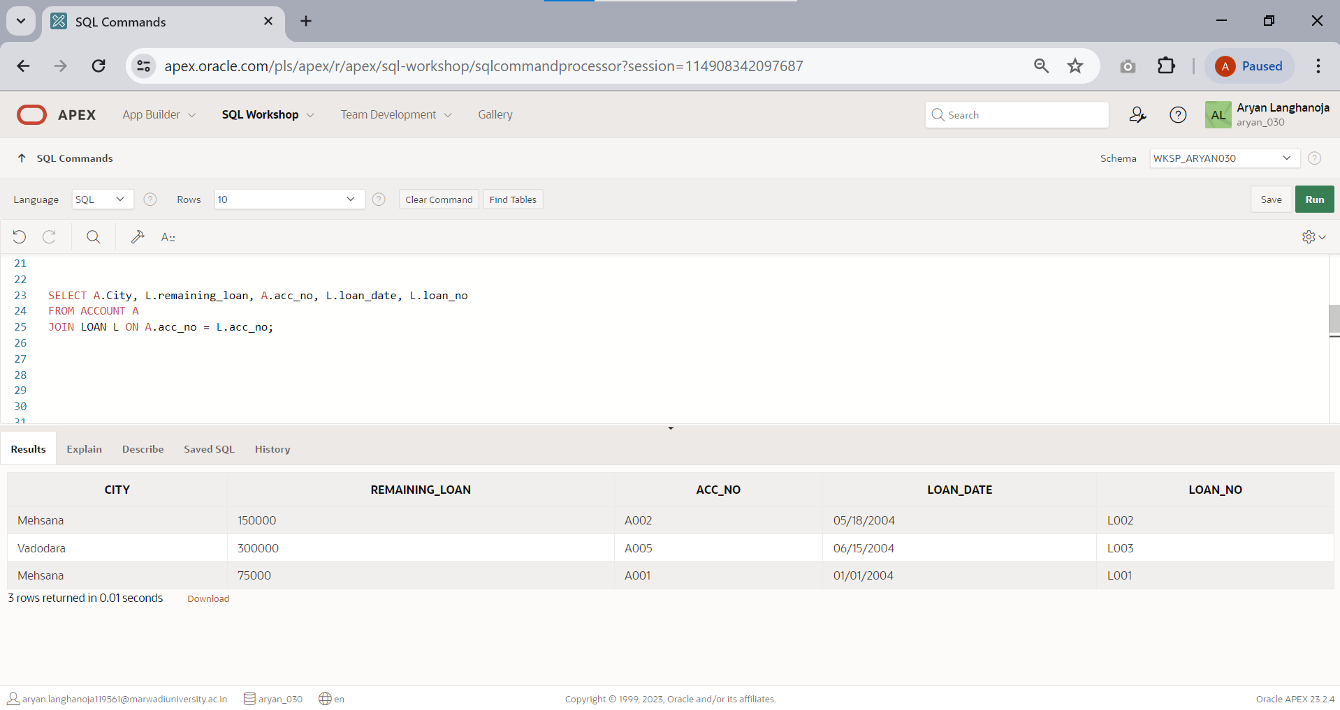

* 1. 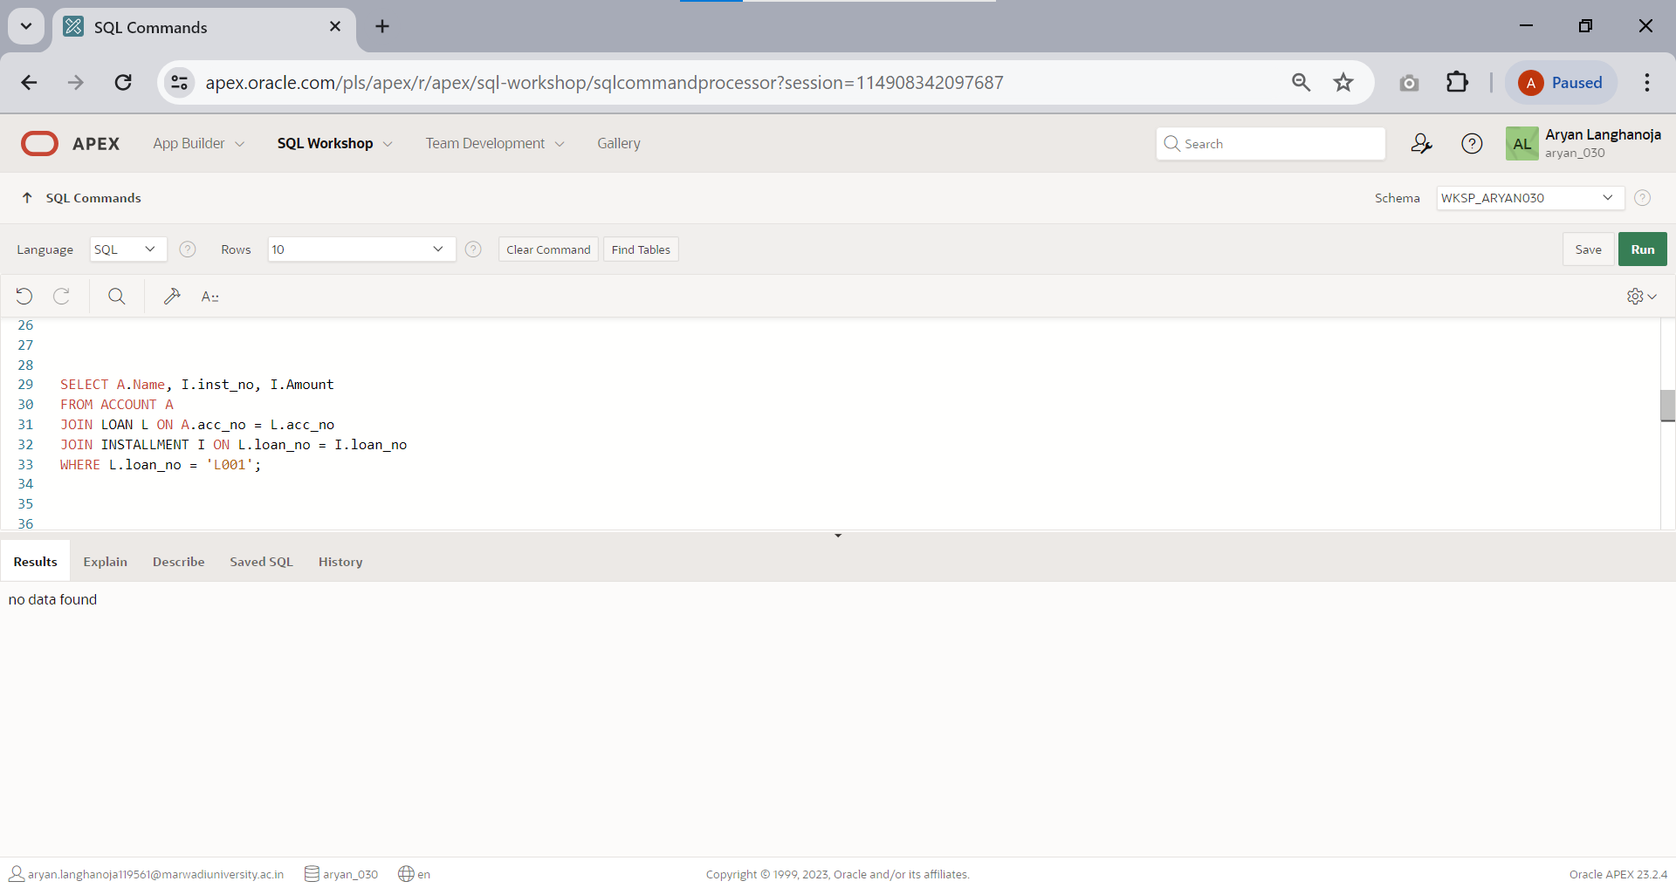Display name of account holder, installment number and installment amount Whose loan number is ‘L001’.
  2. 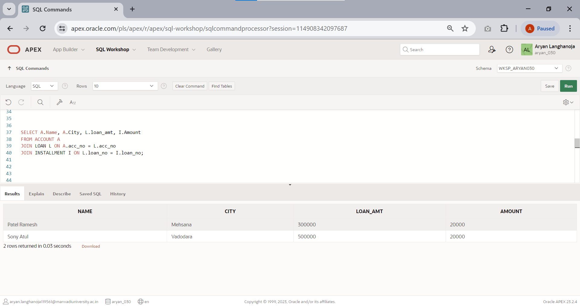Display name of account holder, city, loan amount and installment amount.
  3. 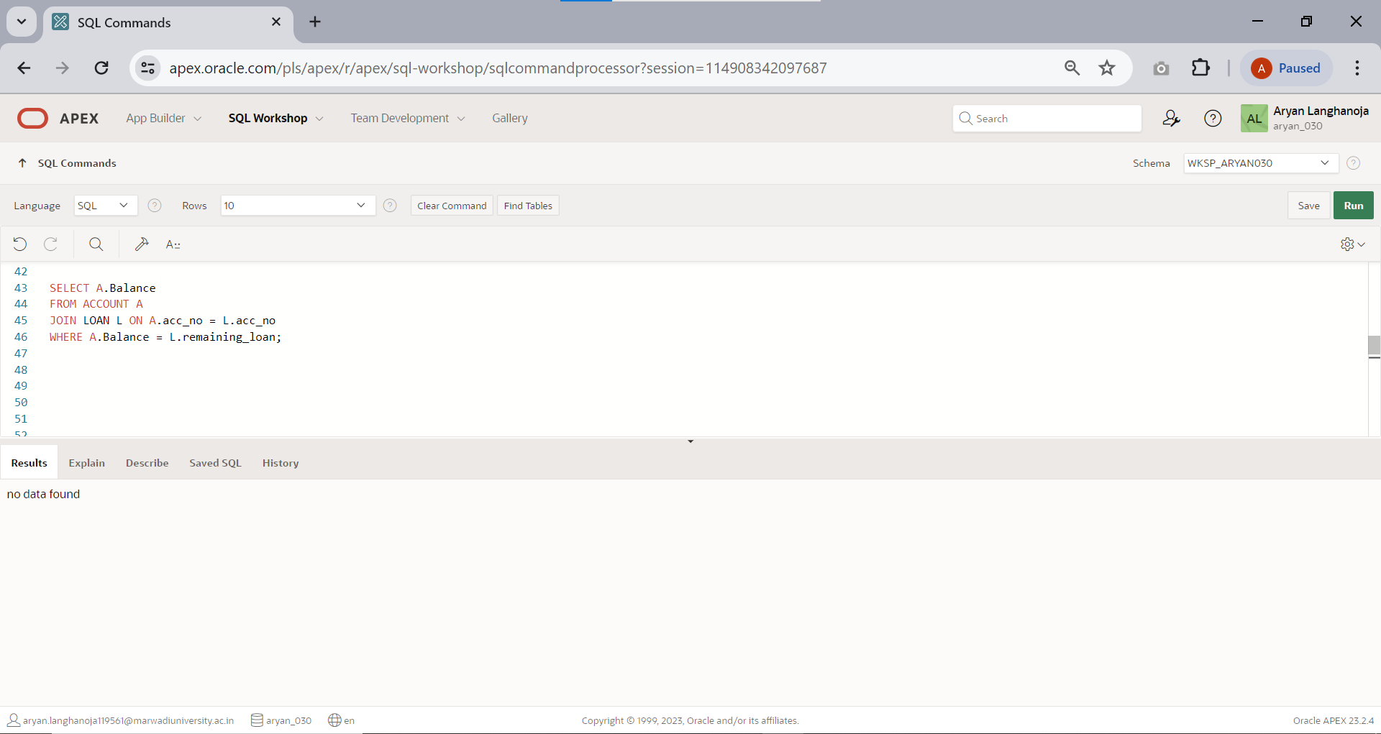Display the balance of account holders whose balance and remaining loan both are same.
  4. List of all account holders’ information whose balance is same as loan amount.

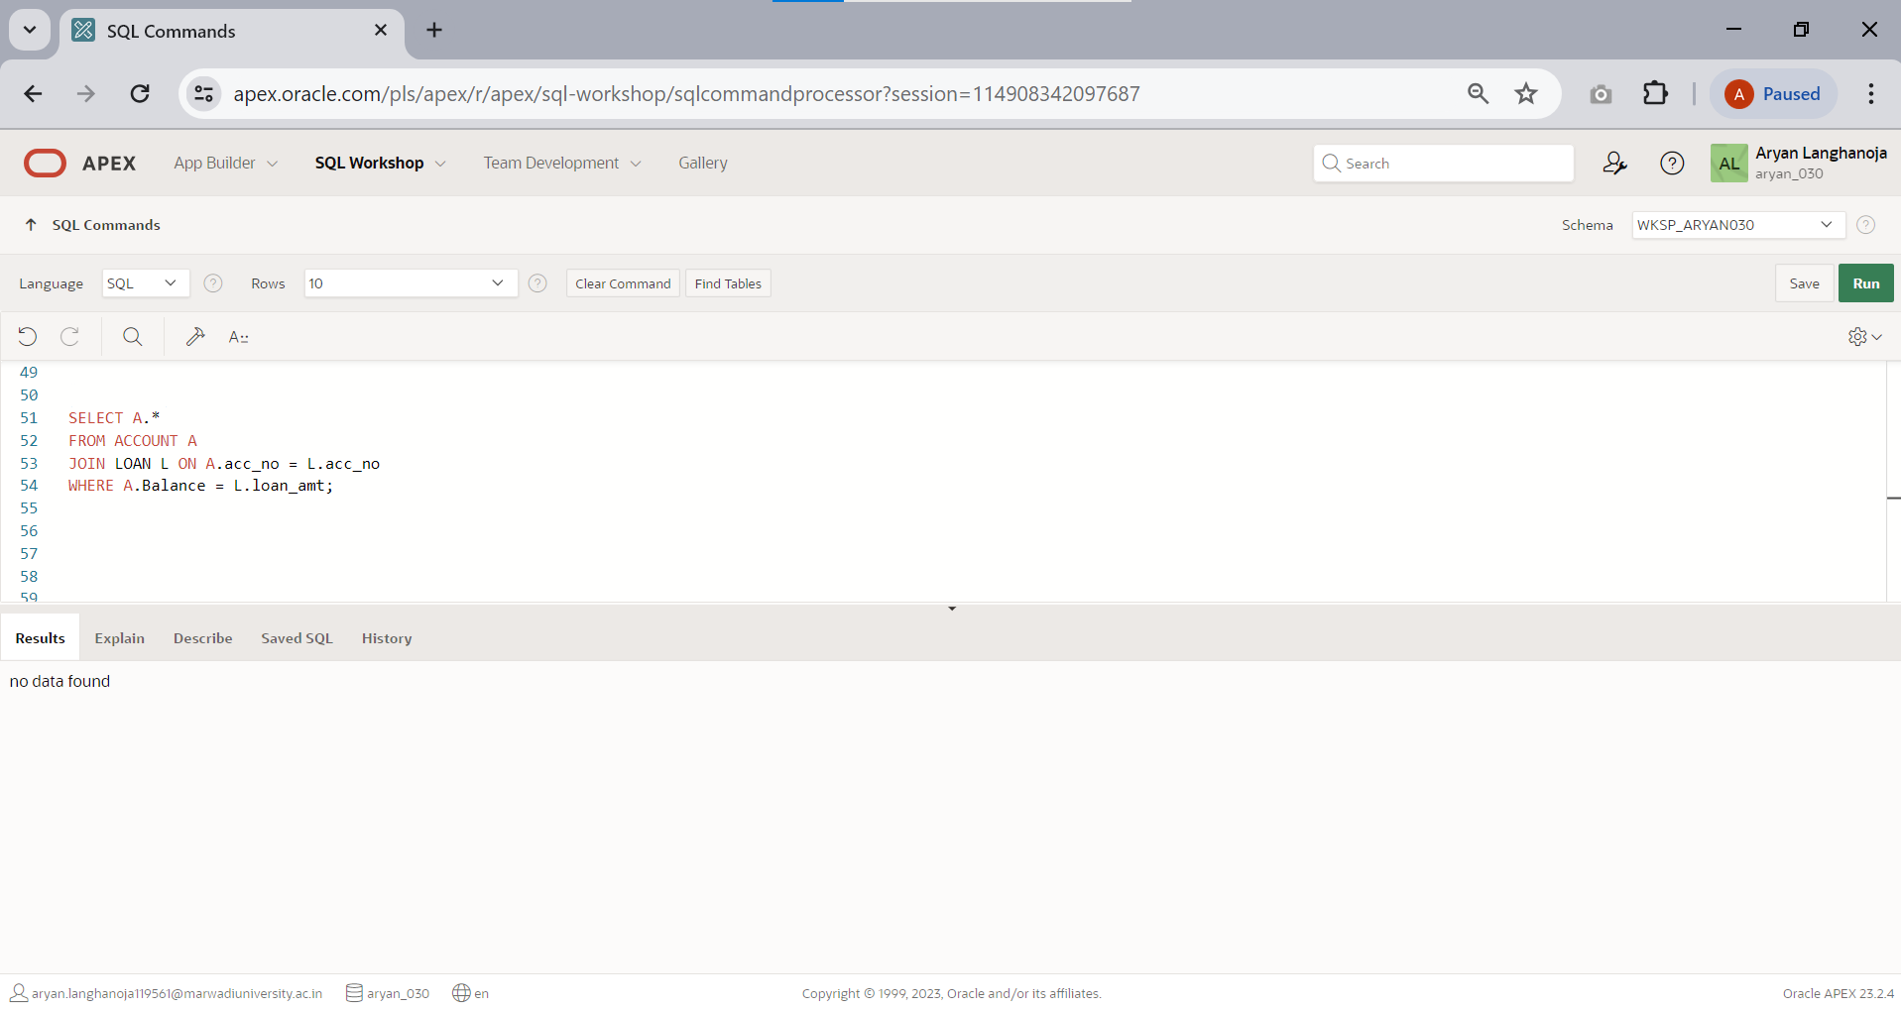

* 1. 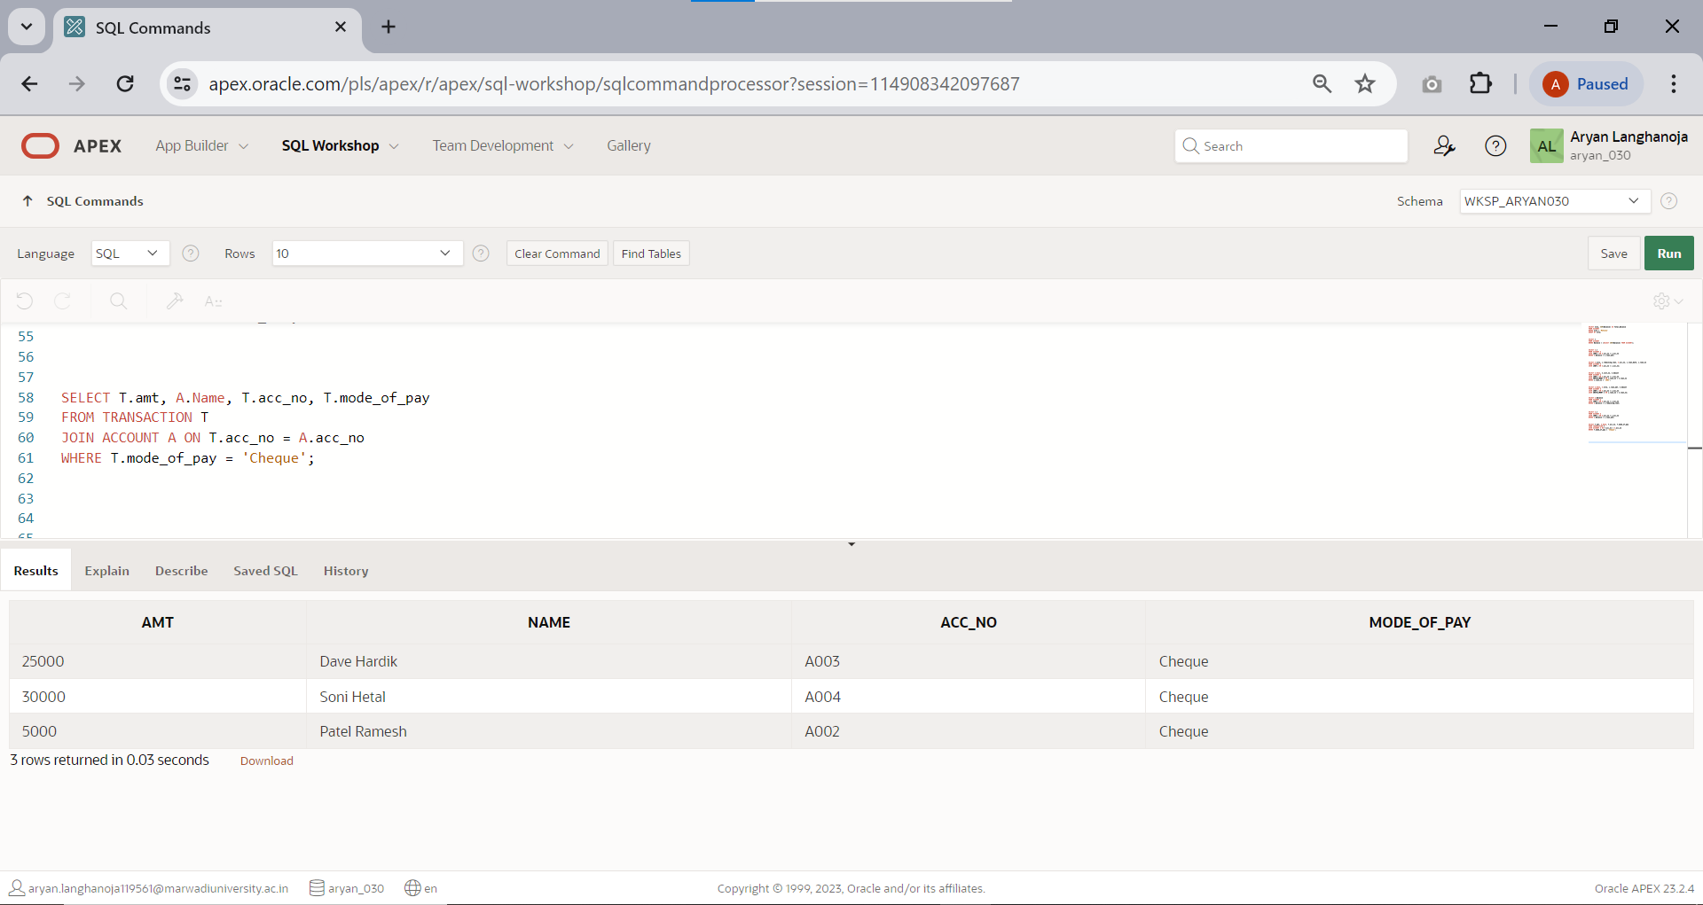Display the amount of transaction, name of account holders, account number and mode of payment whose mode of payment is ‘CHEQUE’.
  2. Display account no, loan amount, amount of transaction.

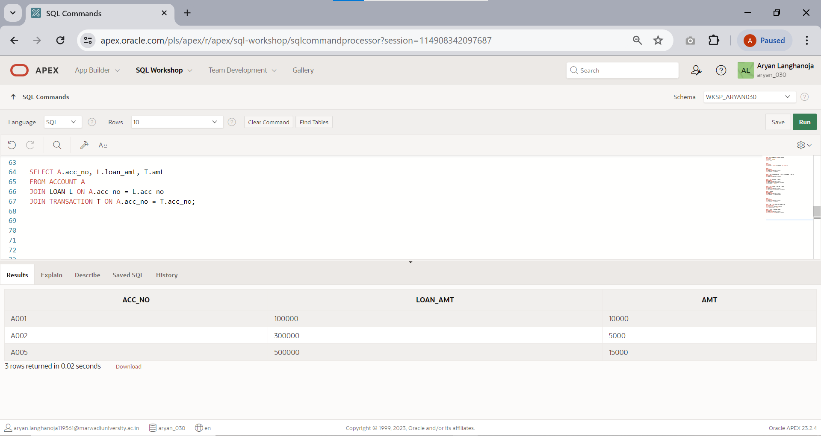

* 1. 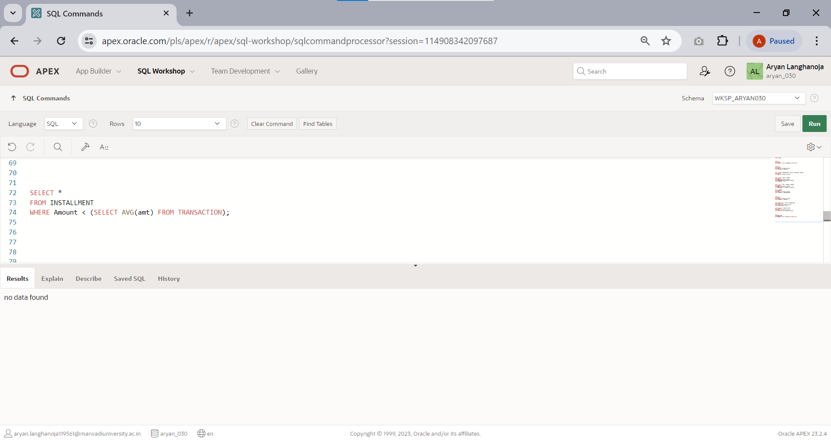List of installment information whose amount is less than average amount of transaction.
  2. 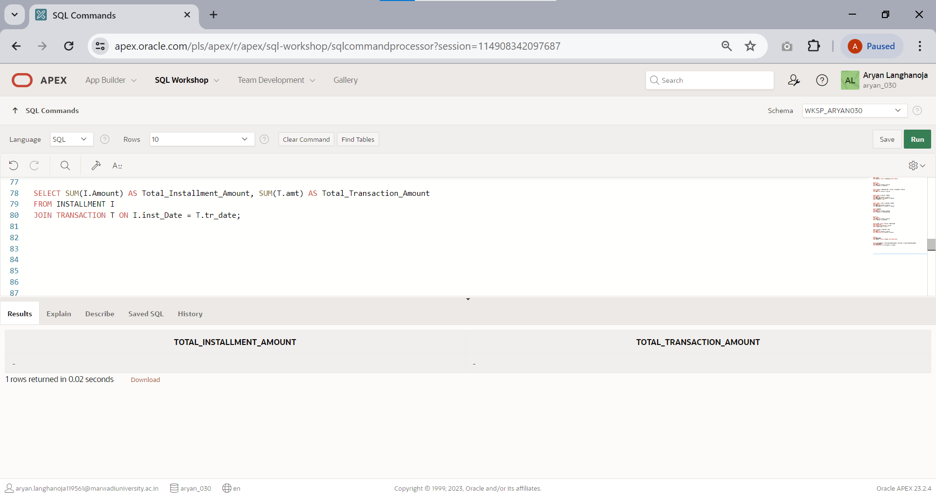Display the sum of installment amount and transaction amount.
  3. 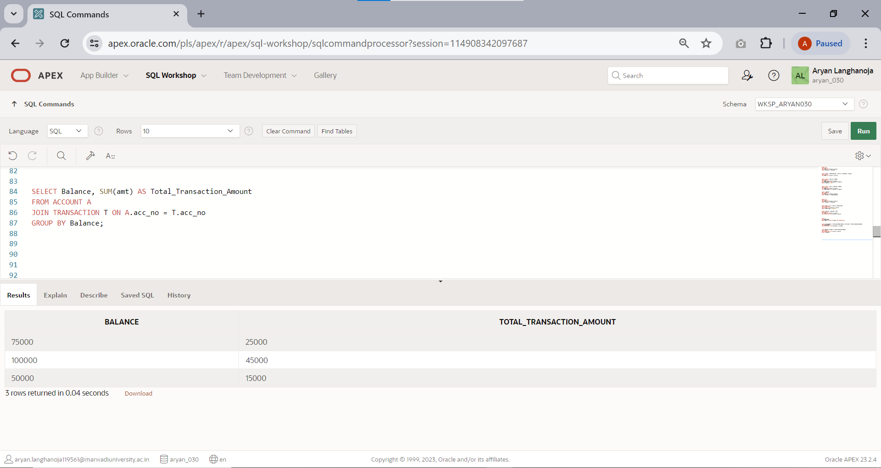Display the balance and amount of transaction group by amount and balance.
  4. List of installment number and account number of account holders.

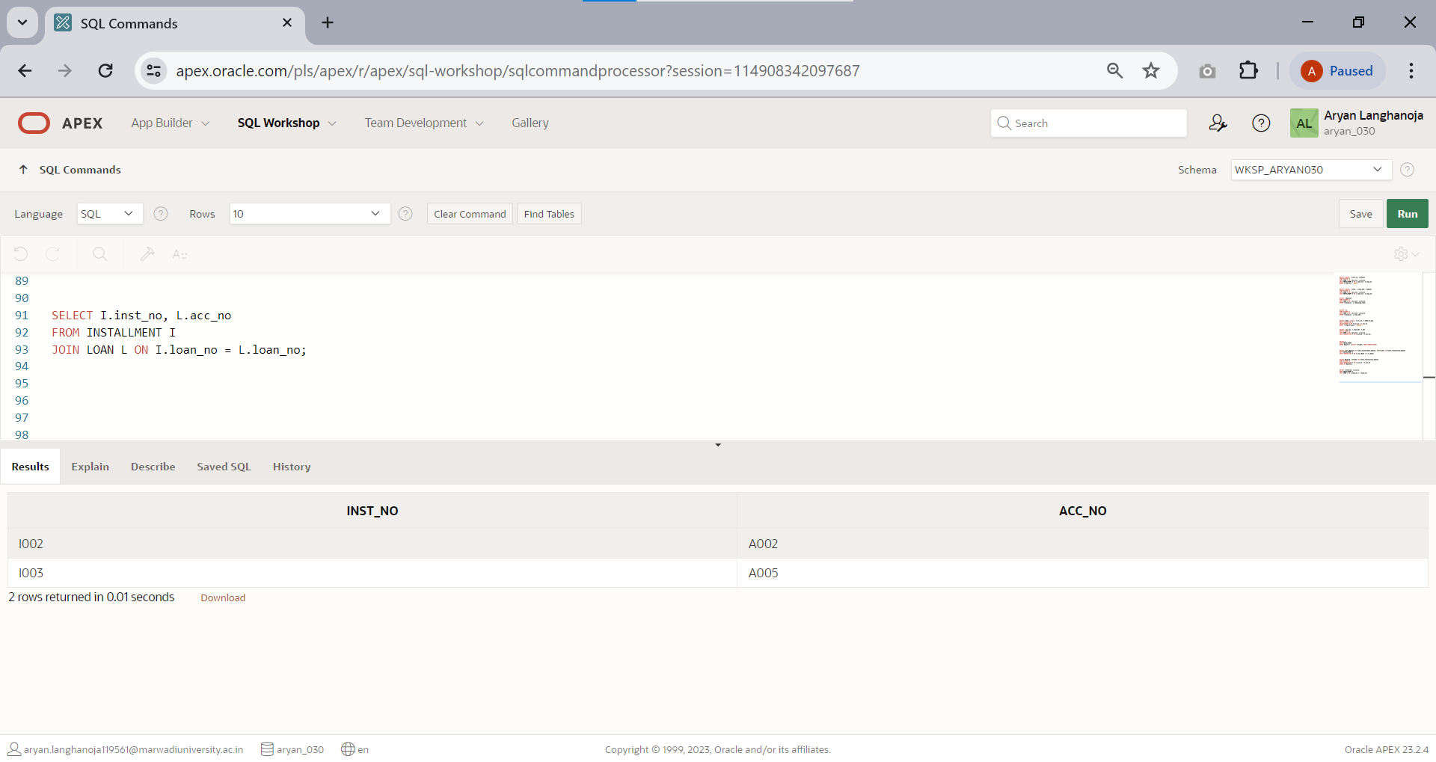

* 1. 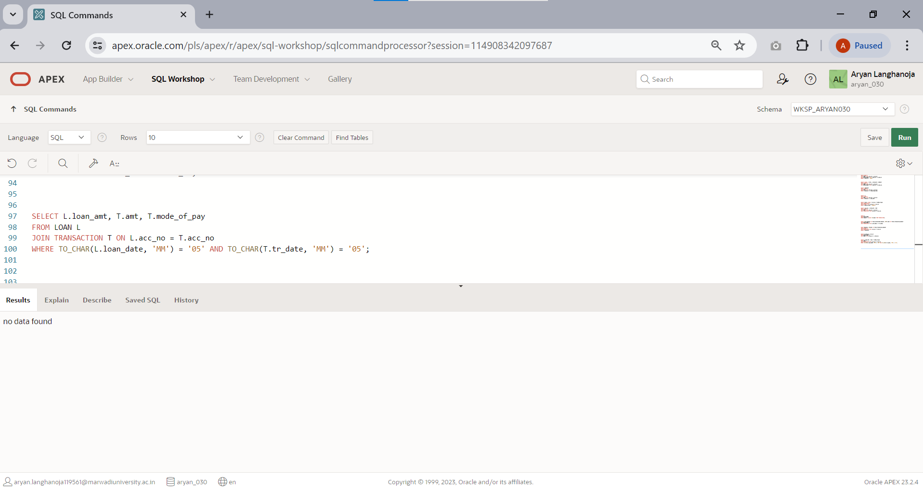Display loan amount, transaction amount and mode of payment where transaction date and loan taken date both are done in month of ‘MAY’.
  2. Display all the information of installment and transaction where installment date and transaction date both are done in month of ‘JULY’.

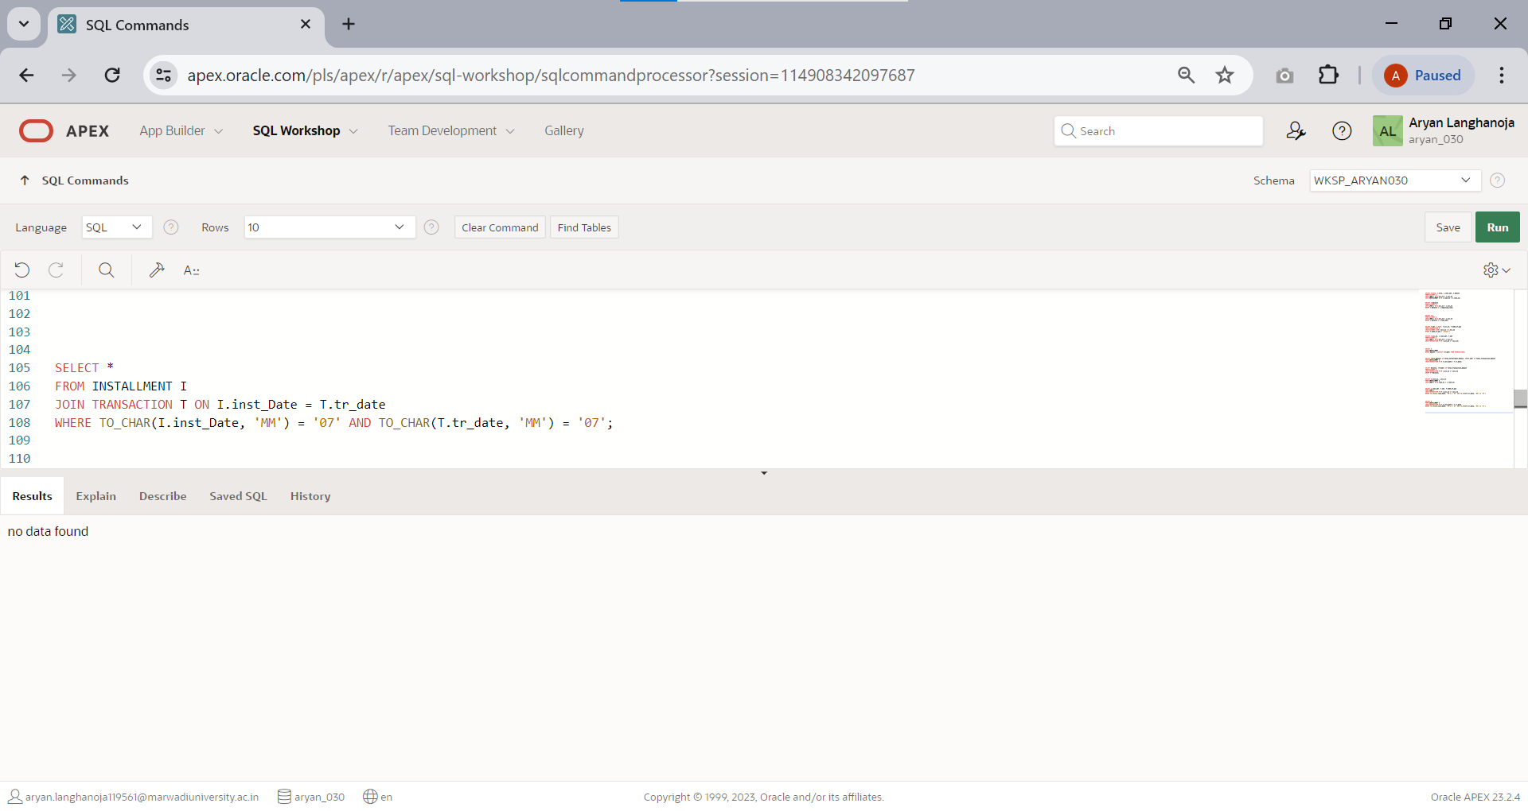

* 1. 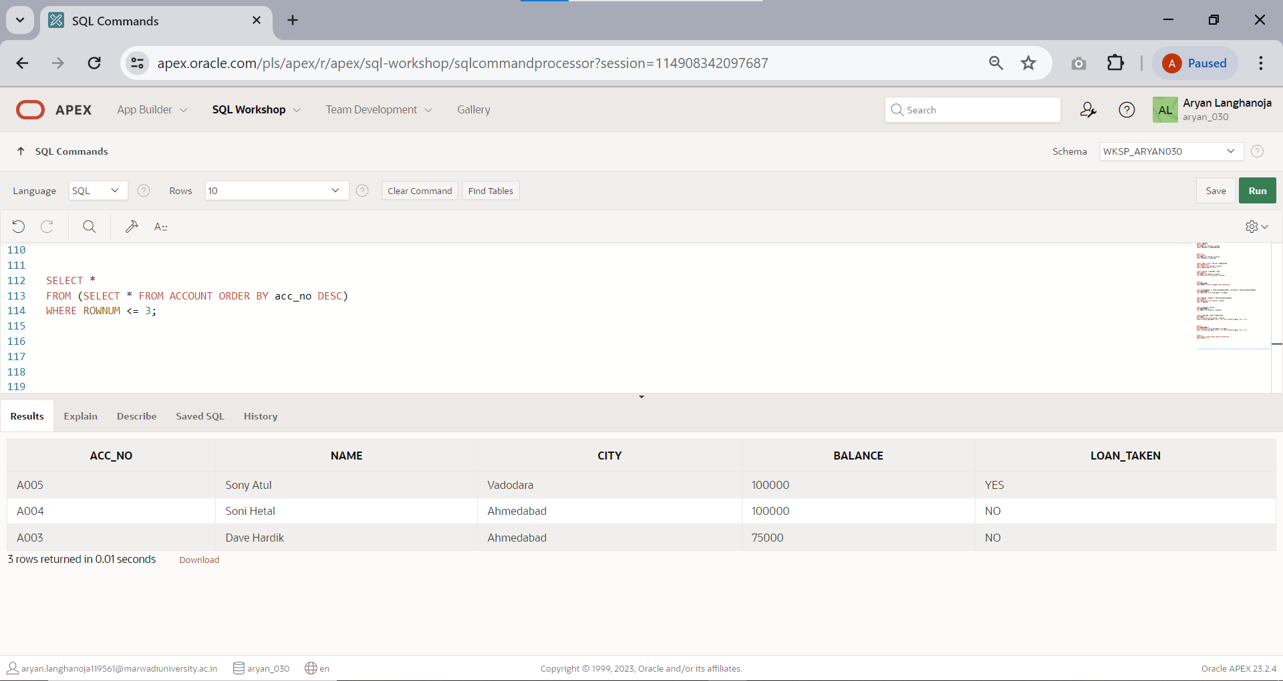Display the last three row of account table.
  2. 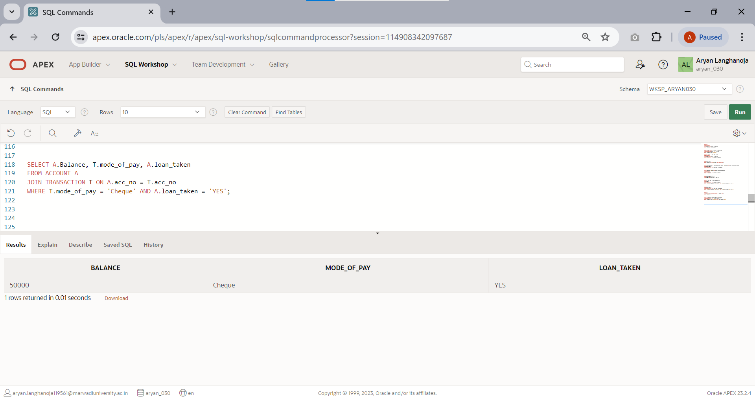Display the balance, mode of payment, loan taken status whose mode of payment is ‘CHEQUE’ and loan taken is ‘YES’.
  3. Retrieve only rows 2 to 5 from account table.

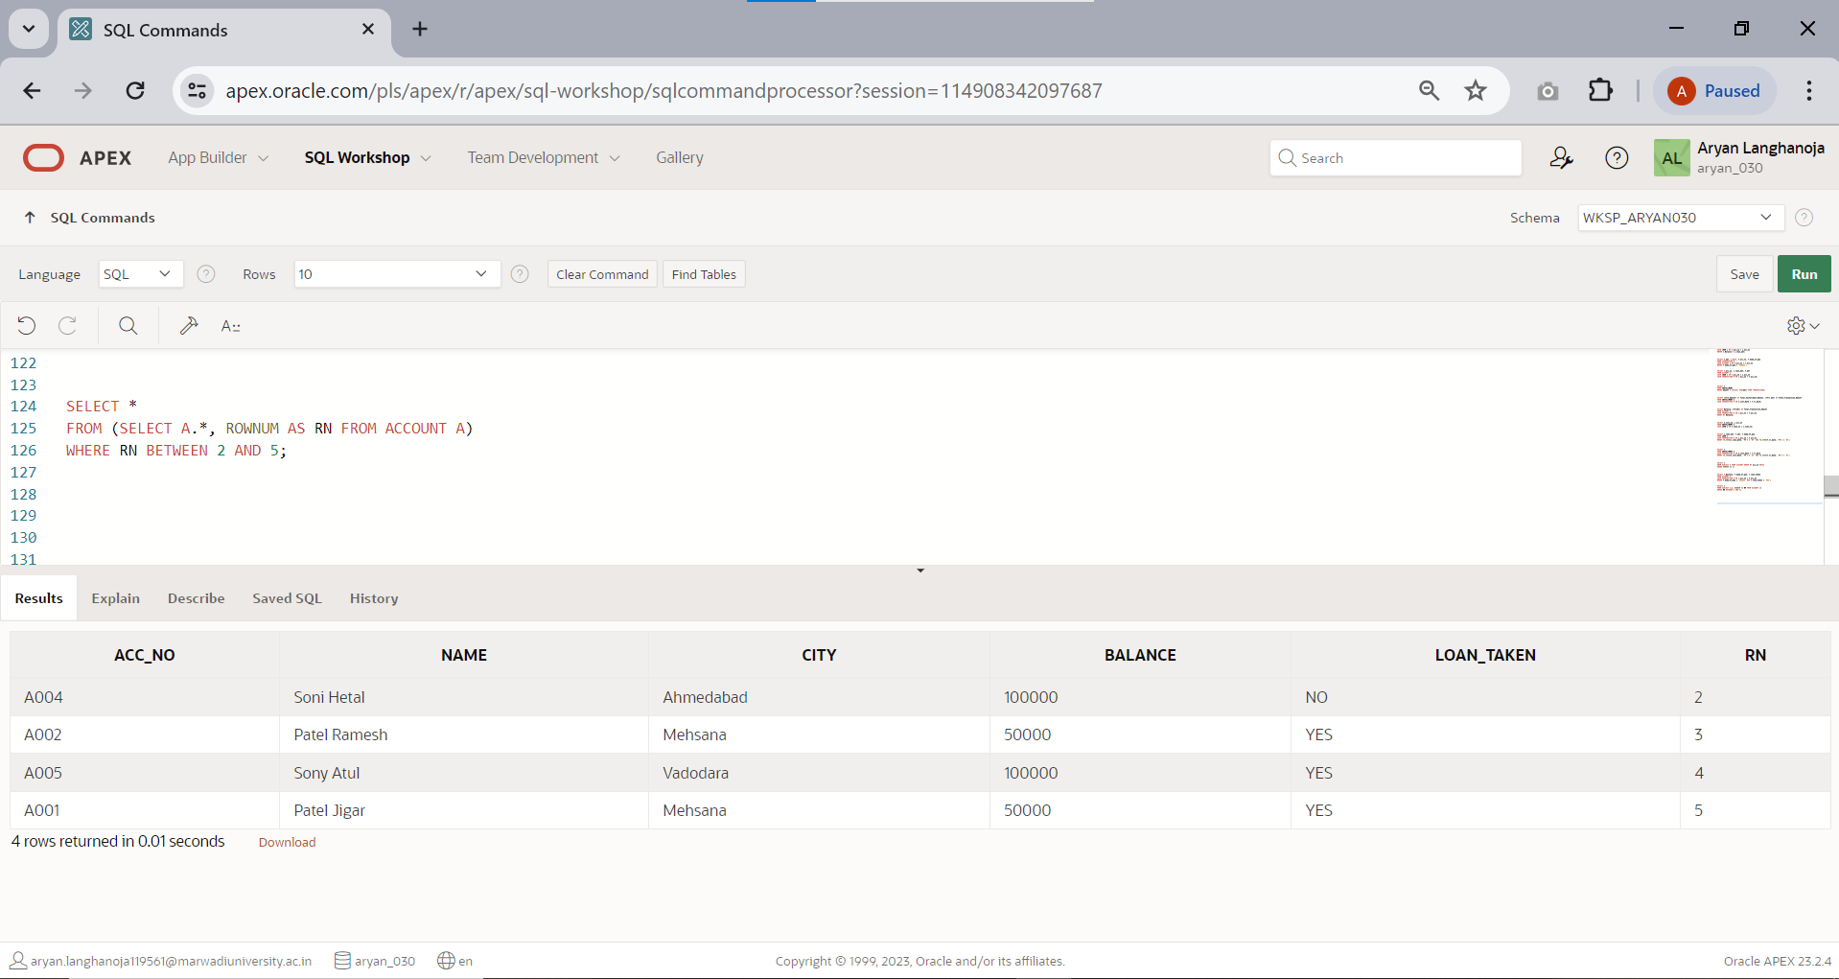

# Practical 8

## Aim: Implement Constraint based and Group by related queries.

TABLE: **SALESMEN**

|  |  |  |  |
| --- | --- | --- | --- |
| **Column Name** | **Data Type** | **Siz e** | **Attributes** |
| SNUM | Varchar2 | 6 | Primary key/first letter must start with ‘S’ |
| SNAME | Varchar2 | 20 | Not null |
| CITY | Varchar2 | 15 |  |
| COMM | Number | 5,2 |  |

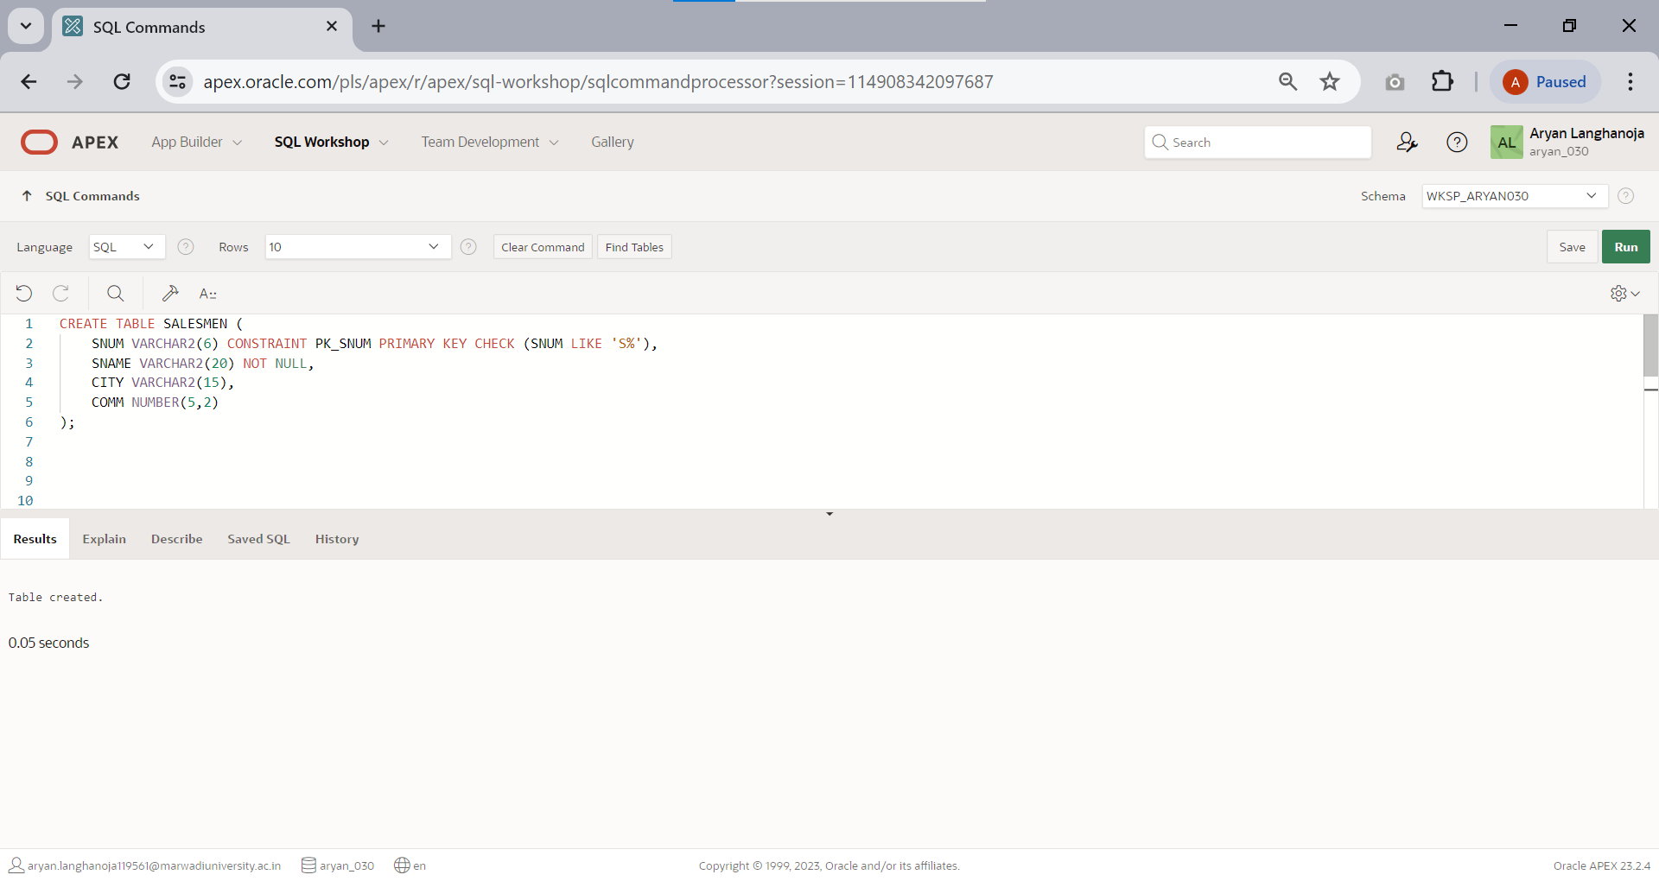

**Insert the following records:**

|  |  |  |  |
| --- | --- | --- | --- |
| **SNUM** | **SNAME** | **CITY** | **CO MM** |
| S1001 | Piyush | London | 0.12 |
| S1002 | Niraj | San jose | 0.13 |
| S1003 | Miti | London | 0.11 |
| S1004 | Rajesh | Barcelo na | 0.15 |
| S1005 | Haresh | New york | 0.10 |
| S1006 | Ram | Bombay | 0.10 |
| S1007 | Nehal | Delhi | 0.09 |

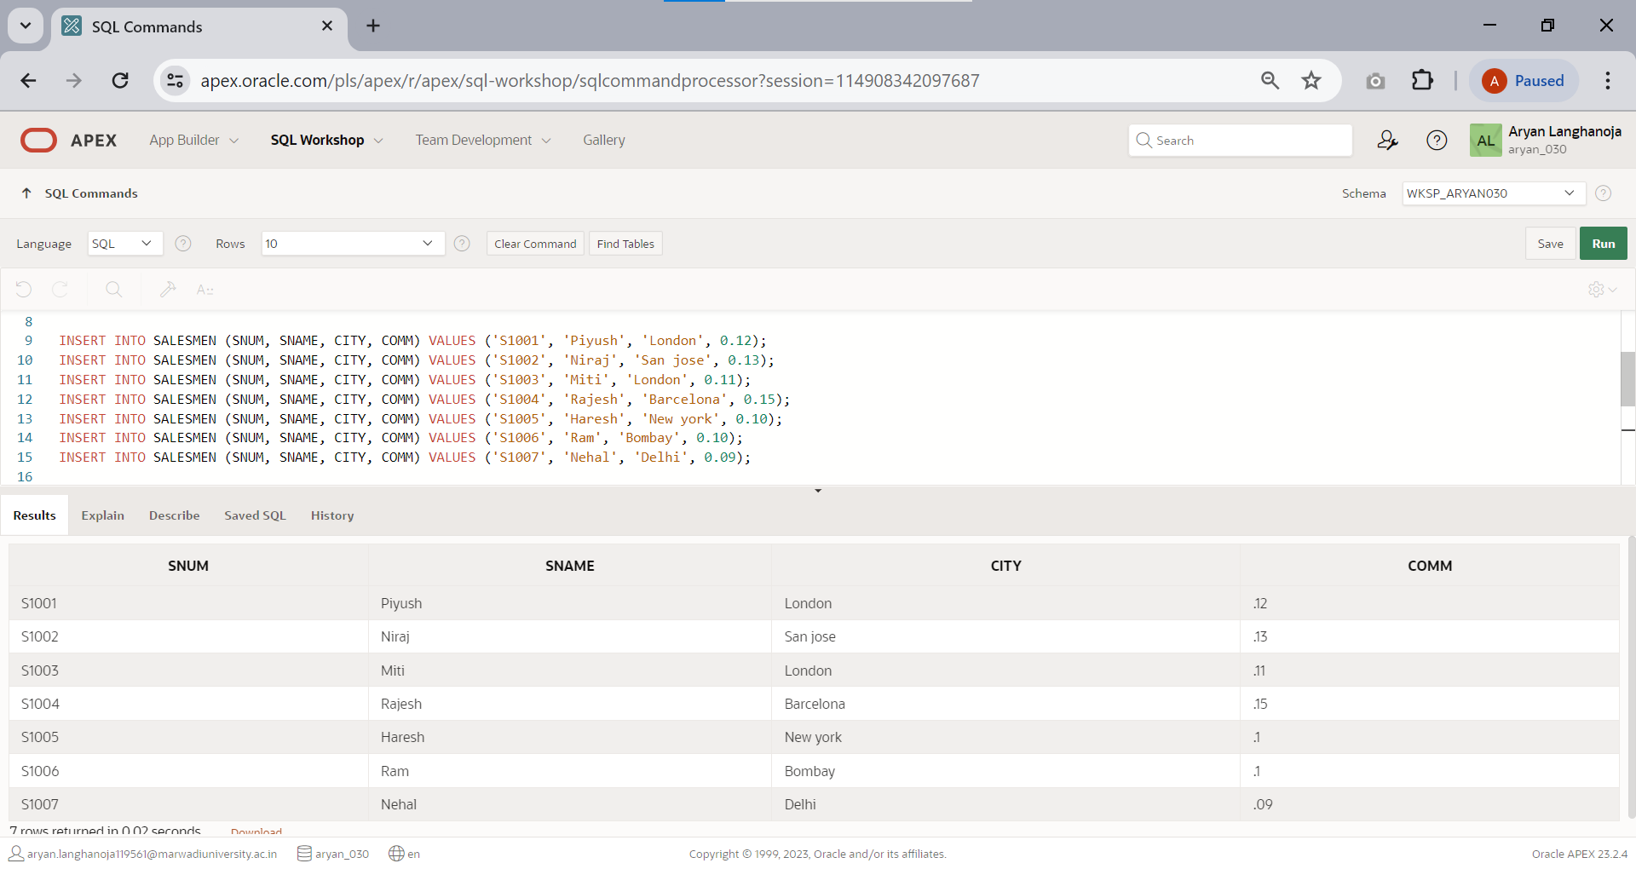

TABLE: **CUSTOMER**

|  |  |  |  |
| --- | --- | --- | --- |
| **Column Name** | **Data Type** | **Siz e** | **Attributes** |
| CNUM | Varchar2 | 6 | Primary key/first letter must start with  ‘C’ |
| CNAME | Varchar2 | 20 | Not null |
| CITY | Varchar2 | 15 |  |
| RATING | Number | 5 |  |
| SNUM | Varchar2 | 6 |  |

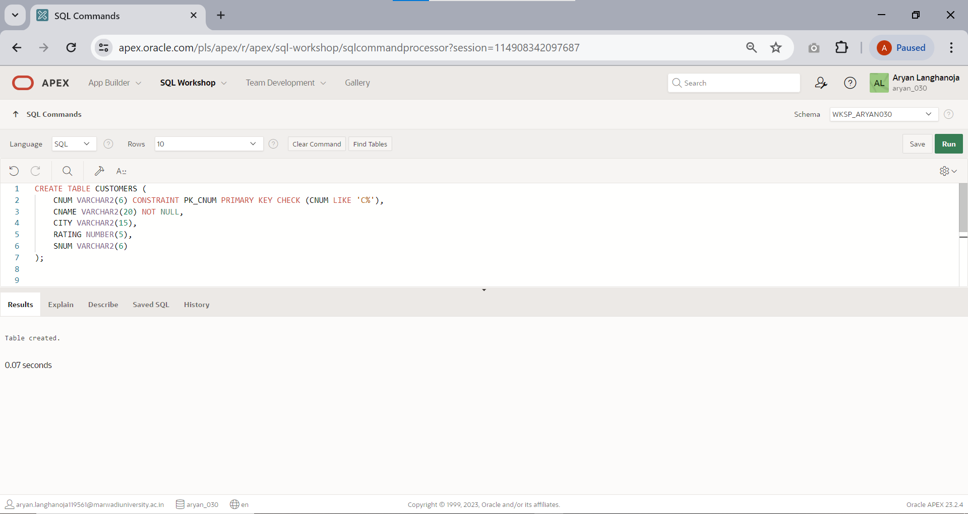

**Insert the following records**

|  |  |  |  |  |
| --- | --- | --- | --- | --- |
| **CNUM** | **CNAME** | **CITY** | **RATI NG** | **SNUM** |
| C2001 | Hardik | Londo n | 100 | S1001 |
| C2002 | Geeta | Rome | 200 | S1003 |
| C2003 | Kavish | San jose | 200 | S1002 |
| C2004 | Dhruv | Berlin | 300 | S1002 |
| C2005 | Pratham | Londo n | 100 | S1001 |
| C2006 | Vyomesh | San jose | 300 | S1007 |
| C2007 | Kirit | Rome | 100 | S1004 |

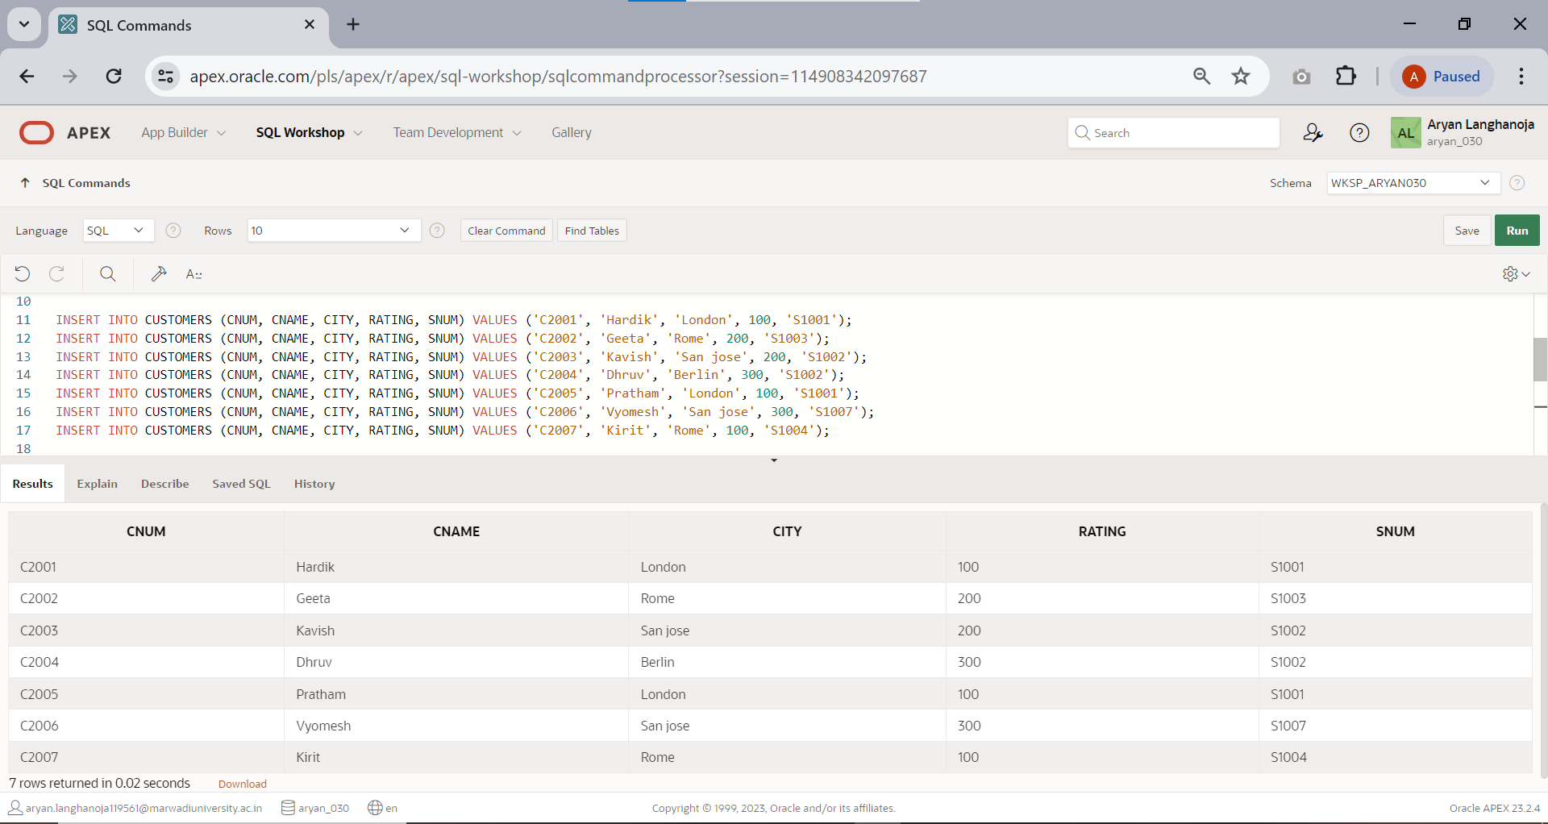

TABLE: **ORDER**

|  |  |  |  |
| --- | --- | --- | --- |
| **Colu mn Name** | **Data Type** | **S**  **i**  **z e** | **Attributes** |
| ONUM | Varcha  r2 | 6 | Primary key/first letter must start with ‘O’ |
| AMT | Numbe r | 1  0  ,  2 | Not null |
| ODATE | Date |  |  |
| CNUM | Varcha r2 | 6 |  |
| SNUM | Varcha  r2 | 6 |  |

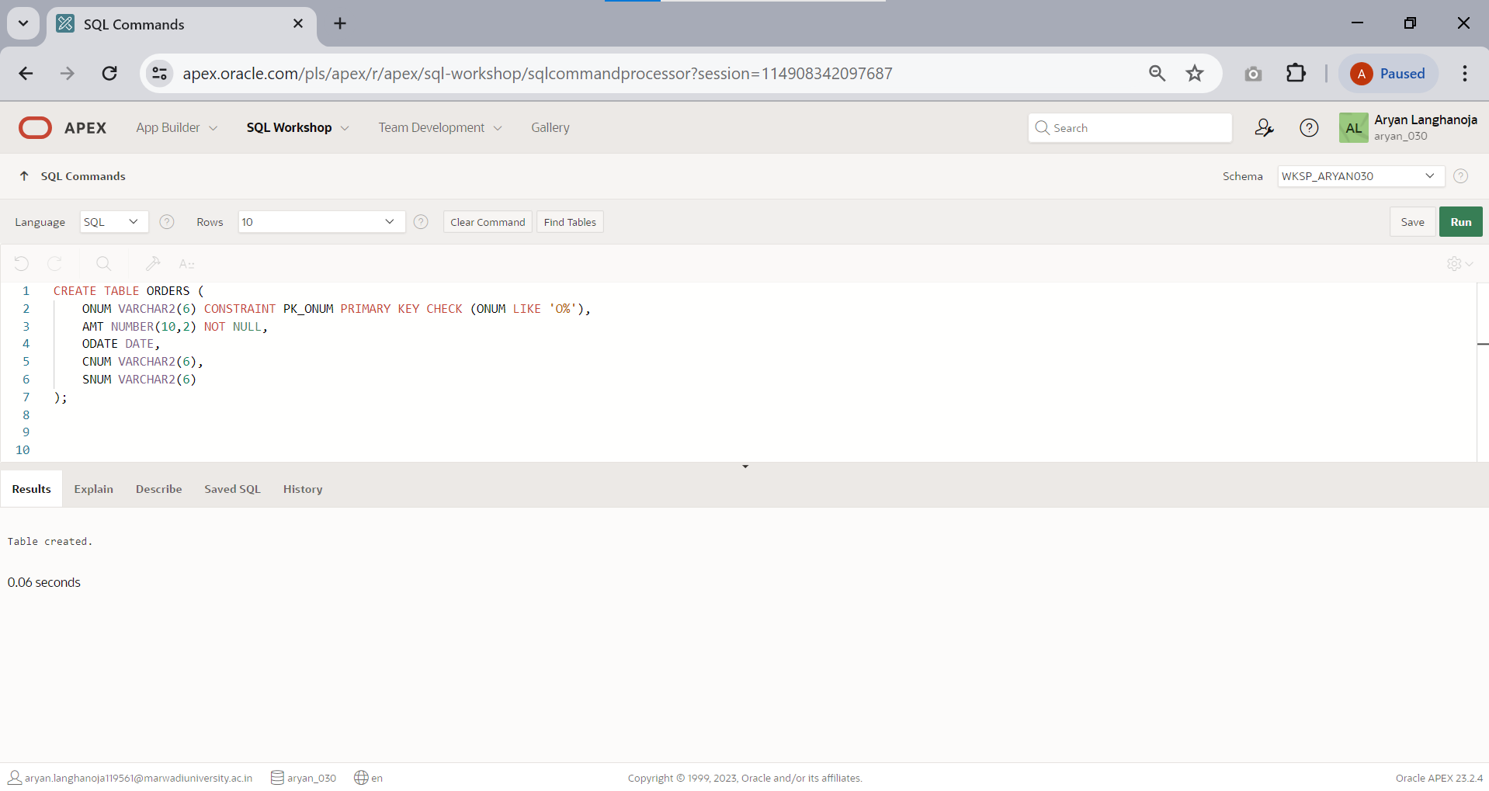

**Insert the following records**

|  |  |  |  |  |
| --- | --- | --- | --- | --- |
| **ONUM** | **AMT** | **ODATE** | **CNUM** | **SNUM** |
| O3001 | 18.69 | 10-Mar-90 | C2008 | S1007 |
| O3003 | 767.19 | 10-Mar-90 | C2001 | S1001 |
| O3002 | 1900.1  0 | 03-Oct-90 | C2007 | S1004 |
| O3005 | 5160.45 | 04-Oct-90 | C2003 | S1002 |
| O3006 | 1098.1  6 | 10-Mar_90 | C2008 | S1007 |
| O3009 | 1713.2  3 | 10-April-90 | C2002 | S1003 |
| O3007 | 75.75 | 10-April-90 | C2004 | S1002 |
| O3008 | 4723.0  0 | 10-May-90 | C2006 | S1001 |
| O3010 | 1309.9  5 | 10-May-90 | C2004 | S1002 |
| O3011 | 9891.8  8 | 10-June-90 | C2006 | S1001 |

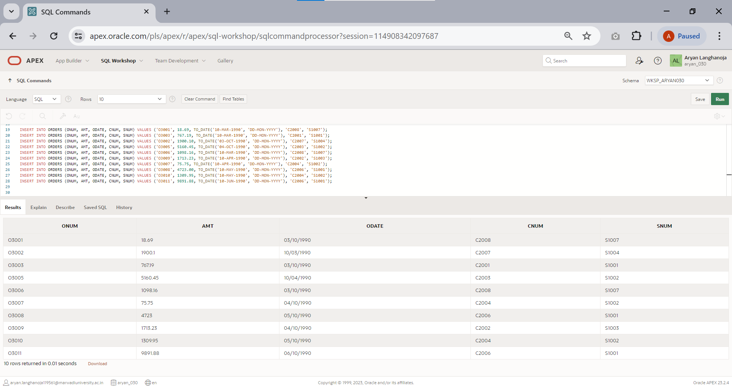

## Perform following queries.

### SELECT

1. 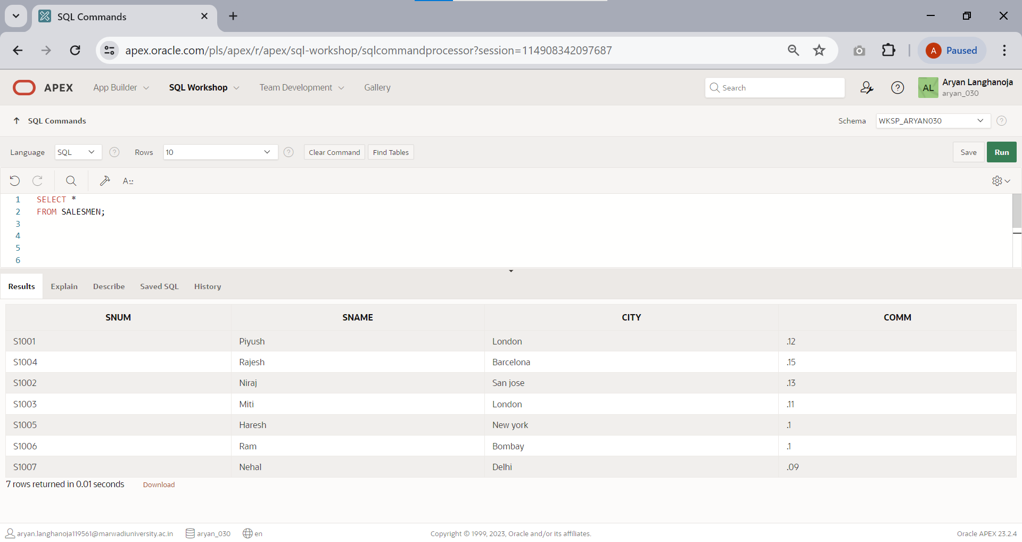Display all the information of salesmen.
2. Display snum,sname,city from salesmen table.

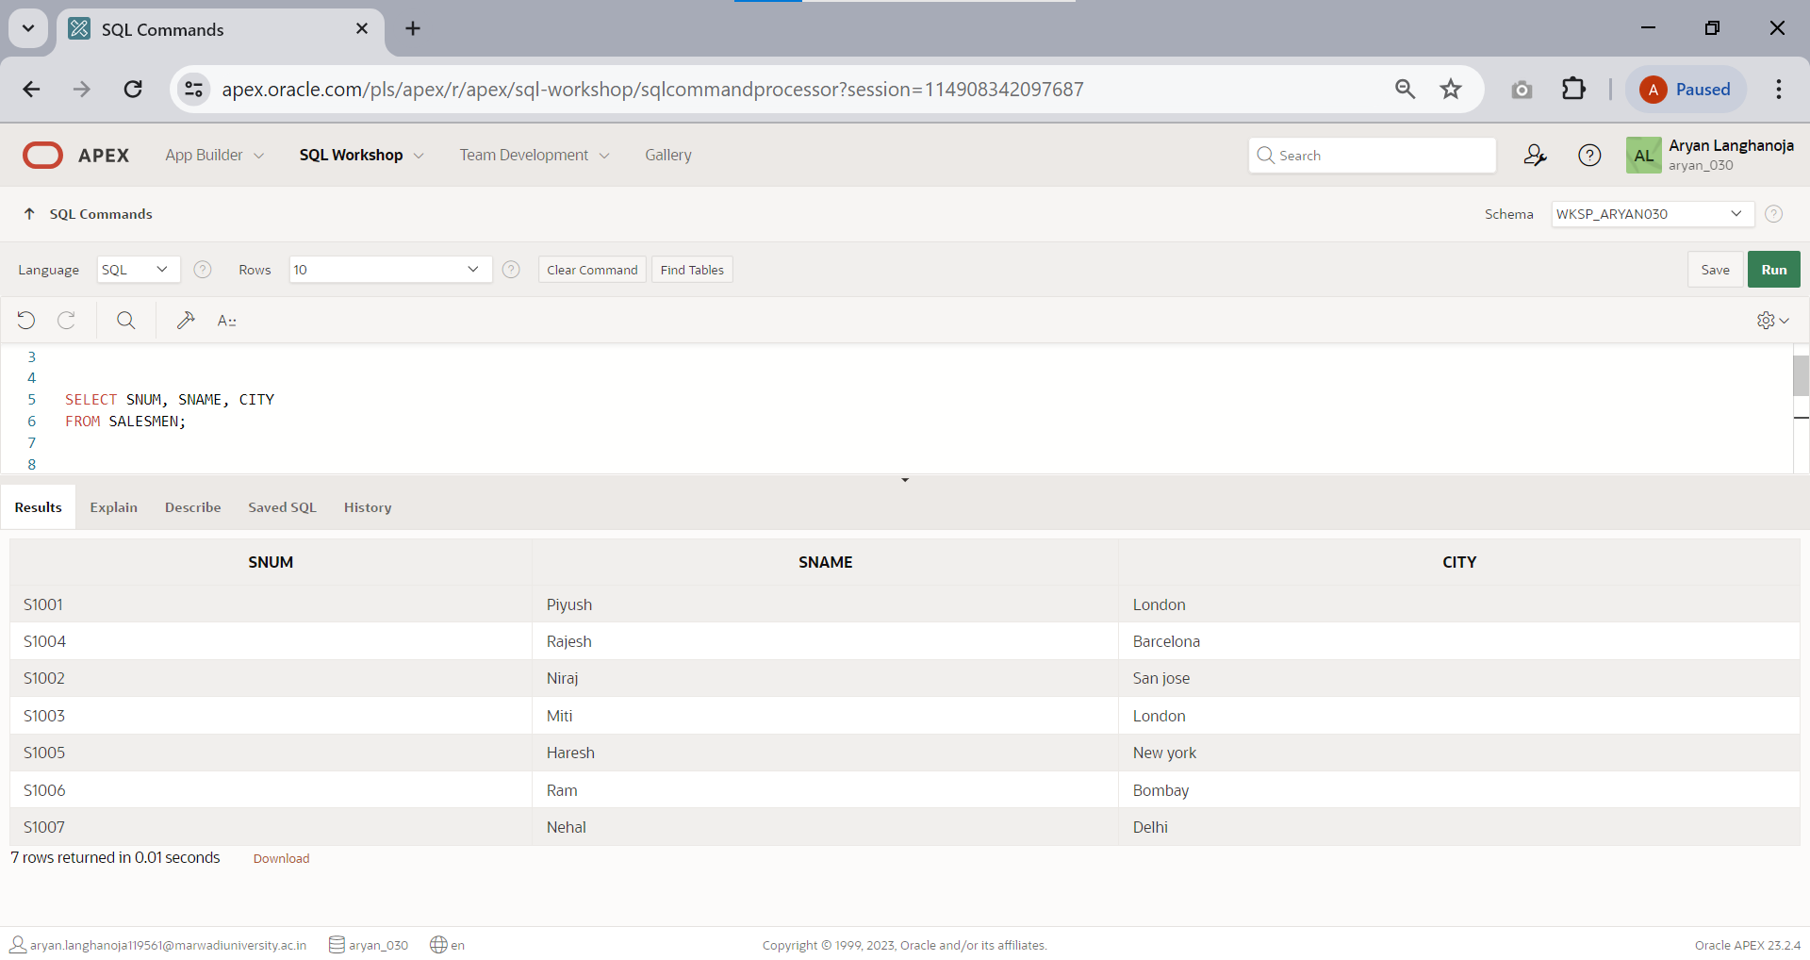

1. 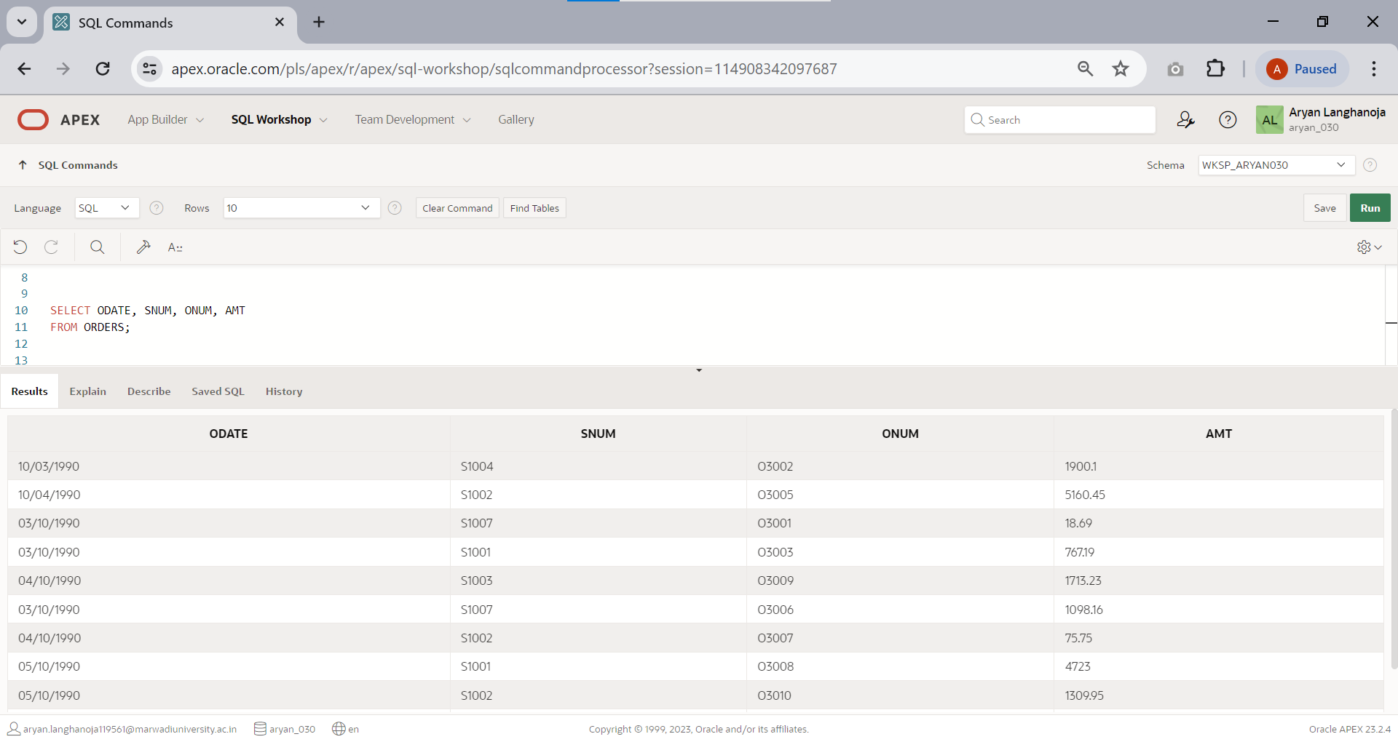Display odate,snum,onum and amt from orders.
2. Display the information of orders without duplication.

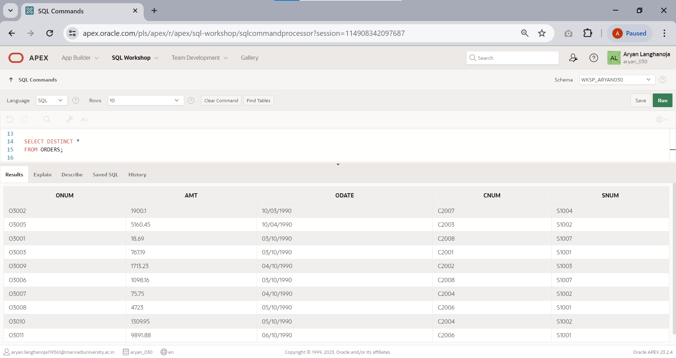

1. 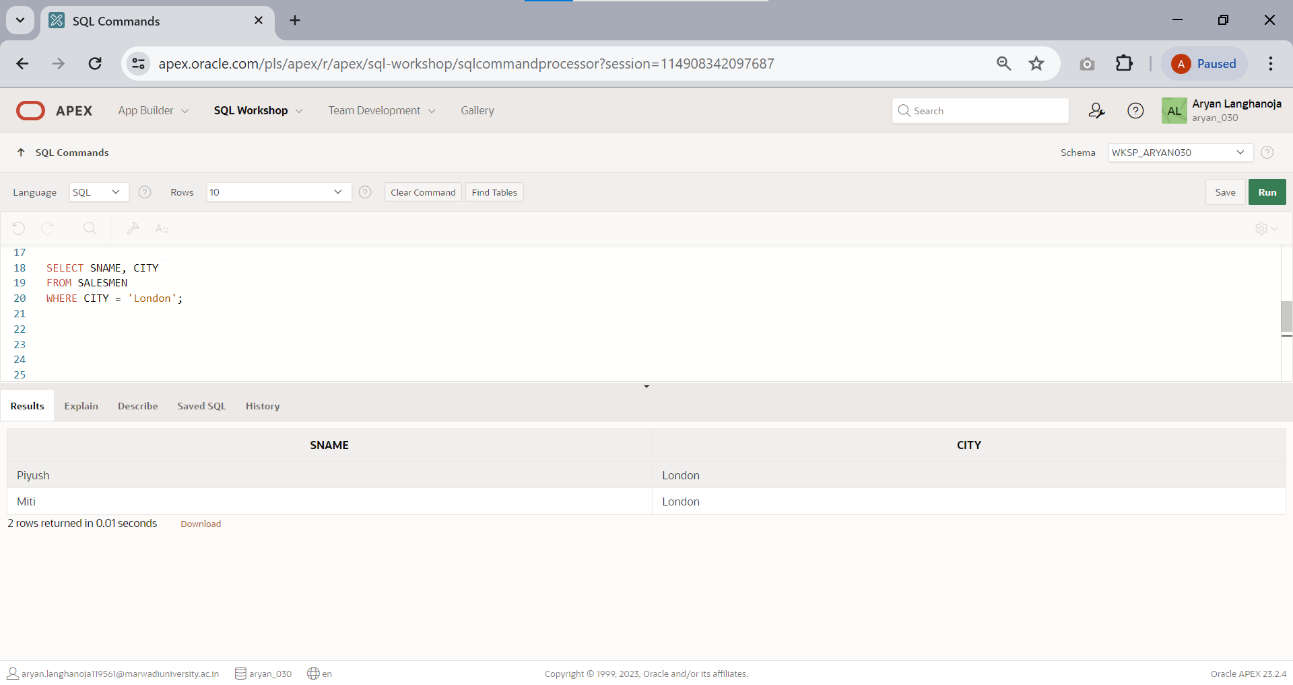List of sname, city from salesmen where city is ‘LONDON’.
2. List all records of customers where rating is equal to 100.

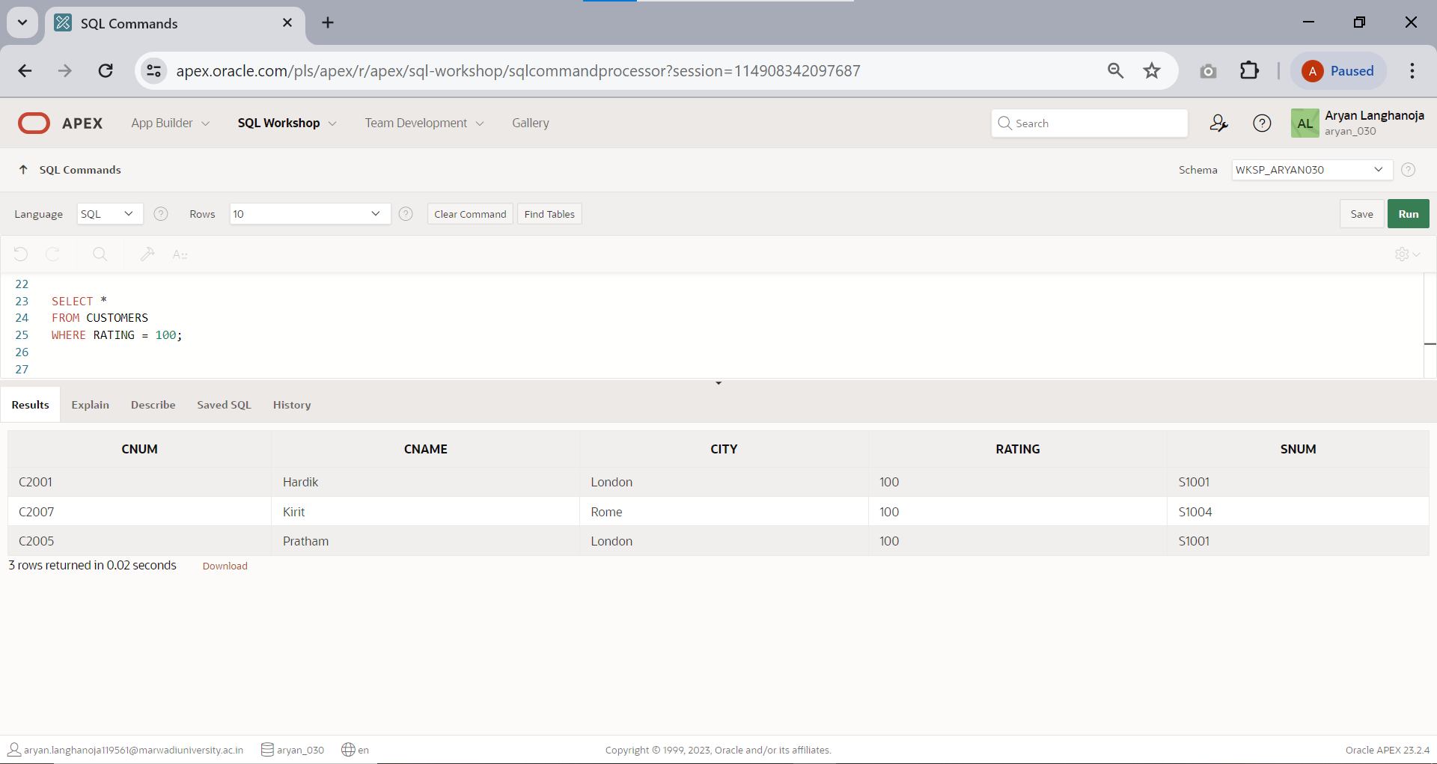

1. 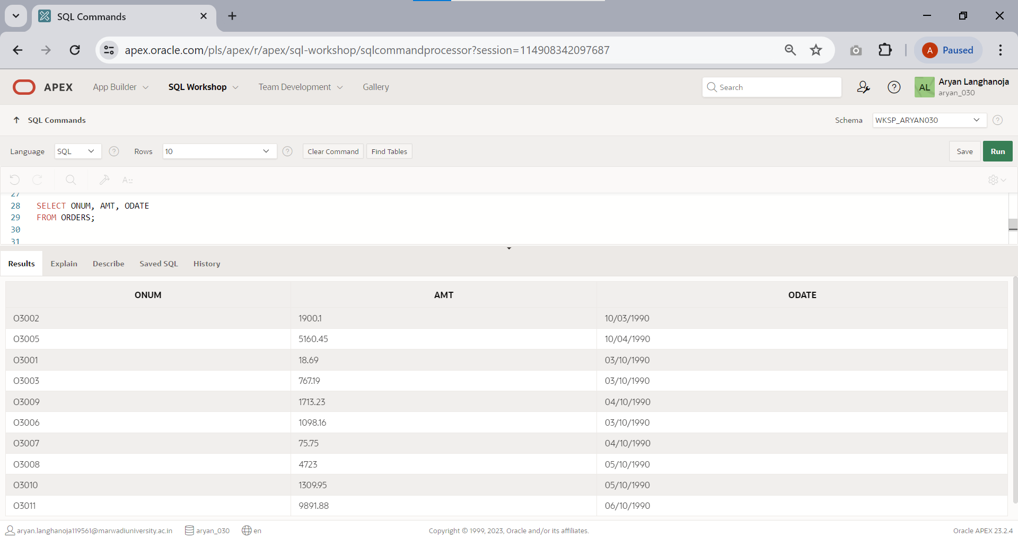Write a select command that produces the order number,amount and date for all rows in the order table.
2. 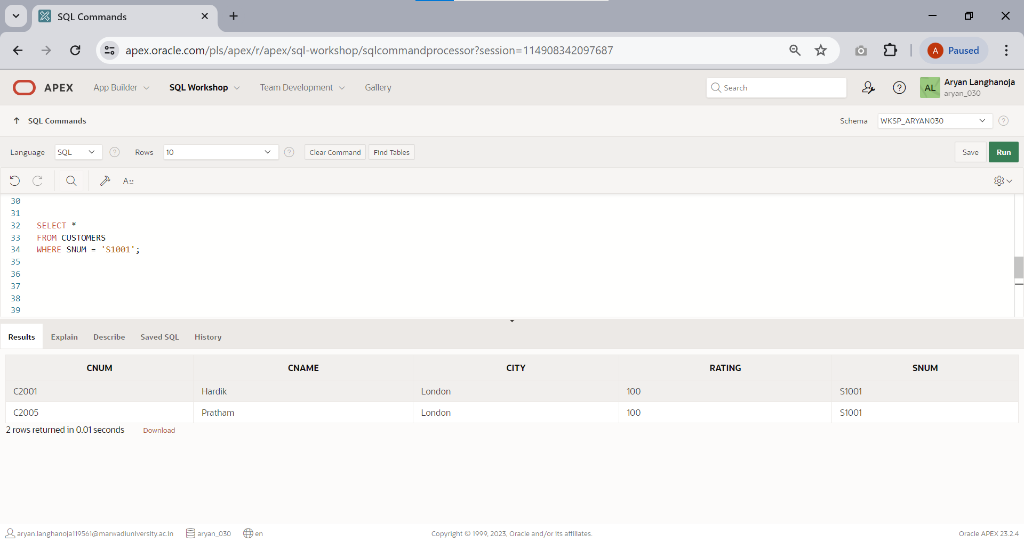Produces all rows from the customer table for which the salesperson’s number is S1001.
3. 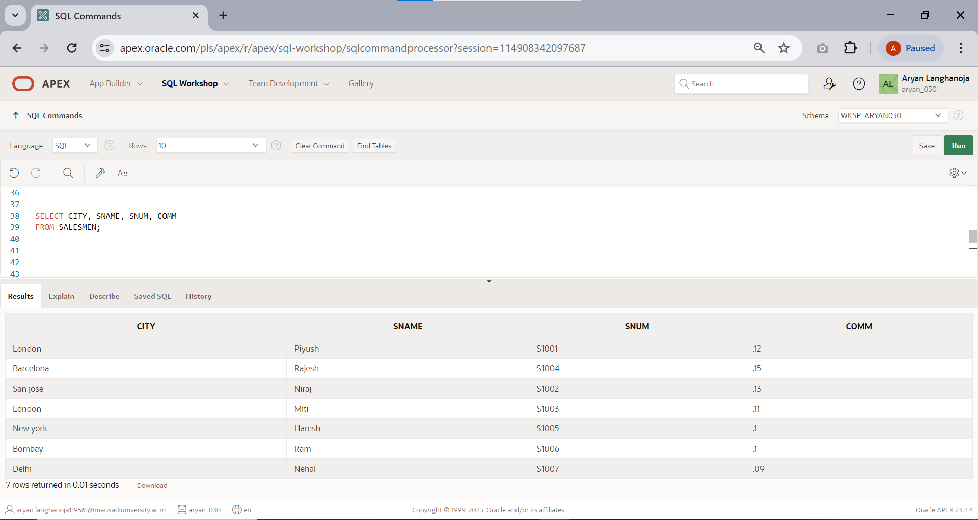Display the salesperson table with the columnin the following order: city,sname,snum,comm.
4. 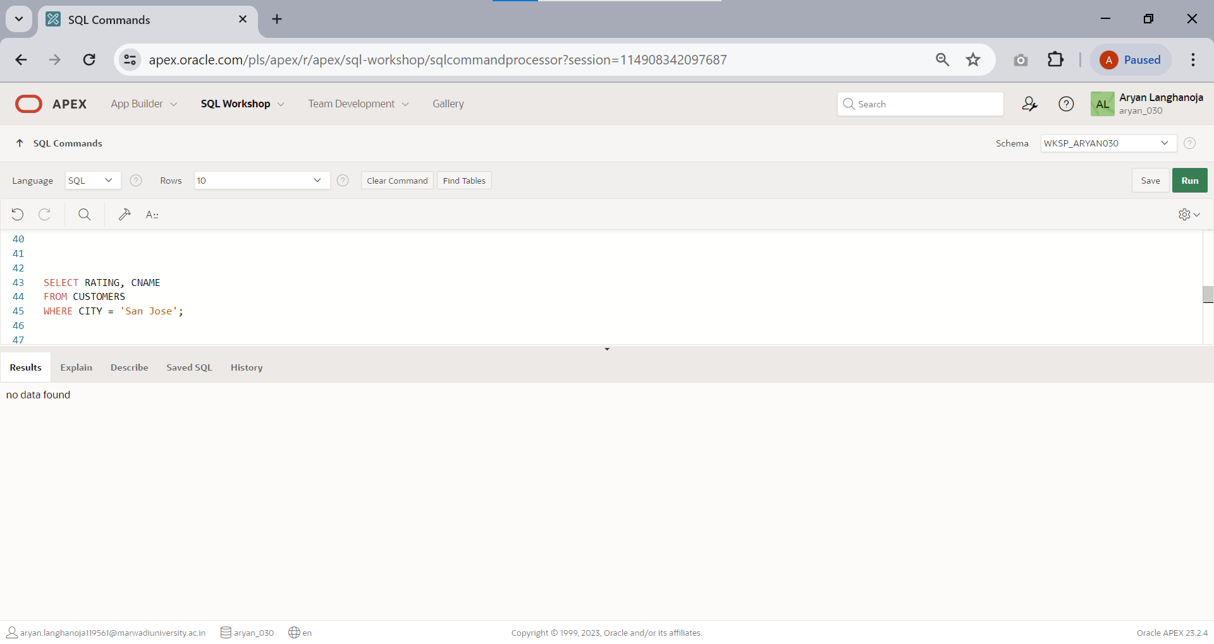Write a select command that produces the rating followed by the name of each customer in SAN JOSE.
5. Display SNUM values of all salesmen without any repeat.

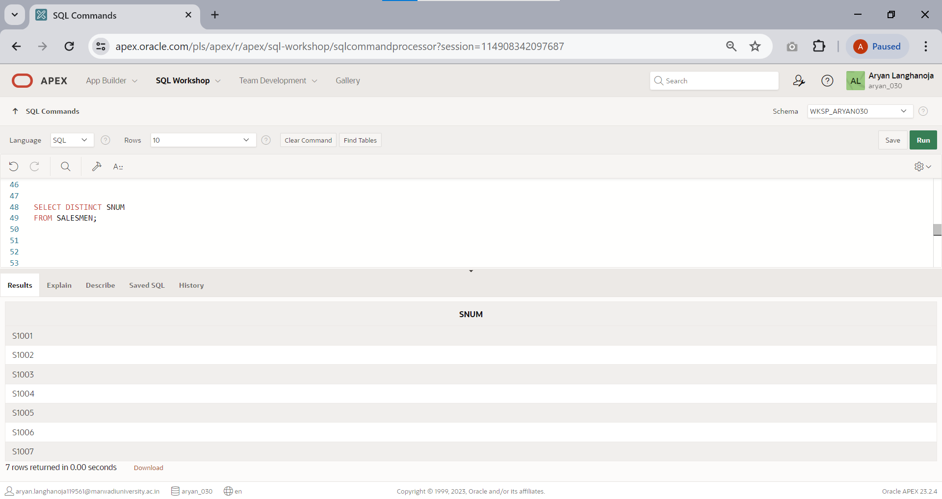

# Practical 9

## Aim: Range Function and Operator based Queries

Perform following queries on the above generated tables.

## OPERATORS

1. 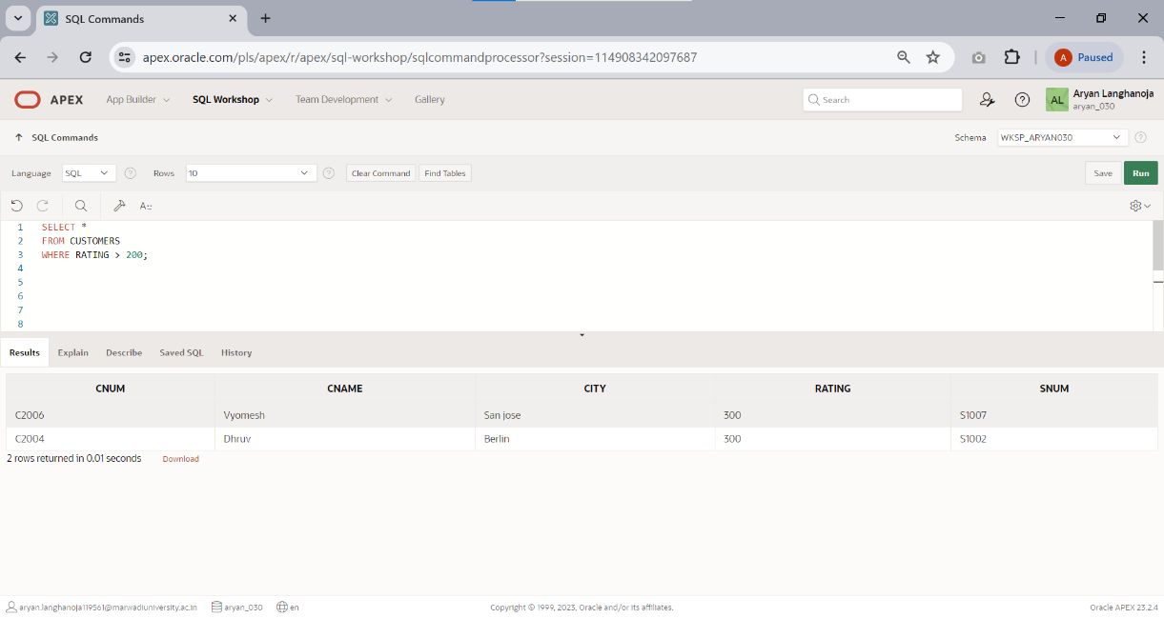List all customers with a rating above 200.
2. List all customers in SAN JOSE who have a rating above 200.

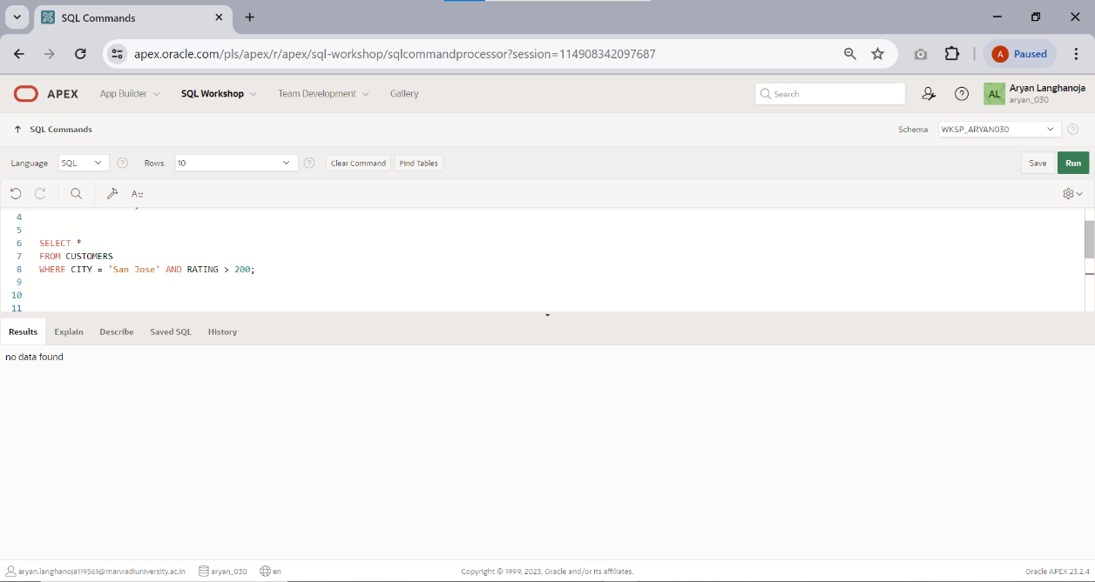

1. 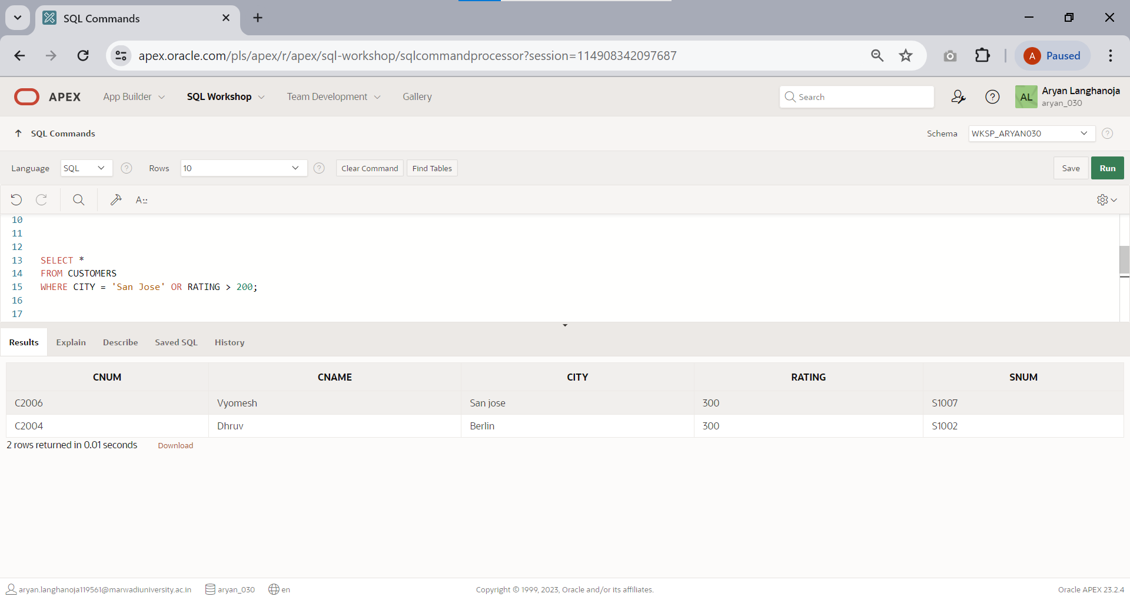List all customers who were either located in SAN JOSE or had a rating above 200.
2. 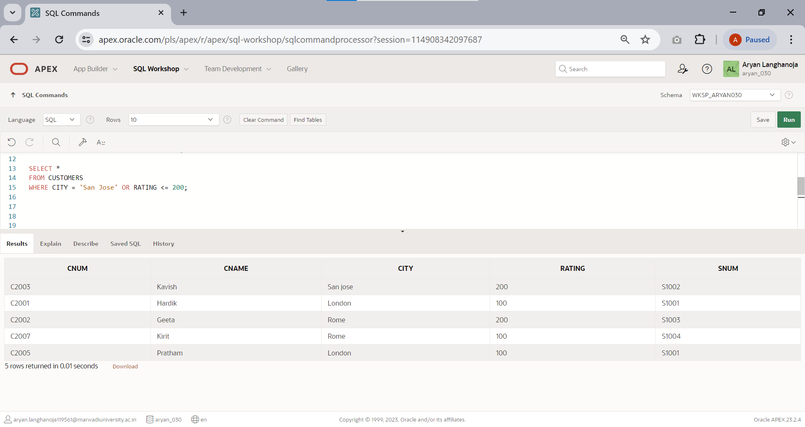List of all customers who were either located in SAN JOSE or not rating above 200.
3. 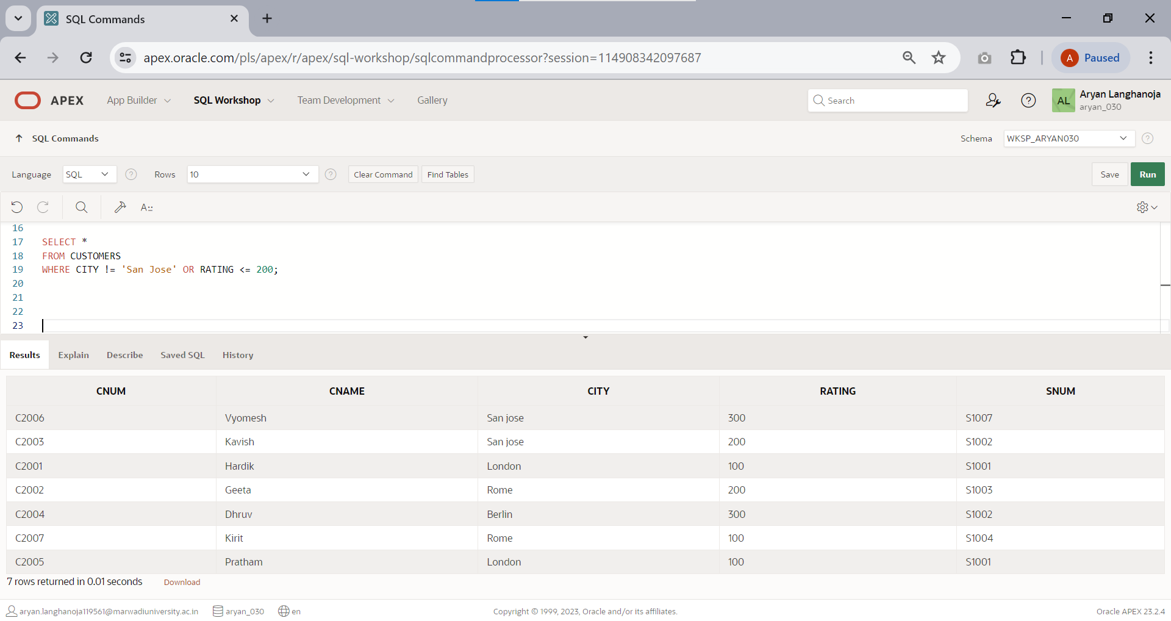List of all customers who were not located in SAN JOSE or rating is not above 200.
4. Write a query that will give you all orders for more than $1000.

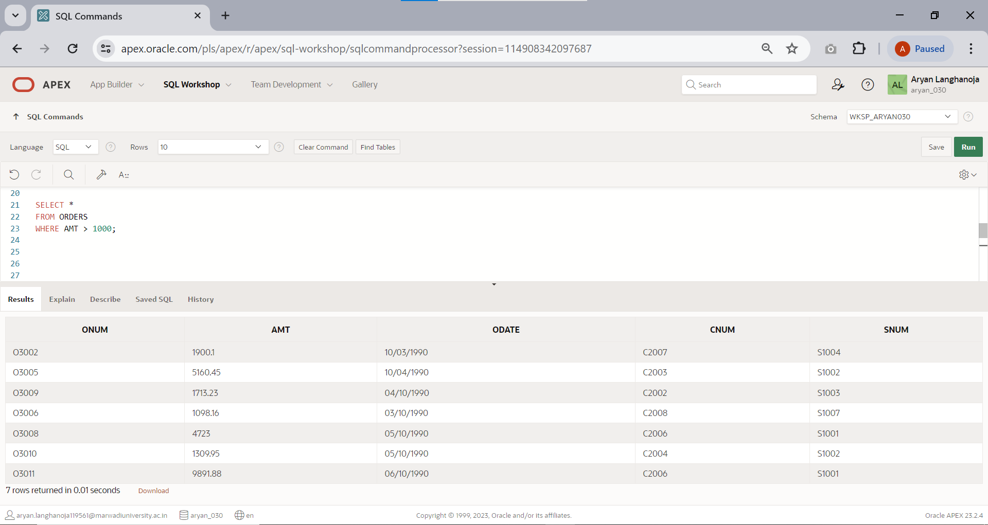

1. 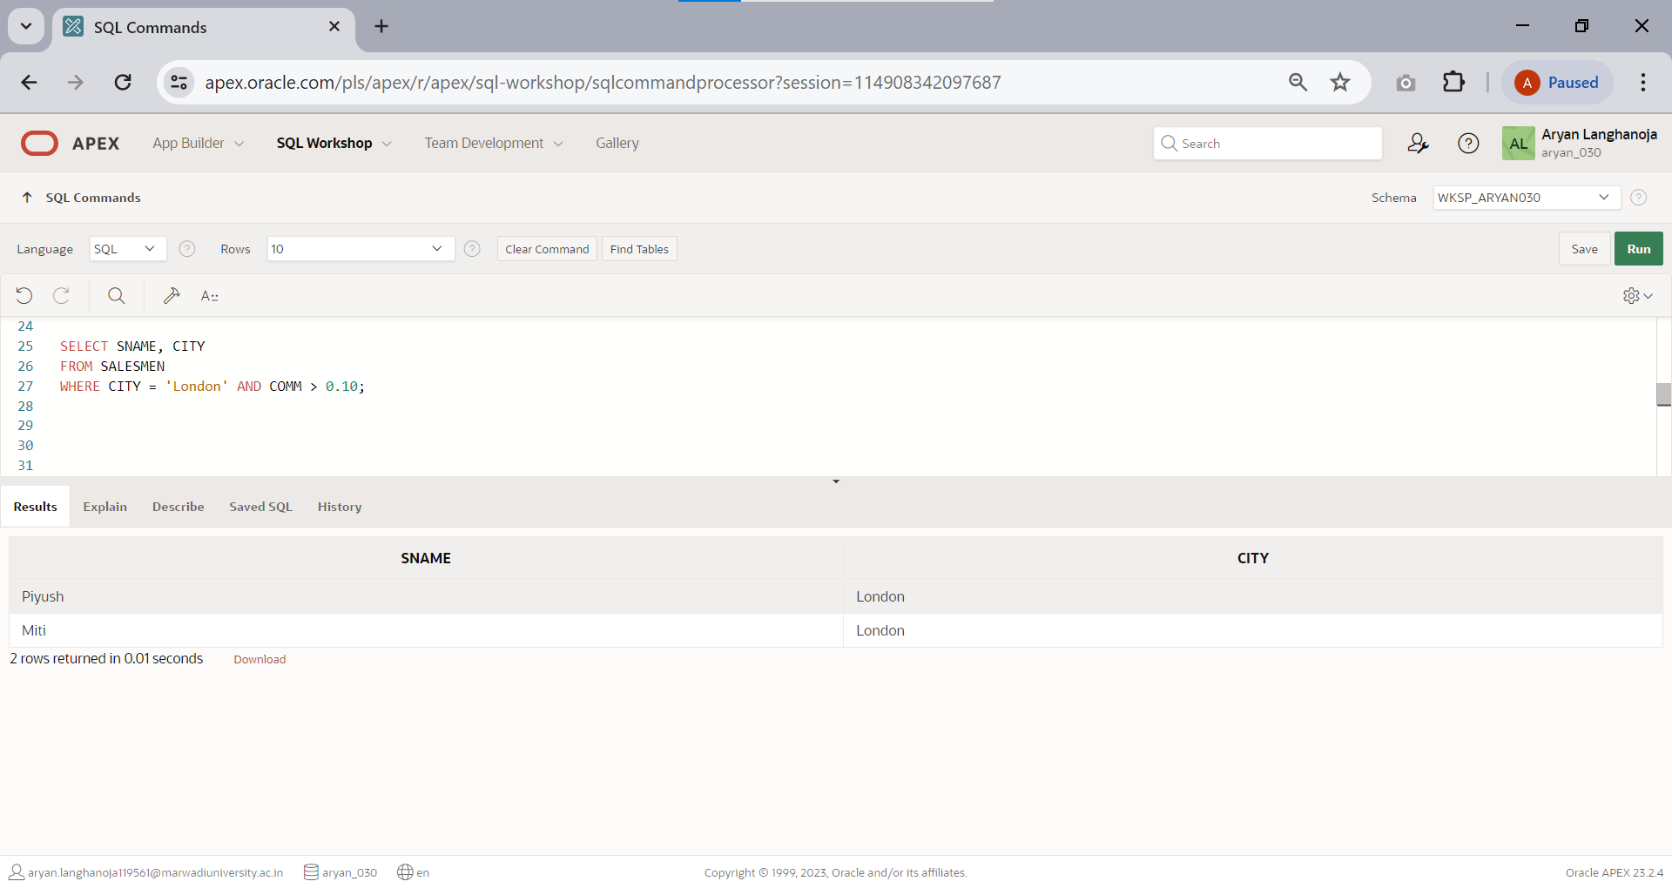Write a query that will give you the names and cities of all salesmen in LONDON with a commission above 0.10.
2. Write a query on the customers table whose output will exclude all customers with a rating

<= 100 and they are located in ROME.

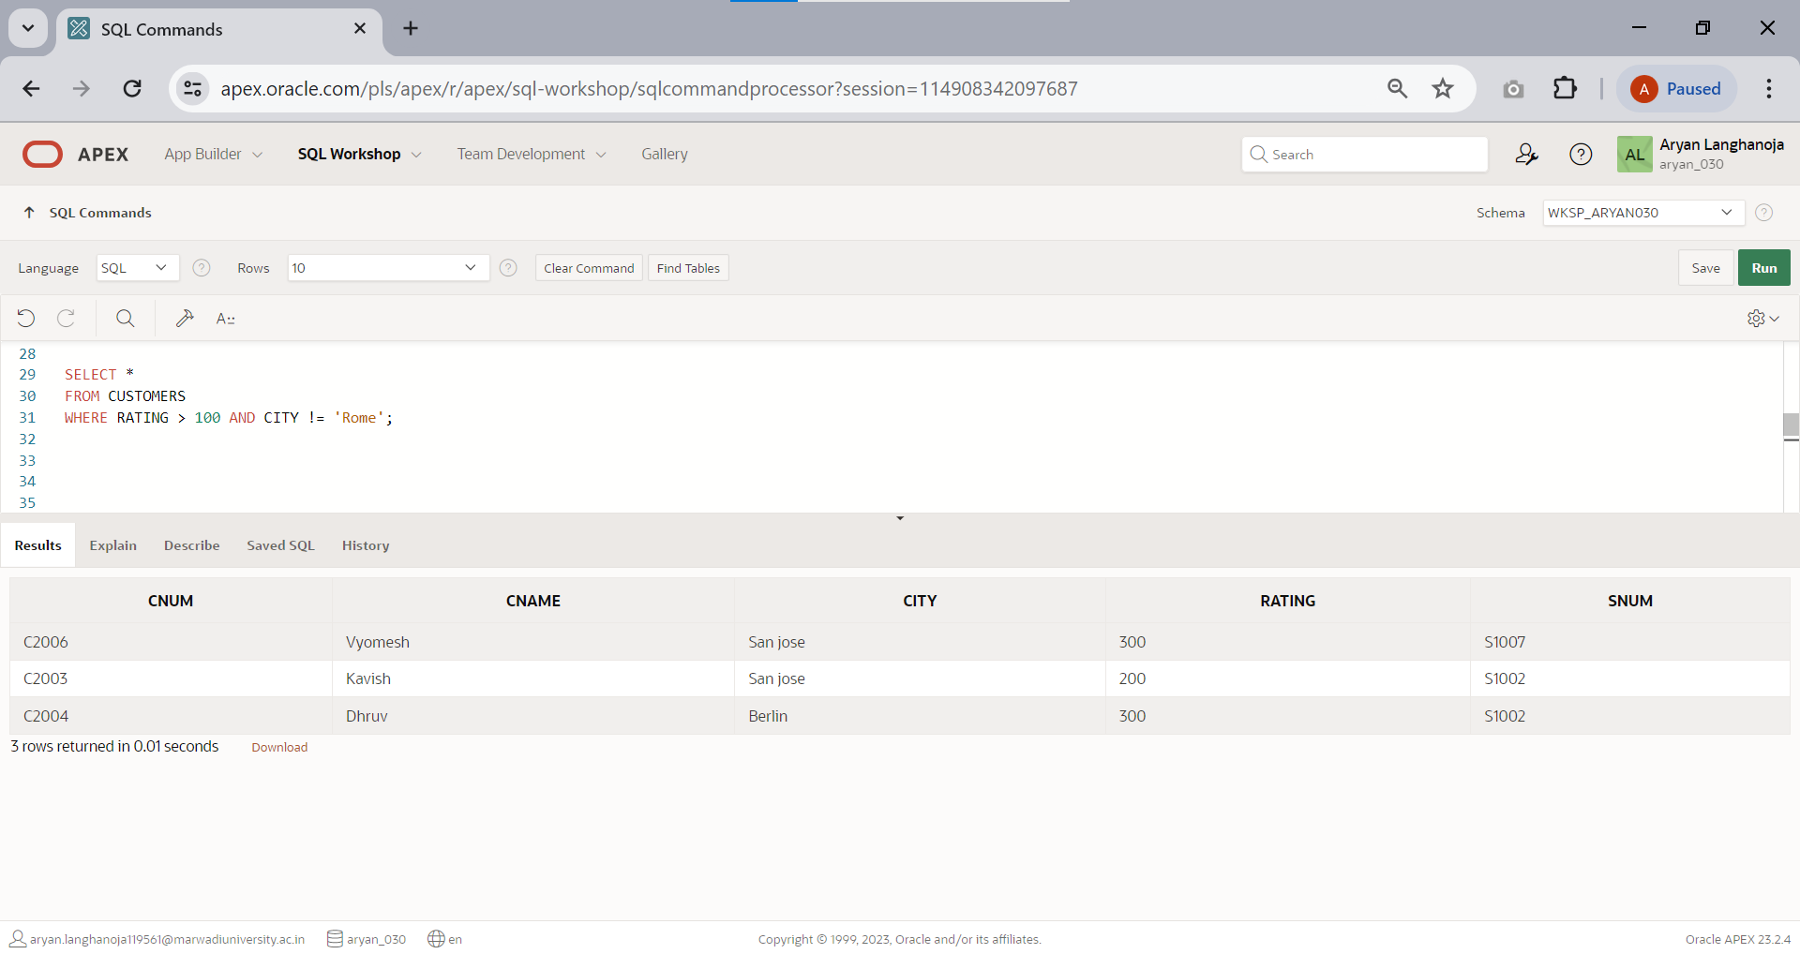

### SPECIAL OPERATORS

1. 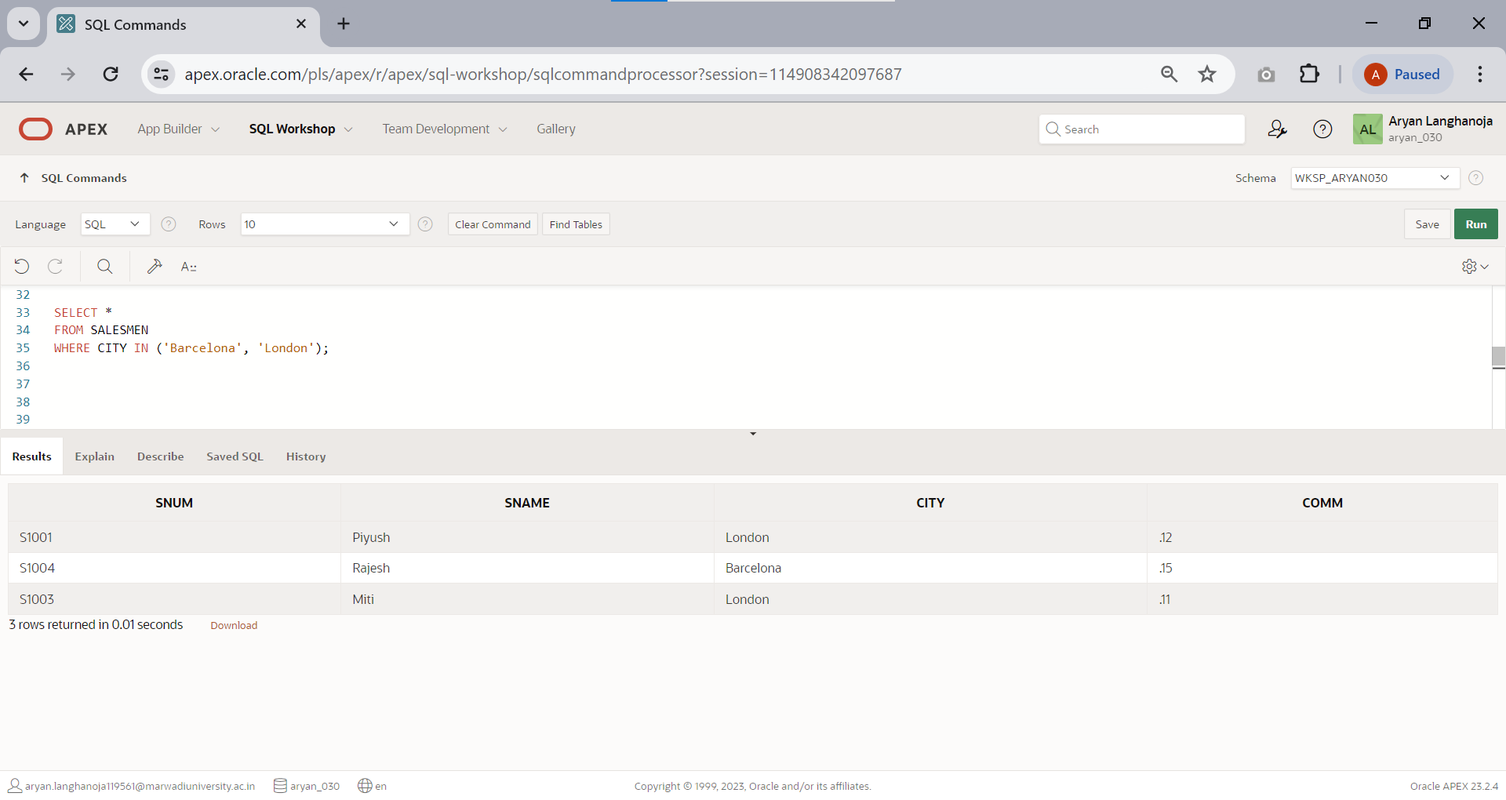Display all salesmen that were located in either BARCELONA or LONDON(use IN keyword).
2. 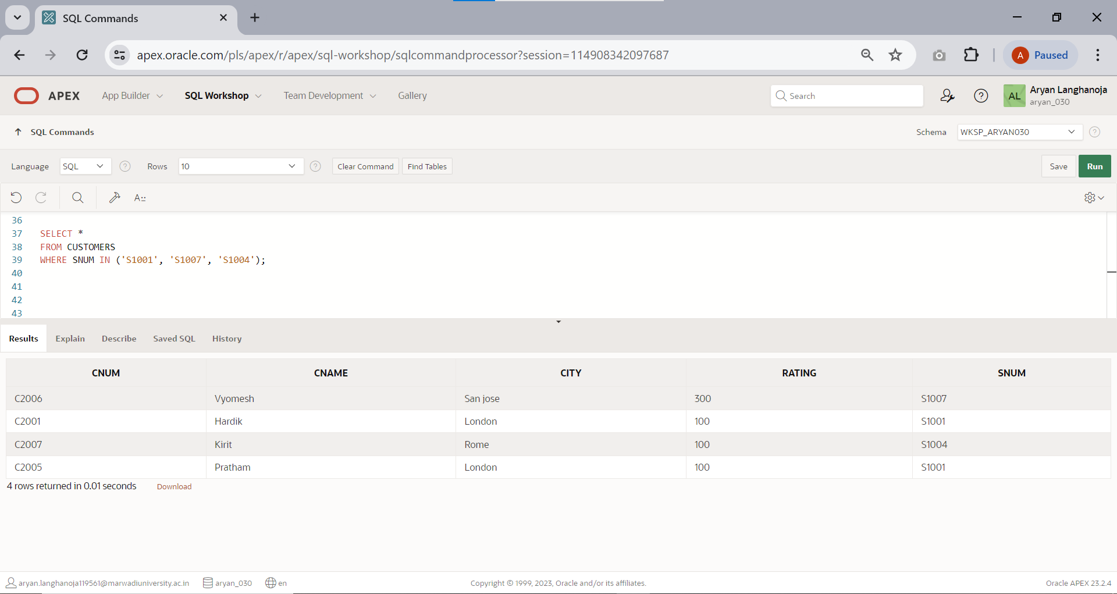Find all customers matched with salesmen S1001,S1007 and S1004.
3. Display all salesmen with commission between 0.10 and 0.12.

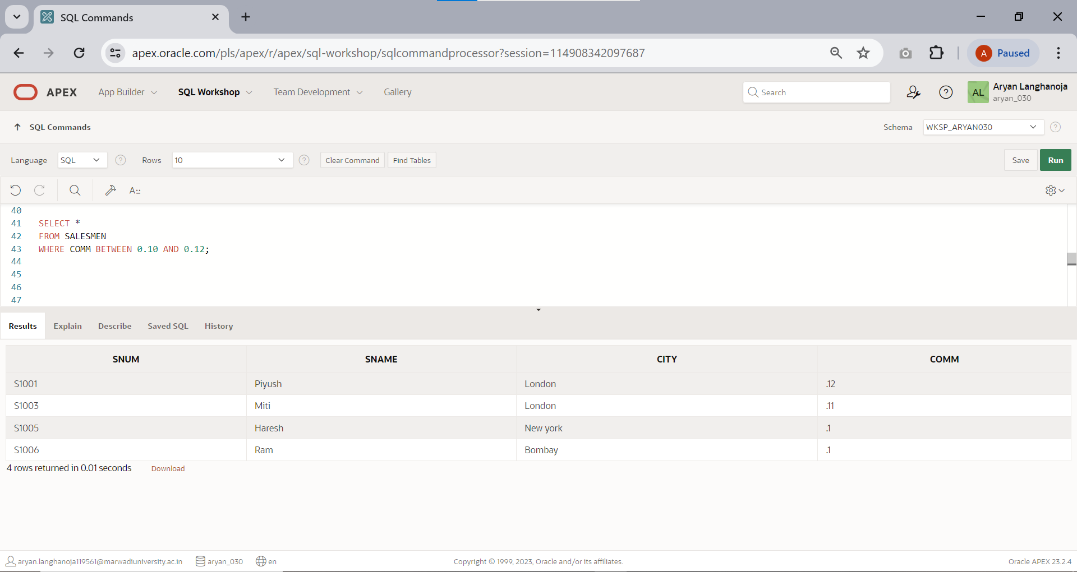

1. 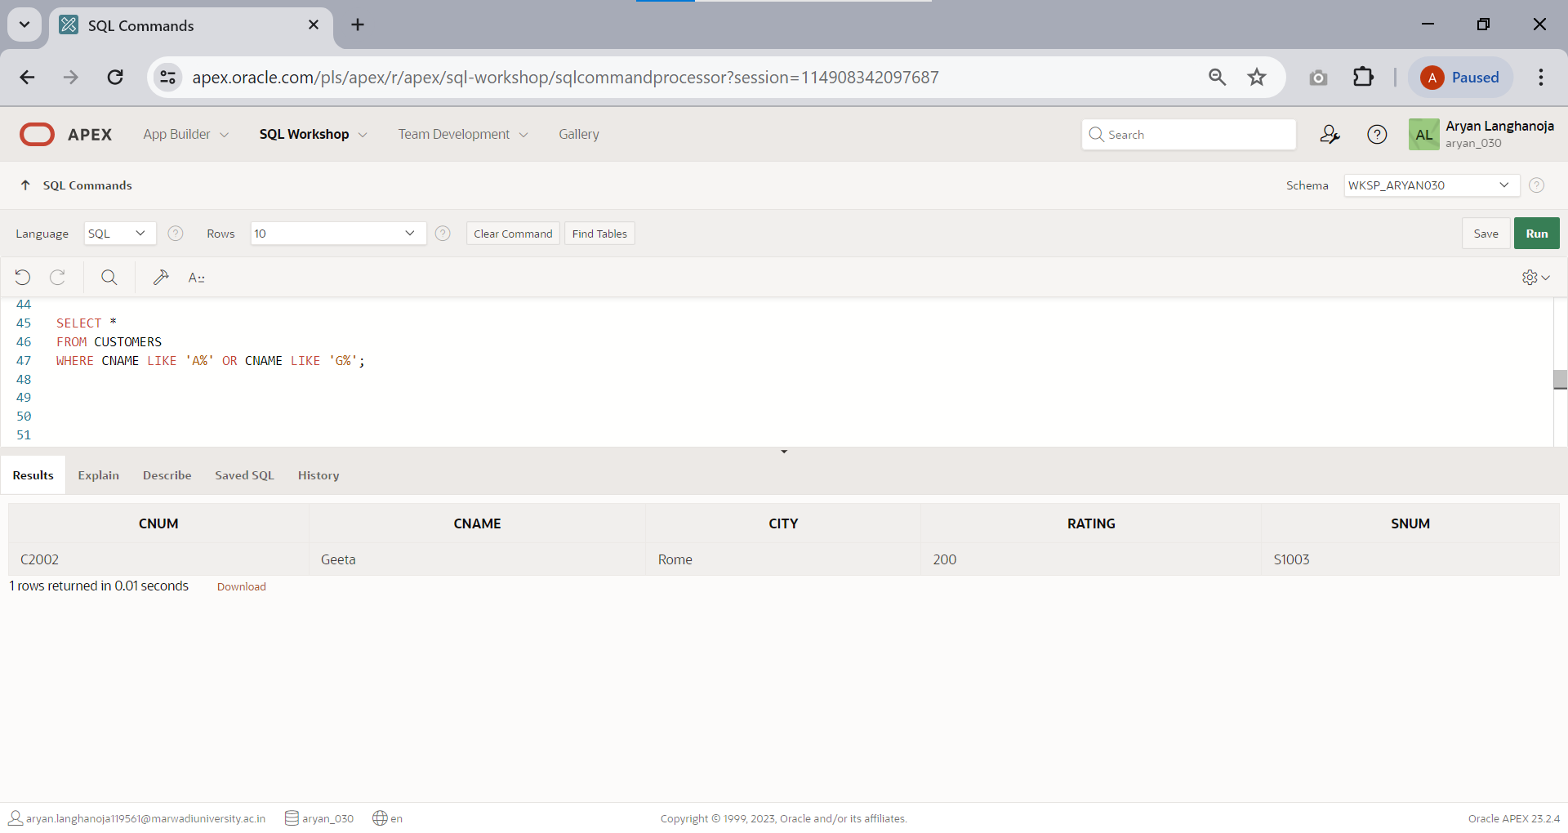Select all customers whose names fall in a ‘A’ and ‘G’ alphabetical.

### LIKE OPERATORS.

1. 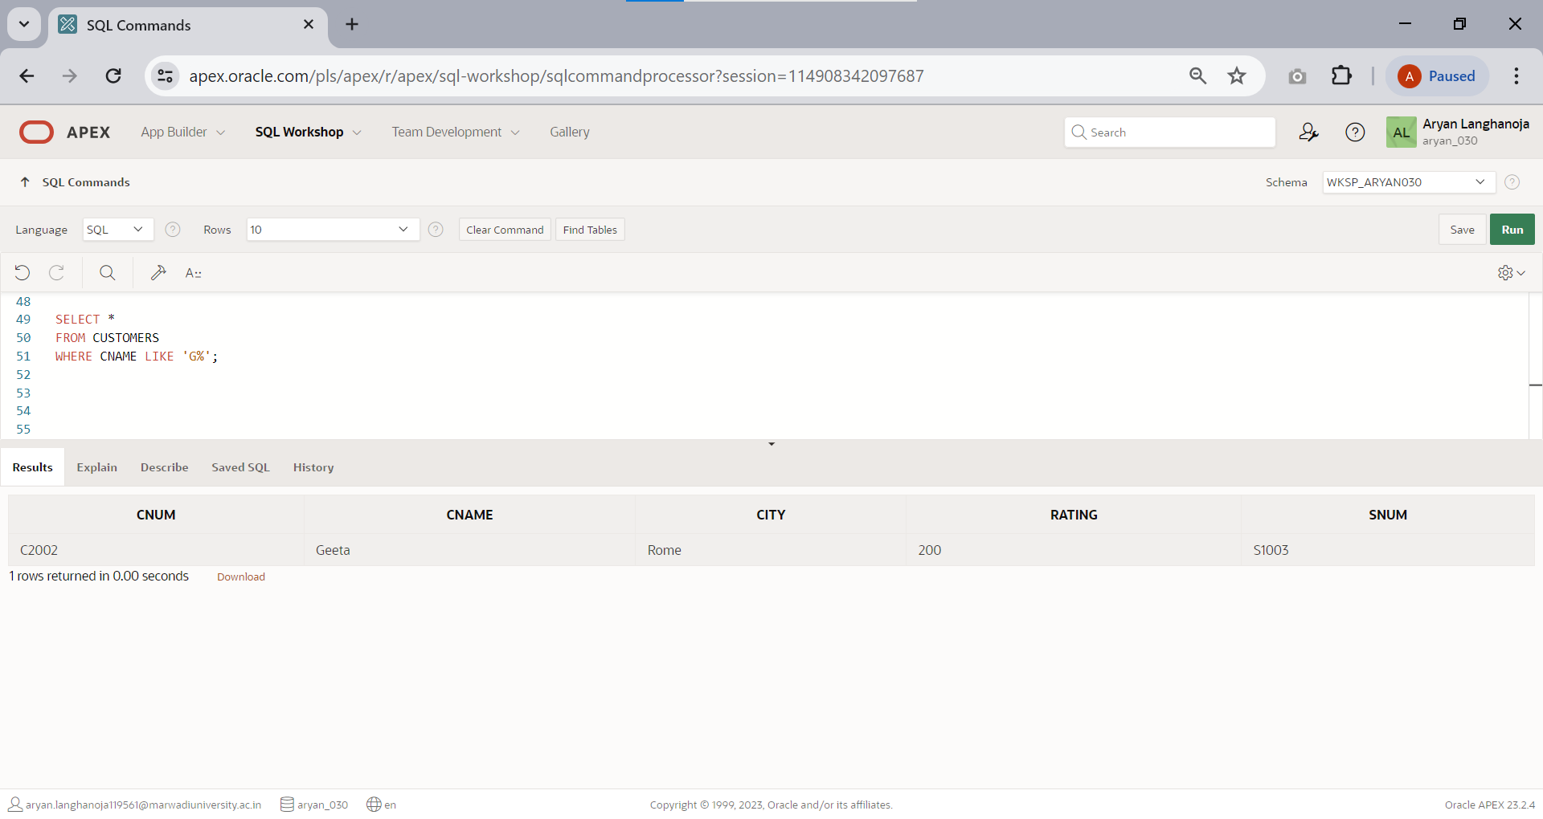List all the customers whose names begin with ‘G’.
2. 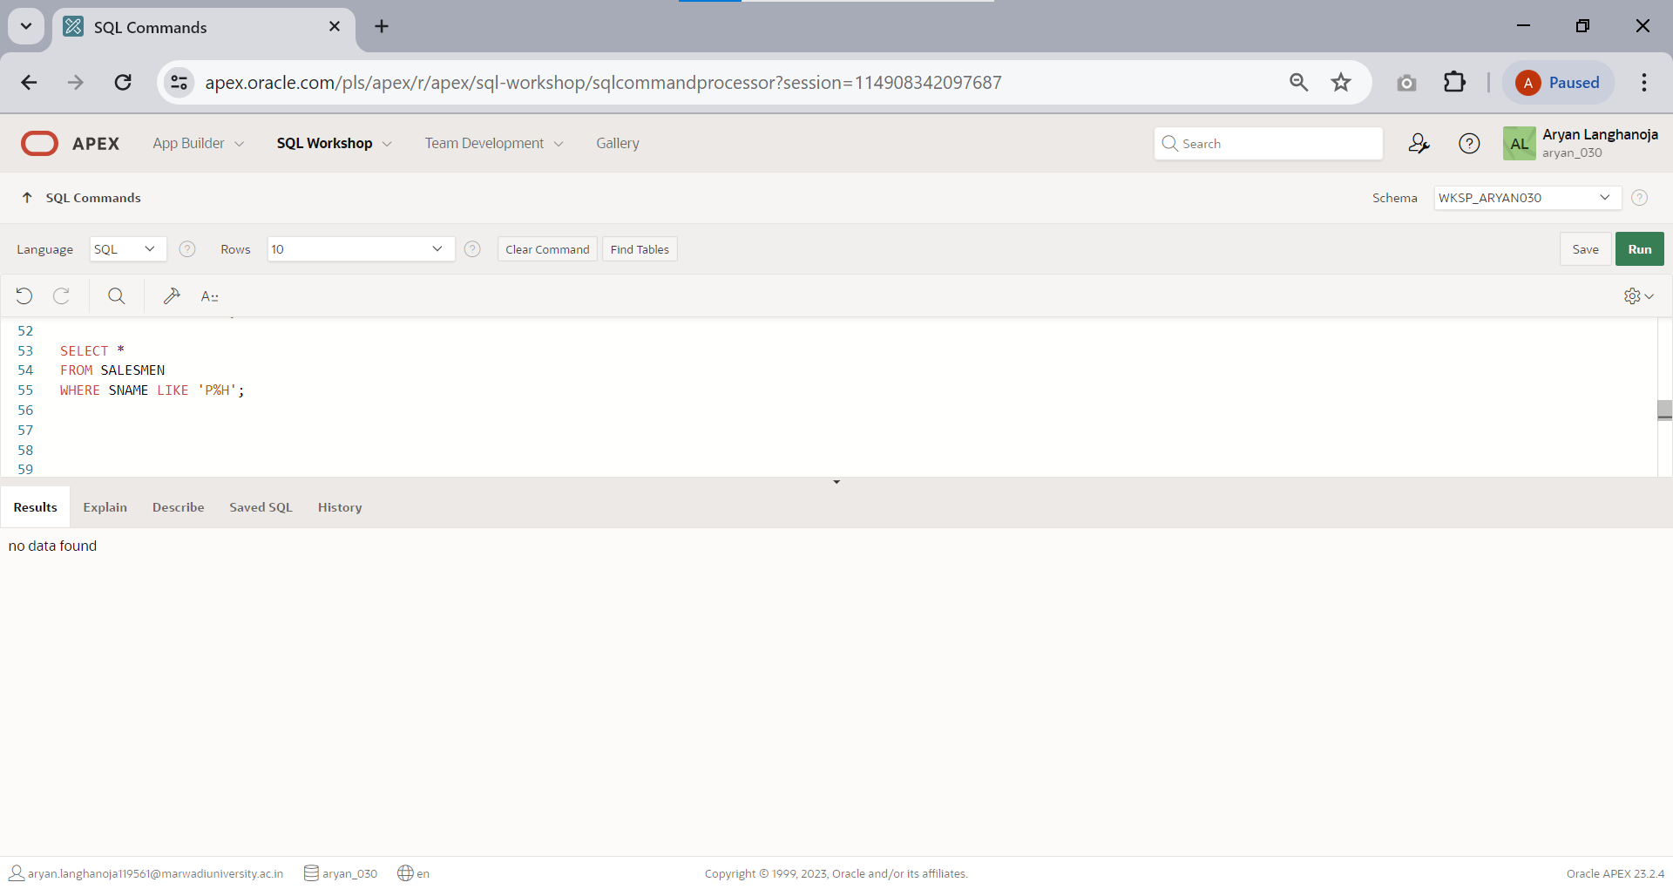List all salesmen whose sname start with letter ‘P’ and end letter is ‘H’.

### NULL OPERATORS

1. 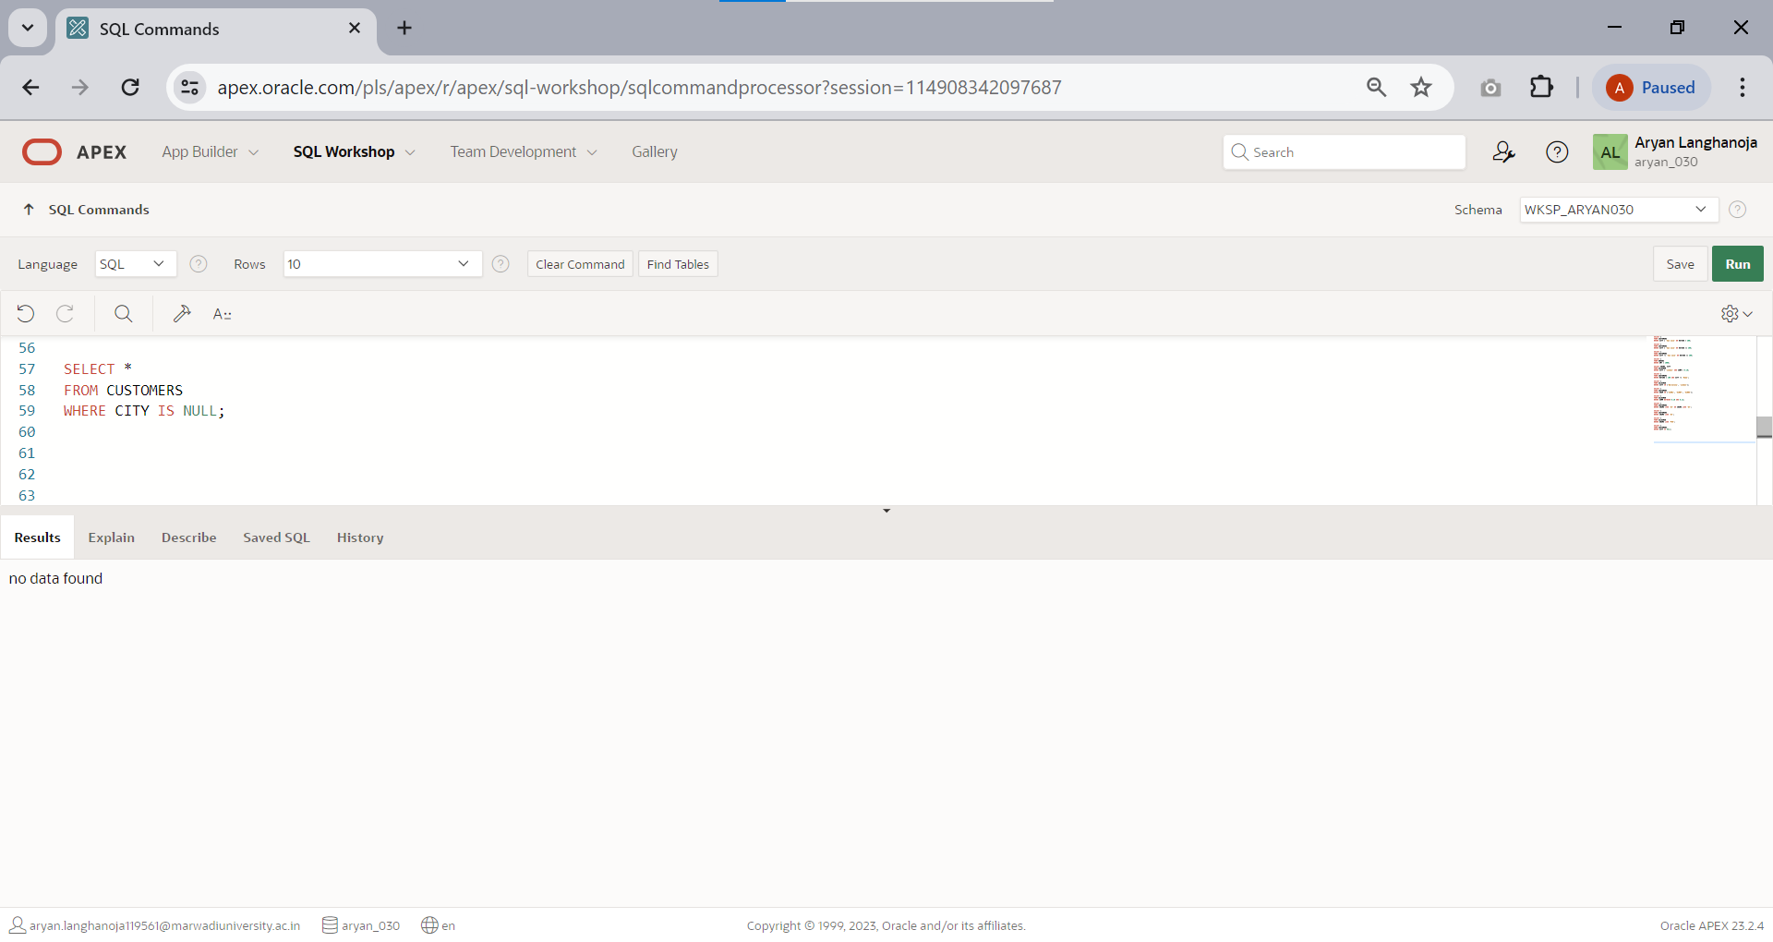Find all records in customer table with NULL values in the city column.
2. Write a two queries that will produce all orders taken on October 3rd or 4th ,1990 ( use IN operator and Use BETWEEN operator )

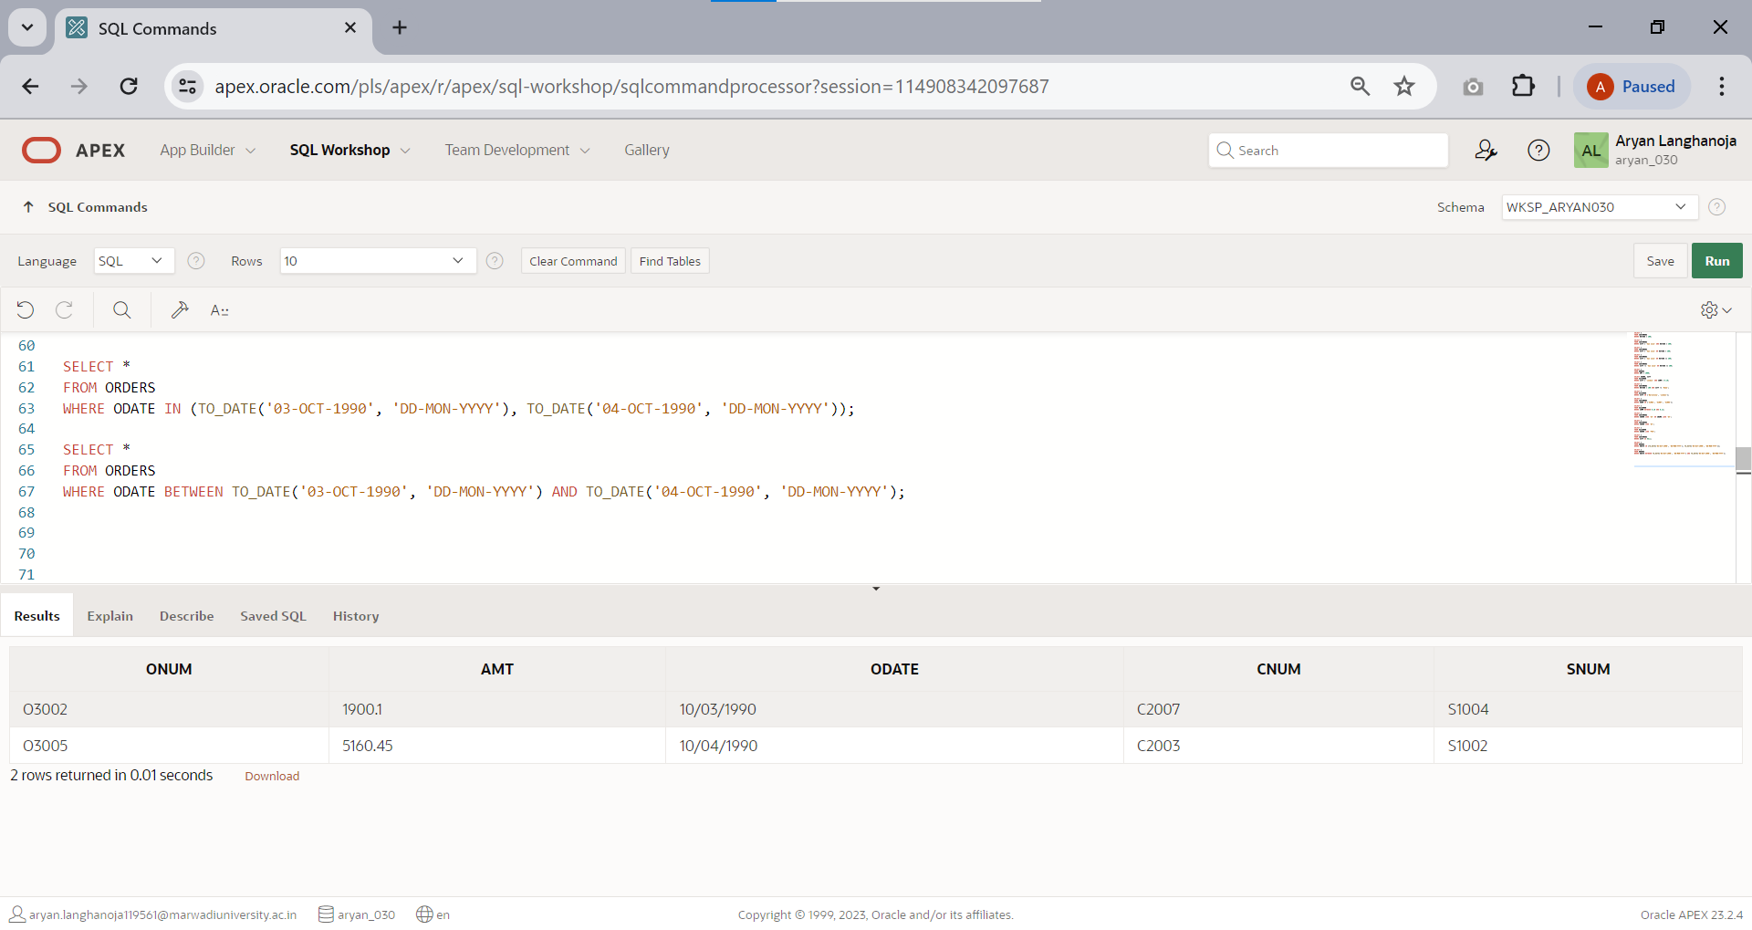

1. 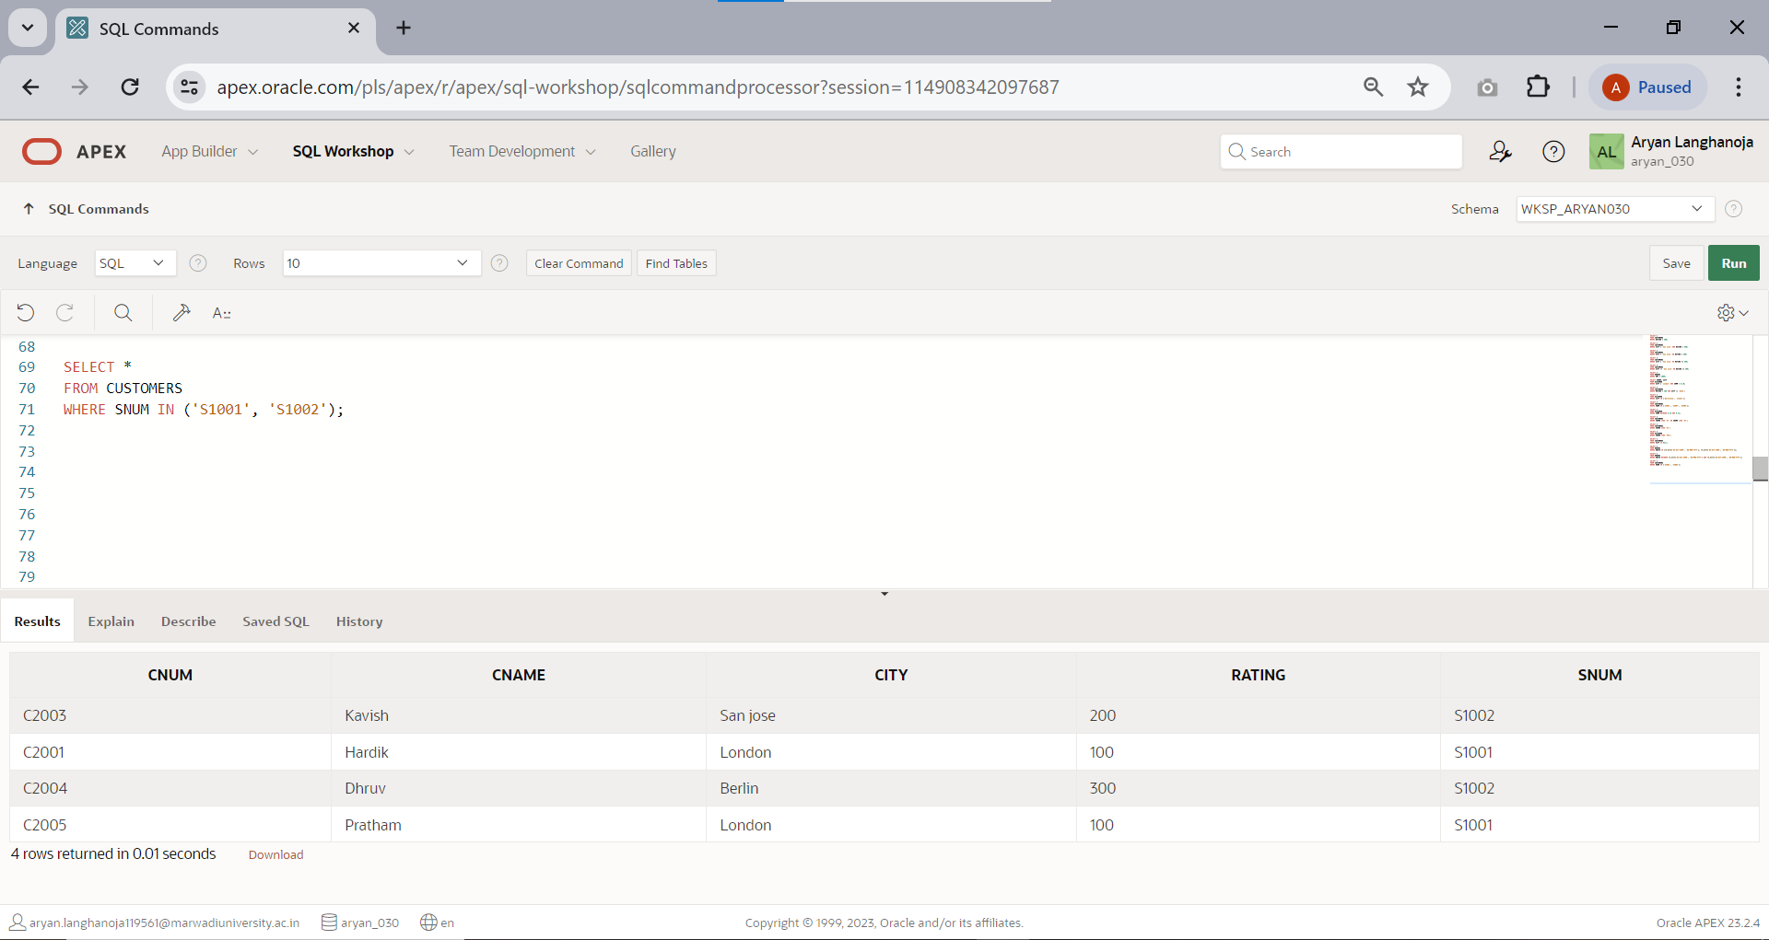Write a query that selects all of the customers matched with S1001 and S1002.
2. 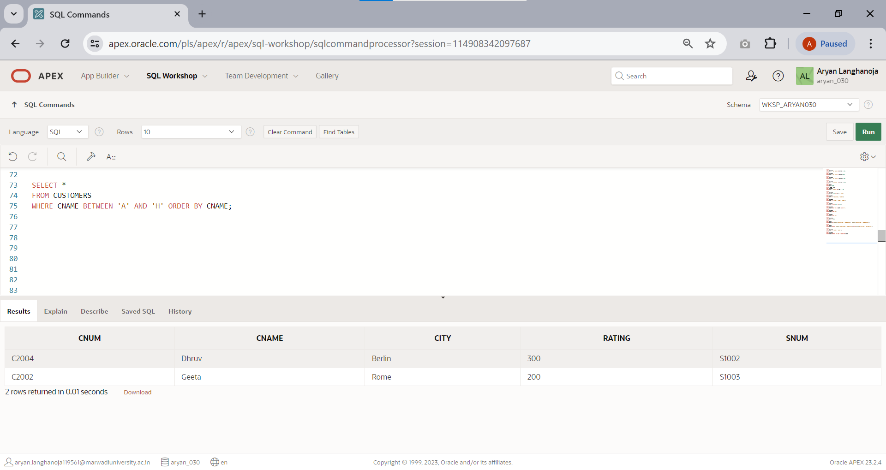Write a query that will produce all of the customers whose names begin with a letter from A to H.
3. 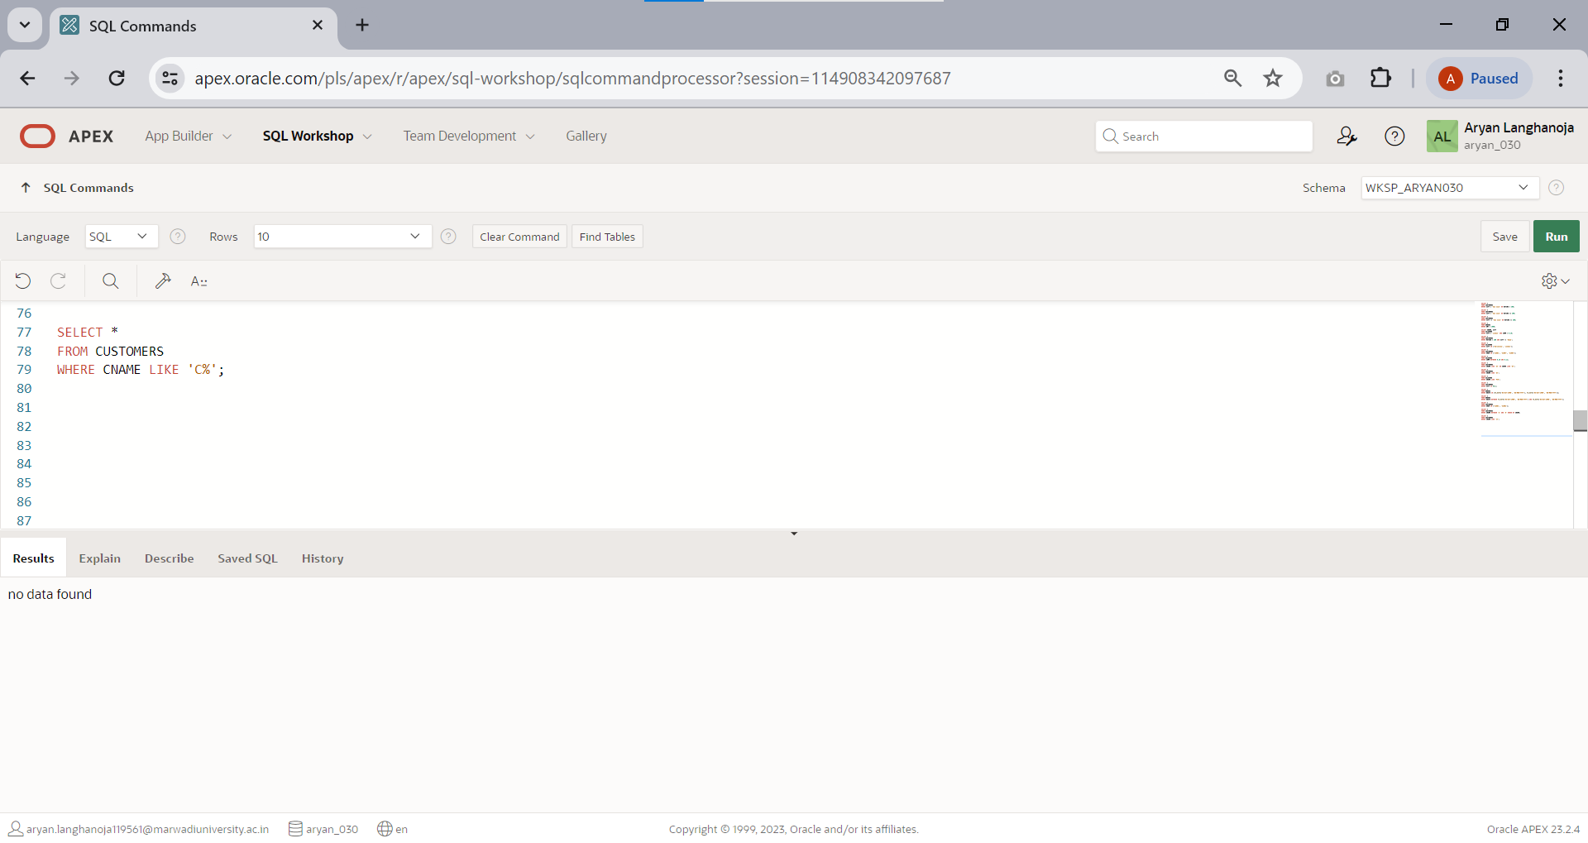Write a query that selects all customers whose names begin with ‘C’.
4. Write a query that selects all orders without ZEROS or NULLS in amt field..

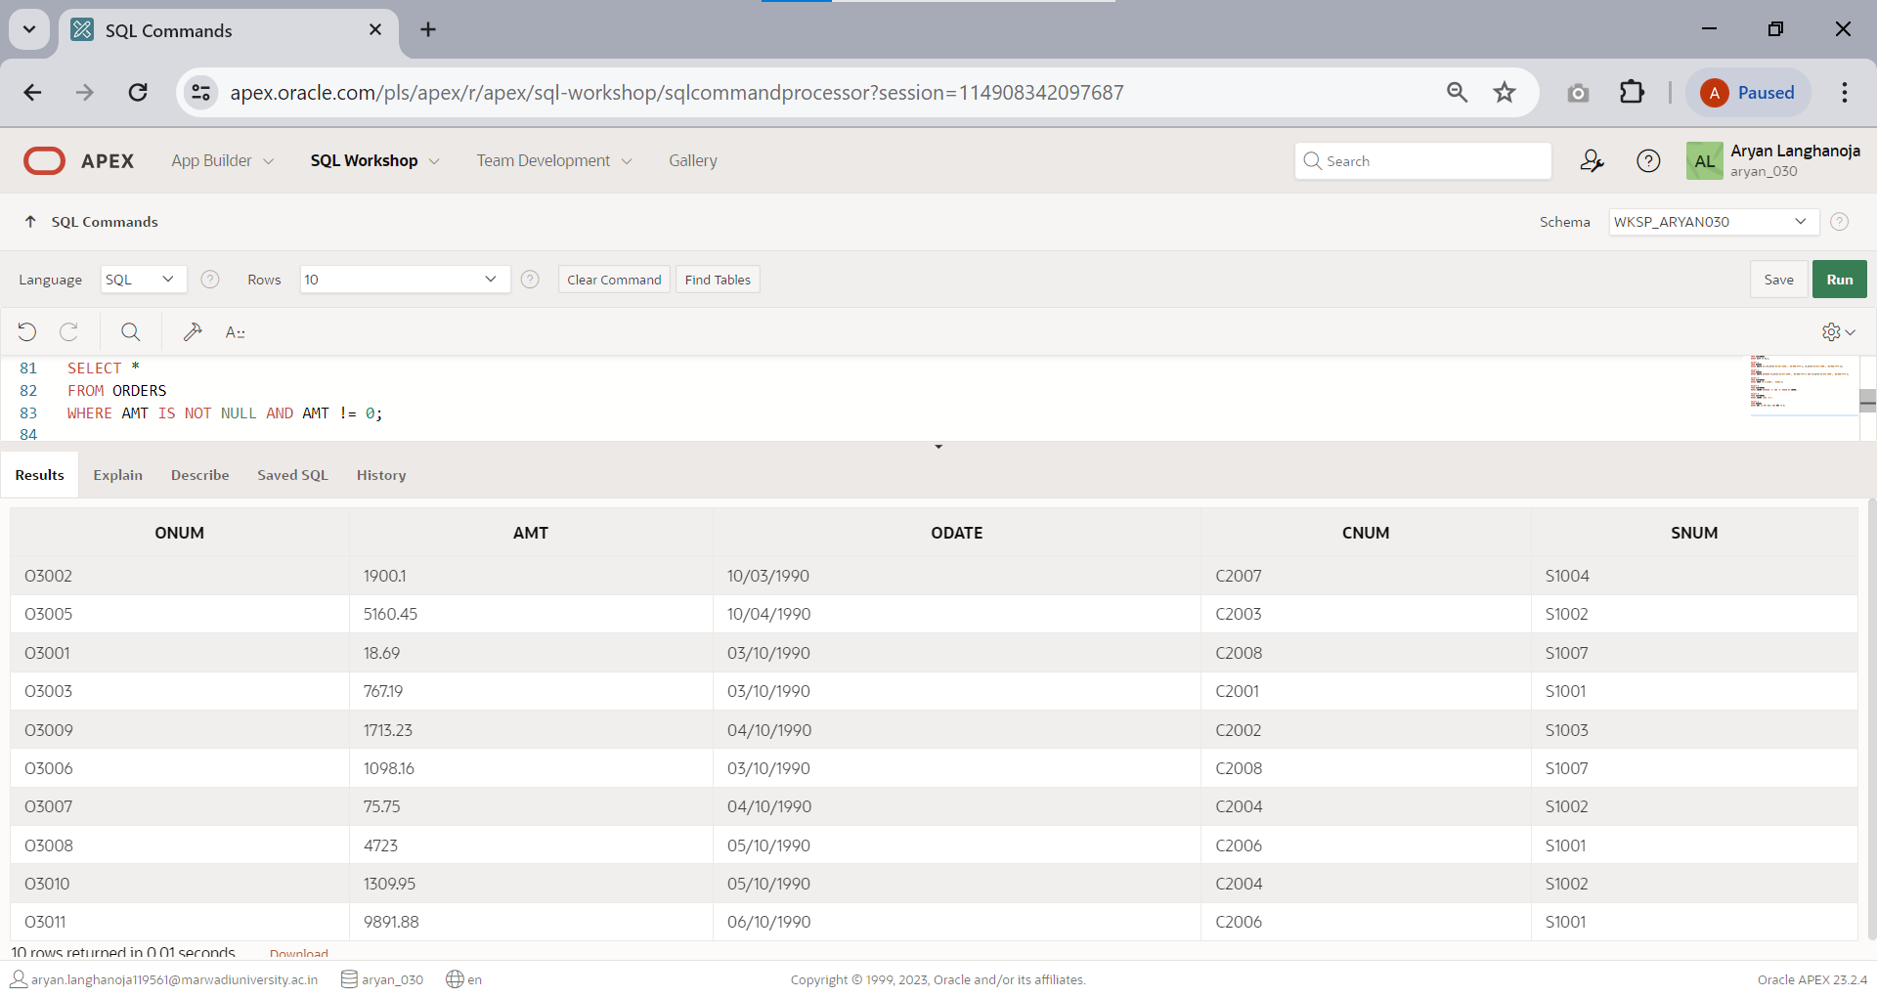

### FUNCTIONS

1. 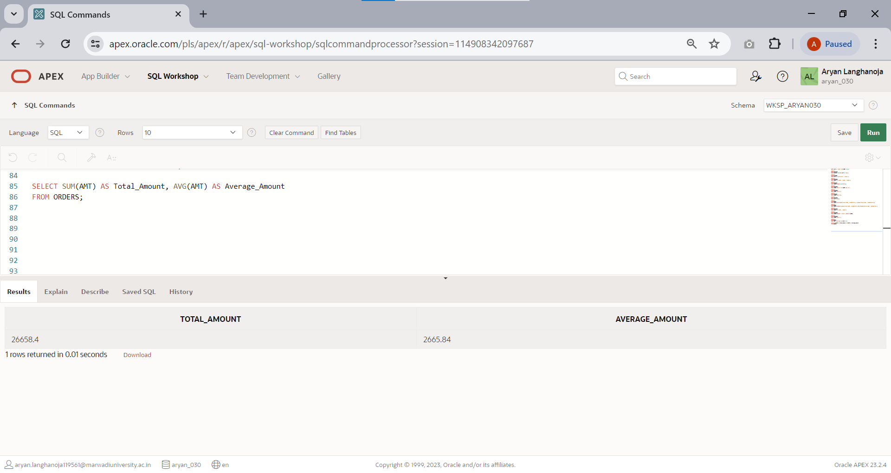Display sum of amt,average of orders.
2. 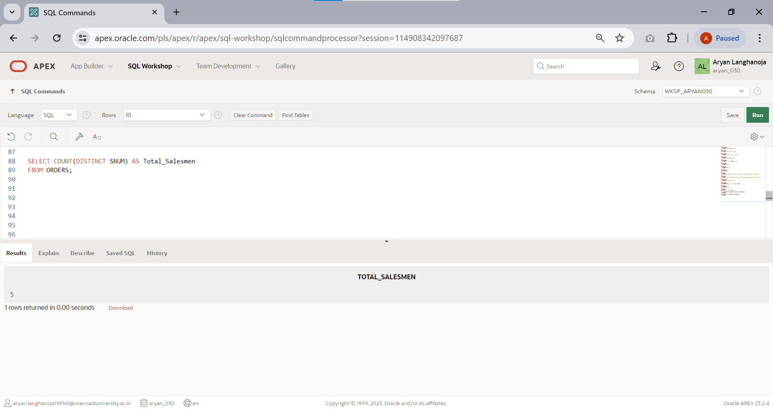To count the numbers of salesmen without duplication in the orders tables.
3. 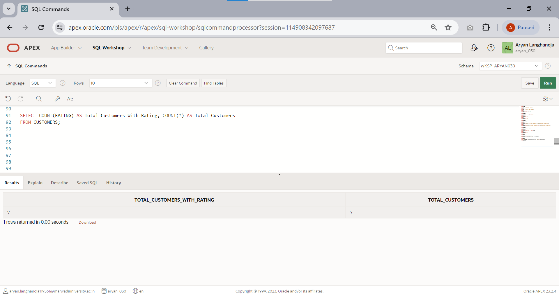Count the rating of customers (with NULL and without NULL).
4. 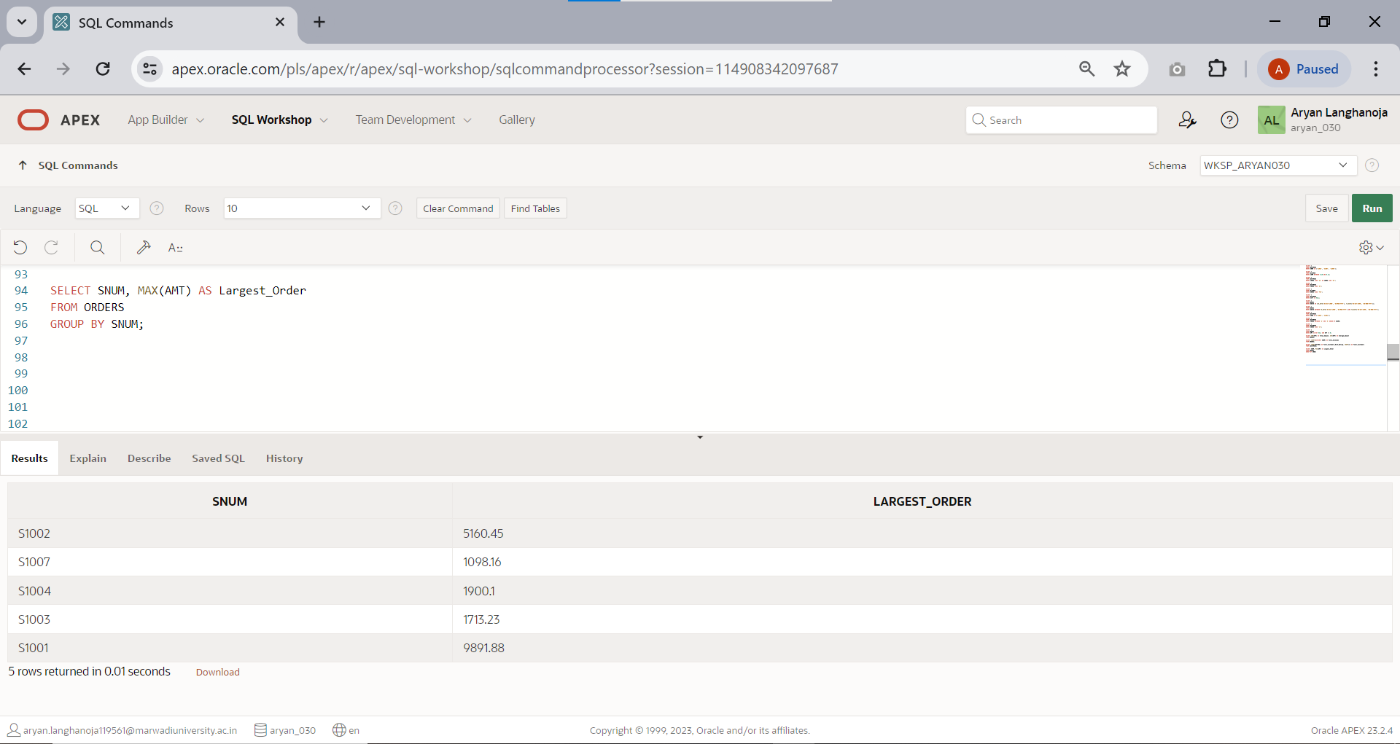Find the largest order taken by each salesperson.(hint: use group by)
5. 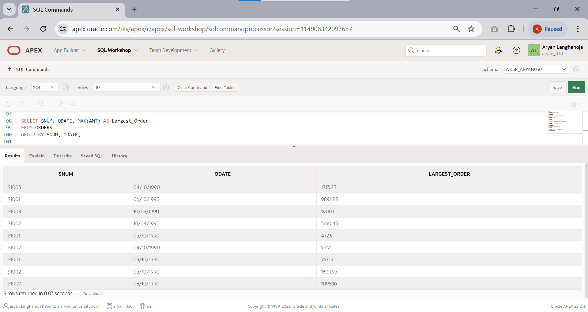Find the largest order taken by each salesperson on each date.
6. Find out which day had the higher total amount ordered.

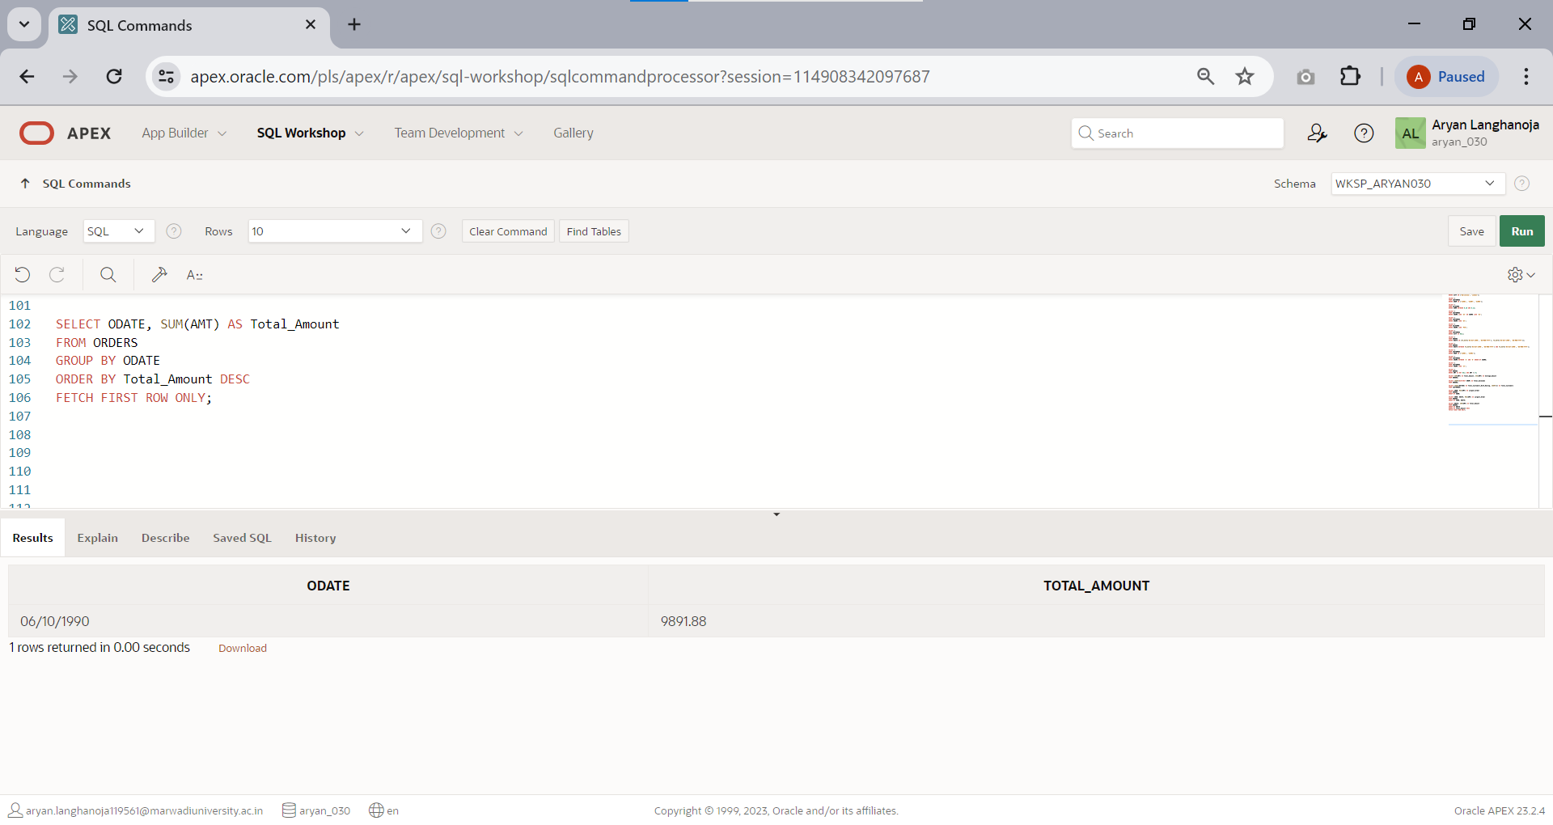

1. Write a query that counts all orders for October 3rd.

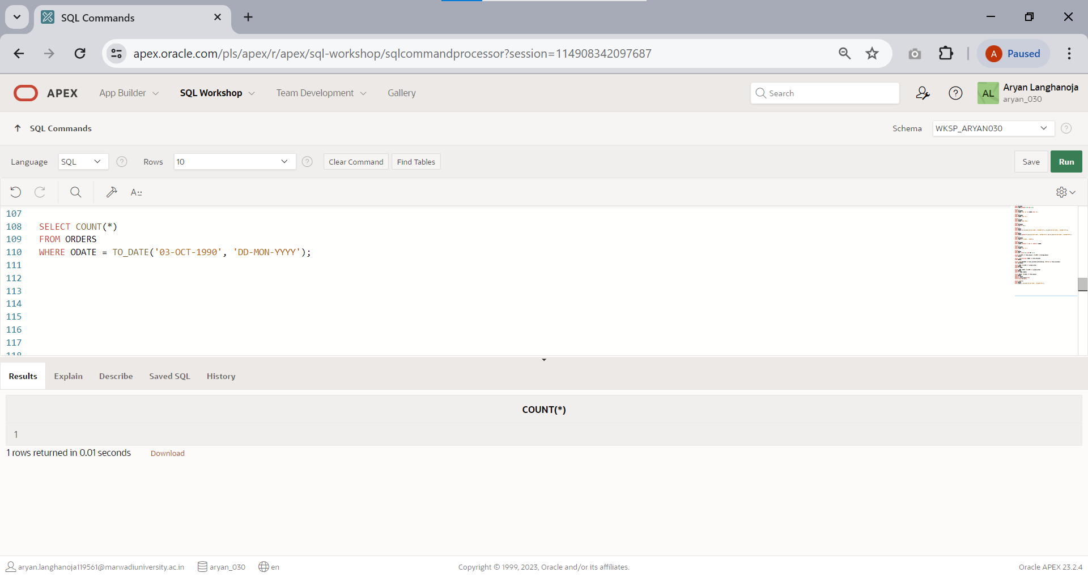

1. 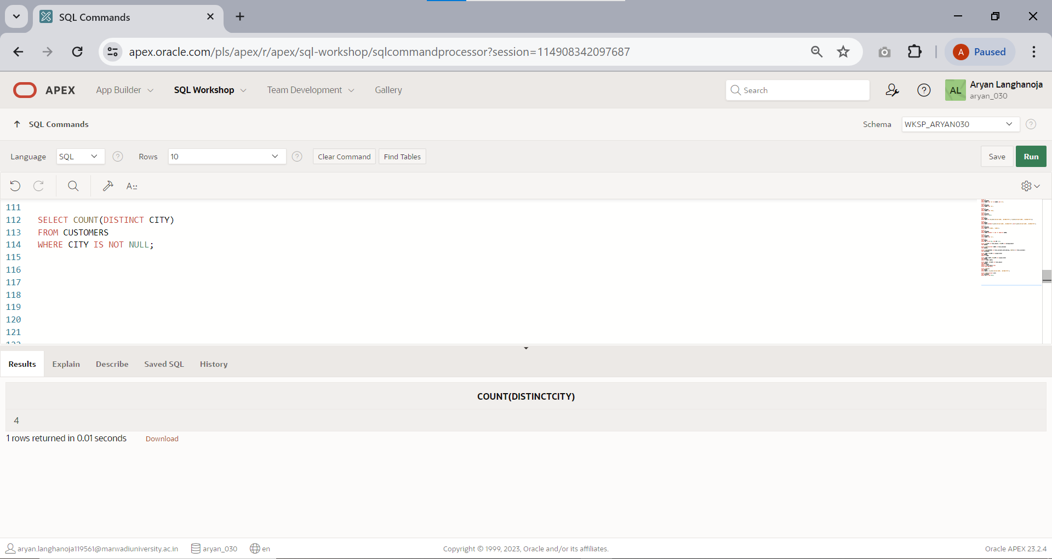Write a query that counts the number of different non-NULL city in the customer table.
2. Write a query that selects the first customer in alphabetical order whose name begin with ‘G’.

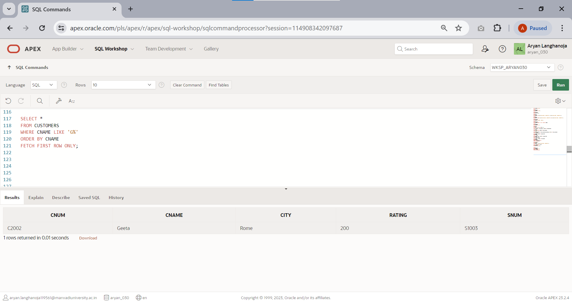

# Practical 10

## Aim: Join based Queries having Functions

Perform queries on above tables

1. 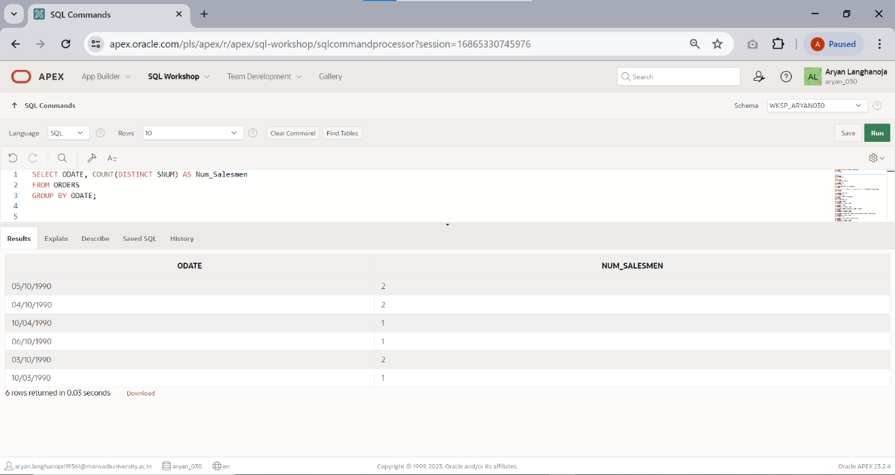Write a query that counts the number of salesmen registering orders for each day(if a salesperson has more than one order on a given day , he or she should be counted only once)
2. Display all the information in descending orders(use column CNUM).

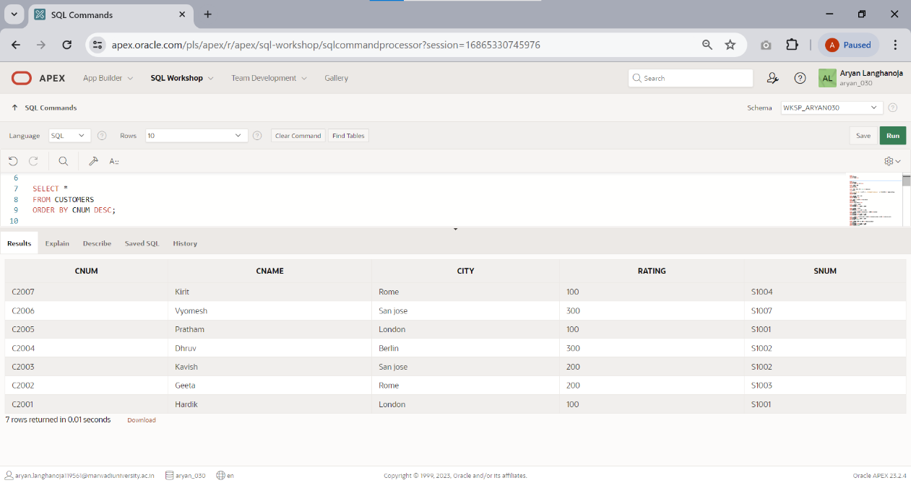

1. 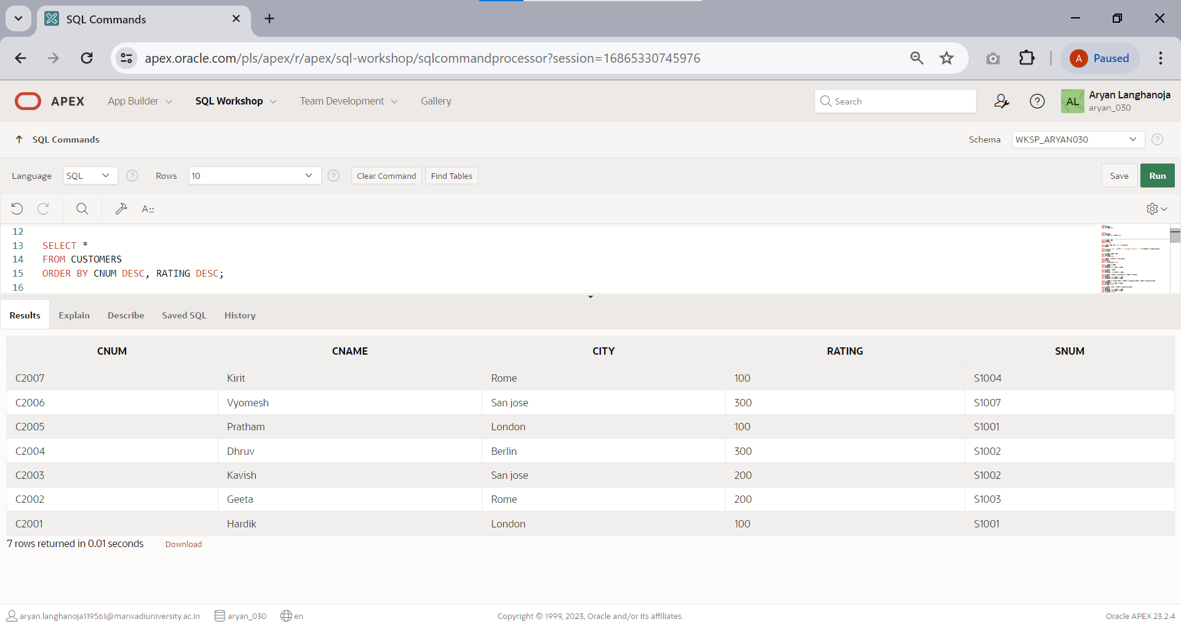Display all the information in descending orders(use column CNUM,AMT).
2. Display sname and comm. From salesmen in descending order(in place of column name use column number).

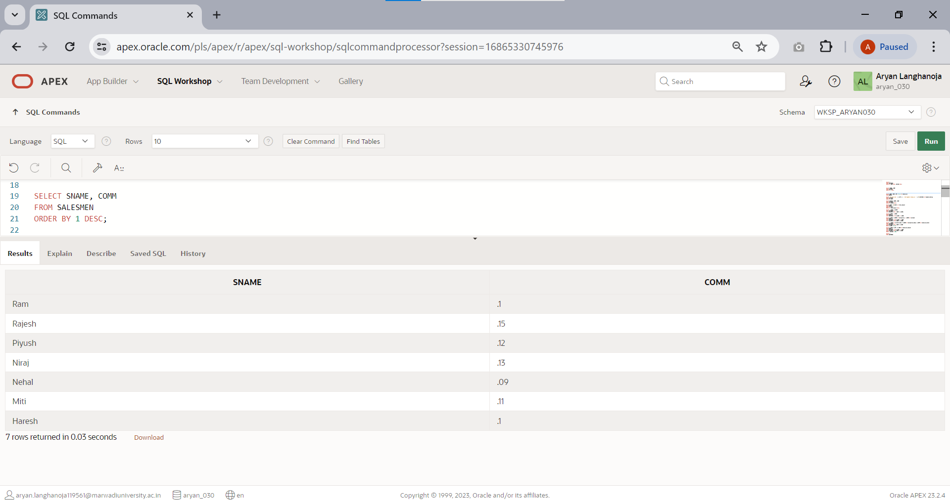

1. 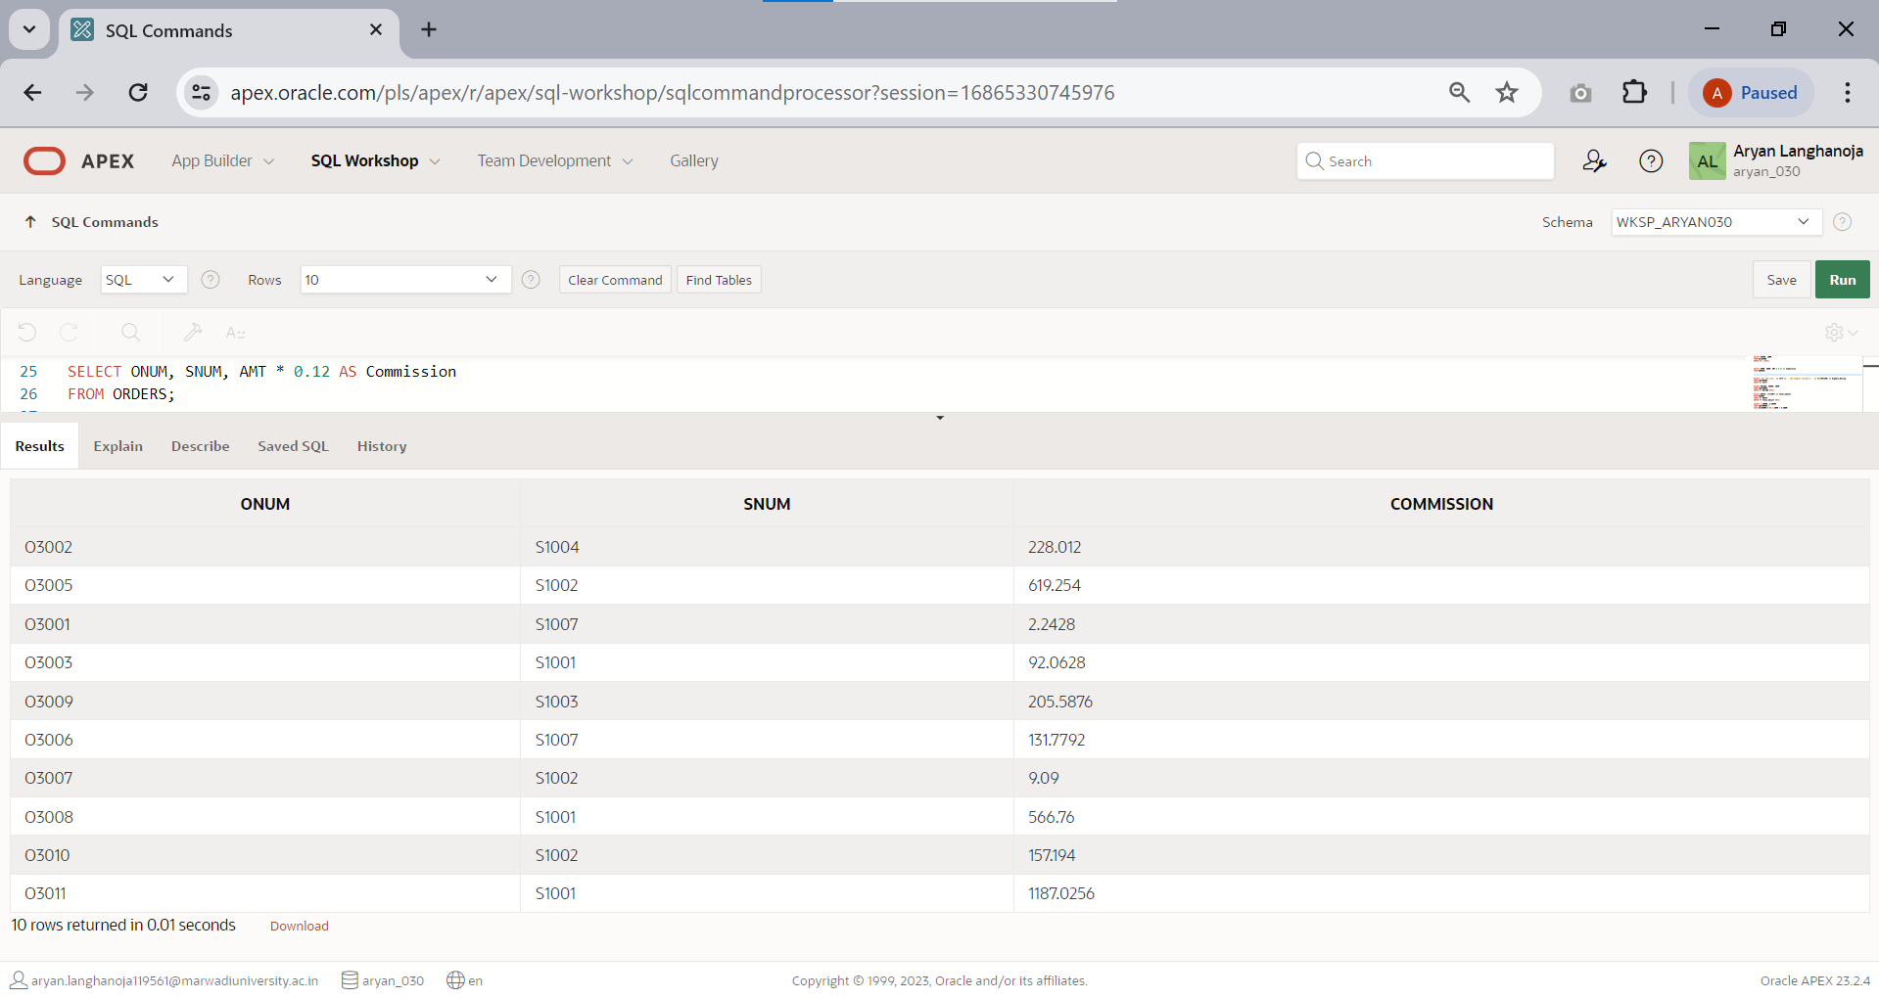Assume each salesperson has a 0.12 commission. Write a query on the orders table that will produce the order number,the salesperson number and the amount of the salesperson’s commission for that order.
2. 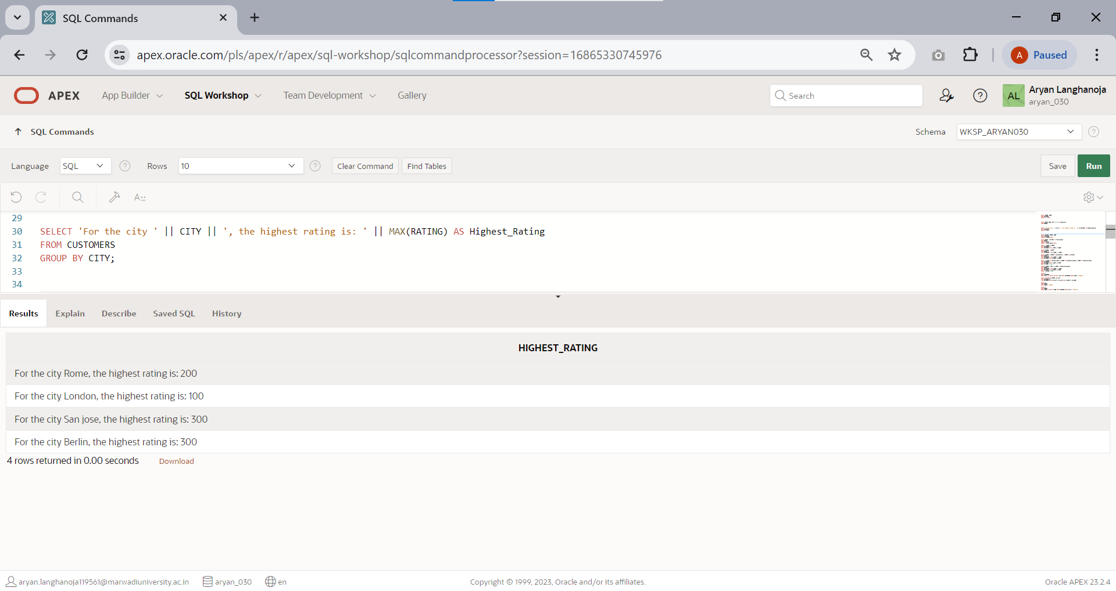Write a query on the customers table that will find the highest rating in each city. Put the output in this form. For the city (city) , the highest rating is: (rating).
3. 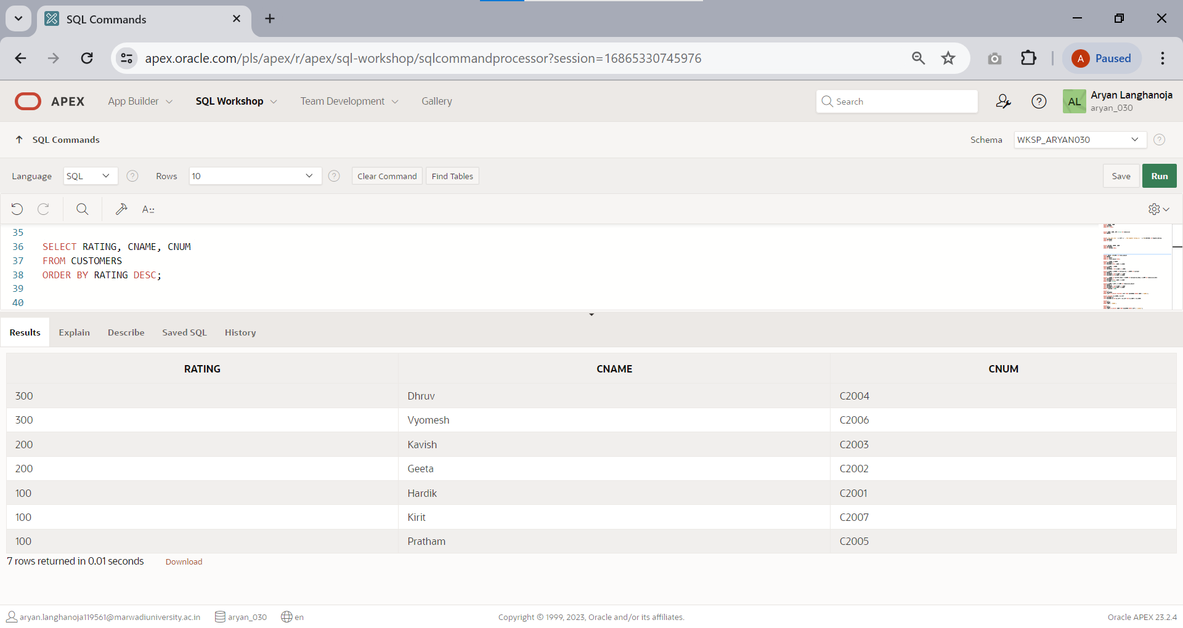Write a query that lists customers in descending order of rating. Output the rating field first, followed by the customer’s name and number.
4. Write a query that totals the orders for each day and places the results in descending order.

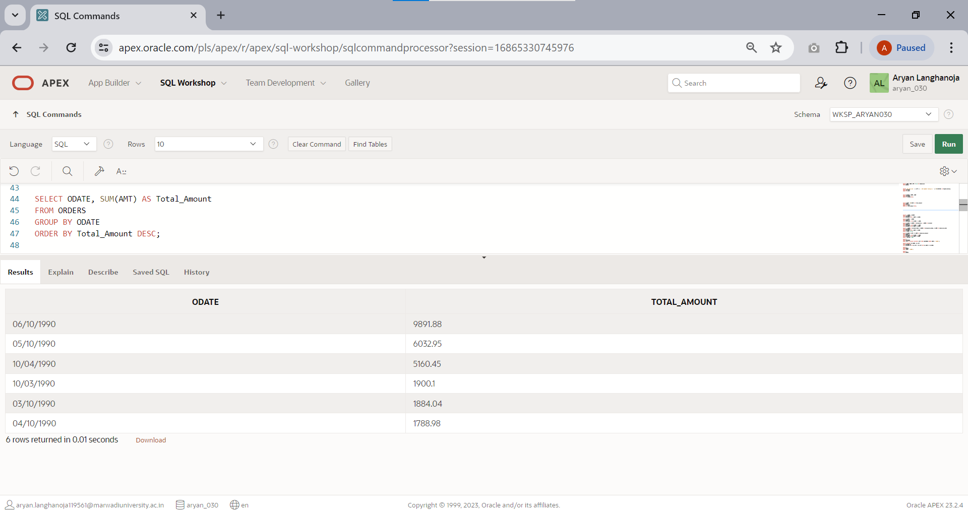

## JOIN

1. 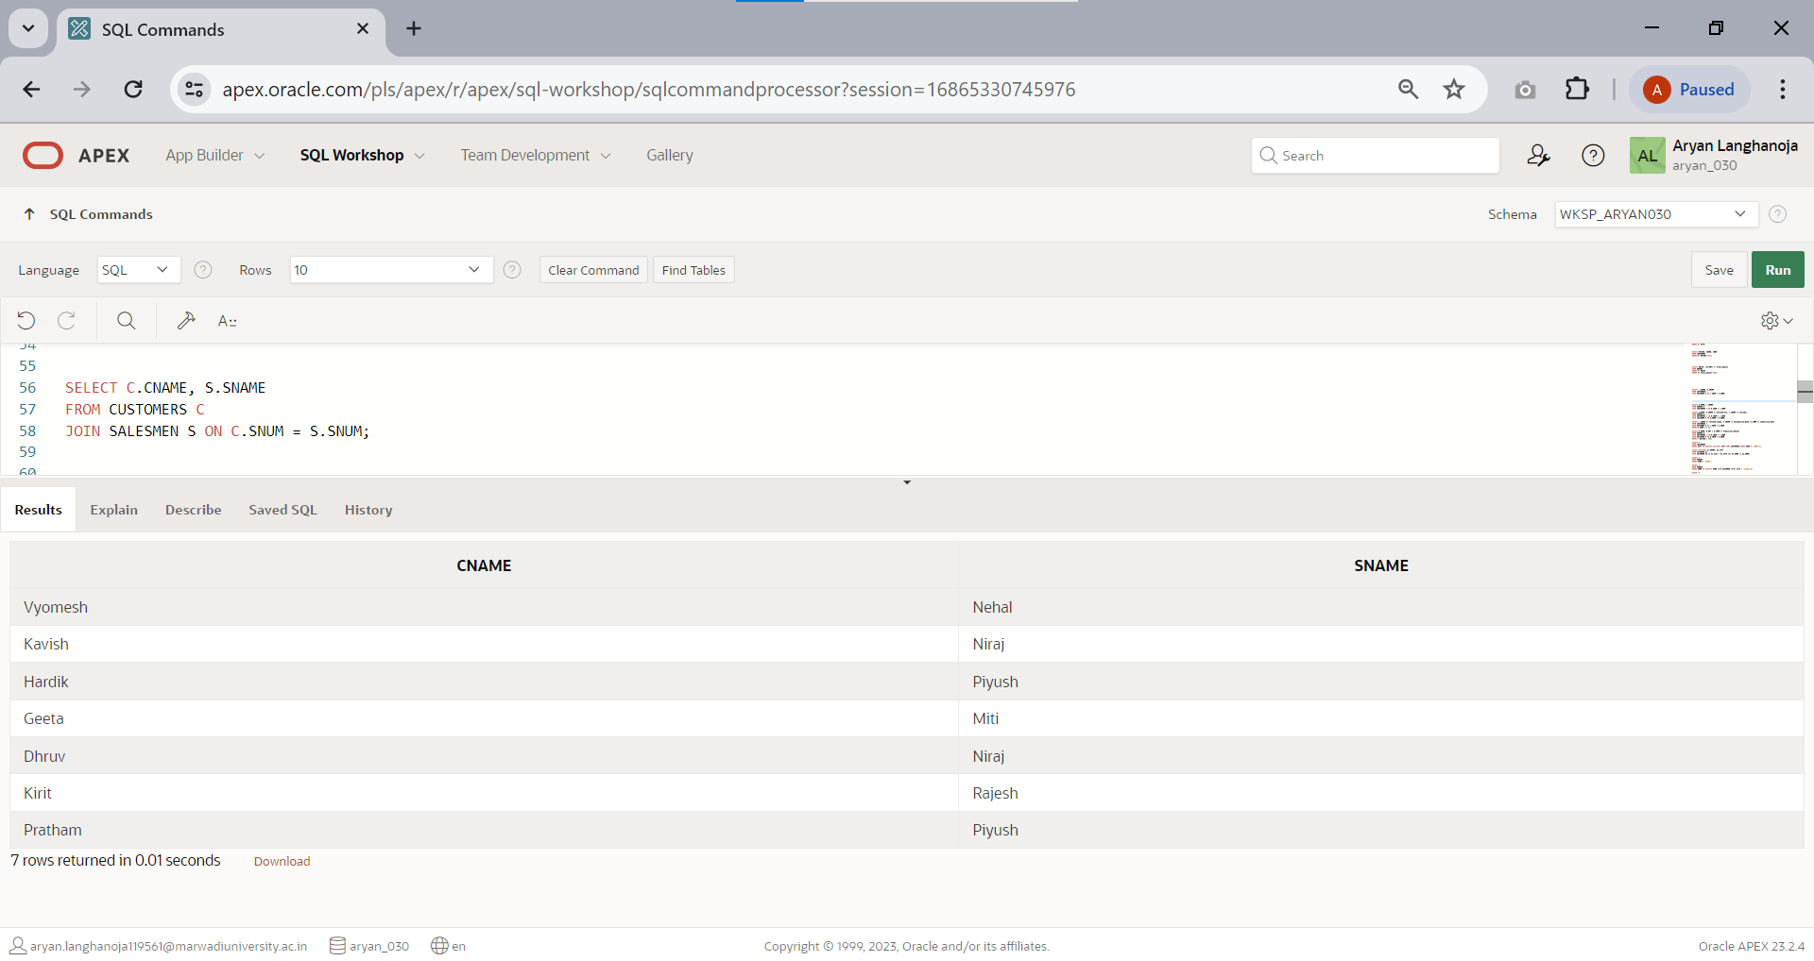Show the names of all customers matched with the salesmen serving them.
2. 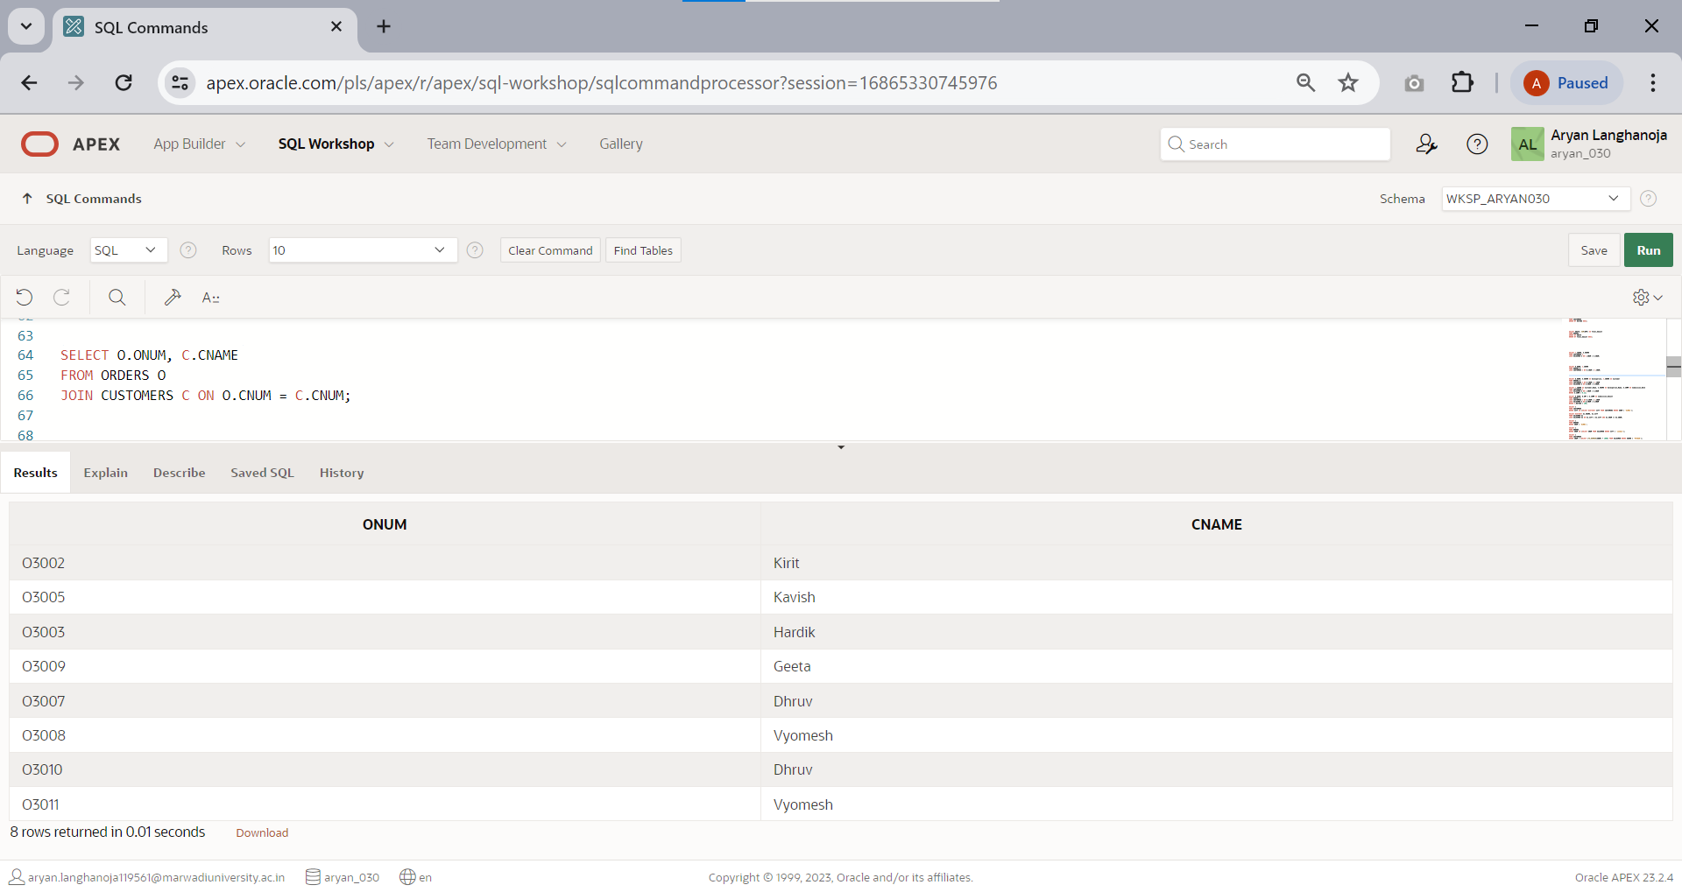Write a query that lists each order number followed by the name of the customer who made the order.
3. 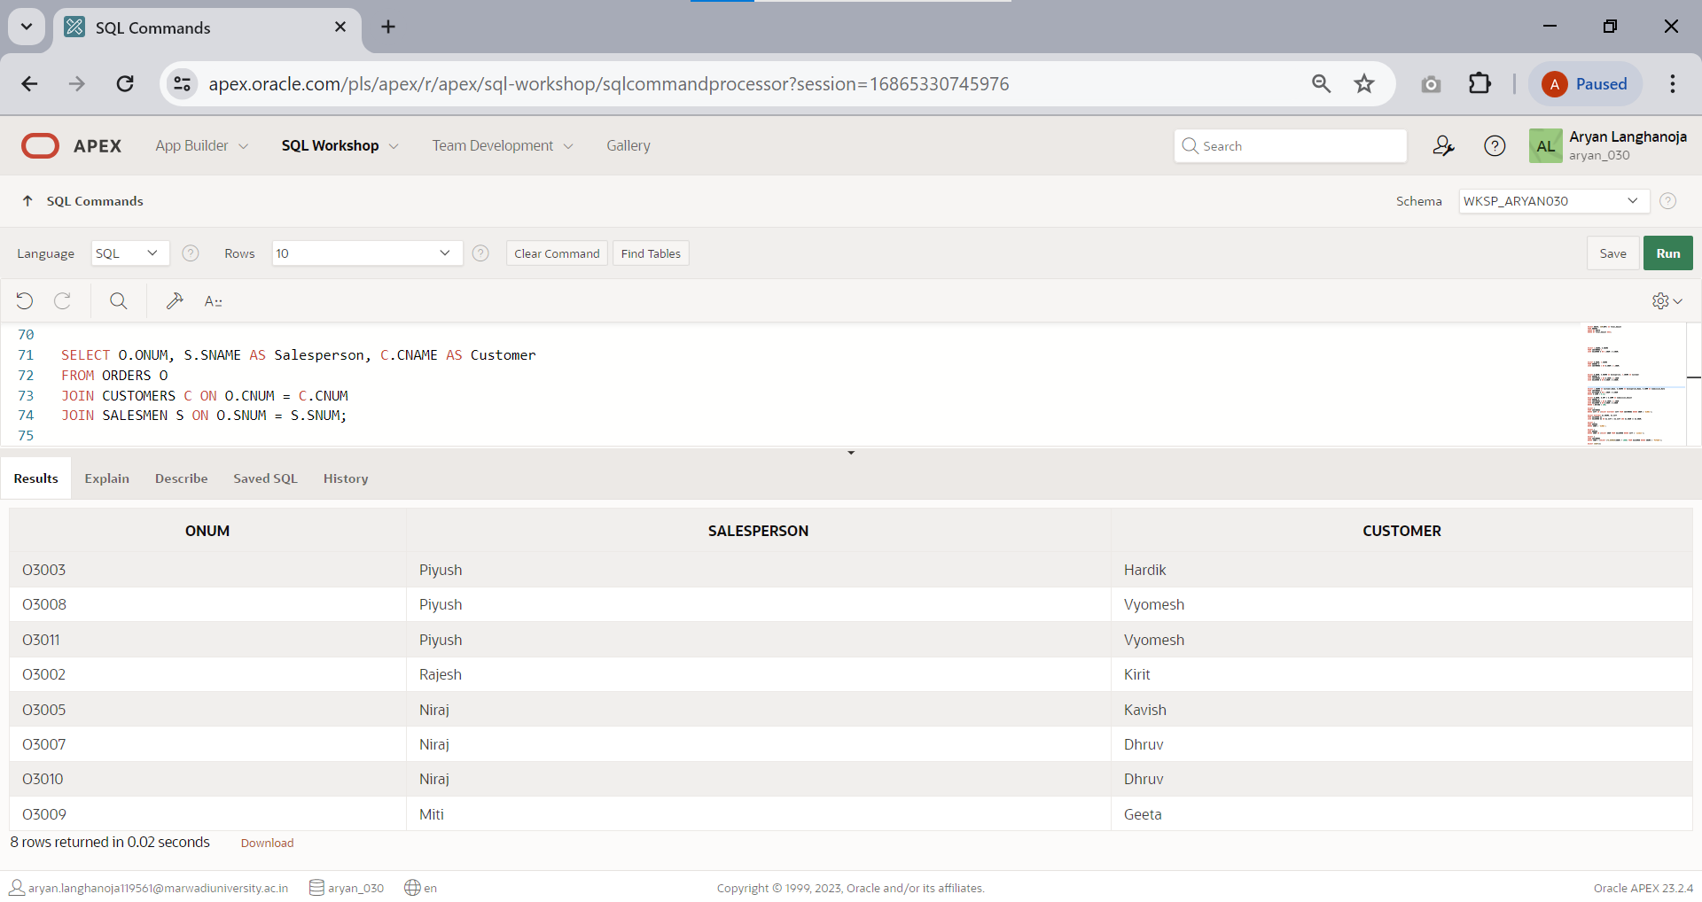Write a query that gives the names of both the salesperson and the customer for each order after the order number.
4. Write a query that produces all customers serviced by salesmen with a commission above

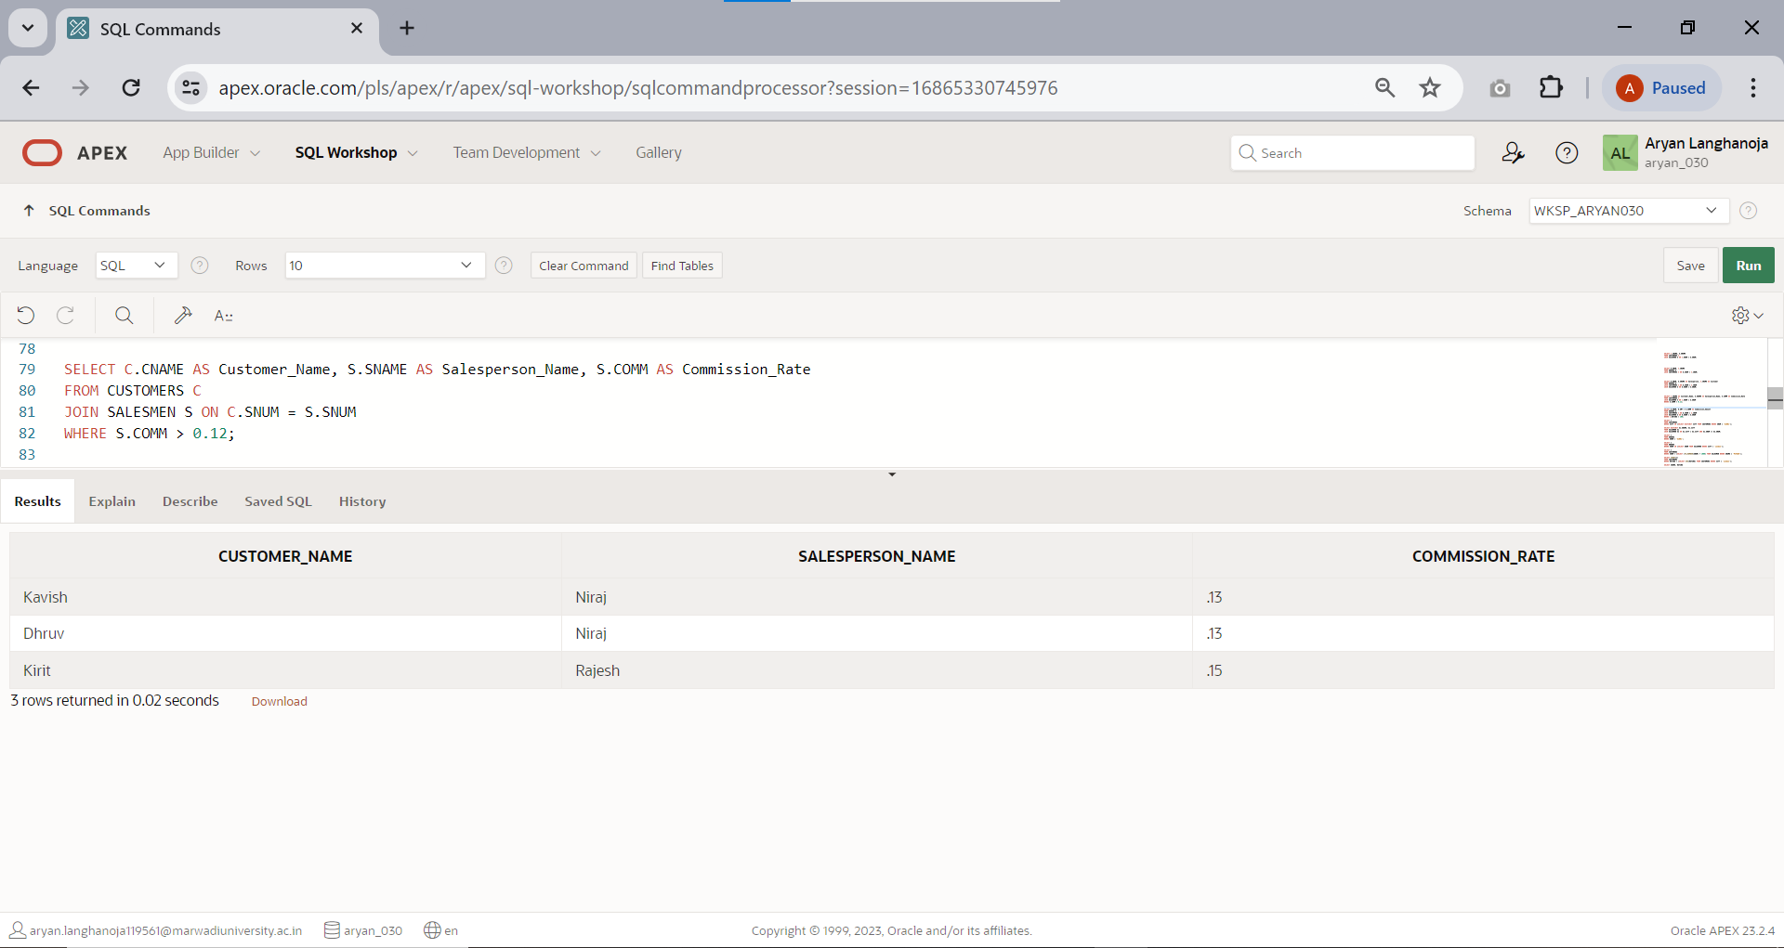0.12. Output the customer’s name, the salesperson’s name and the salesperson’s rate of commission.

1. 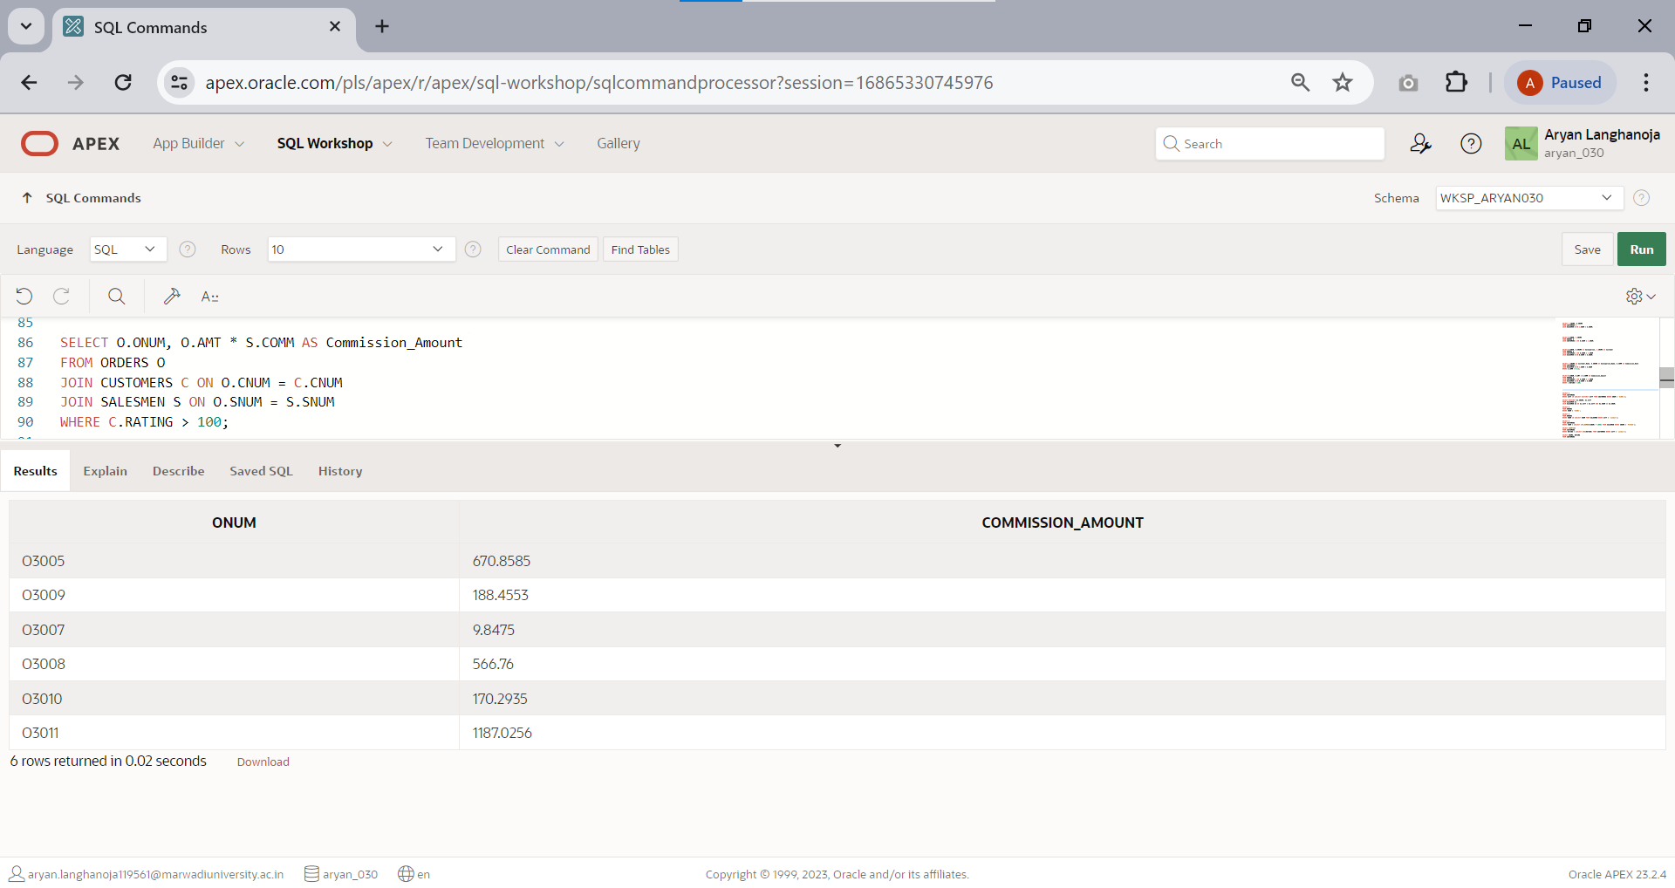Write a query that calculates the amount of the salesperson’s commission on each order by a customer with a rating above 100.

## OTHERS

1. List all customer located in cities where salesperson ‘PIYUSH’ has customer.

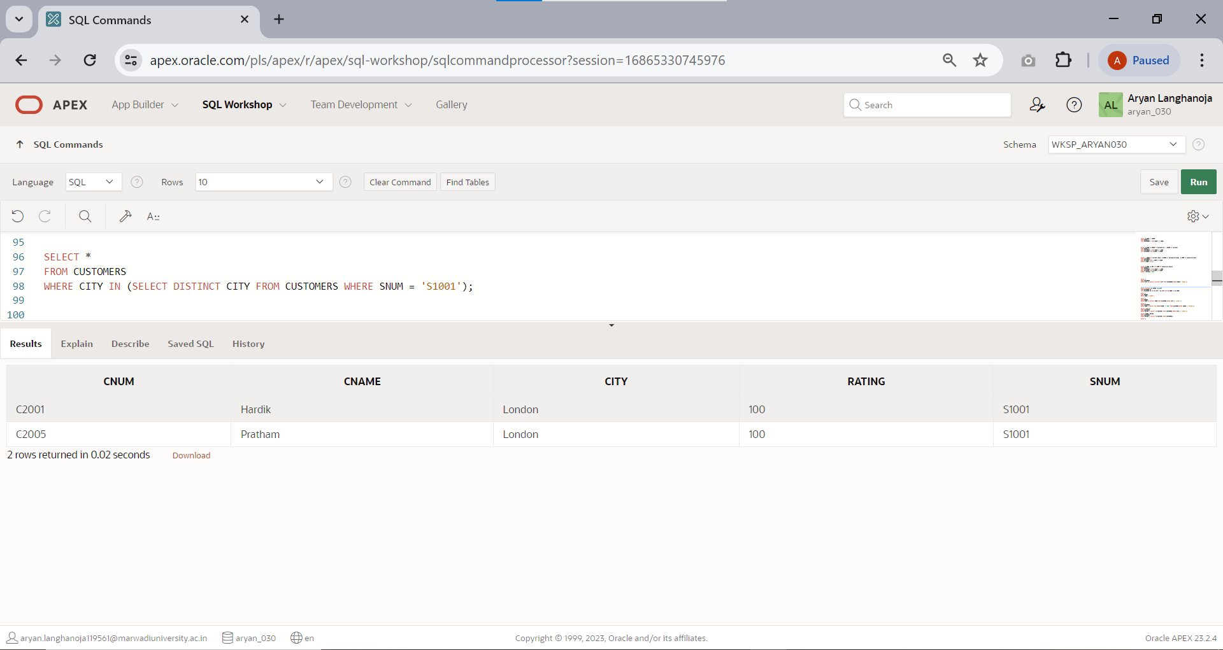

1. 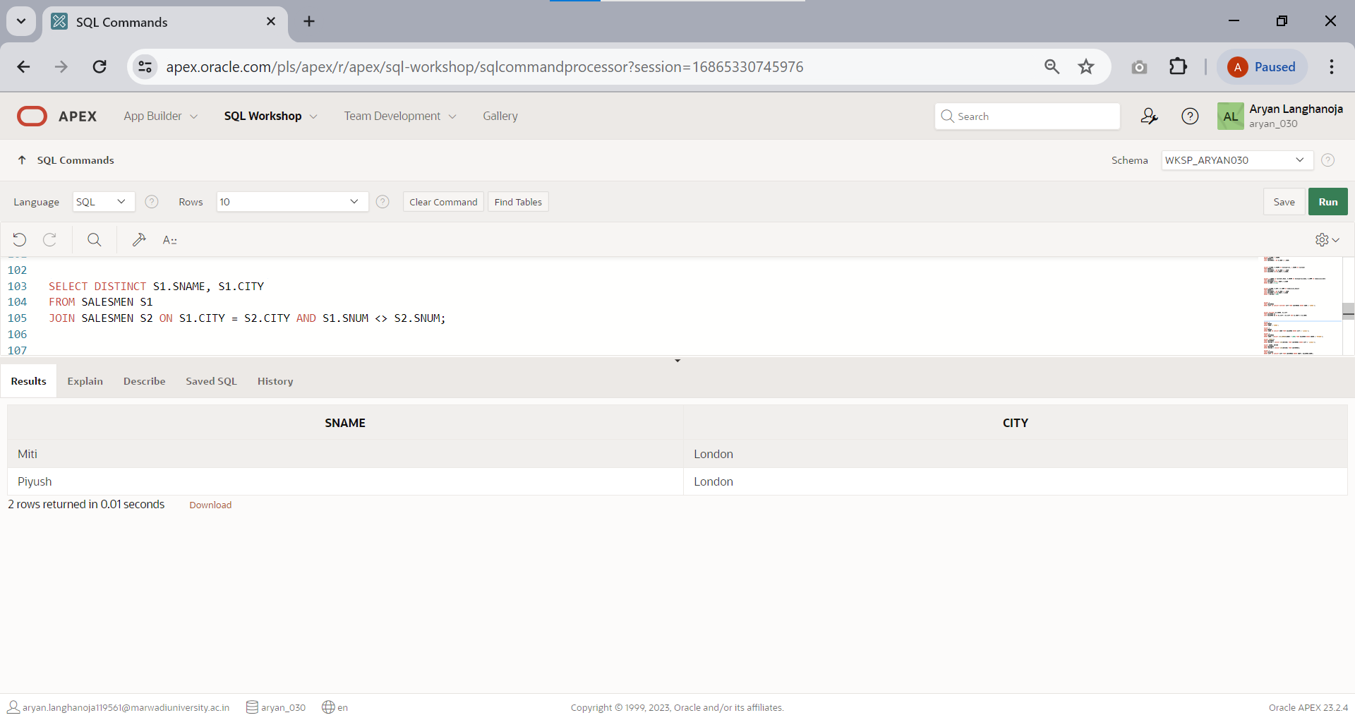List all salesmen who are living in same city without duplicate rows.
2. Extract all orders of ‘PIYUSH’.

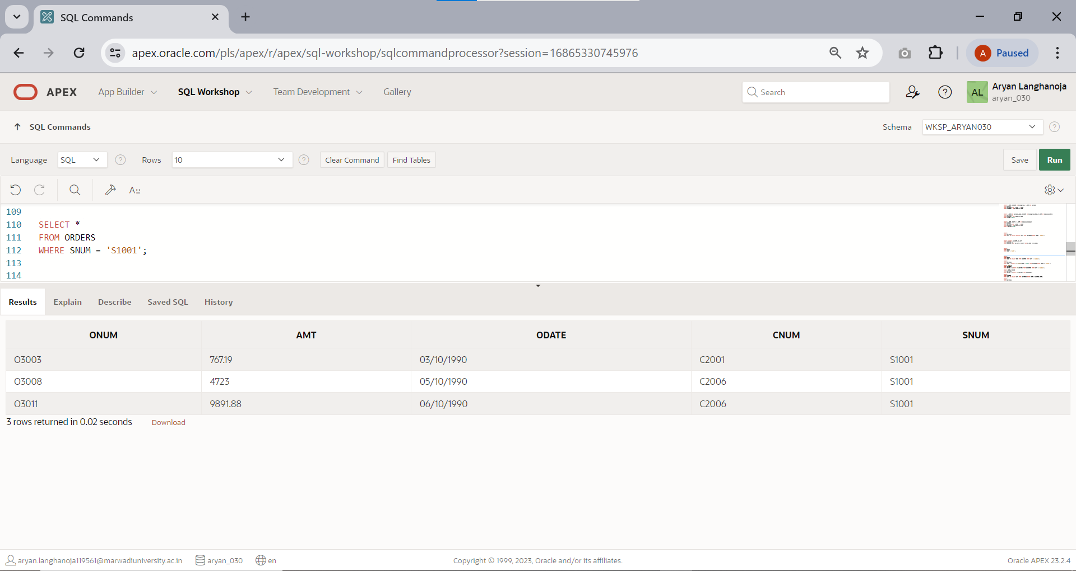

1. 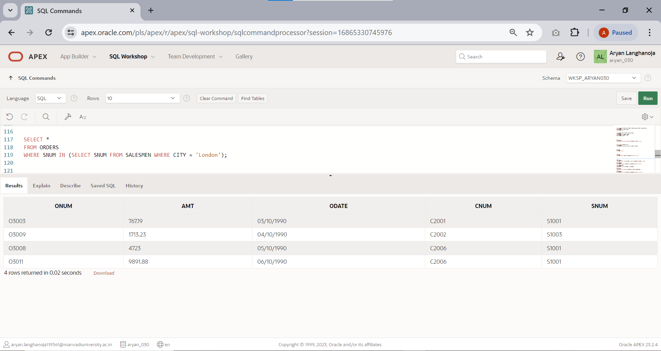Extract all orders of LONDON’S salesmen.
2. Find all customers whose cnum is 1000 above than the snum of ‘PIYUSH’.

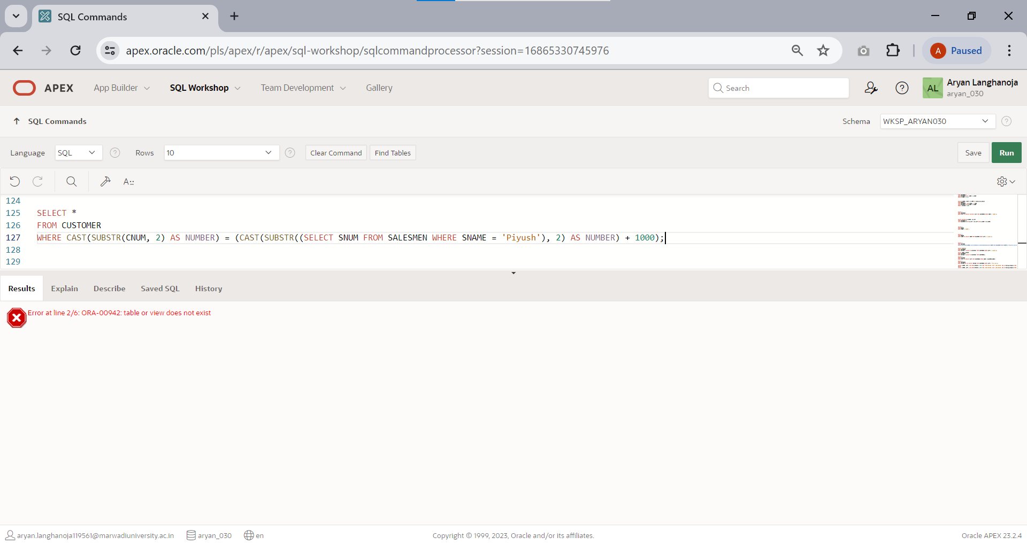

1. 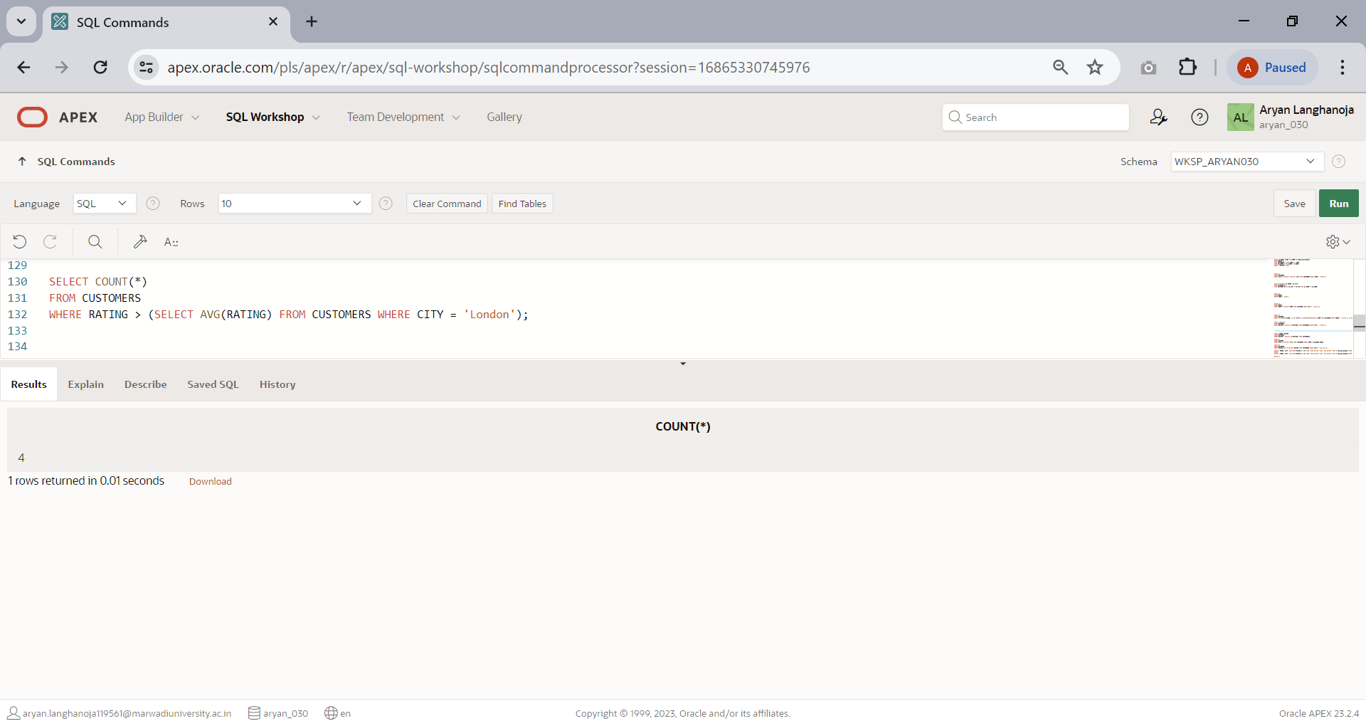Count the no. of customers with the rating above than average Rating of ‘LONDON’.
2. Produce the name and rating of all customers who have above average Rating.

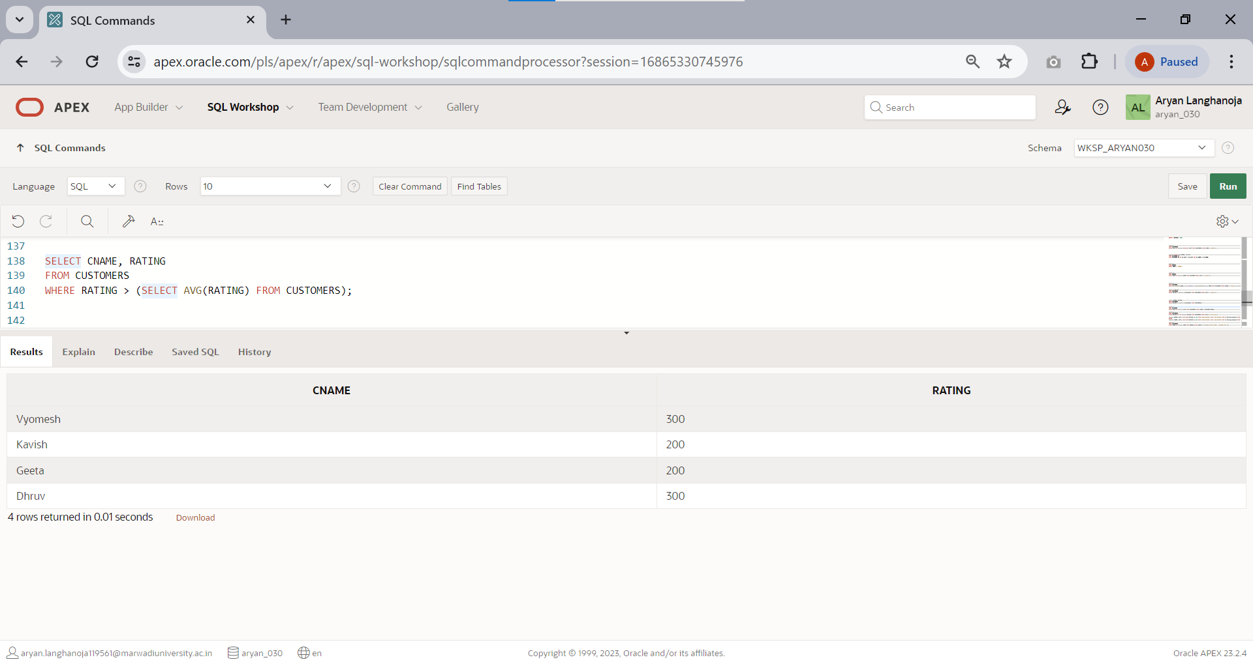

1. 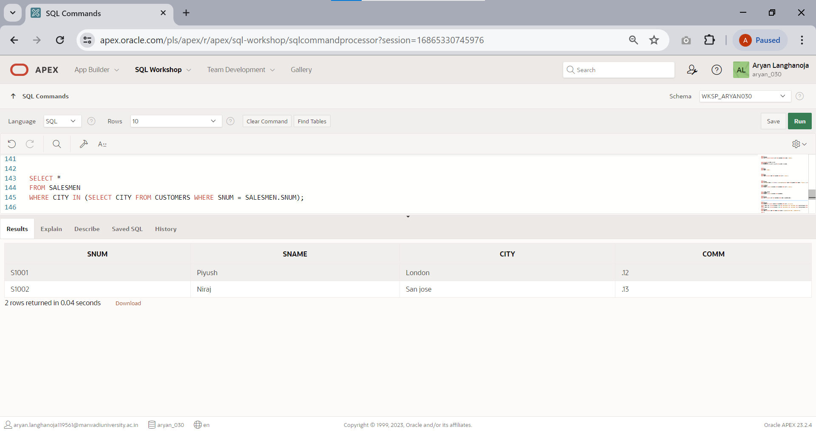List all salesmen with customers located in their cities.
2. Select all customers whose rating doesn’t match with any rating customer of ‘SAN JOSE’.

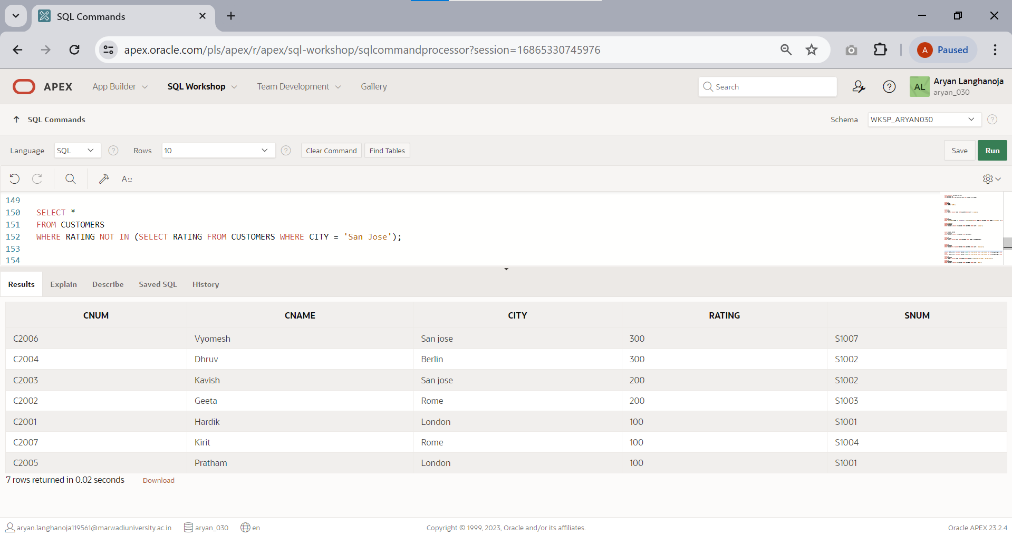

1. 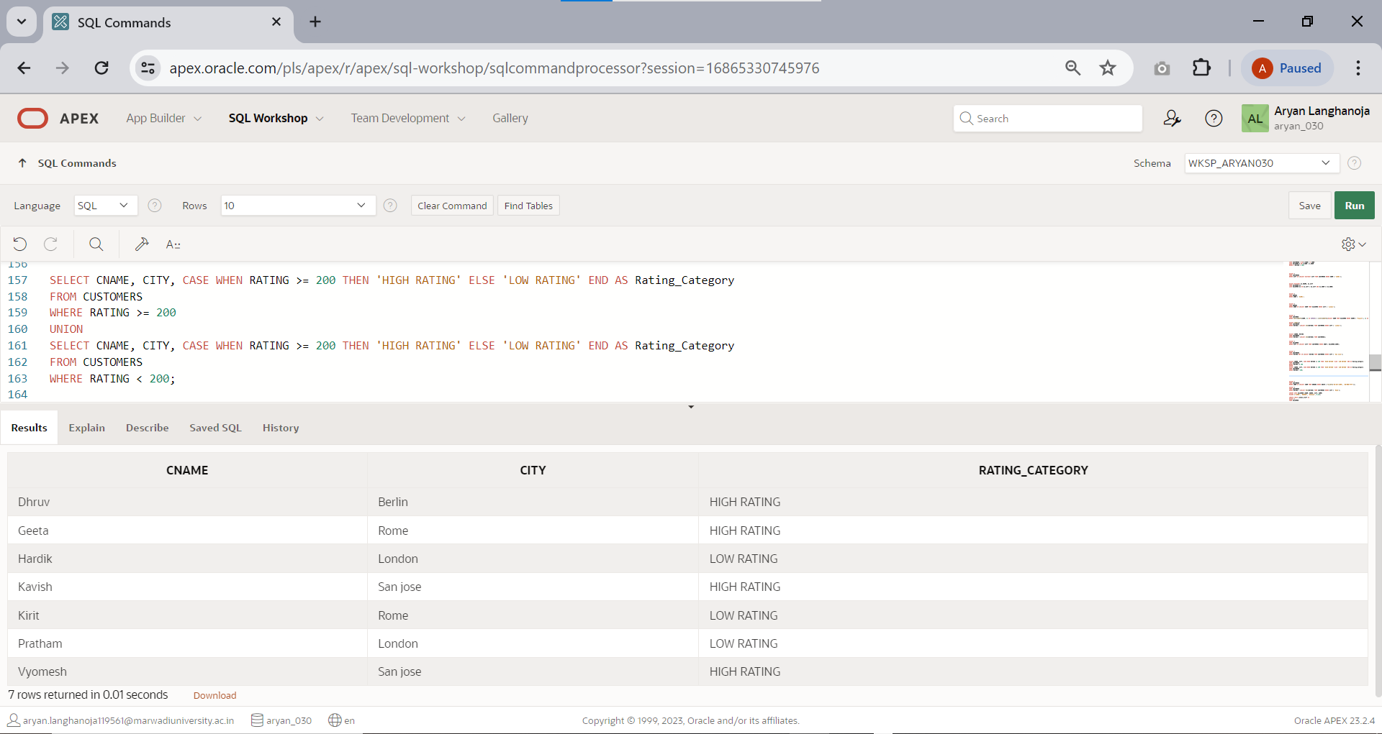Create a union of two queries that shows the names,cities and ratings of all customers. Those with rating of >=200 should display ‘HIGH RATING’ and those with <200 should display ‘LOW RATING’.
2. Find all customers with orders on 3rd october 1990 using correlate sub query.

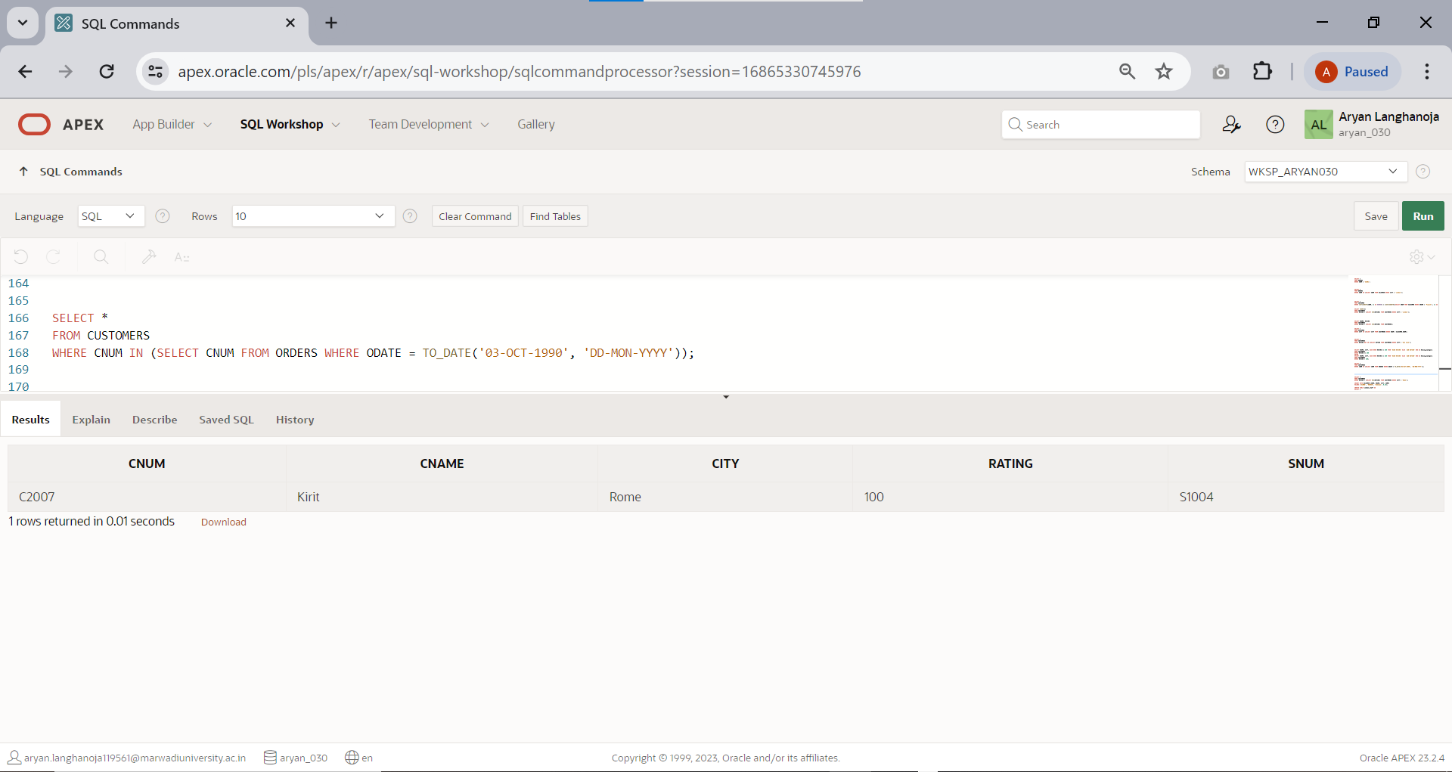

1. 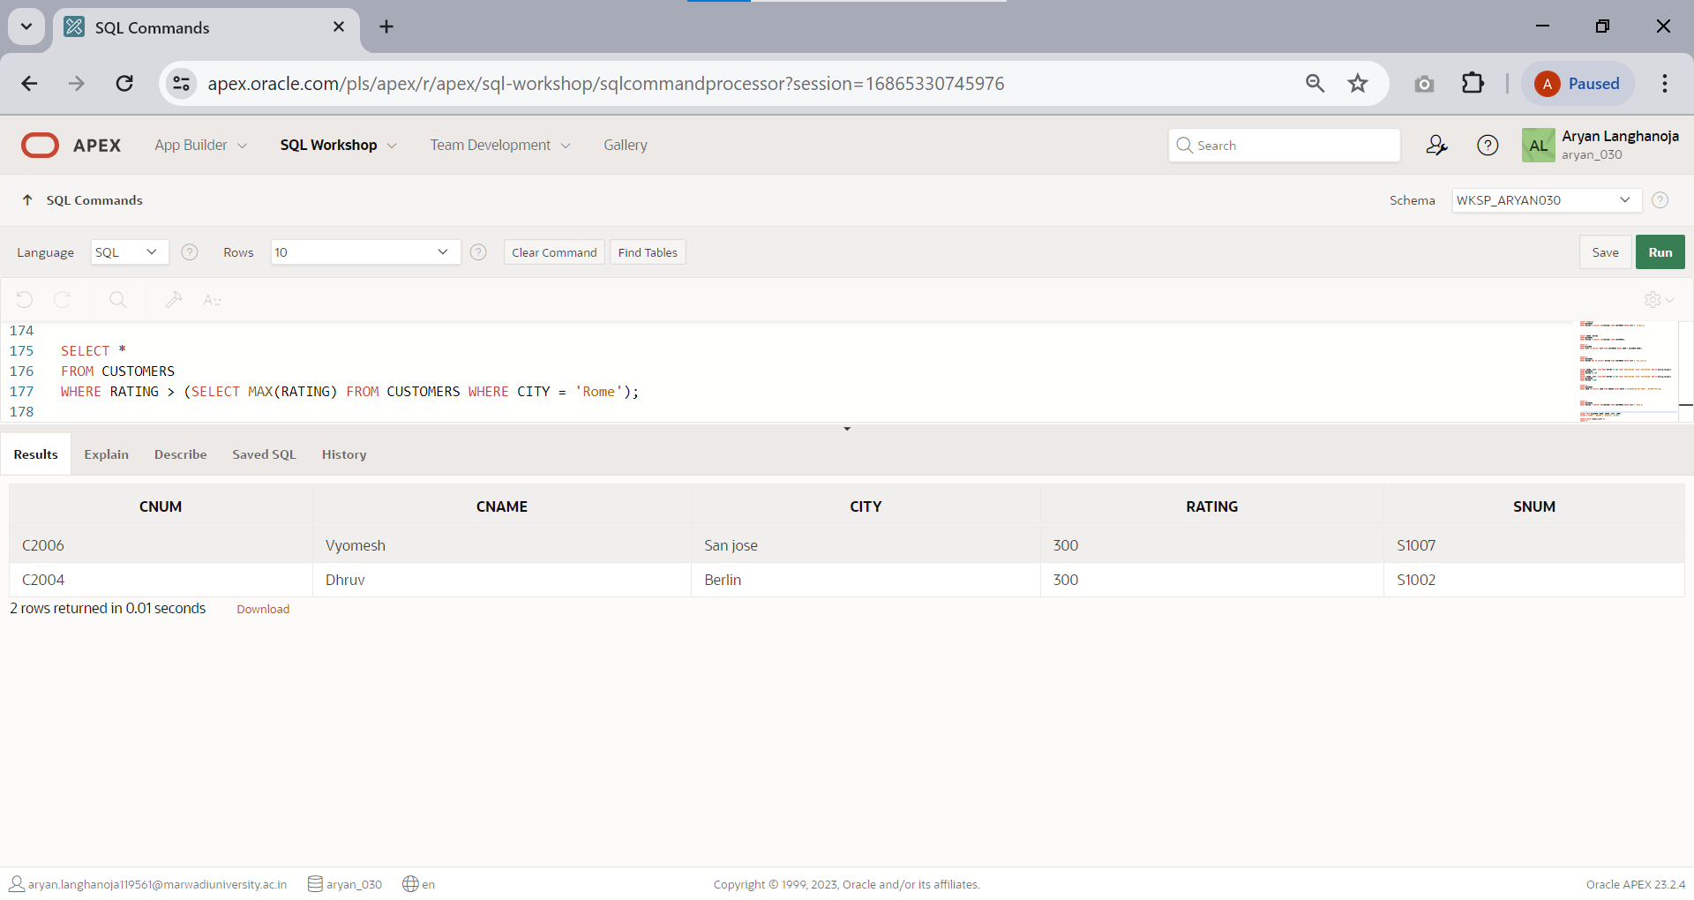Find all customers having rating greater than any customer in ‘ROME’.
2. Insert a row into salesmen table with the values snum is s1008,salesmen name is ‘RAKESH’, city is unknown and commission is 14%.

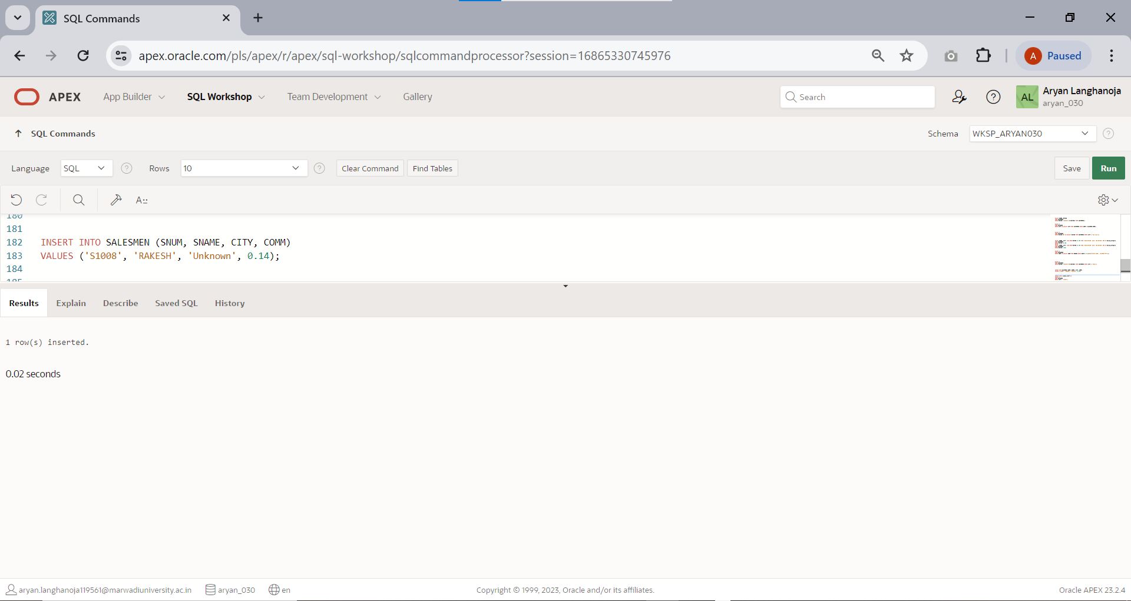

1. 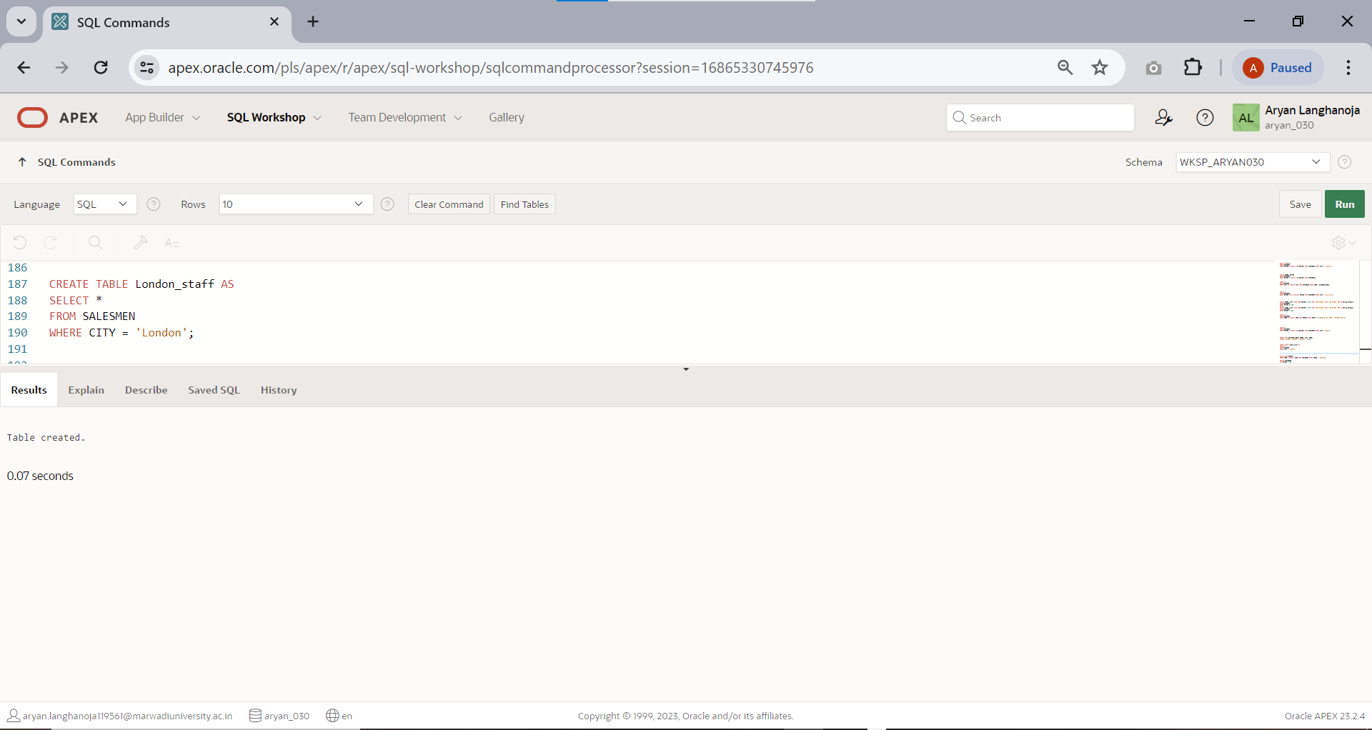Create another table London_staff having same structure as salesmen table.
2. Delete all orders from customer ‘PIYUSH’ from the order table.

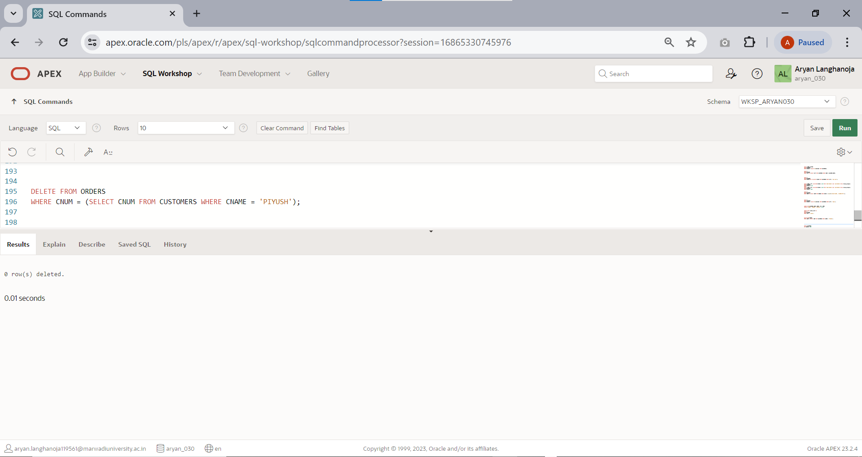

1. 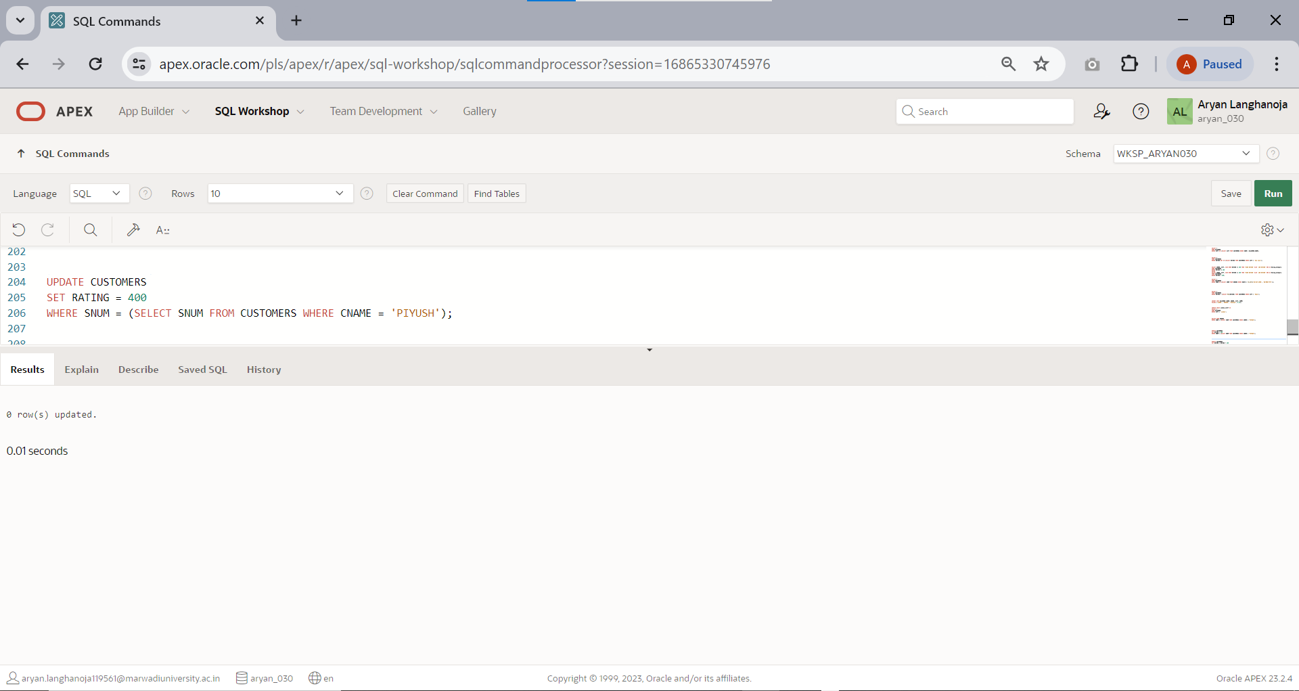Set the ratings of all the customers of PIYUSH to 400.
2. Increase the rating of all the customers in ROME by 100.

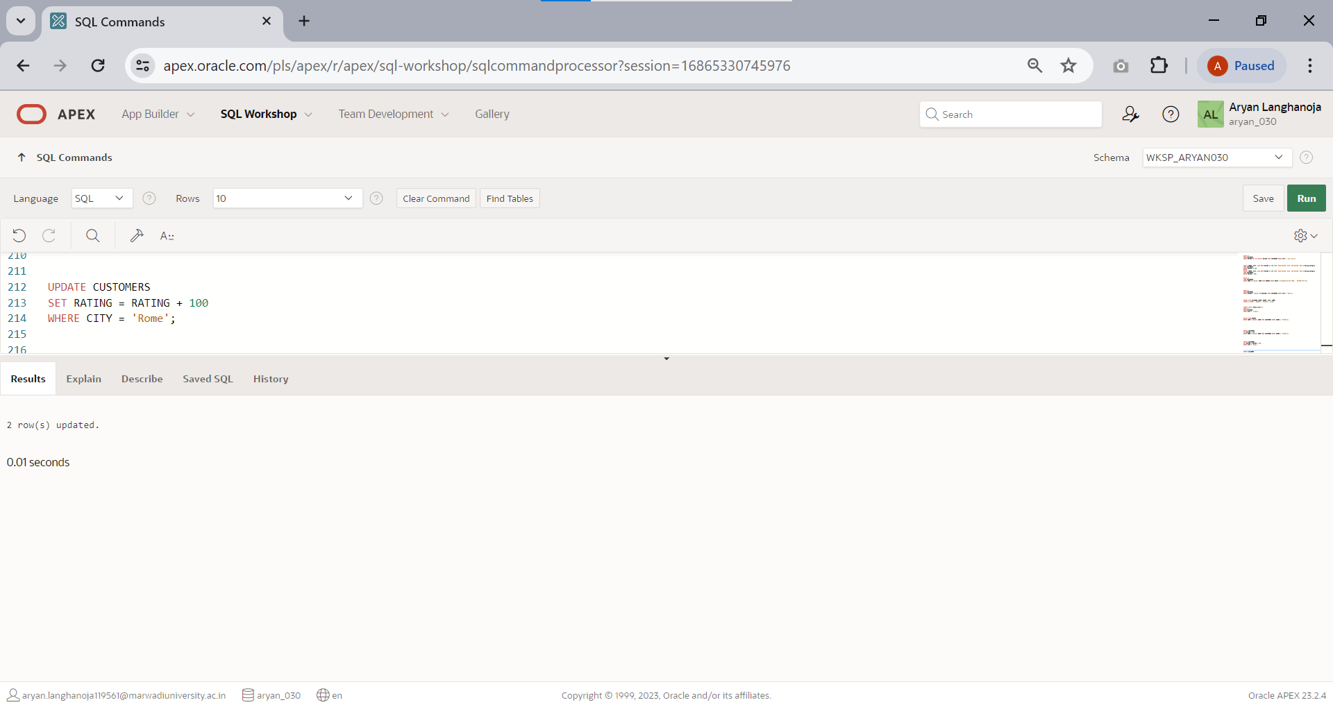

1. 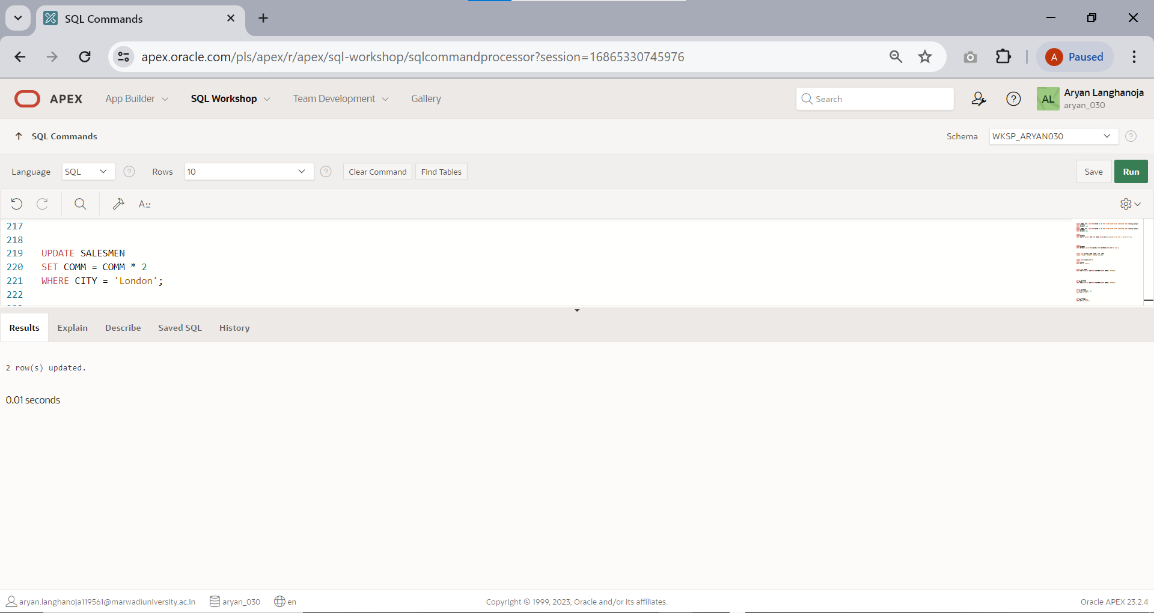Double the commission of all salesmen of LONDON.
2. 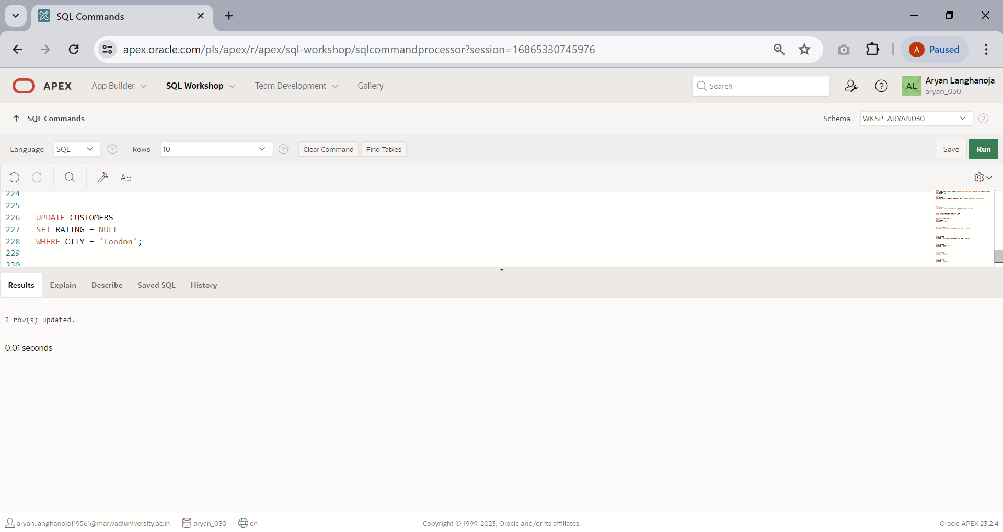Set ratings for all customers in LONDON to NULL.
3. Delete all salesmen who have at least one customer with a rating of 100 from salesmen table.

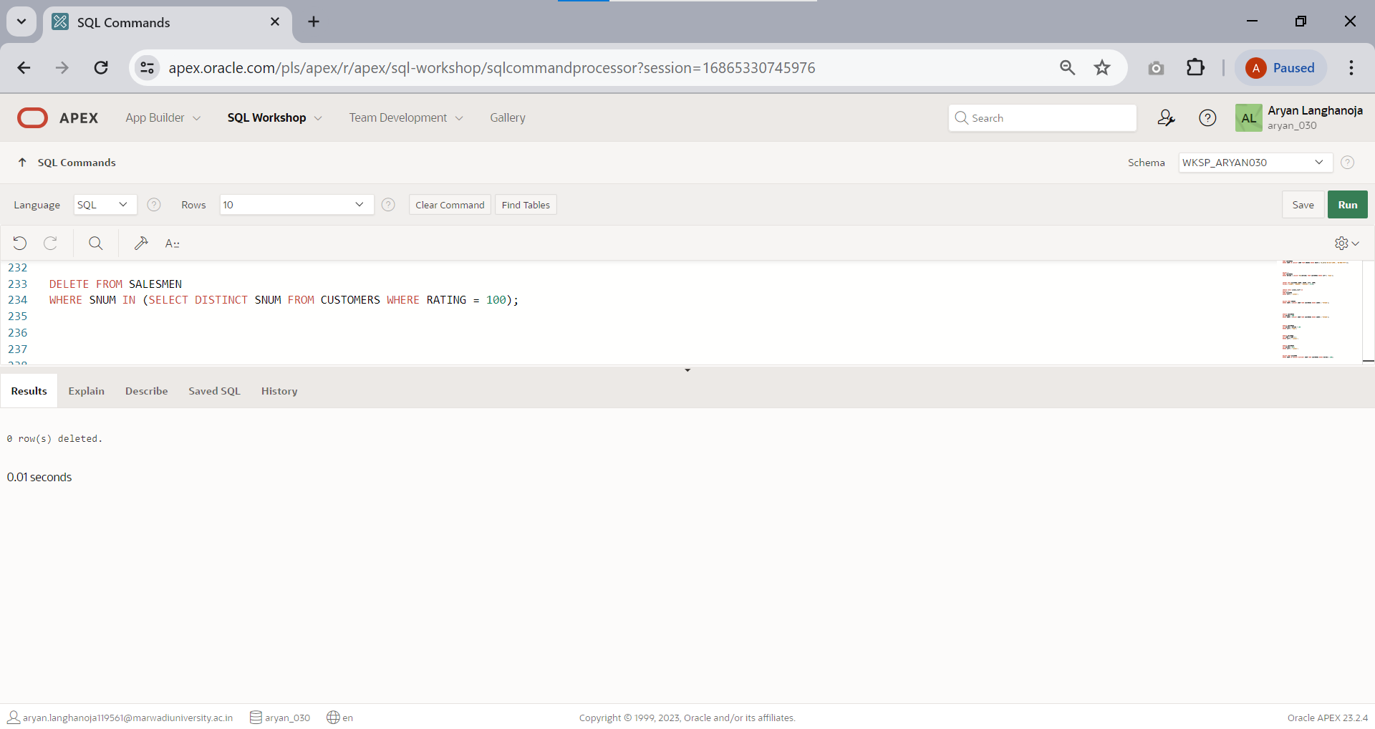

# Practical 11

## Aim: Understand and implement Conditions and looping in PL/SQL

1. 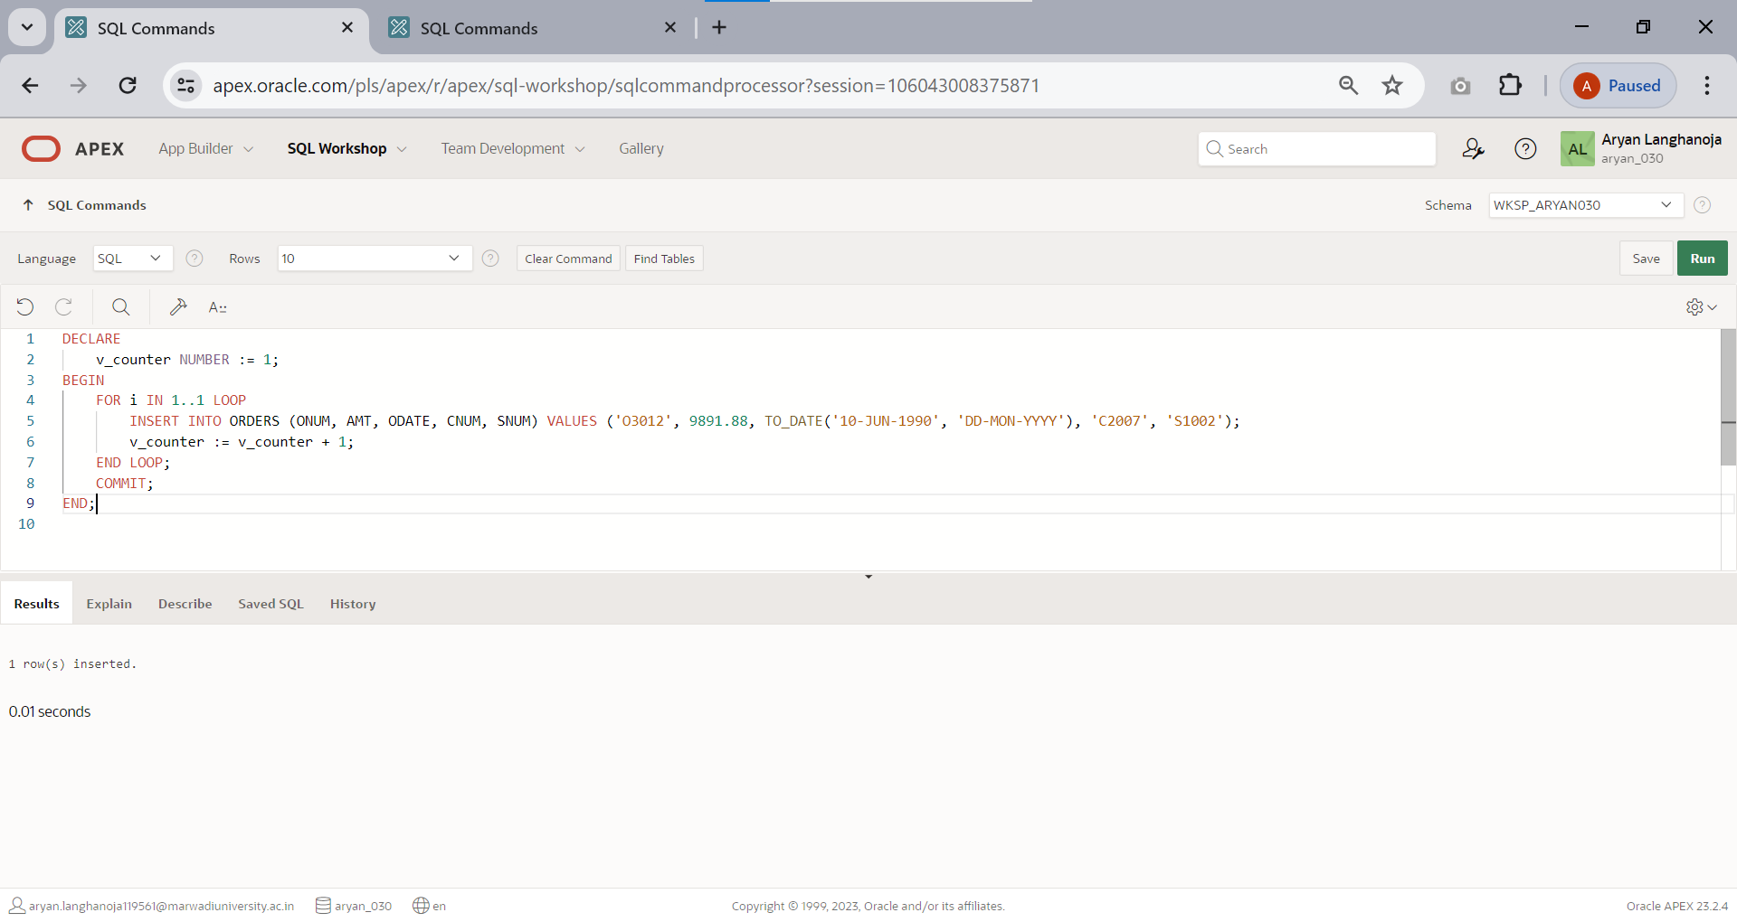Write a Pl/SQL program using FOR loop to insert ten rows into a database table.
2. 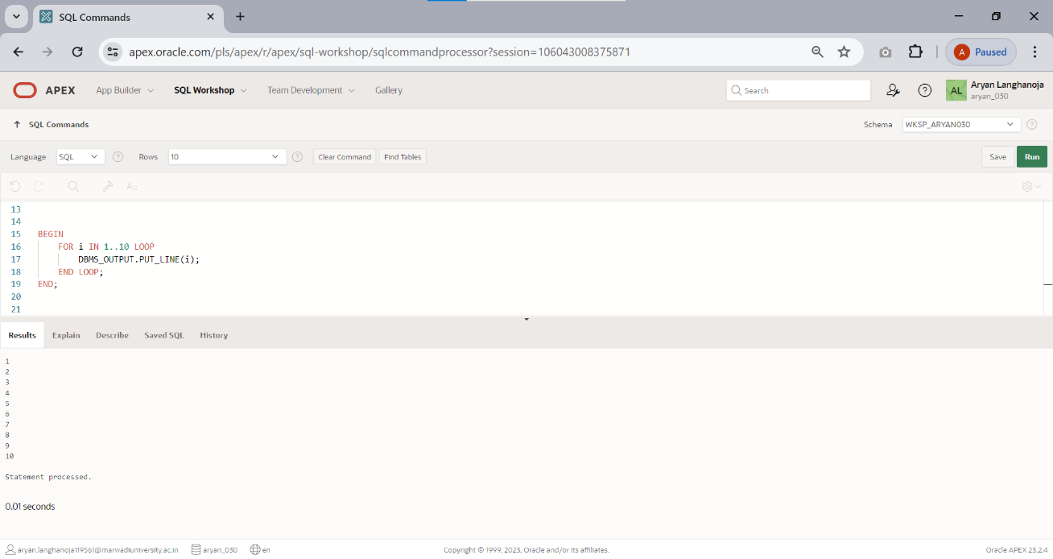Write a Pl/SQL program to print integers from 1 to 10 by using PL/SQL FOR loop
3. Create the procedure for palindrome of given number

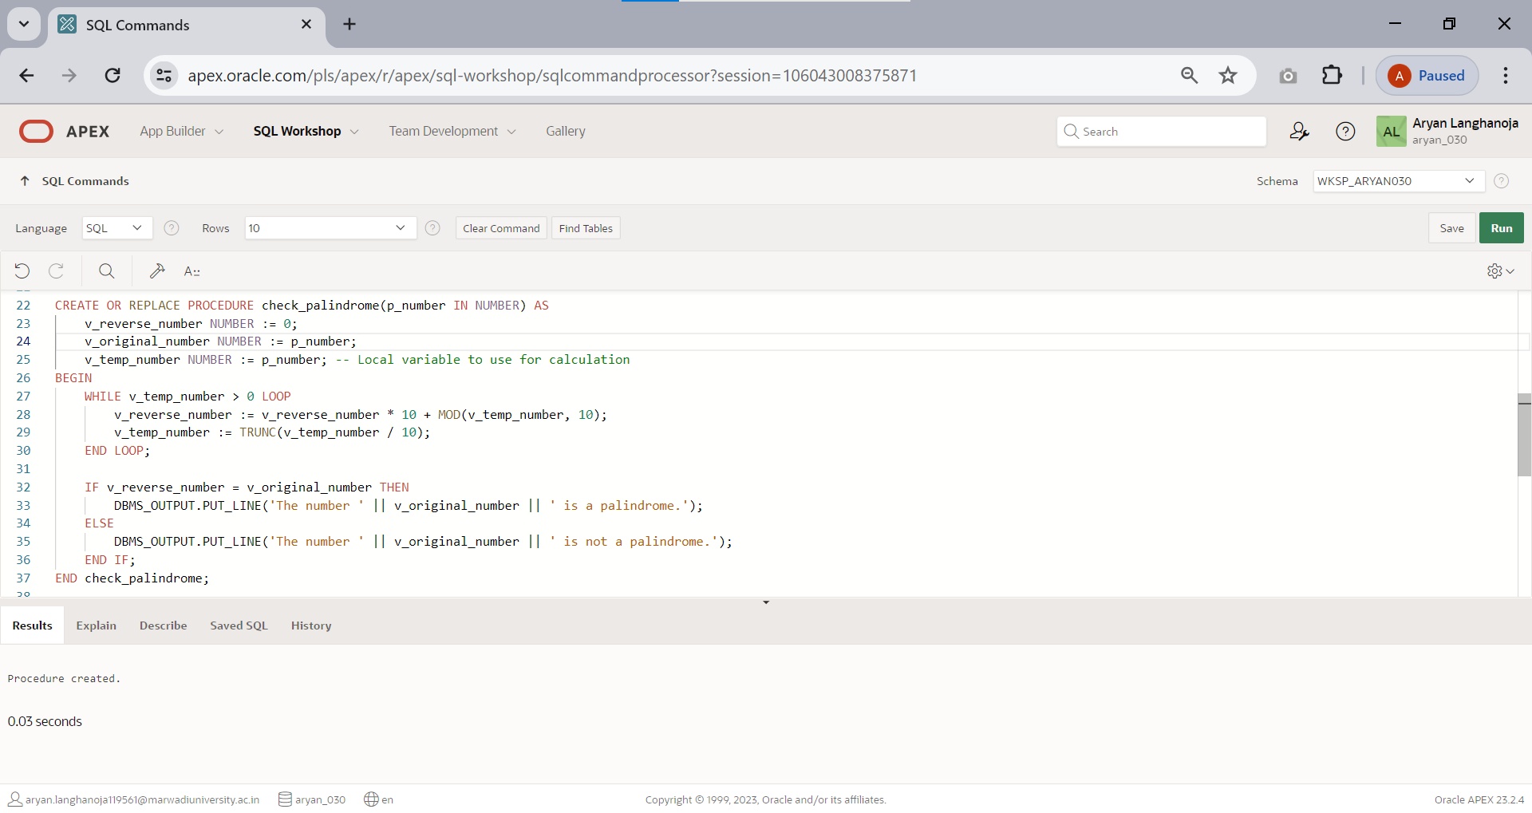

# Practical 12

## Aim: Implement a PL/SQL Block.

1. Given the table ORDER (ONUM, AMT, ODATE, CNUM, SNUM) write a cursor to select the five highest amount (AMT) order details from the table.

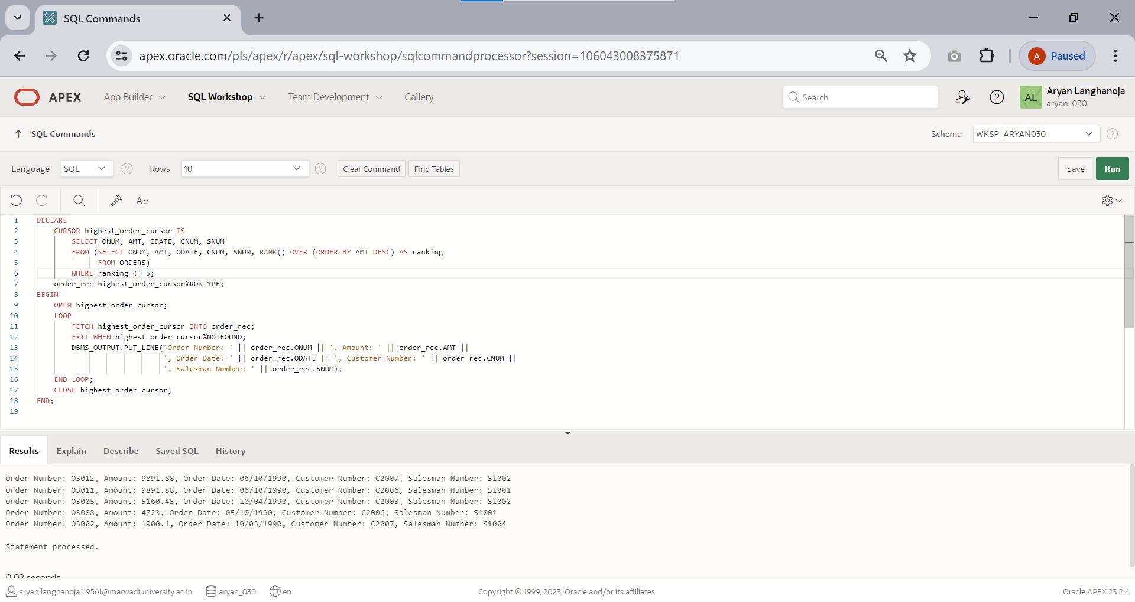

1. To write a Cursor to display the list of customers who are living in San jose or London.

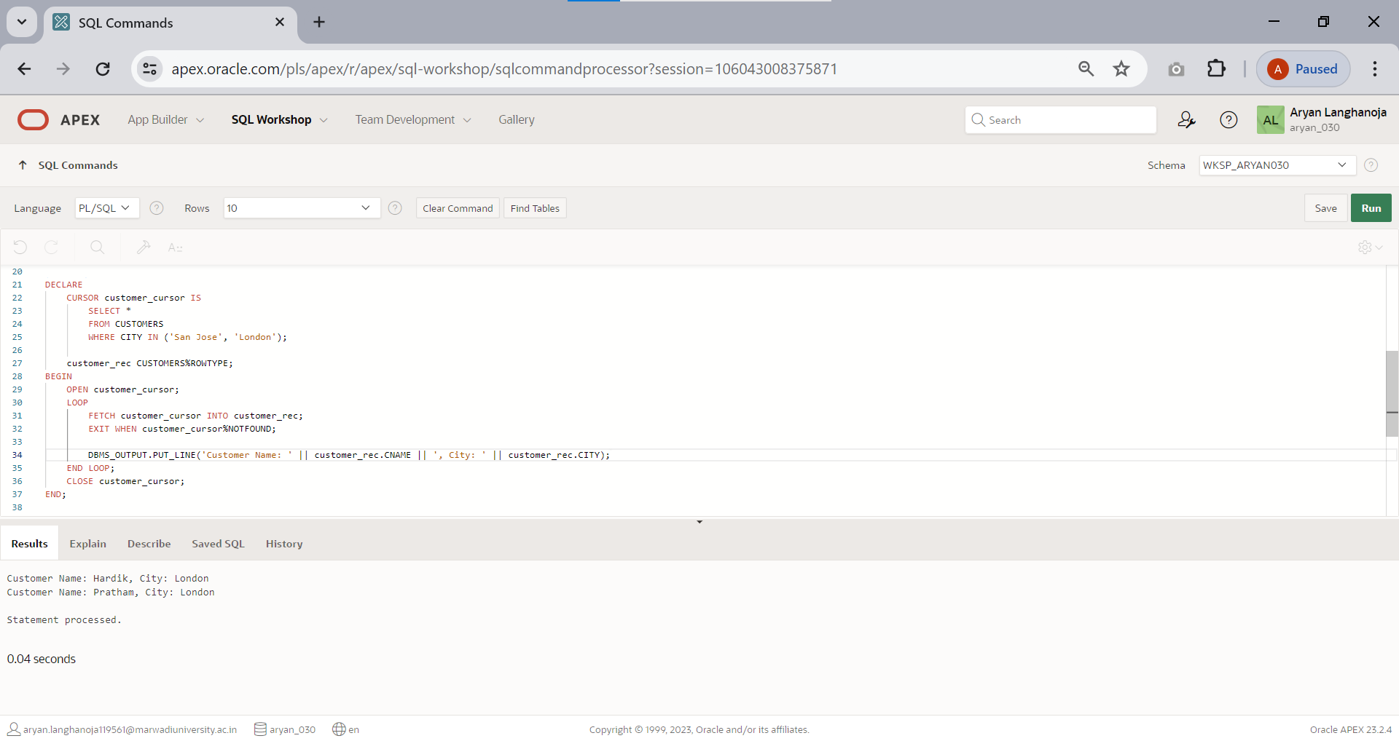

# Practical 13

## Aim Implement a Procedure and Function for given Statement

1. 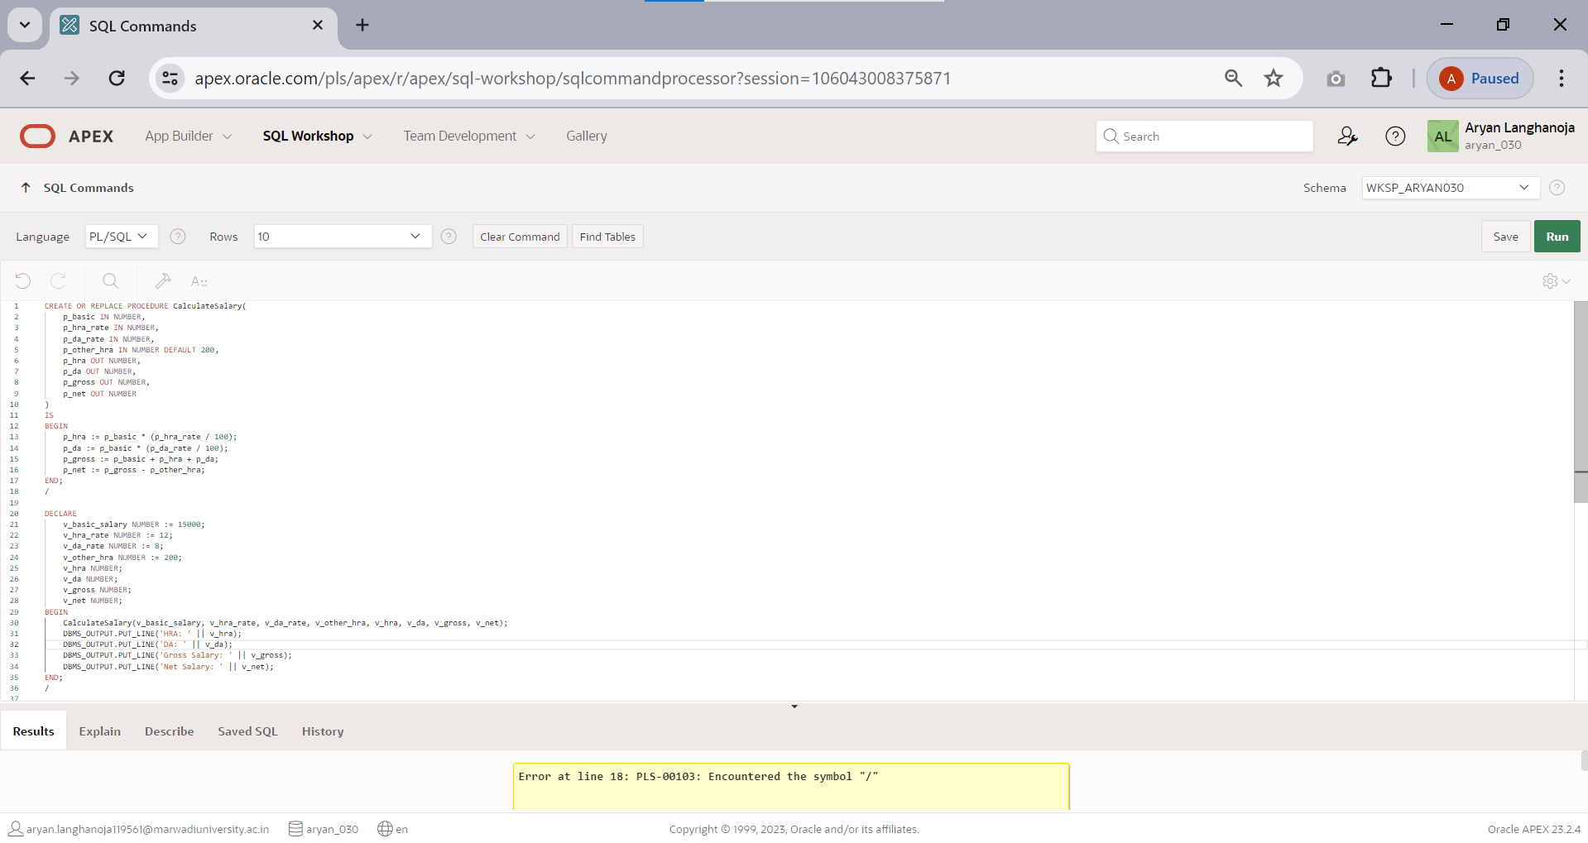Calculate hra,da, gross and net by using PL/SQL program

|  |  |  |
| --- | --- | --- |
| Basic | HRA | DA |
| 15000 | 12% | 8% |
| 12000 | 10% | 6% |
| 9000 | 7% | 4% |
| OTHERS | 5% | 200/- |

1. Write a function to accept employee number as parameter and return Basic +HRA together as single column

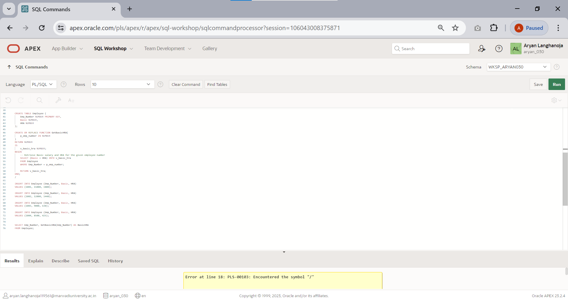

# Practical 14

## Aim: Understand and Implement Triggers.

1. Whenever order amount is updated and its value becomes more than 5000 a trigger has to be raised preventing the operation.

